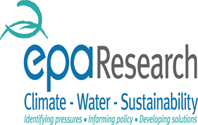
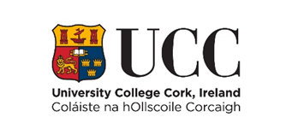


Study on Usage and Waste Management of Amalgam Dental Fillings and mercury free alternatives
As you may be aware with the impending amalgam phase down dentistry in Ireland is facing big changes and we at University College Cork would like to find out how this may affect dentists and the care which they provide to their patients.
The study aims to determine the approximate number of restorations placed by dentists in Ireland and the proportion of these which are dental amalgam or mercury free alternatives; composite, glass ionomer cement and resin modified glass ionomer cement, and to identify key waste management practices and policies for amalgam and mercury free alternatives.
The reason for undertaking this study is the recent international agreement to introduce controls on the use of mercury under the Minamata Convention on Mercury. A new European directive, Regulation EU 2017/852 adopted on 17th May 2017 stipulates the various changes in relation to dental amalgam.
It must be noted the reasons for the introduction of the Minamata Convention on Mercury are solely environmental related to concerns about contamination in the environment from all mercury, dental amalgam being one of these.
