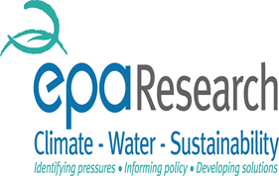
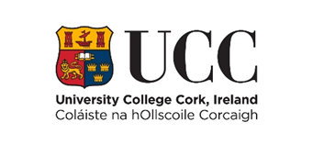


What effect will the Minamata Convention on Mercury have on me the patient?
New regulations in Ireland and the European Union (EU) restricting the use of mercury came into law in July 2018. The regulations are part of a worldwide agreement to reduce global environmental pollution caused by mercury. This includes mercury released during the production, use and disposal of mercury products, such as dental amalgam, the silver coloured material that is commonly used to fill teeth that have decay.
From 1st July 2018 under the Minamata Convention amalgam restorations will no longer be placed in:
- Children under 15
- Deciduous (baby) teeth
- Pregnant or breast-feeding women
Your dentist may place amalgam restorations in certain situations where it is deemed medically necessary, but this will be outlined and explained to you in detail by your dentist.

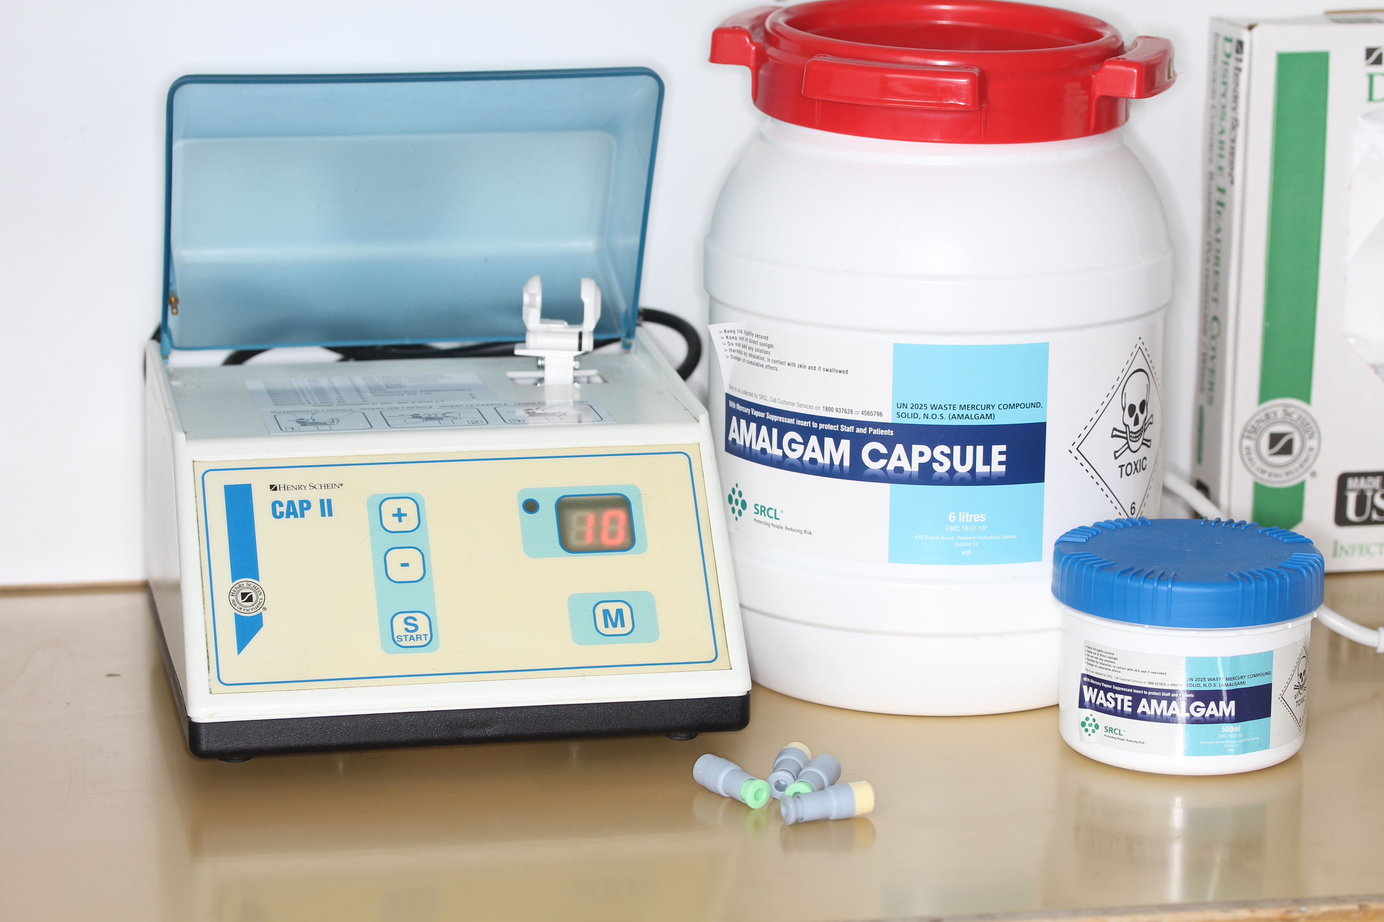

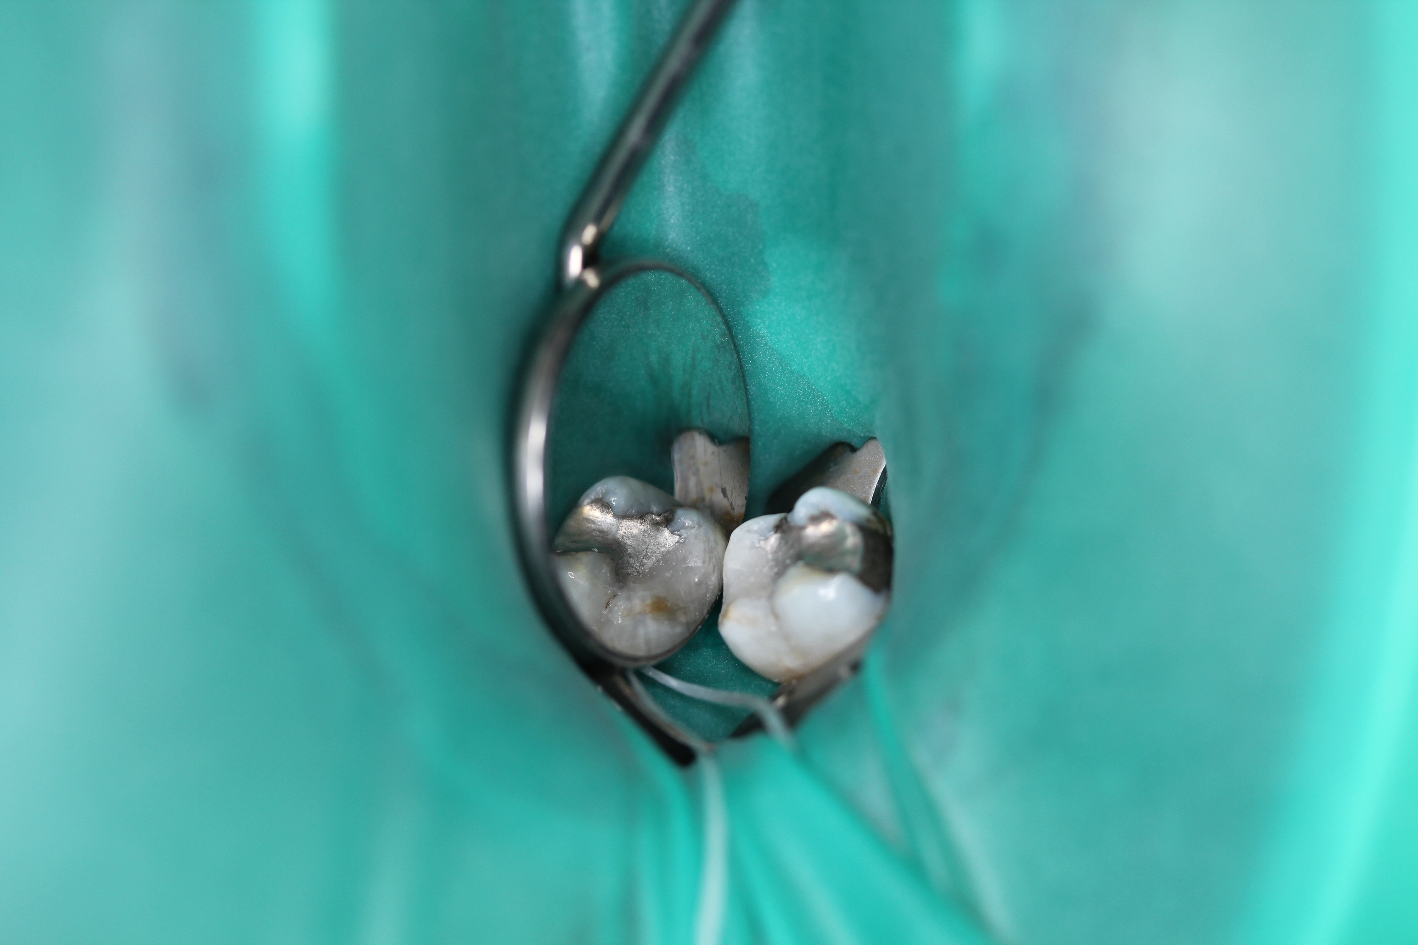
Further information on recommendations relating to dental amalgam can be found at:
http://www.sdcep.org.uk/wp-content/uploads/2018/06/SDCEP-Dental-Amalgam-Information-for-Patients-Under-15.pdf
http://www.sdcep.org.uk/wp-content/uploads/2018/06/SDCEP-Dental-Amalgam-Information-for-Parents-or-Carers-of-Patients-Under-15.pdf
http://www.sdcep.org.uk/wp-content/uploads/2018/06/SDCEP-Dental-Amalgam-Information-for-Pregnant-or-Breastfeeding-Patients.pdf

