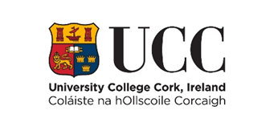
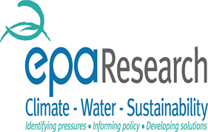


Introduction
The practice of dentistry in Ireland is about to face major changes following the introduction of policy changes in line with Europe’s commitment to the Minamata Convention on Mercury. The Minamata Convention has committed to reducing the use of mercury containing products on a global scale. Dental amalgam, which contains mercury comes under this new legislation. It will begin with a phase down of dental amalgam with an end goal of a total phase out by 2030. The use of mercury containing amalgam restorations in dentistry will be affected following more than 150 years of successful use. Dental amalgam alternatives it is argued simply do not measure up in terms of ease of use and longevity. This will have a significant impact on the practice and teaching of dentistry in Ireland and has implications in terms of the placement of and waste associated with amalgam alternatives. Currently there is limited data available in relation to selection and placement of restorative materials in Ireland. The placement of restorations by dentists’ accounts for a significant proportion of the daily workload and so the changes will significantly impact the day to day work carried out by general dental practitioners.
Dental amalgam in Ireland
In the Irish context there appears to be lack of information relating to the placement of restorations with no national surveys on the selection and use of restorative materials. There is available data in relation to the public service dental treatment schemes outlined below but no data in relation to the out of pocket expenditure on dental treatment which makes up most of the expenditure on oral healthcare in Ireland. Provision within the Irish dental service is complex operating under a public private mix and while there is data pertaining to the placement of restorations under the public scheme there is no such data in regard to the private dental provision which makes up a significant proportion. There are 3 publicly funded schemes in Ireland; the Public dental service (PDS), the Dental Treatment Services Scheme (DTSS) and the Dental Treatment Benefit Scheme. The PDS run by the Health Service Executive (HSE) provides salaried dentists in local health centres to take care of the dental needs of all children and adults with special needs. The DTSS operated by the HSE provides limited dental treatment through contracted independent dental practitioners to low income adults based on means testing. The DTBS operated by the department of social welfare provides insured persons very limited dental treatment provided by private independent dental practitioners. The predominant expenditure on oral healthcare in Ireland comes from out of pocket payments accounting for approximately 83% in 2014 (1).
Under the DTSS dental practitioners will only be reimbursed for amalgam restorations in posterior teeth, remuneration in based on a fee per item basis. The data available in relation to placement of posterior restorations under the scheme is likely to be very different to data in relation to private patients. The data available in relation to the DTSS is not transferable to what occurs in private patients who are paying out of pocket for their oral healthcare.

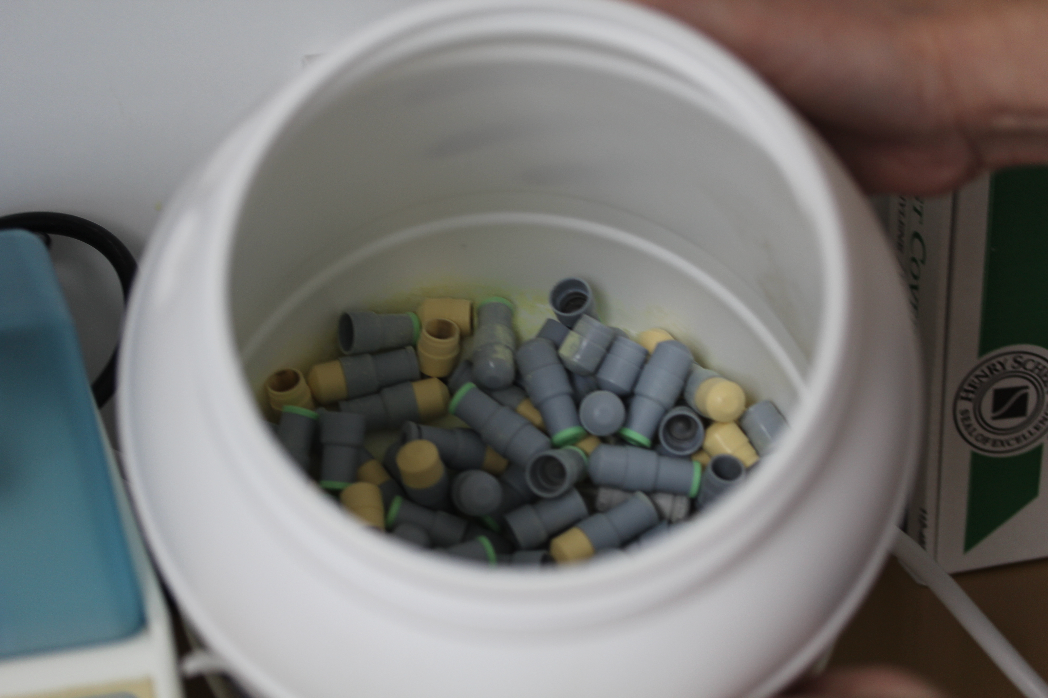

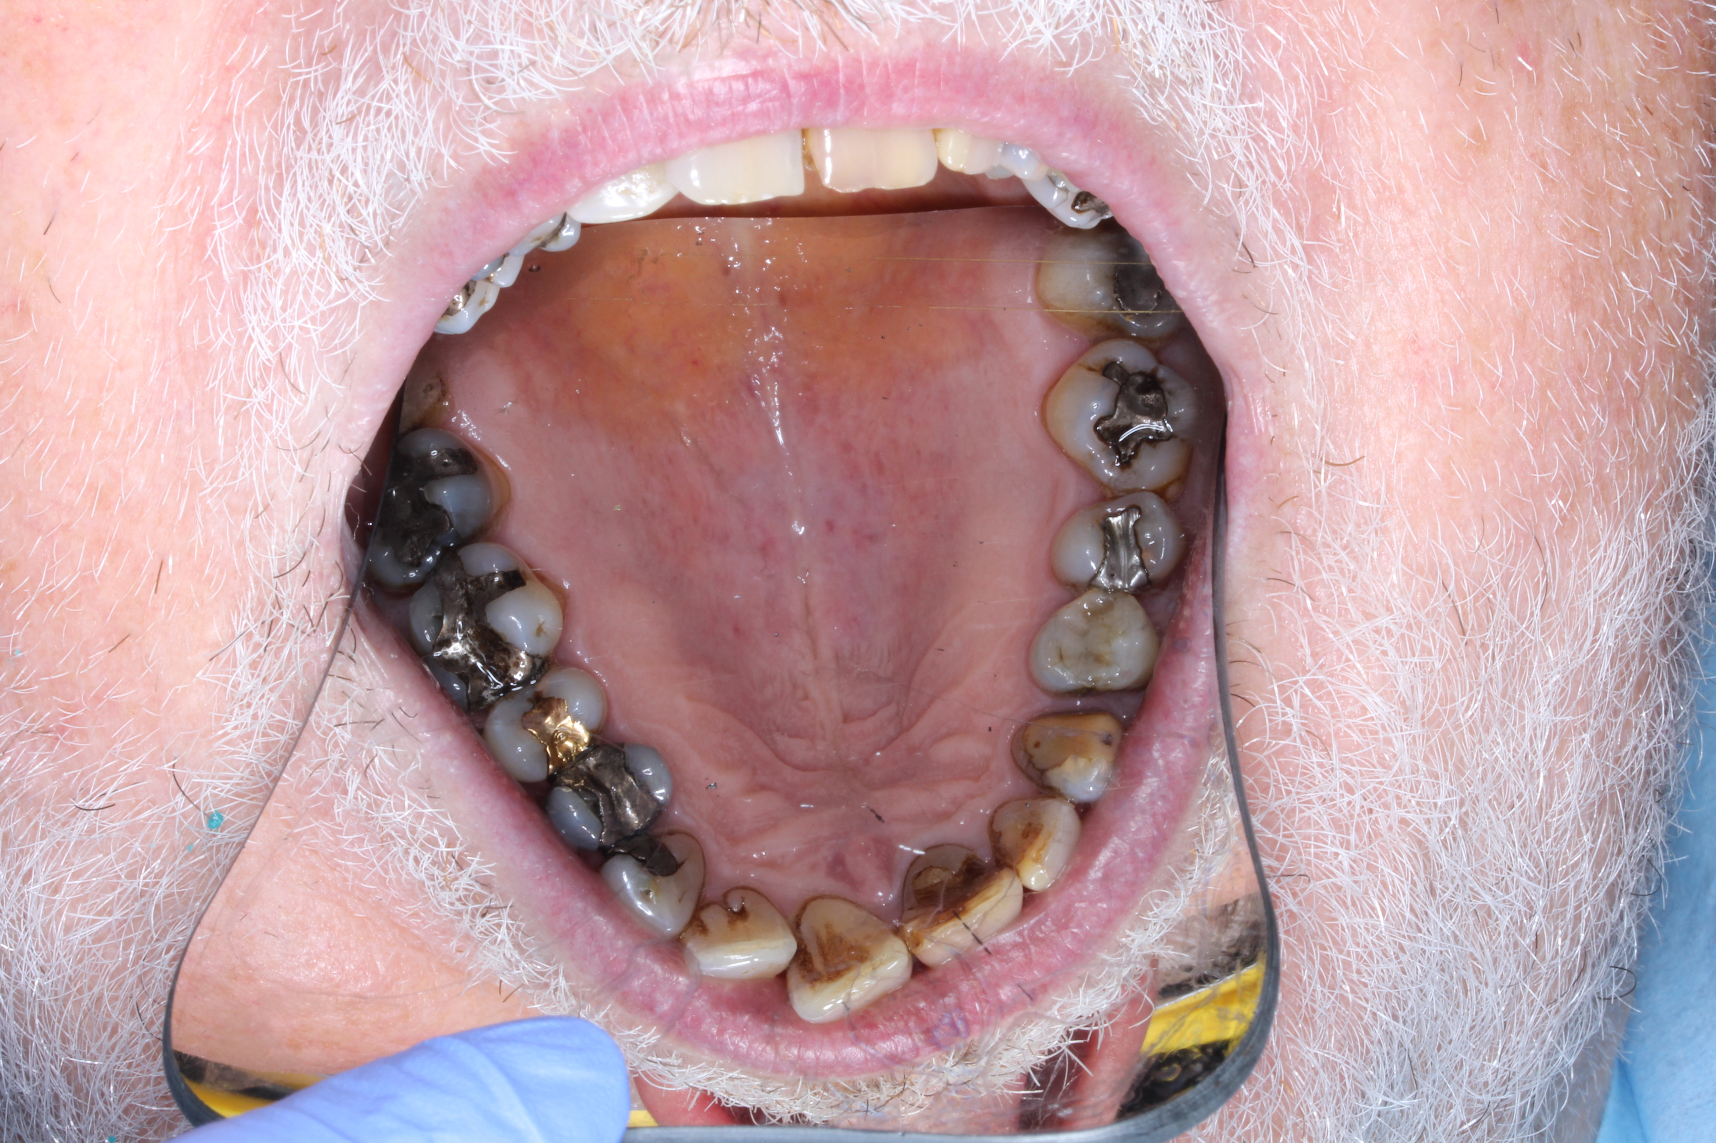
The Minamata Convention – Phase down of dental amalgam
The Minamata Convention for Mercury is an internationally binding treaty which opened for signature in October 2013. The convention gets its name from the city of Minamata in Japan after severe mercury poisoning of seafood occurred causing neurological syndrome called Minamata disease. The aim of the Convention is the protection of human health and the environment from sources of emissions and releases of mercury and mercury compounds. The use of dental amalgam is one of the areas the Convention seeks to address with a proposed voluntary phase down and commitment to other measures pertaining to the use of dental amalgam. The use of dental amalgam has been a contentious issue for many years and in recent times of particular concern is the potential risk to human health and the environment in regard to poor waste management. The Convention has outlined measures in relation to dental amalgam including; minimising the need for dental restorations through national objectives at caries prevention and health promotion minimising its use through setting national objectives, research and development of mercury free alternatives, educating and training dental professionals in mercury free alternatives, discouraging insurance policies and programmes from favouring dental amalgam use and encouraging the use of mercury free alternatives, restriction on the use of dental amalgam to only its encapsulated form and promoting best practice in dental facilities in relation to dental amalgam. Countries have been asked to commit to two or more of the measures outlined in the treaty. The European Parliament adopted Regulation EU 2017/852 on mercury in May 2017 to enable the EU and its member states to ratify the Minamata Convention on Mercury (2).
Under the existing EU Waste Directive 2208/98/EC there is a legal requirement in Ireland to separate amalgam with an amalgam separator, PARCOM recommendation 93/2. Used amalgam capsules must also be stored in an approved container and all amalgam waste from suction u its must be stored in a dedicated container with a sponge impregnated with a mercury vapour suppressant. The practice as the generator of the waste is charged with its disposal and are required to keep records of disposal, Waste Transfer Forms (WTF) formerly C1 forms for 3 years.
With the phase down already underway in Ireland since 1st July research into the placement of amalgam restorations and its alternatives is warranted. There is little available data relating to dentists’ selection and use of restorative materials in Ireland. In the first instance there is need to quantify the number of restorations placed by dentists and the proportion of amalgam and mercury free alternatives ahead of the impending phase down.
The potential for dental amalgam to have a negative impact on human health is still a subject of much debate, while studies have shown a correlation between mercury levels in the blood and amalgam fillings there is no evidence to suggest a negative impact on human health. The environmental impact however is not disputed, the waste created from the extraction, disposal and incineration of dental amalgam is known to contaminate the environment. The contamination also occurs in the cremation of human remains with mercury being released into the atmosphere, land and water (3).
Mercury once released persists in the environment and can travel long distances and bioaccumulate up the food chain to large fish where it can be consumed by humans. Mercury can cause serious damage to human health in the central nervous system, thyroid, kidneys, lungs, immune system, eyes gums and skin. Mercury contamination can also have serious impacts on ecosystems such as reproductive effects on birds and mammals. Biomagnification of up to 100,000 times have been reported from algae to the top of the food chain (4).
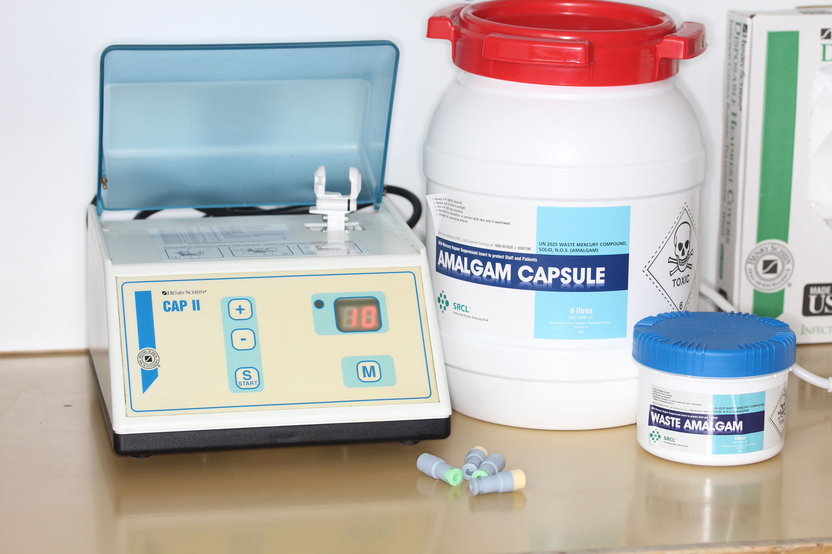
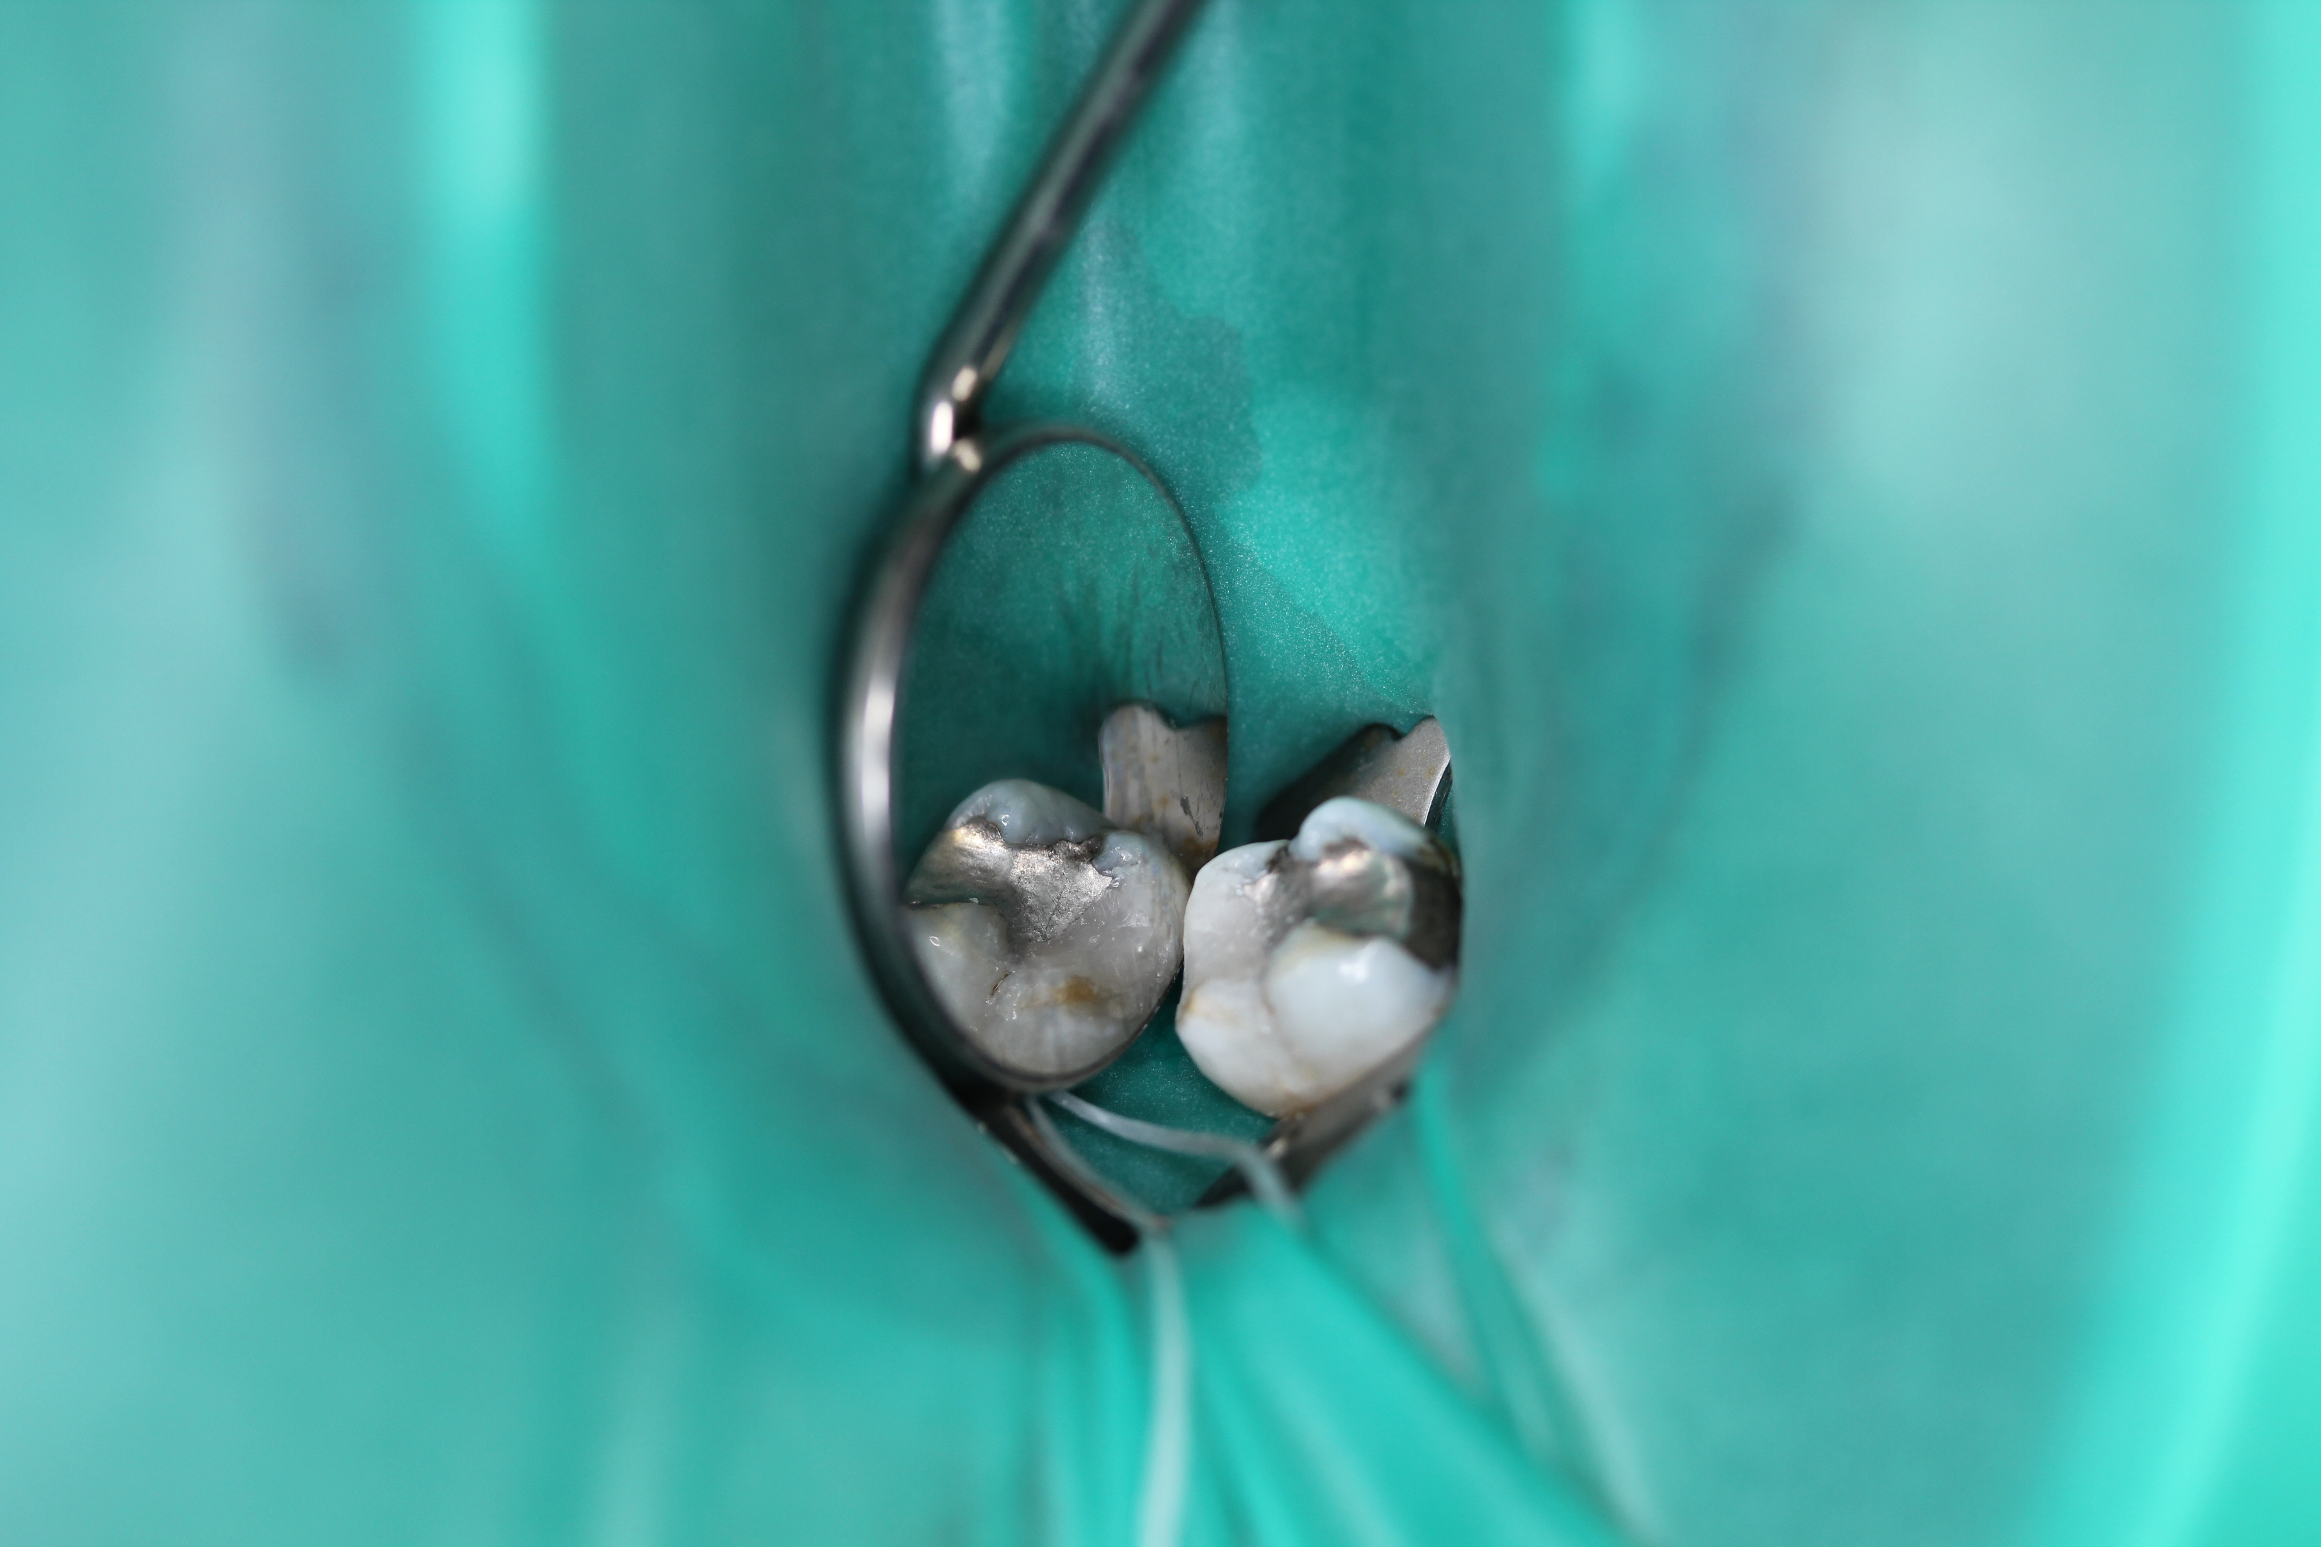

Conclusion
The practice of dentistry in Ireland is undoubtedly going to be affected by the phase down of amalgam which is going to have a major impact on the day to day work carried out by dental practitioners. Public dental schemes may need to revise existing provision in line with changes resulting from the Minamata Convention to allow dentists operating them provide optimal treatment to their patients.
References
1 Woods et al (2017) The healthcare system and the provision of oral healthcare in European Member States; Part 7 Republic of Ireland.
2 Regulation (EU) 2017/852 of the European Parliament and of the Council of 17 May 2017 on mercury, and repealing Regulation (EC) No 1102/2008
3 United Nations Environment Programme (UNEP) (2016) Lessons from countries phasing down Dental amalgam use. UNEP Chemicals and Waste Branch, Geneva, Switzerland.
4 Chin G et al., (2000). The Environmental Effects of Dental Amalgam. Australian Dental Journal.

