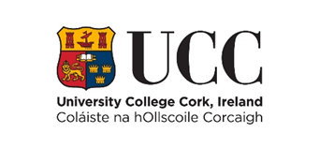

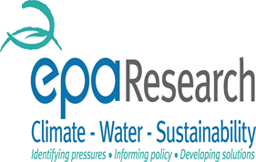

What impact will the Minamata Convention on Mercury have on my practice?
- Dental amalgam only to be used in pre-dosed encapsulated form; use of bulk mercury by the practitioner prohibited (from 1 January 2019)
- Mandatory use of amalgam separators (from 1 January 2019)
- Service standards from Jan 2019: mandatory retention of at least 95% of amalgam particles for separators installed from Jan 2018, and for all separators by 1 January 2021
- Dentists to ensure that their amalgam waste is handled and collected by an authorised waste management establishment
- Member States to set out a national plan (by 1 July 2019) on the measures they intend to implement to phase down the use of dental amalgam
- No use of amalgam in the treatment of deciduous teeth, children under 15 years and pregnant or breastfeeding women, except when strictly deemed necessary by the practitioner on the ground of specific medical needs of the patient (from 1 July 2018);
- the feasibility of a phase out of dental amalgam use in the long term, and preferably by 2030, taking into account national plans for measures to phase down amalgam use, and respecting Member States' competence for the organisation and delivery of health services and medical care.
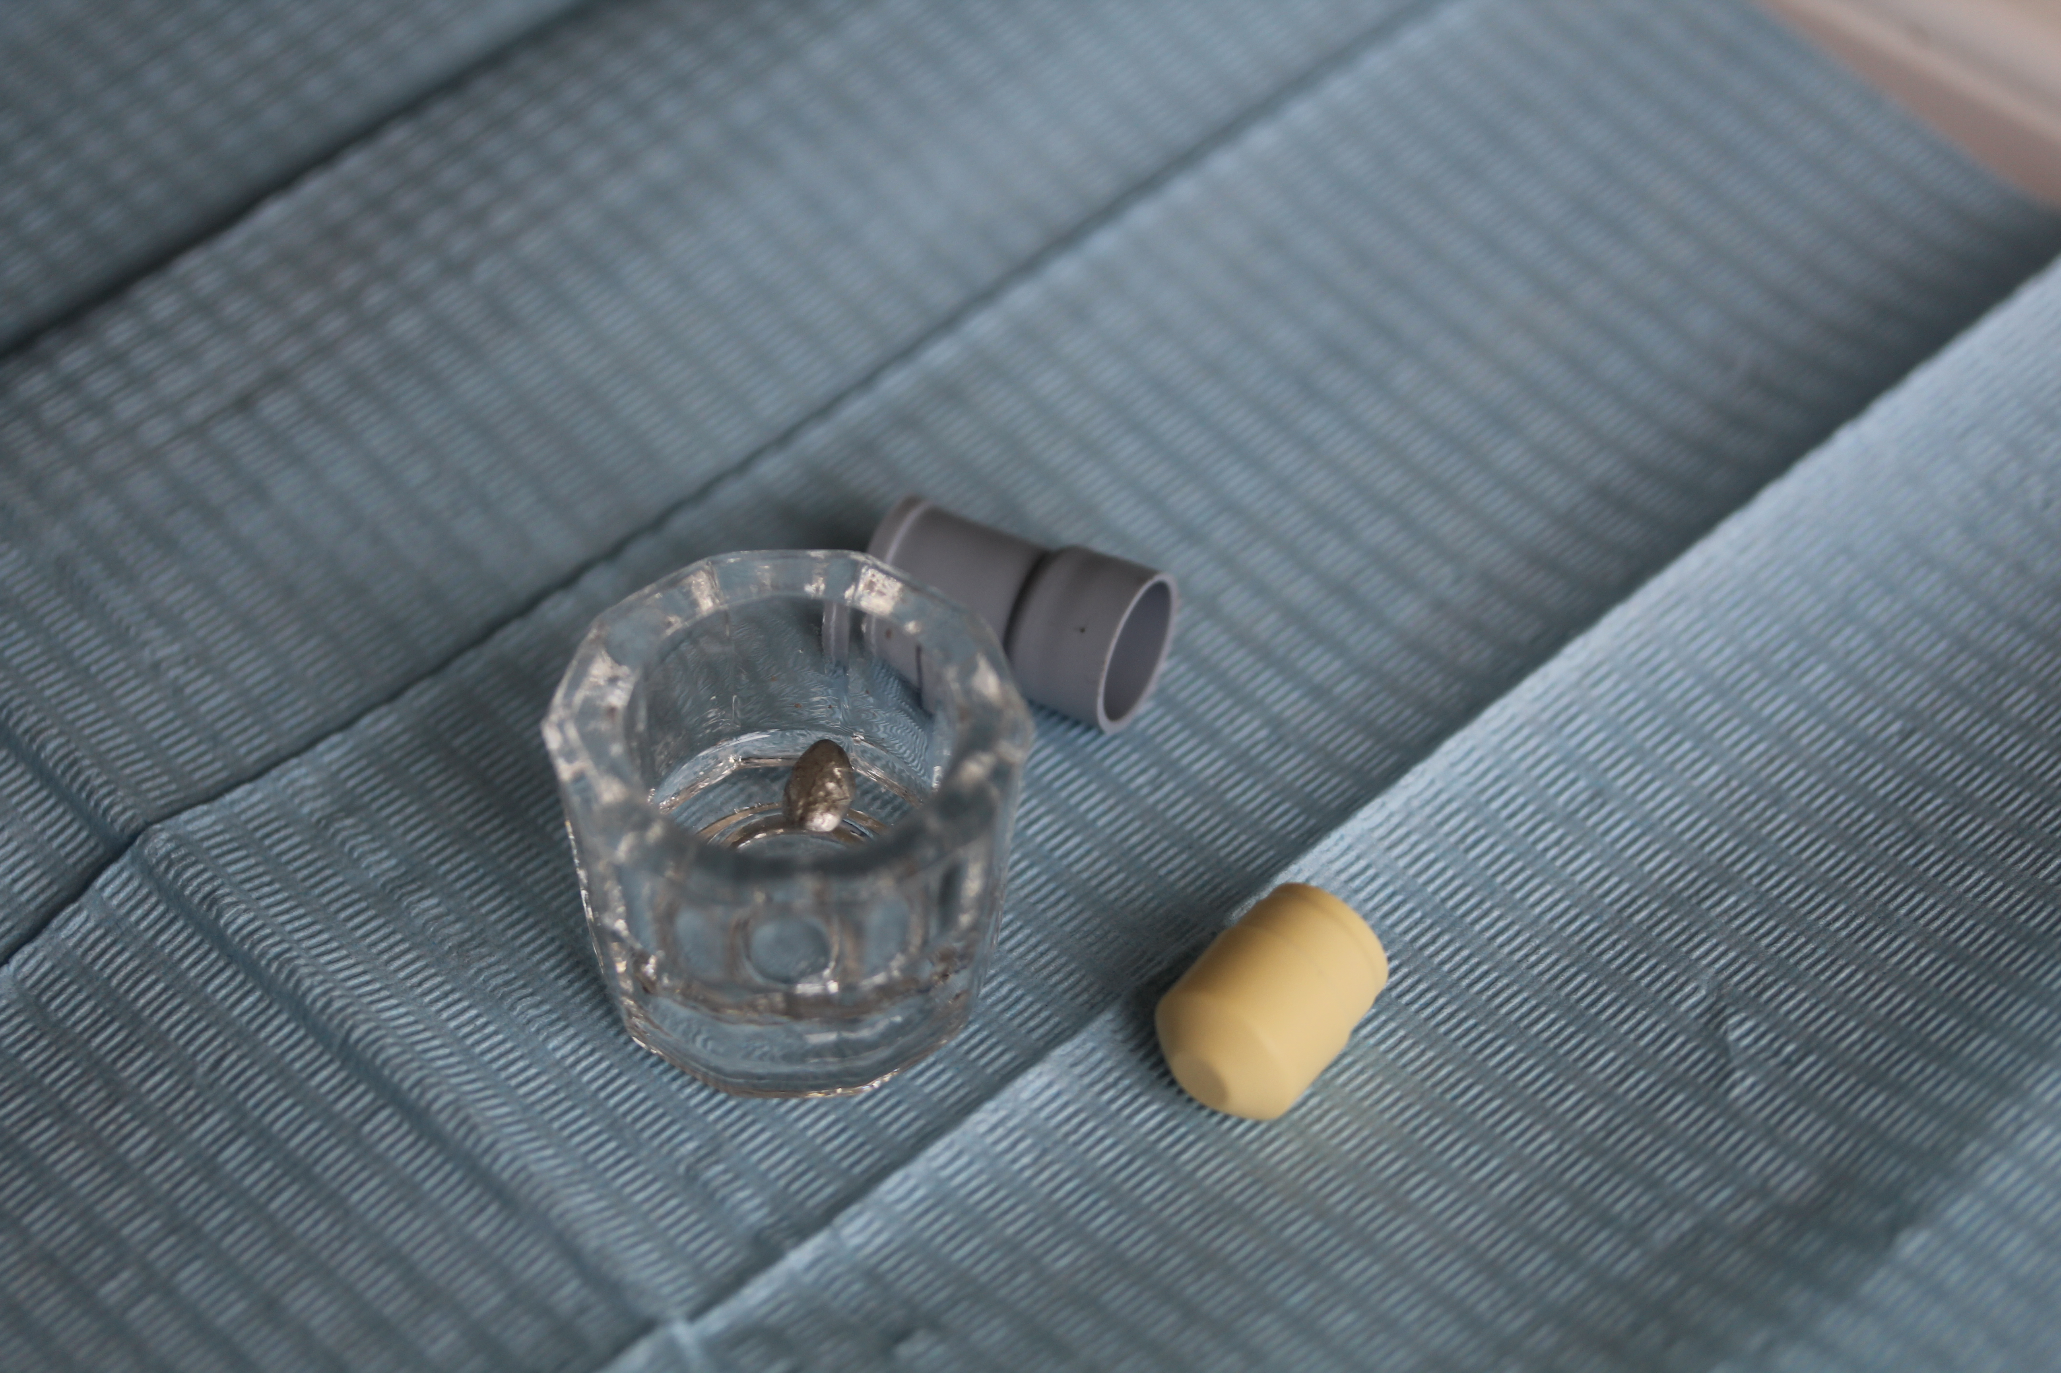
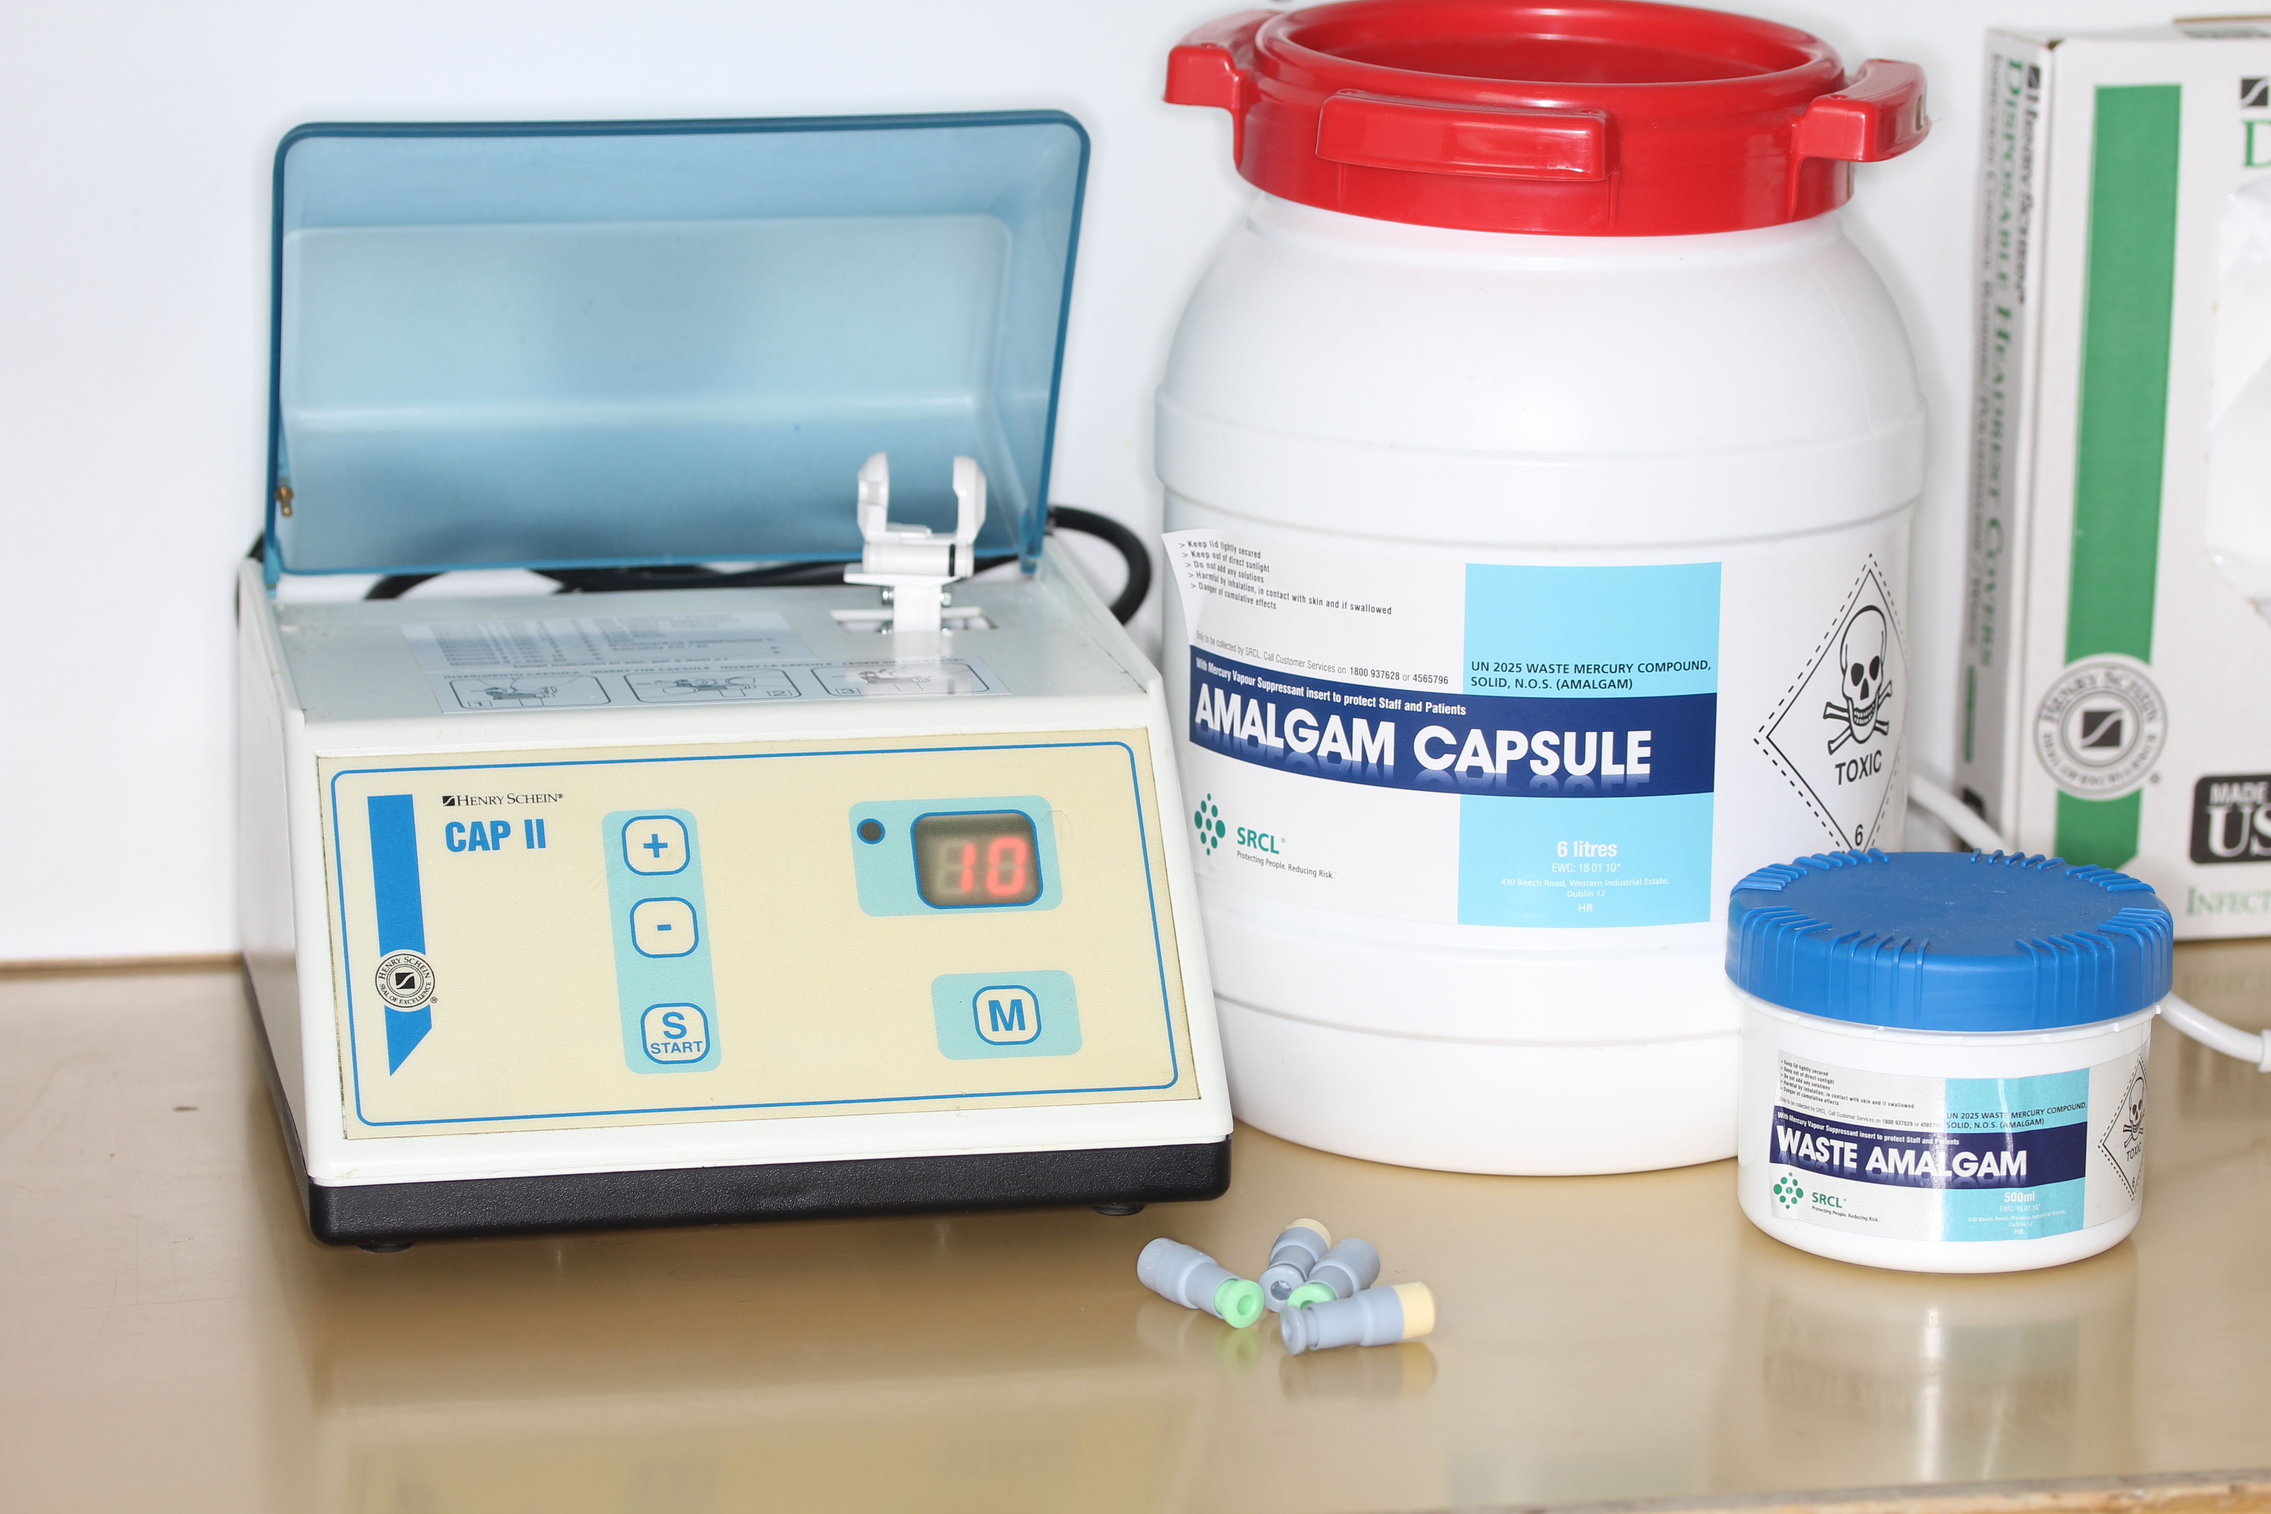
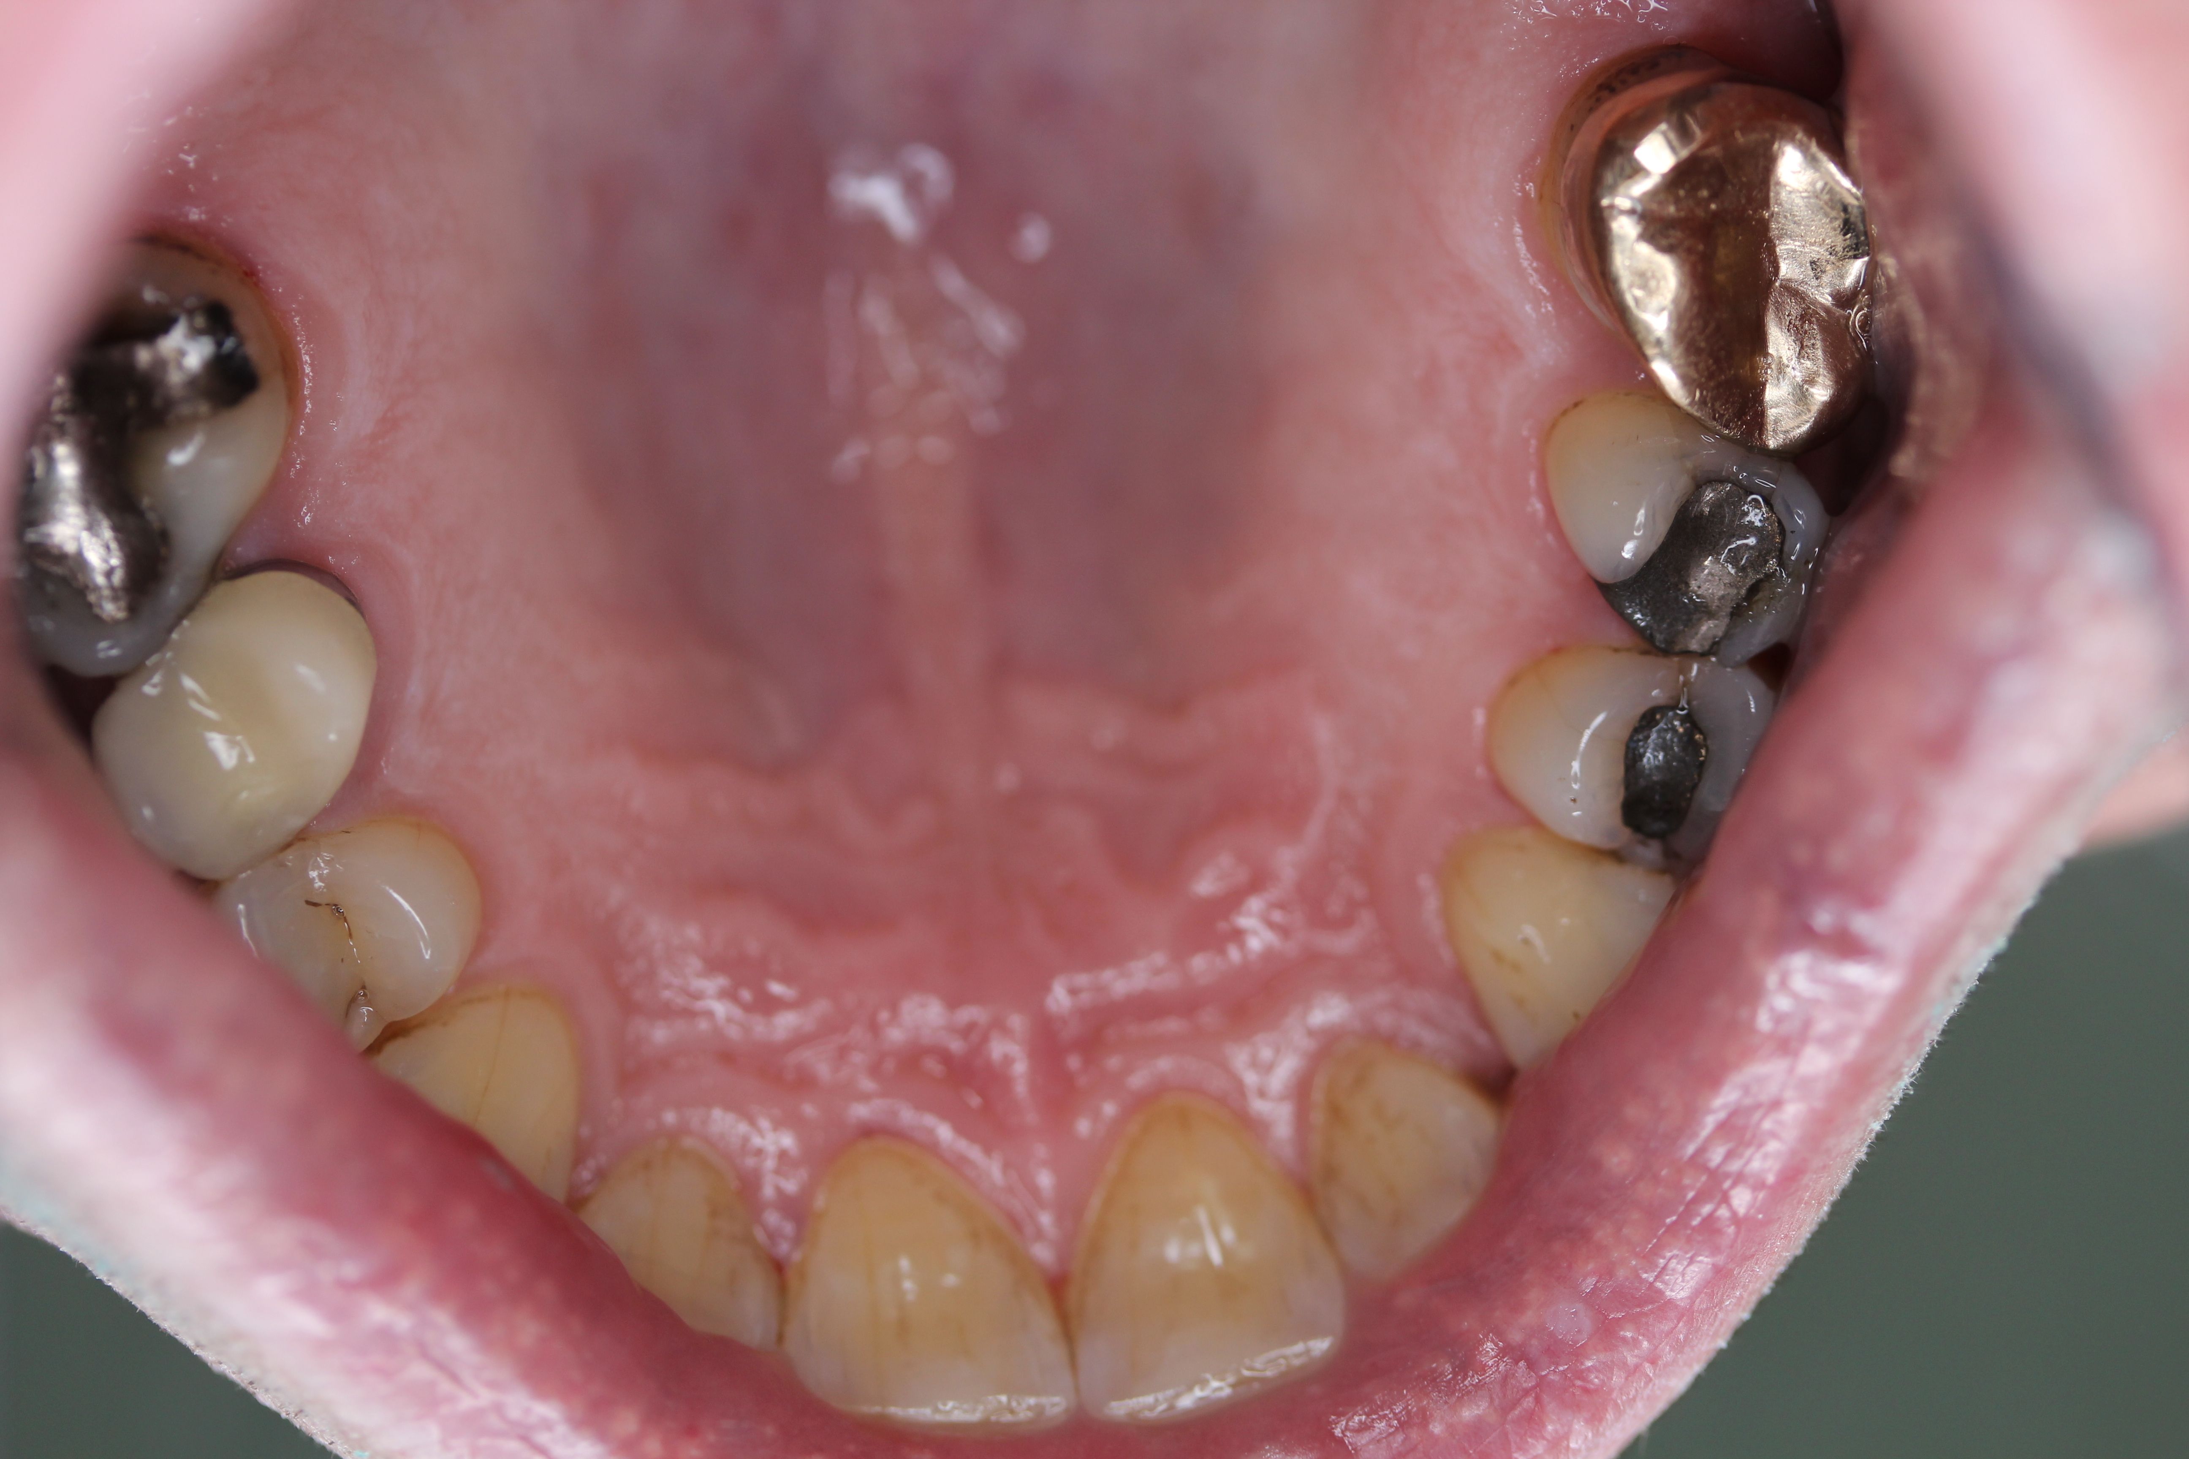

Further guidance for dentists in relation to coded of practice for dental amalgam can be found at: http://dentalcouncil.ie/files/Code%20of%20Practice%20-%20Dental%20Amalgam%20(July%202018)%20-%2020180701.pdf
http://www.sdcep.org.uk/wp-content/uploads/2018/06/SDCEP-Dental-Amalgam-Implementation-Advice.pdf
If you are one of the randomly selected dentists in receipt of the survey we would greatly appreciate your time and input into the study, your responses will be in no way traceable and you will not be identifiable.

