Cork University Dental School & Hospital

Dental Radiography Course for Dental Nurses & Dental Hygienists

Application Form 2025

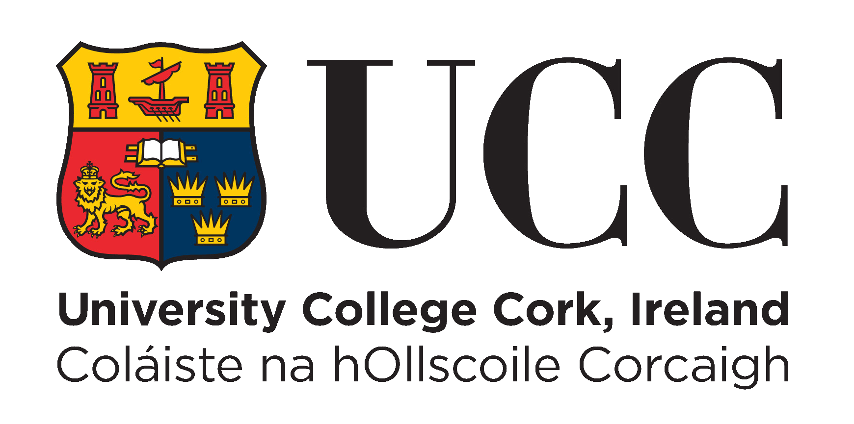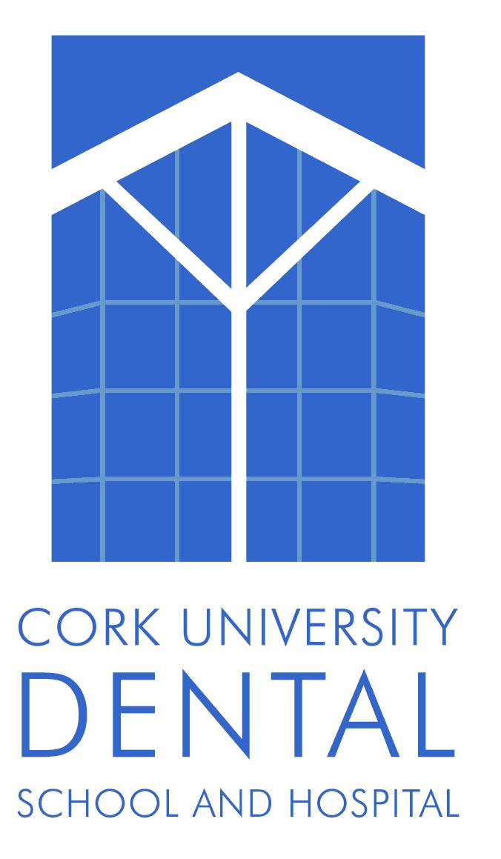

Instructions on Completing this Application Form:

Please ensure that you take time to read to the following instructions for completing your application form, failure to complete the form correctly may result in your application not being considered for a place.

- Use block capitals or print.

- Complete all relevant sections. Use additional pages if required

- Submit documentary evidence of Dental Nursing or Dental Hygiene qualifications with your application form. Do not send originals as they will not be returned. Photocopies will suffice. Please note that if you are currently undertaking a dental nurse training program you must state this in your application form and provide proof of same.

- Sign the application form.

- Course Fee is €1,150.00. Upon offer of a place, this must be paid in full prior to the commencement of the course. Do not send payment now

Completed application form must be received by email only, no later than Friday 30th May 2025 at 5pm. No late applications will be accepted.

Dr Caitriona Ahern
Cork University Dental School & Hospital
Wilton
Cork
Telephone: 021 4901175 or 4545100
E-mail : caitriona.ahern@ucc.ie

SECTION 1: PERSONAL INFORMATION
Name :……………………………………………………………………………….

Address : …………………………………………………………………………..

………………………………………………………………………………………

Date of Birth : ……………………………………………………..

Email address : …………………………………………………………………………………

Mobile phone number : …………………………………………

SECTION 2: EDUCATION

Post-Secondary Education (Highest Level obtained)
Qualification achieved e.g. Certificate/Diploma/Degree | Year | Subjects | Level/Grade Achieved
Use an additional page if necessary.

SECTION 3: CURRENT EMPLOYMENT

Employer Name and Address | Dates (From, To) | Duties
Use an additional page if necessary

SECTION 4: Special Needs
Do you have any special or additional needs?

Yes □ No □

If yes, please explain:
_______________________________________________________________________________________________________________________________________________________________________________________________________________

SECTION 5: ADDITIONAL INFORMATION

Using the space below, please tell us why you should be considered for a place on this programme?

SECTION 6: DECLARATION

Applicant
I certify that the information provided in this application form is accurate and true to the best of my knowledge. I understand that providing incomplete or false information may result in my application not being processed.

Signature of Applicant: _________________________________________________
Date: ________________________________________________________________

Checklist for application

- Application form
- Letter of support from supervising dentist (NB- more than one may be necessary if you are going to a second practice)
- Copy EPA license/ registration
- Copy of Dental Nurse qualification or proof of current enrolment on a qualifying course.

Completed applications must be emailed to
Caitriona.ahern@ucc.ie

Due to demand in the last number of years, regrettably, the number of applications have exceeded places. In this instance, random selection is applied to allocate places.

Closing date for receipt of applications is Friday 30th May at 5pm. Any applications received after this deadline or any incomplete applications will not be considered for a place.

Offers of places will be made in June. On acceptance of a place, full timetable, payment details etc. will be sent to successful applicants.
Payment is not required until August 2025.

