Cork University Dental School & Hospital

Dental Radiography Course for Dental Nurses & Dental Hygienists

Application Form

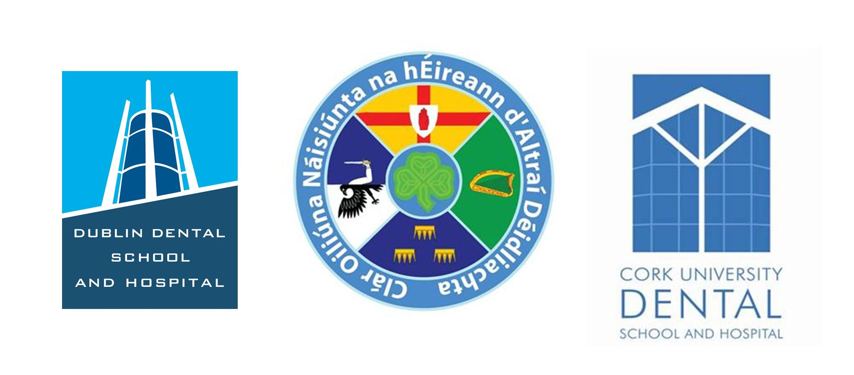

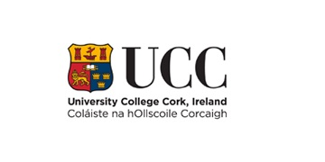

Instructions on Completing this Application Form:

Please ensure that you take time to read to the following instructions for completing your application form, failure to complete the form correctly may result in your application being returned to you.

- Use block capitals or print.

- Complete all relevant sections. Use additional pages if required

- Submit documentary evidence of Dental Nursing or Dental Hygiene qualifications with your application form. Do not send originals as they will not be returned. Photocopies will suffice. Please note that if you are currently undertaking a dental nurse training programme you must state this in your application form.

- Sign the application form.

- Enclose course fee of €975.00. Cheques must be made payable to: University Dental School & Hospital. Cash not acceptable & no refunds will be given.

- Forward completed application form to the following address no later than Friday 7th September 2018 by close of business.

Dr Caitriona Ahern
Cork University Dental School & Hospital
Wilton
Cork
Telephone: 021 4901175 or 4545100
E-mail:caitriona.ahern@ucc.ie

SECTION 1: PERSONAL INFORMATION

Surname: | ____________________________________________________
Forename: | ____________________________________________________
Date of Birth: (dd/mm/yy) _ _ / _ _ / 19 _ _
Current Address:
_____________________________________________________________________
_____________________________________________________________________
_____________________________________________________________________
Email (essential for application):___________________________________
Home Telephone: ________________ |  | Mobile Number: ____________________
Permanent Address (if different from above):
_____________________________________________________________________
_____________________________________________________________________
_____________________________________________________________________
_____________________________________________________________________
Telephone: _______________________ |  |  | Mobile Number: ___________________

SECTION 2: EDUCATION

Post-Secondary Education (Highest Level obtained)
Qualification achieved e.g. Certificate/Diploma/Degree | Year | Subjects | Level/Grade Achieved
Use an additional page if necessary.

SECTION 3: CURRENT EMPLOYMENT

Employer Name and Address | Dates (From, To) | Duties
Use an additional page if necessary.

SECTION 4: SPECIAL NEEDS
Do you have any special needs?

Yes □ No □

If yes, please explain:
_______________________________________________________________________________________________________________________________________________________________________________________________________________

SECTION 5: ADDITIONAL INFORMATION

Using the space below, please tell us why you should be considered for a place on this programme?

SECTION 6: DECLARATION

Applicant
I certify that the information provided in this application form is accurate and true to the best of my knowledge. I understand that providing incomplete or false information may result in my application not being processed.

Signature of Applicant: _________________________________________________
Date: ________________________________________________________________

