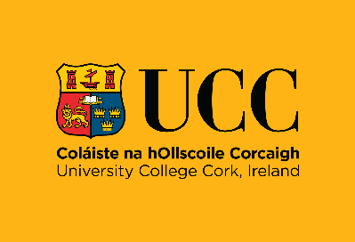
Health Research (Retrospective Chart Review)
at
Cork University Dental School and Hospital

As well as providing dental services to both adults and children, Cork University Dental School and Hospital (CUDSH) is a teaching and research hospital. CUDSH is committed to carrying out health research to high ethical standards to the benefit of patients, to improve dental care and the dental care system. The law allows CUDSH to use your personal data for Retrospective Chart Reviews without seeking your consent. CUDSH takes your privacy seriously and your data will be treated with the highest standards of confidentiality and security.

What is a Retrospective Chart Review?
Also called medical / dental records review. It is a type of health research study where researchers review and examine your existing patient records, which were collected for the provision of health / dental care, to answer one or more health research questions.

When is this type of health research allowed?
- For retrospective health research study only (i.e. looking at existing medical / dental records)
- when the study has been approved by a Research Ethics Committee
- where the study is low risk in terms of your privacy.

How does Retrospective Chart Review work?
Your personal data can only be accessed by:
- a health practitioner employed by CUDSH (e.g. a dentist / doctor / dental nurse / dental hygienist)
- a dental / health student supervised by a health practitioner employed by CUDSH
- a CUDSH employee who would ordinarily have access to your data (e.g. patient dental records clerk)
Your personal data can only be accessed and used for a Retrospective Chart Review by the above authorised individuals and your personal data cannot be shared. The research data gathered from the Retrospective Chart Review will be fully anonymised and can only be shared with third parties if it is fully anonymised. Any results of the study published will not identify you or any patient or former patient.

What is a Research Ethics Committee?
A Research Ethics Committee is an independent group of people appointed to formally assess if health research conforms with recognised international ethical standards. It is responsible for protecting the rights of those who take part in the research and the usage of their personal data for health research.


For more information on CUDSH processing of your personal data please see our data protection notice at www.ucc.ie/en/dentalschool/patients/#data-protection
If you have any queries in relation to the use of your personal data, please contact the Information Compliance Manager, University College Cork at gdpr@ucc.ie

