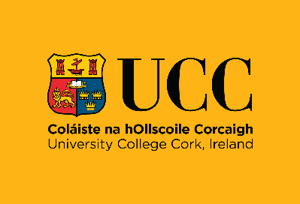
Health Research (Pre-Screening)
at
Cork University Dental School and Hospital

As well as providing dental services to both adults and children, Cork University Dental School and Hospital (CUDSH) is a teaching and research hospital. CUDSH is committed to carrying out health research to high ethical standards to the benefit of patients, to improve dental care and the dental care system. The law allows CUDSH to use your personal data for Pre-Screening without seeking your consent. CUDSH takes your privacy seriously and your data will be treated with the highest standards of confidentiality and security.
What is Pre-Screening?
Where a researcher will see if you might be a suitable candidate for inclusion in a particular health research study. It involves reviewing dental / medical records of patients who have received dental services at CUDSH.
Only personal data necessary to establish if you are a suitable candidate will be accessed. If it appears that you may be suitable for a particular research study, you may be contacted by a researcher to confirm your eligibility and to see if you are interested in participating in a research study.
How does Pre-Screening work?
Your personal data (contained in records) can only be accessed by:
- a health practitioner employed by CUDSH (e.g. a dentist / doctor / dental nurse / hygienist)
- a dental / health student supervised by a health practitioner employed by CUDSH
- a CUDSH employee who would ordinarily have access to your data (e.g. patient dental records clerk)
- a limited number of research active persons called an ‘Authorised Person’ who are appointed by CUDSH (e.g. a research nurse)
An Authorised Person must -
- be an employee of either: a university, a registered charity which supports research and education, a practice which provides, manages or develops healthcare practitioners
- be Garda vetted
- be under the control and direction of a health practitioner employed by CUDSH
The Appointment of an Authorised Person
A legal agreement between CUDSH and the employer of the Authorised Person regulates:
- the appointment of the Authorised Person
- access only to personal data necessary to identify suitable candidates for a specified study
Suitable candidates may be contacted by a CUDSH researcher or a health professional who is an Authorised Person to confirm their eligibility and establish their interest in taking part in the health research study or being contacted by the research team.
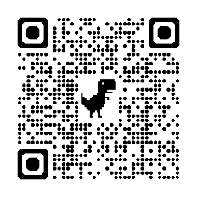
Your participation in health research is voluntary. If you do not wish to participate in research, you can tell the researcher that you are not interested and this will not affect the care and treatment you receive from CUDSH
For more information on CUDSH processing of your personal data please see our data protection notice at www.ucc.ie/en/dentalschool/patients/#data-protection
If you have any queries in relation to the use of your personal data, please contact the Information Compliance Manager, University College Cork at gdpr@ucc.ie

