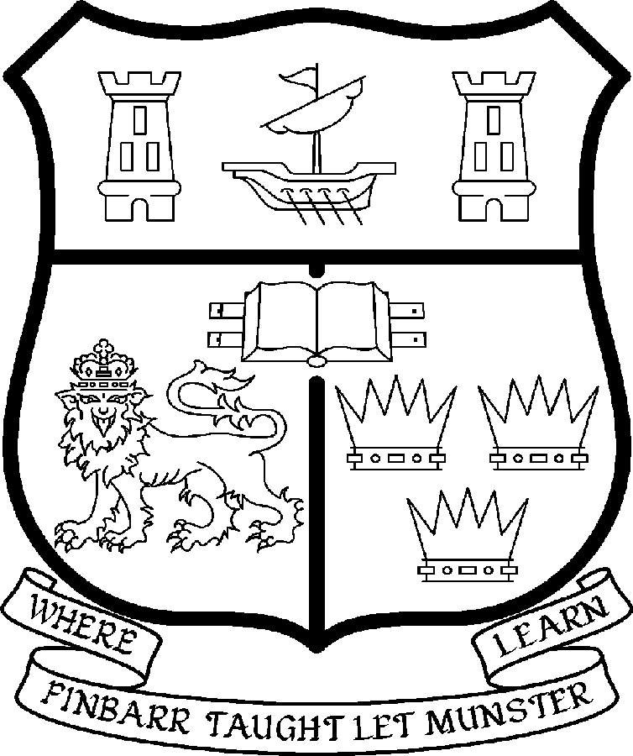
UNIVERSITY COLLEGE CORK
Coláiste na hOllscoile Corcaigh

College of Arts, Celtic Studies and Social Sciences

LECTURER IN THE STUDY OF RELIGIONS
(Study of Contemporary Islam)

Particulars of Post

- Applications from suitably qualified candidates are invited for the post of Lecturer in the Study of Religions with research and teaching expertise in regional and global contemporary (19th-21st century) Islam.
- The post is a permanent full-time post with an expected start date of 01st September 2008. The appointee to the post shall work within the discipline of the study of religions in the College of Arts, Celtic Studies and Social Sciences and shall discharge such duties as are assigned to them.

- The current remuneration – [new entrants] – is as detailed below. The appointment to the post of Lectureship in the Study of Religions will be made at a point below the bar, on the following scale, in accordance with qualifications and experience to date.

 | € |  | €
Minimum | 35,610 | Eighth Point | 50,396
Second Point | 37,674 | Ninth Point | 52,640
Third Point | 40,036 | Tenth Point | 54,348
Fourth Point | 42,068 | Eleventh Point | 56,095
Fifth Point | 44,203 | Maximum | 57,847
Sixth Point | 46,453
Seventh Point | 48,246

The salary includes a premium of 1/19th for pensionable staff paying contributions. Class A1 rate of Pay Related Social Insurance (PRSI) applies to the post. The rate is currently 4% on the first €50,700 of annual earnings.

- Job Responsibilities
The appointee will teach courses including regional and global contemporary (19th-21st century) Islam at undergraduate and postgraduate level and provide research supervision in the study of religions. The Department aims to provide up-to-date knowledge and understanding of contemporary religious beliefs, practices and traditions and to foster critical reflection on the construction of such knowledge and understanding within the cross-cultural study of religions.
The duties of the Lecturer shall be to teach in the field of the study of religions under the direction of the Head of the Department or equivalent for all degrees, diplomas and certificates of the University. S/he shall examine in the discipline of the study of religions for the University and shall carry out such other duties appropriate to the post as detailed below:

- To teach and examine on existing courses at undergraduate and postgraduate level;
- To assist in the development of new programmes as appropriate;
- To engage in individual research and participate in the department’s research activities;
- To provide postgraduate supervision;
- To carry out other duties as appropriate, including administration;
- To participate in the running of the subject of the Study of Religions and in the academic life of the College of Arts, Celtic Studies and Social Sciences.

The above is not exclusive or exhaustive and the post holder may be required to undertake any such duties as may reasonably be expected. All staff are required to be flexible and co-operative and professional within the needs of the post and the Department, College and University.

5. Selection Criteria:
Decisions made at shortlisting, presentation and interview will be made based on the following criteria:

- Expertise in the study of contemporary Islam within the context of the academic study of religions.
- A relevant PhD;
- Relevant teaching experience in Higher Education;
- Evidence of a personal contribution and commitment to excellence in teaching;
- Evidence of significant research achievement within the study of religions as indicated by published work or work in preparation;
- Potential to attract local and international taught postgraduate and research students to the study of religions at Cork
- Competence in the language(s) necessary to the candidate’s field of research
- Evidence of administrative ability;
- Ability to communicate effectively and evidence of appropriate competence in spoken and written English.

Candidates are requested to make a personal assessment of these criteria against their own qualifications, skills and abilities to assess whether they should apply for the post.

- The "Provisions relating to full-time posts as Lecturer" as set out in the attached document also apply to the post.

- Each candidate must complete an application form for the post. Application forms must be completed and returned to: Department of Human Resources, University College Cork. Tel: +353-21-4902671 (Email: recruitment@per.ucc.ie. Fax. +353-21-4276995. Closing date for receipt of applications is 5pm on Tuesday 1st April 2008

- Candidates for posts shall be required to appear before a Board of Assessors in Cork, in which case travelling and subsistence expenses at approved rates will be paid.

- A successful candidate will be required to submit a birth certificate, documentary evidence confirming academic qualifications, and to undergo a medical examination.

- An offer of appointment to a candidate who is not EU nationality is subject to the granting of a Work Permit by the Department of Enterprise Trade & Employment.

- Candidates may be required to produce documentary evidence to support any statements made by them on their application form or any supporting documentation. Candidates should note that any inaccurate information will invalidate their application.

UNIVERSITY COLLEGE CORK IS AN EQUAL OPPORTUNITIES EMPLOYER

GENERAL INFORMATION FOR CANDIDATES

Introduction to University College Cork

University College Cork, a constituent University of the National University of Ireland, is a collegiate, progressive, dynamic research-led university developing a reputation as a world class regional university, built on the history of significant achievements in teaching and learning and research, and strong academic and professional leadership.

The University has a current enrolment of over 17,000 students with a strategic objective of 21,000 by 2011. UCC currently has 1,400 academic and research staff within a total staff compliment of 2,500.

Founded in 1845, as Queen’s College, Cork, UCC is one of Ireland’s oldest institutions of higher learning. The rich history and tradition of UCC is reflected in the imposing limestone buildings of the Main Quadrangle and the mature grounds. UCC’s scenic city centre campus, boasting award-winning architecture, provides a pleasant and vibrant learning environment, which is given an international dimension by the presence of 2,000 international students and many staff from over 75 countries around the world.

UCC is one of the premier research institutions in the State and its research income is consistently one of the highest in the country. The University earns peer-reviewed research income in excess of €60m per annum, has strategic research partnerships with leading multinationals in the agri-food, microelectronics, and pharmaceutical sectors, and is home to 5 of Ireland’s 8 ISI Most Highly Cited authors. The university’s research reputation spans across the broad range of disciplines, strategically built around a number of internationally-recognised Research Institutes, Centres and Departments.

UCC is fully committed to the development of 4th level training and research through the introduction of Graduate Schools and structured PhD programmes and the provision of a wide range of generic and discipline-specific modules supporting the research activity of PhD students. The University offers an innovative, research-led curriculum, taught by world-class academics who consistently attract a quality student intake.
Recent institutional reorganisation has established four Colleges; Arts, Celtic Studies and Social Sciences; Business and Law; Medicine and Health; Science, Engineering and Food Science. The Colleges offer over 120 degree and professional programmes that consistently attract the highest proportion of top school leavers in the country and supports a rapidly growing postgraduate and international student body.

The University has embarked on a programme of development for UCC to firmly establish it as a world-class regional university building on the guiding principles in the University’s Strategic Framework 2006-2011 of excellence in teaching, learning, research and contribution to community and society. UCC will focus on research performance, the quality of the student experience and the manner in which the institution discharges its regional role.

Having twice being designated as the Sunday Times “Irish University of the Year” in the past four years, UCC is also a recent proud recipient of the “Excellence Through People” Gold Standard.

The last five years have seen exceptional growth in student numbers, award winning capital developments supporting science, technology and the arts and significant success in winning research funding, making it in that time the most research active institution in the country.

UCC enjoys excellent links with local business and enterprise along with strong partnerships with some of the world’s most highly valued companies. Relationships with professional and public bodies across a wide range of disciplines are equally a key feature of the University.

Internationalisation of the campus continues to be a key strategic objective of UCC. International enrolment at UCC is among the highest in the sector creating a multi- cultural and ethnically diverse student body and measures taken by UCC to enhance conditions for international student recruitment are regarded as among the best practices by peer institutions. UCC also provides opportunities for Irish students to study overseas making them competitive in a global market. In recent years new exchange opportunities include academic placements in a diverse range of European, US, Canadian and Australian universities, with new developments targeting China.

Staff are essential to the achievement of our mission and UCC places a special emphasis on quality improvement strategies in Human Resource Management. A key objective of the UCC Strategic Framework 2006-2011 is to attract, develop and retain outstanding staff through the development and implementation of best practice HR policies and procedures. We seek to develop staff capable of keeping the University at the forefront in all that it does. The University has committed to establishing a supportive working environment in which the needs of all staff are recognised and their contributions valued and rewarded.

Web Links
UCC website
http://www.ucc.ie/en/

UCC Strategic Plan 2006-2011
http://www.ucc.ie/en/PresidentsOffice/UCCsStrategicPlan/DocumentFile,1005,en.pdf

THE STUDY OF RELIGIONS AT UNIVERSITY COLLEGE CORK

UCC’s College of Arts, Celtic Studies and Social Sciences (ACSSS) comprises more then 20 disciplines within the arts and social sciences (see:
http://www.ucc.ie/en/CollegesandDepartments/ArtsCelticStudiesandSocialSciences/
A website for the study of religions subject area is currently under development.

In 2005 the College of ACSSS began a strategic initiative to establish the study of religions as a new discipline for UCC and for Ireland. The decision to focus on contemporary forms of religion was taken partly in light of the rapid transformation of Irish society in recent decades; a transformation which has brought with it significant new religious and cultural plurality. A Visiting Professor of Religious Studies (Prof. Gwilym Beckerlegge) was appointed for the academic year 2006/2007 to design an appropriate course and steer it through the formal approval process. A new strand entitled ‘Religions and Global Diversity’ within the BA Arts degree was approved in March 2007 and offered to arriving undergraduates for the first time in September 2007.

Considerable flexibility has been built into both the structure and module outlines of the BA ‘Religions and Global Diversity’ programme (see outline below). The programme comprises core modules and options, many of which contain their own optional elements. Staff of the department will be expected to develop both the programme and the constituent modules in the light of their individual expertise and interests. The programme will be enriched by modules relating to religion in Ireland and beyond already offered by other departments. Religions and Global Diversity is currently approved as a Minor, Joint, or Major programme, but with sufficient student numbers it could develop into a Single Honours programme.

Students entering the BA Arts at UCC (about 1000 students each year) choose four different subjects in their first year, taking one introductory course in each. Encouragingly, nearly 100 new students opted on arrival this year to take the new course ‘Religions in the Contemporary World: An Introduction to the Study of Religions’. In 2007-8 this course is being taught by a temporary lecturer, Dr Gregory Shushan, with some input from Professor Brian Bocking whose permanent appointment as Professor of the Study of Religions commenced in January 2008. Level 2 (= year 2) BA courses in the subject will be offered for the first time in 2008-9.

Meanwhile, UCC aims to double its postgraduate (taught MA and MPhil/PhD research) student numbers over the next few years. A new MA programme in the study of religions will be designed and put forward for approval early in the Autumn of 2008 with a view to commencement in 2009/10, and Study of Religions will seek from the outset to attract significant numbers of suitable research students. Recruitment of international students at all levels will be important to the growth and visibility of the subject-area.

It is anticipated that incoming members of the department will develop research interests that include, where appropriate, the study of religion in the contemporary Irish context. The College is committed to an interdisciplinary approach to teaching and research and the department will seek to develop opportunities for collaboration between the new discipline and cognate areas.

UCC Library at present supports teaching in the study of religions mainly at introductory BA level. There has been a considerable expansion in access to online journals and other e-resources in religions at UCC during the last two years and the Library offers a full inter-library loan service. The intention is to use available funding to strengthen study of religions resources particularly in those areas where the new appointees will contribute to the curriculum, and to develop holdings strategically to support postgraduate and staff research wherever possible.

External funding will be sought as appropriate to support library resources and other aspects of the developing subject-area.

The appointees to the two posts currently being advertised will play a crucial role, with Professor Bocking, in the development of a flourishing and innovative BA, MA and PhD programme in the study of religions at Cork. It is anticipated that further staffing appointments will be made in coming years on the basis of increased student recruitment and research productivity, with the overall aim of establishing Study of Religions at UCC as one of the premier departments for the study of religions in Europe.

Further details of the two posts and application forms and information can be found on the UCC Human Resources website at:
http://www.ucc.ie/en/hr/EmploymentOpportunities/

Informal enquiries about the new posts should be made, by email in the first instance, to Professor Brian Bocking at b.bocking@ucc.ie

14 Feb 2008
Outline structure of the BA route in ‘Religions and Global Diversity’

(Arts students at UCC normally take courses equivalent to 60 credits per year, thus in year 1 students take 4 courses, each worth 15 credits.)

Arts 1 (= year 1)
‘Religions in the Contemporary World: An Introduction to the Study of Religions’ is the single Religions and Global Diversity core course [15 credits over 2 sessions]. It is also offered to single-semester International Students as 2 x 7.5 credits modules, one in each session.

The core course draws upon Irish, European and global examples.

Arts 2 and 3 (= years 2 and 3)
Students following Religions and Global Diversity at Joint or Major levels will be required to take in each of these years:
i) a Religions and Global Diversity core course [10 credits over 2 sessions], which will also be offered to single-semester International Students as 2 x 5 credits modules, one in each session. In year 2 the core course is entitled Religious Texts and their Interpretation and in year 3 the core course is entitled Religions, Peace, and Social Justice. (The content of these courses as taught will reflect the interests and expertise of staff appointed).
ii) one Studies in Traditions module (5 credits)
iii) an Independent Study Project (10 credits)
iv) together with:

Joint
1 x 5 credits module from the list of Religions and Global Diversity options
(these options are entitled Religions and Globalisation, Case Studies in Religion and Politics, Founders, inspirational figures and their representations and Religions and the world of work. As with the core courses, these courses are flexibly designed to accommodate the interests and expertise of staff appointed.
or from the list of approved inter-departmental options

Major
3 x 5 credits modules from the lists of Religions and Global Diversity options
and approved inter-departmental options, of which 1 but no more than 2 must be chosen from the list of Religions and Global Diversity options.

14 Feb 2008

