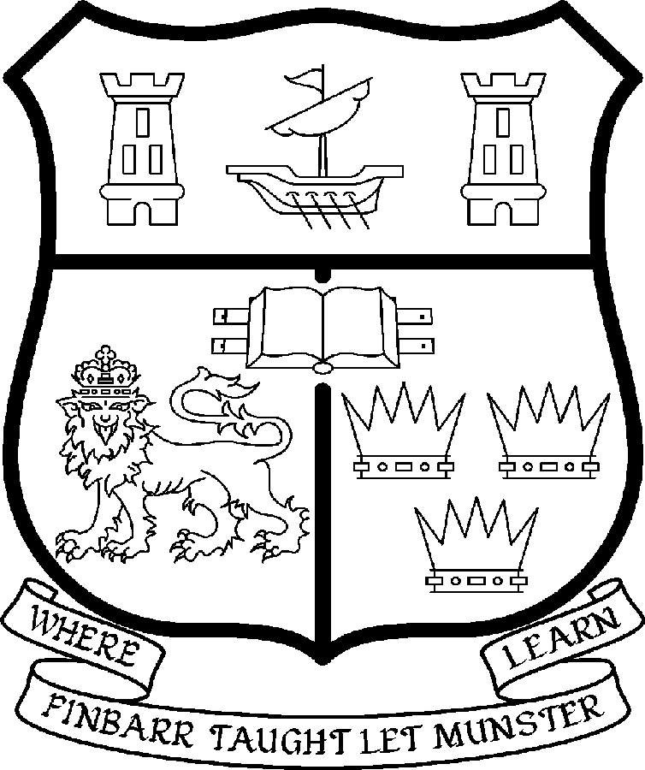 | UNIVERSITY COLLEGE CORK  Coláiste na hOllscoile Corcaigh
LECTURESHIP IN CHINESE STUDIES
(THE STUDY OF CONTEMPORARY CHINA)

Particulars of Post

1. The Lectureship in Chinese Studies (the Study of Contemporary China) is a permanent and whole-time post, based in the College of Arts, Celtic Studies and Social Sciences. The appointee shall work under the direction of the Director of the Irish Institute of Chinese Studies and shall discharge such duties as shall be assigned to him/her by the said Head.

The current remuneration – [new entrants] – is as detailed below. The appointment to the post of Lectureship in Chinese Studies (the Study of Contemporary China) will be made at a point on the following scale in accordance with qualifications and experience to date. For appointments made on the following salary scale up to and including the twelfth point below the bar, there is provision for subsequent progression beyond the BAR in accordance with the terms of the Academic Promotions Scheme to a salary scale segment with a maximum of €83,504 (new entrants)

 | € |  | €
First Point | 35,610 | Eighth Point | 50,396
Second Point | 37,674 | Ninth Point | 52,640
Third Point | 40,036 | Tenth Point | 54,348
Fourth Point | 42,068 | Eleventh Point | 56,095
Fifth Point | 44,203 | Twelfth Point | 57,847
Sixth Point | 46,453
Seventh Point | 48,246

BAR

First point above the bar | 63,389 | Fourth point above the bar | 76,488
Second point above the bar | 67,756 | Fifth point above the bar | 83,504
Third point above the bar | 72,131

The salary includes a premium of 1/19th for pensionable staff paying contributions. Class A1 rate of Pay Related Social Insurance (PRSI) applies to the post which is currently 4% with an earnings ceiling of €50,700.

- Duties of the Post:

The appointee will teach and assess undergraduate and graduate modules on Chinese political economy, Chinese business, Intercultural management and China’s international relations. S/he will have a strong background in social sciences and will integrate modern social science approaches into his/her teaching and research. The Lecturer will contribute to the further development of the existing five undergraduate and postgraduate programmes currently offered at the Irish Institute of Chinese Studies (IICS) at UCC. S/he will attract external funding and contribute to the international standing of the IICS by producing first class international presentations and publications. The postholder will support the director of the IICS in establishing the IICS as a leading regional centre for teaching and research on China and Asia and in fostering co-operation with partners in China, Asia, Europe and America.

In addition, the successful candidate will be expected to:

- Undertake supervision of postgraduate and PhD research students;
- Develop links with professional and academic bodies and external agencies;
- Cooperate with other academic units to help promote and develop research and teaching links in UCC and Chinese partners to enhance the international profile of UCC;
- Contribute to administrative and other extra curricular duties including fieldwork supervision in China as directed by the Head of the Institute.

The above listing is not exclusive or exhaustive and the post holder may be required to undertake any such duties as may reasonably be expected. All staff are required to be flexible and co-operative and professional within the needs of the post and the institution, College and University. The University is undertaking a major reform of its internal structures which may necessitate possible future changes in the organisation of its activities.

3. Selection Criteria:

Decisions made at shortlisting, presentation and interview will be made based on the following criteria:

Essential Criteria

Candidates should have

- A PhD in economics, political science, sociology or a cognate area, with a specialization in the political economy of contemporary China;
- A proven track record of international presentations and publications on Chinese and Asian politics and economics;
- Demonstrated ability to teach and supervise students both at undergraduate and postgraduate level;
- Experience or demonstrated potential of curriculum development in Chinese Studies;
- Experience in the supervision of research Masters and PhD students;
- Strong organisational skills;
- Excellent communication skills;
- Experience or demonstrated potential in raising external funding;
- A high level of spoken and written language proficiency in Mandarin Chinese and English.

Desirable Criteria

- Experience of working or field work in China;
- A willingness to contribute to interdisciplinary initiatives;
- An ability and willingness to undertake administration, extra curricular initiatives and field work supervision in China.

Candidates are requested to make a personal assessment of these criteria against their own qualifications, skills and abilities to assess whether they should apply for the post.

- The normal Statutory or other provisions relating to full-time Lectureships and Senior Lectureships shall apply to the post.

- Each candidate must complete an application form, which can be downloaded at:
http://www.ucc.ie/en/hr/FormsContractDocuments/DocumentFile,35042,en.doc

- Candidates for posts shall be required to appear in person before a Board of Assessors in Cork, in which case travelling and subsistence expenses at approved rates will be paid.

- A successful candidate will be required to submit a birth certificate, documentary evidence confirming academic qualifications, and to undergo a medical examination.

- References will be sought in relation to all candidates invited to attend for interview

- An offer of appointment to a candidate who is not EU nationality is subject to the granting of a Work Permit by the Department of Enterprise Trade & Employment.

- Candidates may be required to produce documentary evidence to support any statements made by them on their application form or any supporting documentation. Candidates should note that any inaccurate information will invalidate their application.

- Completed application forms must reach Recruitment Office, Department of Human Resources, University College, Cork, Ireland, on or before Friday 4th April 2008. Tel: +353-21-4902671 Email: recruitment@per.ucc.ie. Fax. +353-21-4276995.

UNIVERSITY COLLEGE CORK IS AN EQUAL OPPORTUNITIES EMPLOYER
GENERAL INFORMATION FOR CANDIDATES

Introduction to University College Cork

University College Cork, a constituent University of the National University of Ireland, is a collegiate, progressive, dynamic research-led university developing a reputation as a world class regional university, built on the history of significant achievements in teaching and learning and research, and strong academic and professional leadership.

The University has a current enrolment of over 17,000 students with a strategic objective of 21,000 by 2011. UCC currently has 1,400 academic and research staff within a total staff compliment of 2,500.

Founded in 1845, as Queen’s College, Cork, UCC is one of Ireland’s oldest institutions of higher learning. The rich history and tradition of UCC is reflected in the imposing limestone buildings of the Main Quadrangle and the mature grounds. UCC’s scenic city centre campus, boasting award-winning architecture, provides a pleasant and vibrant learning environment, which is given an international dimension by the presence of 2,000 international students and many staff from over 75 countries around the world.

UCC is one of the premier research institutions in the State and its research income is consistently one of the highest in the country. The University earns peer-reviewed research income in excess of €60m per annum, has strategic research partnerships with leading multinationals in the agri-food, microelectronics, and pharmaceutical sectors, and is home to 5 of Ireland’s 8 ISI Most Highly Cited authors. The university’s research reputation spans across the broad range of disciplines, strategically built around a number of internationally-recognised Research Institutes, Centres and Departments.

UCC is fully committed to the development of 4th level training and research through the introduction of Graduate Schools and structured PhD programmes and the provision of a wide range of generic and discipline-specific modules supporting the research activity of PhD students. The University offers an innovative, research-led curriculum, taught by world-class academics who consistently attract a quality student intake.
Recent institutional reorganisation has established four Colleges; Arts, Celtic Studies and Social Sciences; Business and Law; Medicine and Health; Science, Engineering and Food Science. The Colleges offer over 120 degree and professional programmes that consistently attract the highest proportion of top school leavers in the country and supports a rapidly growing postgraduate and international student body.

The University has embarked on a programme of development for UCC to firmly establish it as a world-class regional university building on the guiding principles in the University’s Strategic Framework 2006-2011 of excellence in teaching, learning, research and contribution to community and society. UCC will focus on research performance, the quality of the student experience and the manner in which the institution discharges its regional role.

Having twice being designated as the Sunday Times “Irish University of the Year” in the past four years, UCC is also a recent proud recipient of the “Excellence Through People” Gold Standard.

The last five years have seen exceptional growth in student numbers, award winning capital developments supporting science, technology and the arts and significant success in winning research funding, making it in that time the most research active institution in the country.

UCC enjoys excellent links with local business and enterprise along with strong partnerships with some of the world’s most highly valued companies. Relationships with professional and public bodies across a wide range of disciplines are equally a key feature of the University.

Internationalisation of the campus continues to be a key strategic objective of UCC. International enrolment at UCC is among the highest in the sector creating a multi- cultural and ethnically diverse student body and measures taken by UCC to enhance conditions for international student recruitment are regarded as among the best practices by peer institutions. UCC also provides opportunities for Irish students to study overseas making them competitive in a global market. In recent years new exchange opportunities include academic placements in a diverse range of European, US, Canadian and Australian universities, with new developments targeting China.

Staff are essential to the achievement of our mission and UCC places a special emphasis on quality improvement strategies in Human Resource Management. A key objective of the UCC Strategic Framework 2006-2011 is to attract, develop and retain outstanding staff through the development and implementation of best practice HR policies and procedures. We seek to develop staff capable of keeping the University at the forefront in all that it does. The University has committed to establishing a supportive working environment in which the needs of all staff are recognised and their contributions valued and rewarded.

Web Links
UCC website
http://www.ucc.ie/en/

UCC Strategic Plan 2006-2011
http://www.ucc.ie/en/PresidentsOffice/UCCsStrategicPlan/DocumentFile,1005,en.pdf

University College Cork is an Equal Opportunities Employer

The Irish Institute of Chinese Studies (IICS) at University College Cork
The Irish Institute of Chinese Studies (IICS) at UCC was established in June 2006. It offers programmes of study and research to enhance mutual cultural understanding and facilitate the expansion of economic, social and political ties between China and Ireland. It is committed to the development of Chinese Studies within Ireland and beyond, establishing itself as a leading regional centre for teaching and research on China and Asia, and fostering cooperation with partners in China, Asia, Europe and America.

The IICS has successfully started five academic programmes:
BA Chinese Studies: BComm (International) with Chinese Studies: Higher Diploma Chinese Culture and Business: MA Chinese Culture and Business; MPhil/PhD in Chinese Studies.
The IICS has obtained significant external funding for the support of research and teaching in the field of China and is and has been hosting 10 visiting scholars.
The inaugural international conference was on China in the 21st Century and drew together distinguished scholars from the United States, China, France, the United Kingdom, Germany, Iceland, Sweden, Indonesia, Korea, and Ireland. Overall, more than 130 people attended the two-day event, including leading representatives from the Irish government and Irish enterprises. It enjoyed broad media coverage in the press and media (Iris Times, Irish Examiner, Evening Echo, UCC News and RTE TV One and RTE Radio One).
An ambitious research programme covers a wide range of topics from social, economic and political changes to globalized sports (Beijing Olympics 2008!). It has received external and internal funding of 30,000 pounds for research projects. Staff members have been publishing internationally and continue to do so.
The Chinese government has awarded the establishment of the UCC Confucius Institute to the IICS in 2007 to promote Chinese language and culture in Ireland including substantial funding of 100,000 US$ and teaching resources.
Building on its experiences, the IICS considers it to be of utmost significance to consolidate its initial success by providing high quality teaching and quality research.

For further information please see IICS website www.ucc.ie/institutechinesestudies

