Organ Donation – Opt In or Opt Out??
A senior biology student module
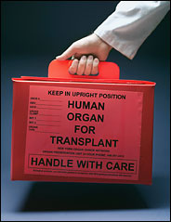

TABLE OF CONTENTS

- Abstract 1
- Objectives of Module 1
- Learning Outcomes of Module 3
- Curriculum Content 4
- Prior Knowledge 4
- Kind of Activity 4
- Anticipated Time 4
- Student Activities 5
  - Scenario 5
  - Your Tasks 6
- Teachers Guide 10
  - Introduction 10
  - Background Information 11
  - Teaching Approach 11
  - Results of Student Activities 26
  - Assessment 29
  - Summary and Conclusions 32

- Abstract:
Scientific literacy enables all citizens to play an active role in decision-making concerning scientific and technological issues. In order to develop scientific literacy, science teachers need to promote the development of scientific knowledge and competences for analysing the consequences and problems related to rapid scientific and technological growth. The goal of this module is to enable students to learn about organ donation and to develop an ability to apply their knowledge and understanding so that they are to make an informed evaluation of the bioethical issues involved in meeting the demand for organs. The module aims at promoting thinking competences, attitudes and values that enable students to play a constructive, participative and responsible role in society.
There is currently a severe global shortage in the number of donor organs available for transplantation. Although Ireland has one of the highest rates of organ donation (per million population) in the world, the number of people on transplant waiting lists is on the rise. At present, Ireland operates an opt in system where people are asked to sign an organ donor card. However, in order to reduce transplant waiting lists other options are being explored which all have significant social, ethical and economic implications. This teaching module enables students to join an investigative team to assess the potential impact of an opt-out system for organ donation in Ireland and report on their findings.

- Objectives of the Module: The overall objective is to give students an opportunity to work as part of an investigative team assessing the potential impact of an opt out system for organ donation in Ireland. Specific objectives to enable this are:
- To encourage in students an attitude of scientific inquiry, curiosity and discovery through working individually (personal motivation) and within teams.
- To develop an understanding of organ donation and knowledge about the structure and function of organs which are donated and illnesses they are used to treat.

- To give students an understanding of role play through playing the role of the person they are allocated and thinking about the information they need to find.
- To enable students to become familiar with searching for information on the internet, interpreting and analysing the information they select to best answer their questions.
- To enable students to experience group work, working as a team to come to an overall decision on the suitability of an opt out system for organ donation in Ireland.
- To give students an opportunity to defend their ideas and discuss other ideas/ arguments and to develop their ability to make informed decisions about contemporary issues.
- To give students an appreciation of the complex issues involved and the challenge of trying to reach a general consensus on the issue.
- To provide students with the experience of presenting their decisions and their arguments orally and in written format.

- Learning Outcomes: On completion of this module students should be able to:

- Discuss the ethical issues surrounding organ donation and transplantation.
- Describe what organs are donated, their structure, function and the illnesses they are used to treat.
- Carry out a role play effectively.

- Prepare and present a report on their views on the potential impact of an opt out system of organ donation in Ireland.
- Carry out a data search, process the information, select and analyse data.
- Construct and present an argument for or against the introduction of an opt out system of organ donation in Ireland.
- Apply their scientific knowledge to and be empowered to make informed choices about organ donation.

- Curriculum content: Human biology; ICT.

- Prior Knowledge: General knowledge of the human biological systems. Basic ICT skills.

- Kind of activities:
- Webquest (discussion through role playing and decision making).
- Data search and analysis (ICT skills).
- Critical and creative thinking.
- Presentations (ICT skills).

- Anticipated time: 8 lessons (40 minutes per lesson)

Organ Donation – Opt In or Opt Out??

- Student Activities

8.1 Scenario
Due to the serious shortage of organ donors and consequent long waiting lists for transplant operations in Ireland, it has been suggested that the current approach to organ donation needs to be changed. The government is considering changing the current system which is an opt in system where a person decides in advance of death to donate his/her organs and carries an organ donor card expressing their wish to be a donor. The new system being discussed is an opt out system whereby if someone does not expressly opt out, e.g. via their driving licence form, they are presumed to be willing donors. In other words, everyone would be a donor unless they decided to opt out.
An Organ Donation Taskforce has been established to address the organ donation problem. You are invited to be part of an expert working group that has been commissioned by this task force to investigate the potential impact of an opt out system for organ donation in Ireland.
The group has five members: a medical professional, a medical lawyer, a member of a bio-ethics group, representative from the Irish donor network and a public representative.
The question of whether or not changing to an opt out system for organ donation is right for Ireland is a finely balanced one, generating impassioned debate and a wide range of opinions. Your group must research this scientific problem and report on your findings giving reasons justifying your decision. If you decide against the opt out system you should propose alternative solutions.

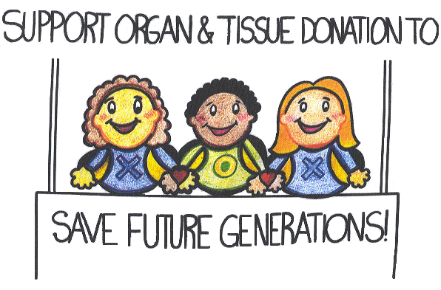
8.2 Your tasks
Working scheme for groups
- Read the newspaper articles supplied by your teacher highlighting the controversial issues around organ donation. Participate in class discussion on the tensions that surround the subject of organ donation.
- Observe media images and advertisements promoting organ donation. Consider the following questions;
- What information do the adverts give you?
- How do they make you feel?
- Are they effective? How? If not, how could they be improved?
Vote for the most effective advert – justifying your choices and giving feedback to each other.
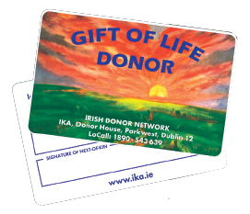
- Note down the 3 most important things you have learnt from the lesson and consider who else you should be sharing these key messages with…family, friends.


- Read through the scenario again and as a group, discuss your ideas and make a list of scientific questions that need to be investigated, looking at the problem from every member’s viewpoint. Plan what each member needs to do to find out the answers to the questions on the list.

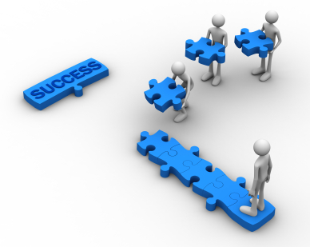

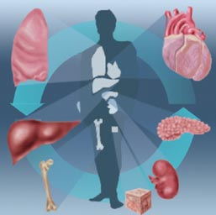
- Building on your previous knowledge of organ systems and structures, learn about what organs are donated and the illnesses they are used to treat.


- Computer session. Role play.
The expert group you are part of has five members:
  - a medical professional,
  - a medical lawyer,
  - a member of a bio-ethics group,
  - representative from the Irish donor network and
  - a public representative.

In your role you must investigate whether you think an opt out system is the way forward in Ireland. Should the current opt in system be kept or are there alternative options?
Think about the information you need to gather. Refer to the questions drawn up by your group in lesson 1.


Search the internet for information to help your investigation (see the list of websites to start you on your search). Select the information that is relevant to you in your role and write a short report listing the reasons for your decision.


- Report back to your group with your findings. Work as a team, discussing the decisions presented by the different members. You must reach a consensus viewpoint and be prepared to justify this to the rest of the class.
Write a report or create a poster presentation/PowerPoint presentation on your findings on whether an opt out system is the way forward for organ donation in Ireland and if not, suggesting alternative solutions. Try to make it as structured and easy to read as possible.

Extension activity: Design a public information leaflet to encourage people to become organ donors.

List of Useful Websites:

The following websites contain information on organ donation issues.
- http://www.organdonation.ie/
- The Irish Donor Network: http://www.alpha1.ie/index.php/organ-donation-and-transplant/57-irish-donor-network
- The Irish Kidney Association - www.ika.ie
- Report on Public Consultation on Consent for Organ Donation: http://www.dohc.ie/issues/human_tissue_bill/consent_submissions_overview.pdf?direct=1
- http://www.beaumont.ie/index.jsp?p=454&n=457
- http://www.transplantireland.ie/

Organ Donation – Opt In or Opt Out??

- Teacher’s Guide

9.1 Introduction
This teaching module is based on the PROFILES template. PROFILES modules are society-based, designed to be relevant to students, pay close attention to developing scientific literacy and the module structure follows a philosophy of “education through science”. The title of the module is in the form of a question as this stimulates students to start thinking about the issue. This approach differs from traditional teaching methods and is a move away from a standard science and conceptual learning need towards wider, student relevant and intrinsically motivated learning. The title is related to an issue or concern and the students need to find the answer to the question posed and reach a decision. During this process science conceptual learning will take place.

The module was designed with the goal of enhancing scientific literacy of students using a model for the nature of science education that is based on the educational needs, as determined by the curriculum, but where the teaching emphasis is on “education through science”. The focus is on developing reasoning skills in students, to guide them to develop argumentation skills, to draw conclusions and make judgemental decisions using scientific knowledge and ideas. The teaching methodologies and strategies selected were carefully chosen after researching what methods would best enable the desired learning outcomes and overall goal of the module.

9.2 Background Information
In order to develop science literacy, teachers need to develop teaching strategies where students can critically discuss and debate contemporary issues in science and their applications. The debate around organ donation and how to increase donor levels is a good example of such an issue. In an effort to improve Irish donation rates, the new programme for government has pledged to replace the current opt in system – whereby a person decides to donate his/her organs – with an opt out system where consent is presumed.
This teaching module enables students to join an investigative team to assess the potential impact of an opt out system for organ donation in Ireland and report on their findings. They will investigate the options currently being explored, each with their own social, ethical and economic implications. They will then present their recommendations on whether or not an out system should be introduced. If they decide against the opt out system, they should propose alternative options.

9.3 Teaching Approach
Lessons 1 & 2: Introduction to the Scenario and Subject of Organ Donation
- The lesson starts with a presentation of the scenario. The written scenario is handed out with an explanation that each group has a critical role in the overall class project. Distribute examples of kidney and organ donor cards.
- Newspaper articles introducing the controversial issues around organ donation are read and discussed by the class (see teaching resources, hand-outs 1a - d). The objective of this activity is to facilitate comprehension of the tensions that surround the subject of organ donation.
- Show PPT presentation “Information on Organ Donation” (Teaching Resources, PPT)

- Show the class video clips and media images/advertisements promoting organ donation (see teaching resources, media files and PPT) asking them to consider the following questions;
- What information do the adverts give you?
Q. How do they make you feel?
Q. Are they effective? How? If not, how could they be improved?

Ask the class to vote for the most effective advert, justifying their choices and giving feedback to each other.
- Ask the students to write down the 3 most important things they have learnt from the lesson and to consider who they should be sharing these key messages with…family, friends etc..
For homework they should familiarise themselves with the scenario and think about what needs to be investigated to carry out the task effectively.

Lesson 3
Arrange the students into groups of five, allocating each member one of the roles listed in the scenario. Ask them to read the scenario and working scheme closely, to discuss any ideas they have and to make a list of scientific questions that they need to investigate further. Circulate and advise each group. Be very supportive but at the same time steer the students in a direction where they will get the most relevant information so that they can draw conclusions from the internet search and other resources (refer to questions in the role play section of this guide).

Lesson 4
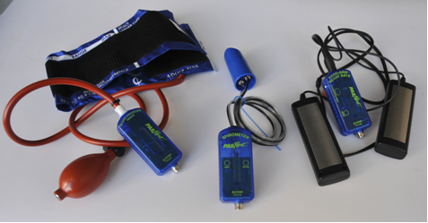
This lesson is designed to broaden students’ knowledge of what organs are donated, their structure and function and illnesses they are used to treat (see teaching resources, hand-out 2). The aim of this lesson is to develop the students understanding of the organisational complexity of the human focusing on what organs are donated, their structure, location and function and the systems they are part of. Many of the human systems can be explored and developed further, at the discretion of the teacher. The illnesses organs are used to treat are explained and discussed.

Student Activity: Healthy organs are essential if we are to enjoy healthy living. Blood pressure monitoring, a spirometer to monitor lung capacity and a hand grip heart monitor should stimulate much activity for students in this module

Lesson 5: Role Play (ICT session and homework)
In this activity the student will engage in a role play and search for information on the internet. Students should reflect on what information they need to gather and ascertain what knowledge is relevant to their role (provide guidance where necessary; refer to role play details on the next page). They should refer to the questions drawn up by their group in lesson 1. They then carry out a data search, select and analyse relevant information and write a brief account of their findings to report back to their group.

Role Play
Given the complexity of the issues and the possibility of the diversity of opinions surrounding it, an evaluation according to different perspectives is essential. Each person in the group must take on a different role.
The roles and some questions to help guide the students as they carry out their research are listed below:
- Member of an ethics working group: How can the number of organ donors be increased via a system that is morally acceptable to society? Look at ethical issues such as the black market for organs, payment for organs, living donors, the case of India where poor people are paid for organs, or Iran where they have solved their kidney shortage by paying for organs. Is payment for organs an option? Is the current opt in system working? Investigate the alternatives. Is opt out the way forward? How would people opt in or out? What about children and other vulnerable groups?
- Representative of the Irish Donor Network: What do donor families and recipients think about an opt out system? Should next of kin continue to have the ultimate decision rights regarding organ donation of their loved one? What are the views of members of the Irish donor network such as the Irish kidney association, cystic fibrosis association etc.
- Doctor: What is the current situation regarding transplant waiting lists in Ireland. How could organ donation levels be improved? Would an opt out model work in Ireland? Should the current opt in system be improved and continued? What does the medical profession think?
- Public representative: How would citizens react to an opt-out system? Is the current system promoted enough? How could public awareness be raised? The problem of common myths about organ donation. Political issues such as who should receive organs, e.g. should alcoholics receive livers? Is opt out the way forward or are other options better?

- Medical lawyer: Consider legal issues around an opt out model; should the next of kin have final consent (soft opt out) or not (hard opt out). What are the different consent systems in use around the world? What would work best in Ireland?

Lessons 6 & 7
Following the role play activity students re-join their groups and discuss the decisions presented by the different members.
The group must: a) reach a consensus viewpoint and be prepared to justify this to the rest of the class and; b) write a report or create a poster/PowerPoint presentation on their recommendations whether an opt out system is the way forward for organ donation in Ireland. If they decide against the opt out system they should suggest alternative options.
The role of the teacher is to act as a facilitator, providing guidance and advice to students when needed.

Lesson 8
Each group presents their results and a class discussion follows. Can an overall consensus be reached???

Teaching Resources

List of useful Websites
The following websites contain information on organ donation issues. They must be used by both students and teachers to prepare and implement this task.
- http://www.organdonation.ie/
- The Irish Donor Network: http://www.alpha1.ie/index.php/organ-donation-and-transplant/57-irish-donor-network
- The Irish Kidney Association - www.ika.ie
- Report on Public Consultation on Consent for Organ Donation: http://www.dohc.ie/issues/human_tissue_bill/consent_submissions_overview.pdf?direct=1
- http://www.beaumont.ie/index.jsp?p=454&n=457
- http://www.transplantireland.ie/

Hand-outs
- Newspaper articles
a) http://www.irishtimes.com/newspaper/health/2011/0329/1224293284073.html
- http://www.imt.ie/opinion/2011/06/organ-donation-%E2%80%94-the-controversy-continues.html
- http://www.irishexaminer.com/ireland/kfeysnqlmhmh/rss2/#ixzz1eLSn8SK0
- http://www.examiner.ie/ireland/600-waiting-for-organ-donations-165444.html#ixzz1eLPLQxqs

- Hand-out Two:

Organ | Function | Treatment
Heart | Pumps blood around the body | End-Stage heart disease
Lungs | Absorb oxygen and release carbon dioxide | Cystic fibrosis, emphysema, or other end -stage lung disease.
Kidneys | Extract waste from blood, produce hormones | Renal (kidney) disease (eliminates need for dialysis)
Liver | Secretes enzymes for digestion and regulates blood sugar | End stage liver disease
Pancreas | Digestion and absorption of nutrients | Diabetes (reduces the risk of losing limbs or sight)
Small bowel or small intestine | Digestion and absorption of nutrients | Punctured intestine, mal-absorption or tumours
Corneas | Allow light to enter the eye | Restoration of sight
Skin | Protects the body against dehydration, injury and infection | Severe burns (decreases pain, infection, scarring, heat and fluid loss)
Heart valves | Prevent blood from flowing the wrong way | Corrects heart defects in babies/children, used to treat adults with diseased valves
Bone | Supports the body, protects vital organs | Facial reconstruction, limb salvage, correction of birth defects, cancer treatments, spinal and oral surgery
Bone Marrow | Forms blood cells | Leukaemia
Cartilage | Connective tissue that serves as skeletal tissue
Tendons | Attach muscle to bone | Repair joint injuries
Fascia | Fibrous tissue covering muscle | Repairs tendons, muscle ligaments and deformities
Dura | Membrane covering the brain | Corrects damage caused by tumours or accidents

Media Files

Video clips:
- An award winning TV commercial to raise organ donation awareness in New Zealand (1 min):
http://www.youtube.com/watch?v=KqpgFXOxOz4
- The UK government's first TV ad for organ donation (31 sec):
http://www.guardian.co.uk/media/video/2009/oct/30/organ-donation-tv-ad

Adverts:
Some possible adverts (also in the PowerPoint presentation)


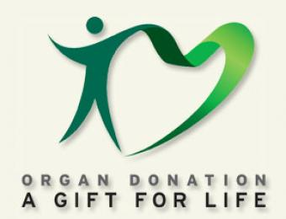

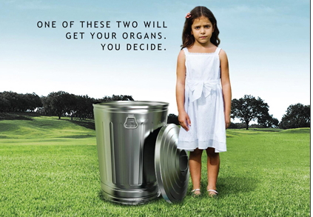



PowerPoint Presentation

Slide 1
Slide 2
Slide 3
Slide 4
Slide 5
Slide 6
Slide 7
Slide 8
Slide 9
Slide 10
Slide 11
Slide 12
Slide 13
Slide 14
Slide 15

9.4 Results of Student Activities

Students performed the following activities to increase their knowledge and awareness of organ donation to enable them to undertake the tasks triggered by the scenario presented to them:
- Discussion of the newspaper articles examined in class.
- Observation, critique and discussion of adverts/images: The students voted for the most effective advert, choosing the one with the girl next to the dustbin as it was the most thought provoking advert that captured their interest the most.
- Noting the 3 most important things they learnt from the lesson: The students reflected and distilled the important messages they learnt from the discussions, presentations and media articles during the introductory lessons.
- Discussion on what organs are donated, their structure, function and illnesses they are used to treat: Students showed interest in the PPT presentation on this and contributed to class discussions during same.
- Student Activity: Healthy organs are essential if we are to enjoy healthy living. Blood pressure monitoring, a spirometer to monitor lung capacity and a hand grip heart monitor stimulated much activity for students during this module. The equipment was displayed during all the lessons throughout the module so that students could examine and experiment with it.

In order to answer the question raised in the scenario/module, students carried out the following activities:
- Initial Group Work: The students were organised in groups of five and roles allocated to each member. They discussed their ideas and produced a list of scientific questions that they needed to investigate further. On their own initiatives they proceeded to explore each member’s role in detail helping each other to come up with research questions they could develop during their information search. They looked through the list of websites they were provided with and discussed which ones would be most useful to each member of the team. They brainstormed for other websites they could search, categorising which member they would be most relevant to as they did so.
They prepared a list of excellent questions with minimal help from the teacher. Those students that weren’t able to think of many questions were helped by others in their group and the team work was very positive and supportive.

- Role Play (ICT session and homework): Roles were allocated blindly to enable fairness and students immersed themselves in their roles, some with more enthusiasm than others, but on the whole they activity was a very positive experience for them. Armed with their list of questions and websites from their initial group work they searched the internet for answers to guide them in their task. There was a spirit of collaboration with students informing each other of “cool websites”.
Websites visited included:
    - http://www.organdonation.ie/
    - The Irish Donor Network: http://www.alpha1.ie/index.php/organ-donation-and-transplant/57-irish-donor-network
    - The Irish Kidney Association - www.ika.ie
    - Report on Public Consultation on Consent for Organ Donation: http://www.dohc.ie/issues/human_tissue_bill/consent_submissions_overview.pdf?direct=1

    - http://www.beaumont.ie/index.jsp?p=454&n=457
    - http://www.transplantireland.ie/
    - http://www.facebook.com/Organdonationireland
    - http://www.donateyourorgan.com/

- Brief Reports on their Findings: The students wrote brief reports on their thoughts following their web search. In the reports, they logically justified their views using the information they gathered to support their arguments.

- Group work: Students listened and showed respect for the ideas and views of others. They worked in a focused and organised way. They were open-minded about the ideas, considering context of the information. They debated with each other constructively, questioning one another all the time to ensure they could justify all their decisions reached. They were empathetic of the nature of the task. They behaved in an adventurous manner, questioning ideas and making links with prior knowledge. They produced a clear, logical decision, integrating different pieces of information. During the final class discussion their goal was to reach an overall consensus. After some discussion a general consensus was reached that the current opt in model should remain but that incentives and schemes should be explored promoting organ donation and awareness. It was suggested that marketing campaigns etc. be set up to enable this.

- Presentation: The four groups in the class each chose different methods to present their results. These included oral presentations, poster presentations and written presentations.

9.5 Assessment
This task is to be assessed based on the following aspects:
- Understanding the terms and concepts involved;
- The quality of the research conducted;
- Clarity in sharing the gathered information;
- Participation during the different stages of the activity;
- The power of argumentation;
- The justification and defence of opinions;
- The quality of the presentation;
- Meeting timetables and deadlines;

Suggested Assessment of student learning:
The teacher may decide whether to assess the student based on the learning outcomes and class objectives or based on group work. It is suggested that assessment be both formative and summative. In formative assessment ‘comment only’ or ‘allocation of marks/grade’ are at the discretion of the teacher. In ‘comment only’ marks may be recorded privately by the teacher for record purposes.
The following assessment methods are suggested:
- The Report
The brief or report from the role play aspect of the inquiry provides a straightforward manner to assess its outcomes.

- Peer assessment of the presentations
This aligns with the group-based processes, and allows students to understand the criteria by which the success of the inquiry task will be judged.

- Formative assessment of the individual research activity. Assessment of students’ individual work based on the teacher’s observations; see table 1 for details.
- Formative assessment of group work and group presentation. During the activity the teacher observes the students and completes the chart with comment; see table 2.
These forms of assessment are suggestions. The teacher can use other criteria for assessment if he/she feels that they meet the objectives of the task.
Summative Assessment: It is suggested that summative assessment should be based on learning outcomes in line with curriculum guidelines.

Table 1: Student assessment tool based on the teacher’s observations.

Individual work | Teacher Comment / Mark / Grade
Performs the activities according to the guidance provided.
Participates and contributes to class discussions.
Thinks about the role he/she is playing and what questions he/she wants answered.
Understands the objectives of the activity and knows which information to search for.
Carries out an effective search of the internet.
Selects information effectively.

Analyses the information effectively
Draws conclusions and makes justified decisions

Table 2: Assessment of group work and presentation.

Group work | Teacher Comment/Mark/Grade
Contributes to the group discussion during the theoretical inquiry phases (raises questions and hypotheses, draws conclusions, makes justified decisions)
Shows tolerance with, and gives encouragement to, the group members.
Cooperates with others in a group and fully participates in the work of the group.
Oral participation: Student listens and speaks in a balanced way.
Illustrates leadership skills –guiding the group by thinking creatively and helping those needing assistance (cognitive or psychomotor); summarising outcomes.
Presentation | Teacher Comment/Mark/Grade
Presents the activity in a clear and practical manner with justified decisions.
Presents by illustrating knowledge and understanding of the subject.
Creative ideas and solutions presented along with good use of creative materials.
Uses precise and appropriate scientific terms and language.
Ref: Jack Holbrook, ICASE, PARSEL

  - Summary and Conclusions

- Results from the study indicate the module was both highly interesting and motivational for students and teachers alike. The overall view of the teachers on the success of the teaching module was very positive, reporting that the module was well received by students, who showed high levels of interest and motivation. The module stimulated intrinsically motivated learning.
- The relevance of the module to society and the students’ everyday life increased enjoyment and interest in the subject which stimulated intrinsic motivation in the students.
- The teachers believe that the module reinforced learning in competency domains, enabling students to acquire knowledge, new skills and abilities.
- The inquiry approach was valued by students who enjoyed the opportunity to be involved in role-play, decision-making, communication and collaboration-related activities. Such activities aroused their interest and participation. The results suggest that the majority of students feel comfortable with the change of the traditional approach to teaching and that the inquiry approach stimulates positive attitudes towards learning science. It is believed that the positive experiences developed during the module could be the foundation of a lasting positive attitude towards biology/science.
- Teachers perceive the approach as valuable but identify two major obstacles to implementing inquiry in their lessons. The considerable amount of time required to plan and implement inquiry lessons is seen as a potential barrier and the issue of assessment also is an important factor. The traditional assessment system does not assess many of the competences and learning attributes which incorporate the PROFILES approach.

- This study highlights the important role that teachers play in increasing students’ engagement which is evident in similar studies. Teachers have a key role to play in the development of science education and need support, direction and guidance if inquiry-based science education is to be implemented effectively.
- Adapting to IBL can be difficult for both teachers and students and due consideration should be given to their training needs. A small minority of the students were resistant to a change from traditional teaching approaches. This can be daunting for students initially and takes them out of their comfort zones and may diminish their levels of learning satisfaction and possible learning success. It is imperative that they are provided with the necessary support and guidance during this time.

