Mouthwash – Does alcohol really make a difference?
Table of Contents
Abstract 3
Objective of the module 4
Learning Outcomes 4
Curriculum content 4
Kind of activity 4
Anticipated time 4
Prior Knowledge 5
Student Activities 6
Scenario 6
Your tasks 7
Task 1 7
Task 2 8
Task 3 9
Task 4 10
Task 5 10
Teacher Guide 11
Introduction 11
Background Information 11
Teaching Approach 12
Lesson 1: (Task 1) 12
Lesson 2: (Task 2) 13
Lesson 3: (Task 3) 14
Lesson 4 (Task 4) 15
Lesson 5 and 6 (Task 5) 16
Results of Student Activities 18
Sample Results obtained by students 19
Assessment 21
Summary and Conclusions 25

Mouthwash – Does alcohol really make a difference?
This biology module is aimed towards a class of mixed ability students that are aged 15-16 years.

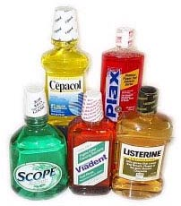

Abstract
This series of tasks allows students to form an investigative team in order to examine whether mouthwash containing alcohol is more effective at killing bacteria than mouthwash that does not contain alcohol. Students will work together to design and carry out their own investigation as to whether alcohol based mouthwash is better at killing bacteria than non alcohol based mouthwash. The fundamental objective of the module design is that the teacher is viewed as a guide and facilitator rather than a leader.

Sections include

1. | Student activities | Describes the scenario in more detail and the tasks the students should perform.
2. | Teaching guide / notes | Suggests a teaching approach and references
3. | Assessment | Gives suggested formative assessment strategies

Objective of the module
To give students an opportunity to work as part of an investigative team to determine whether mouthwash containing alcohol is better at killing bacteria than mouthwash that doesn’t contain alcohol.

Learning Outcomes
On completion of this module students should be able to:
- Describe the structure of the mouth.
- Identify the functions of the various parts to the mouth.
- Design and conduct an experiment to examine whether alcohol based mouthwash is better at killing bacteria than non alcohol based mouthwash.
- Analyse the results of the experiment and suggest some reasons for these results.
- Present their findings to fellow students and teachers of the school in a short presentation.

Curriculum content
Physical digestion, Microbiology (growing cultures on agar plates),

Kind of activity
Working with others, analysis of results, presentation of findings, information processing, cognitive thinking, researching through the internet, manipulation of scientific apparatus,

Anticipated time
This module should take approximately 5 lessons of 80 minutes duration. Each of the four tasks should be carried out in an 80 minute class with the final class used for presenting their findings to fellow students and teachers.

Prior Knowledge
Students should know that bacteria are found everywhere including the mouth. They would have a knowledge of basic microbiology from junior cert and that microorganisms can be grown using a nutrient medium like agar.
Mouthwash and oral health – Does alcohol really make a difference?

Student Activities

Scenario
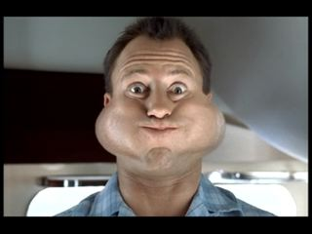
In 2008, it was suggested by research dentists in Australia that alcohol in mouthwash can cause oral cancer. So why take the risk of using alcohol based mouthwashes?

We have all seen the advertisements on television for Listerine whereby there is a little explosion in a man’s mouth and suddenly his mouth is bacteria free. Listerine contains a relatively high concentration of alcohol so does this really make a difference to the effectiveness of the mouthwash?

Have you ever wondered what the point of alcohol in mouthwash is? How does it affect the taste of mouthwash? And most importantly is it possible to fail a breathalyser test after a good rinse with alcohol based mouthwash?

In this series of activities you are invited to form an investigative team of scientists to find out the answer to the question – Why is alcohol added to mouthwash?
You will also have to design and carry out an experiment to investigate the effectiveness of Listerine compared to non alcohol based mouthwashes. Does alcohol really make a difference? You decide!

Your tasks
During the next 5 weeks you will have a series of tasks to carry out. By the 5th week you should be confident enough to present your findings to fellow classmates and school teachers. Who knows, you might be so confident that you can enter it into a science fair competition!

Task 1
What is found in your mouth?
As a group you must meet and identify all the features that are found in your mouth. A short report on your findings should be designed and written by you for your teacher.

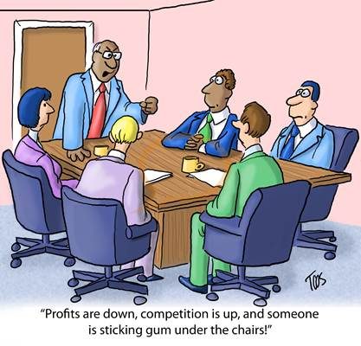

Task 2
In this task you must work in pairs to investigate differences between the mouthwashes provided. You have to design and complete a comparison table for each mouthwash highlighting various physical and chemical features about the mouthwash.

Investigate the reasons why alcohol is put into mouthwash. Highlight some of the advantages and disadvantages in adding alcohol to mouthwash.

A report should be made based on what you have learnt in this class and it should include your comparison table.


Task 3
In this task you have to design and perform an experiment to investigate the effectiveness of alcohol based mouthwash compared to non alcohol based mouthwash. Once you know what investigation you are doing and have a properly constructed method and results table you can submit your ideas to the teacher. If your teacher agrees with your idea and can supply you with the materials then you can begin your investigation.


Task 4
This task allows you to analyse the results obtained from your experiment. What can you conclude from the experiment? Is there a way in which you could improve this experiment? Are there any mistakes that were made that affected the results? How can these be overcome in future experiments?
Record your results and conclusions in your report.
Your teacher will divide the class into groups and you have to prepare a short presentation for your fellow class mates and a few teachers from your school about what you have discovered in this biology module. In this presentation you should include the group opinion as to whether the government should ban alcohol based mouthwash in Ireland.

Task 5
Carry out the presentation for the class and some teachers of the school.


Mouthwash – Does alcohol really make a difference?

Teacher Guide

Introduction
The author chose to design this module as she has an interest in inquiry based science education and wanted to test it out in her transition year biology class. Transition year is the perfect year to test this inquiry based science education module with, as there is no pressure of state exams.

Background Information
This module is designed for 15-16 year old students of mixed ability. The author teaches in an all girls secondary school in Cork (Ireland) that caters for approximately 780 students. The authors class comprised of 25 girls of mixed ability. The science department in the authors school is very supportive of inquiry based science education. The laboratory in the authors school is brand new and well catered for in terms of scientific equipment. The research tasks in this module were carried out in the computer room of the school.
The author completed this module in 6 weeks. She is timetabled for one double class period of biology with transition years per week. Initially it was hoped that the module be completed within 5 double classes (80 minutes per class). However preparation of and carrying out the presentations took longer than expected and so the module was completed within 6 double classes.
The author divided up the class into pairs of students and each pair completed the tasks together. The careful pairing of students was essential to the smooth running of this module. As the class was mixed ability, a confident biology student was paired with a student that finds biology a challenge.
Each task was printed on a separate A4 page and handed to students at the beginning of each lesson. Handing all the tasks at the beginning of the module was avoided as the author wanted to keep students focused on the task at hand for each lesson. The PowerPoint presentation for each task was put up for students before they entered the classroom so they could get an idea as to what the lesson was about as they entered the class.
After discussion with the students it was agreed that each task coupled with the reports would be kept in a folder for the module. Each report was examined by the author after each class period to ensure students were enjoying the module and completing the tasks assigned to a high standard. At the beginning of the module the students were made aware that there would be a small exam at the end of the module where they could showcase their researched knowledge.

Teaching Approach
Lesson 1: (Task 1)
The first slide of the PowerPoint presentation was up on the screen before the students entered the laboratory. When they entered the laboratory they recognised the man in the photo and this got them talking about what was to come in the lesson.
The scenario was presented to the students pointing out that everyone in the class had a critical role to play in successfully completing this module. It was also noted that by the end of the module the students had to show their findings in a presentation to the class and some teachers of the school. Students were also told that they had to submit a report for assessment at the end of the module.
Students spent the first class researching on the internet what structures are present in the mouth, the diseases associated with them and how people are affected if these structures were absent or impaired. They also researched the function of each of these structures.
Some students struggled to find more than the obvious (teeth and tongue) so the author guided them to think of more structures by giving students mirrors and asked them to have a closer look inside. When they were still struggling the author asked students to put their (clean) fingers in their mouth and investigate by having a feel around. Questions that the author posed to the students included: Does everything feel the same inside there? What’s different? Why is this different? This more ‘hands on’ technique helped the weaker students.
Students compiled a short report on their findings that were written in a professional way. Students interpreted the information they got and processed it in their own words. Copy and paste was not allowed.

Lesson 2: (Task 2)
Task 2 involved giving the students different mouthwashes (alcohol and non alcohol based) and getting them to compare each one. They had to design and complete a table comparing the alcohol based mouthwash with the non alcohol based mouthwash. As it was uneconomically viable to buy two bottles of mouthwash for each group the author took a picture of the mouthwash labels (back and front), inserted them into a Word document and printed out samples for each group. The mouthwash bottles were also present in the lab for the students to have a closer look if they wished. The pictures were also part of the PowerPoint presentation for this lesson and were projected up onto the screen.
Some students asked to taste the mouthwash. The author had anticipated such a query and poured the two mouthwashes into separate clean cups. Using the authors supply of straws, the students tasted the mouthwash and spat it out into the sinks in the laboratory. Students were asked not to drink from the bottles. The author supervised the students while they tasted the mouthwash. Students enjoyed the tasting and were able to describe the taste of each mouthwash in their comparison table.
They were then guided to look at the alcohol mouthwash and, after a small discussion, they were curious as to why alcohol is put into it. They researched the answer to this question on the internet in the computer room. A short report with their designed and completed tables and their answer to ‘why is alcohol put into mouthwash?’ was written and handed to the author at the end of the lesson.

Lesson 3: (Task 3)
For this class period students had to devise an experiment to test the theory of whether alcohol based mouthwash does a better job at killing bacteria than non alcohol based mouthwash. The equipment students needed was placed on the teachers bench to assist them with designing the experiment. The list of equipment included:
- Agar plates (sterile agar plates were bought from the suppliers)
- Acetate markers (used to label the agar plates)
- Sterile swabs (unopened cotton buds is an alternative that can be used instead)
- Mouthwash (alcohol and non alcohol)
- Parafilm
The author found it difficult not to tell the students the exact procedure they needed for the experiment. Some students found it very difficult and pleaded with the author to tell them what to do while others flourished and found the experiment designing very exciting. After much discussion with each other and with the author there were a number of possible experiments designed. Students collectively decided the best experiment to perform as a class was the following:
- The class was divided into ‘alcohol based mouthwash’ and ‘non alcohol based mouthwash’.
- The bottom of the petri dish was labelled with student initials, the type of mouthwash and divided it into two halves.
- One half was labelled ‘before’ and the second half ‘after’.
- Gums and teeth were swabbed for 2 minutes using the sterile swab.
- This was transferred to the entire ‘before’ section on the agar plate ensuring minimal opening of the lid.
- Each student rinsed their mouths with the allocated mouthwash for 30 seconds after which they spat the mouthwash into the sink.
- Gums and teeth were re-swabbed for 2 minutes using a new inoculating loop and this was transferred to the entire side of the plate labelled ‘after’.
- The plates were then sealed with the parafilm and incubated at 37 °C for 1 week.
Before the students were allowed to carry out the experiment the safety point on the PowerPoint presentation was discussed. Students understood that safety is essential and they knew from Junior Certificate that the agar plates should only be opened minimally at all times.
All students completed a report based on the experiment in a professional scientific way. Their report included the following headings: Title, Date, Equipment, Method, Results, Conclusions and Diagrams.
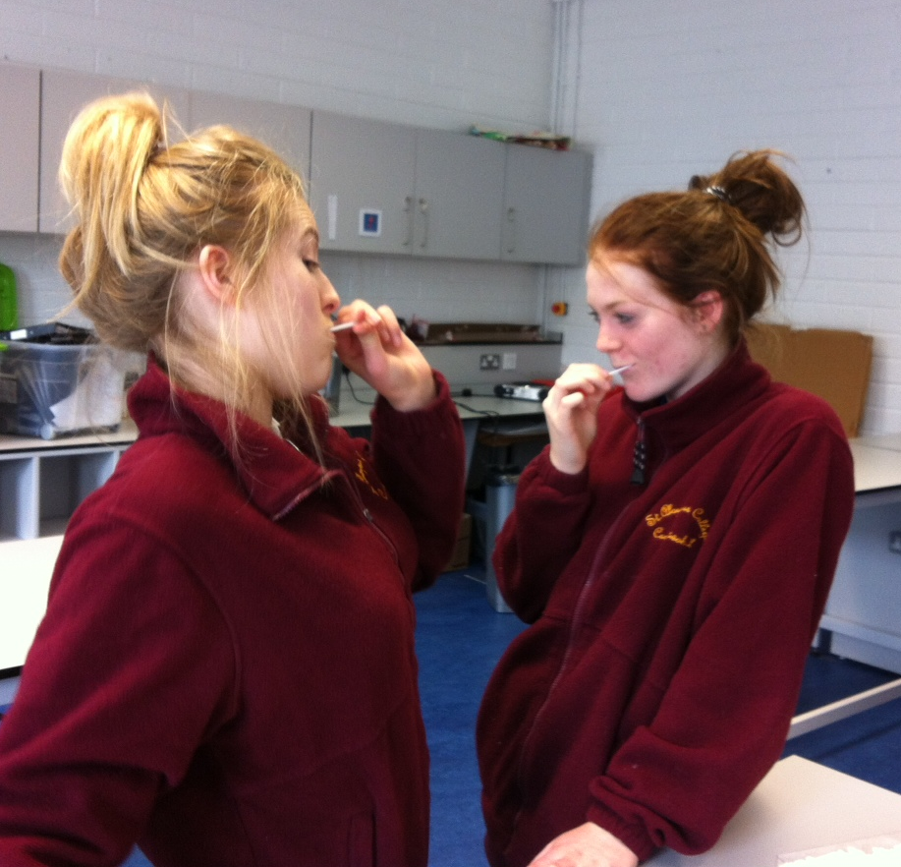
Students swabbing for two minutes

Lesson 4 (Task 4)
Students were interested to find out there was growth on their agar plates. After some discussion they emerged with many ways to analyse their results. Some students decided that the best method of analysis was visual inspection and to estimate how much of the plate was covered by bacteria before and after rinsing with the particular mouthwash. They then compared the alcohol verses the non alcohol mouthwash agar plates and based their conclusions on these observations.
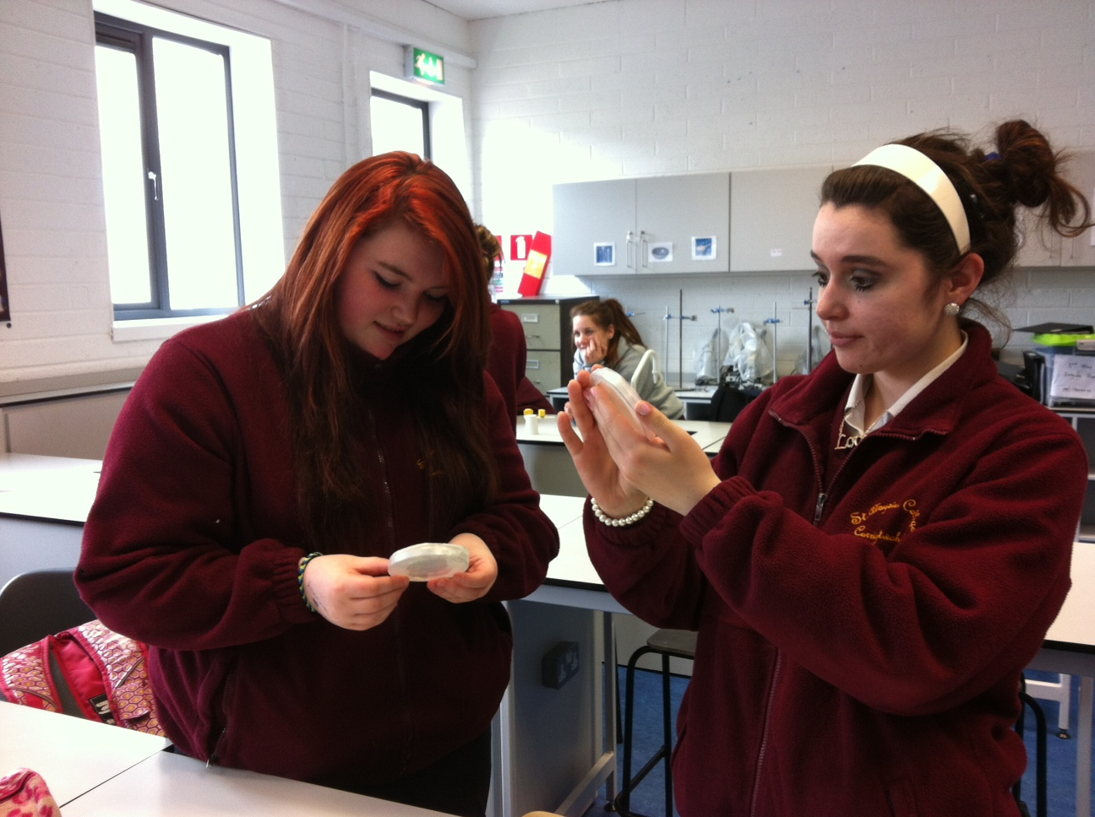
Students analysing by inspection

Interestingly, some of the more confident science students decided to use graph paper to find out the percentage of the agar that was covered with microorganisms before and after rinsing with mouthwash.
They placed the agar plate flat on a sheet of graph paper and drew a line around the perimeter of its base. They also marked on the graph paper where the dividing line was positioned on the agar plate. They removed the agar plate, drew the dividing line on the page and counted the number of small boxes on both sides of the dividing line within the perimeter. They recorded these numbers. They then placed the agar plate on the graph paper and counted the number of small boxes that the bacterial and fungal colonies covered on either side of the dividing line. They recorded these numbers and put them over the total number of boxes on that side of the line and multiplied it by 100 over one to get the percentage cover of microorganisms. They were able to compare the percentage of the plate that was covered with microorganisms before and after rinsing with the mouthwash and calculate by subtraction the percentage that was killed using the mouthwash. Once this was done for the alcohol and non alcohol mouthwashes they were able to conclude which one was better at killing bacteria.
Students were asked to discuss their findings with the class and their reasoning behind their conclusions as to which mouthwash was better at killing bacteria.
They concluded their report and began on their presentation preparation.

Lesson 5 and 6 (Task 5)
The students presented their findings to the class and two teachers of the school. The author and the fellow teachers sat at the back of the classroom amongst the students. All students decided to present their findings with a PowerPoint presentation. It is important to note that students were also given the option of designing a leaflet or a poster to present to the class but nobody decided to take that route of presentation.
Students handed up their folder containing all the information they researched over the six weeks.
Finally the students completed the small self assessment (Table 1) and the exam designed to test their research knowledge they acquired during the module. After this class the author completed an evaluation form (Table 2) below for each student.
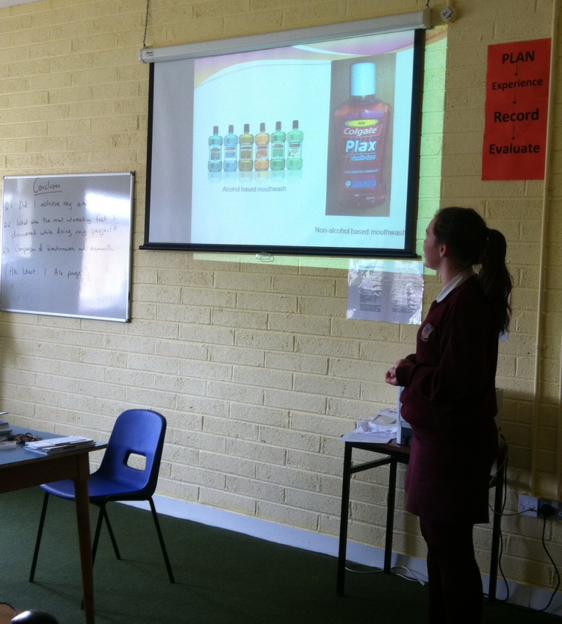
Students presenting their PowerPoint presentations to the class

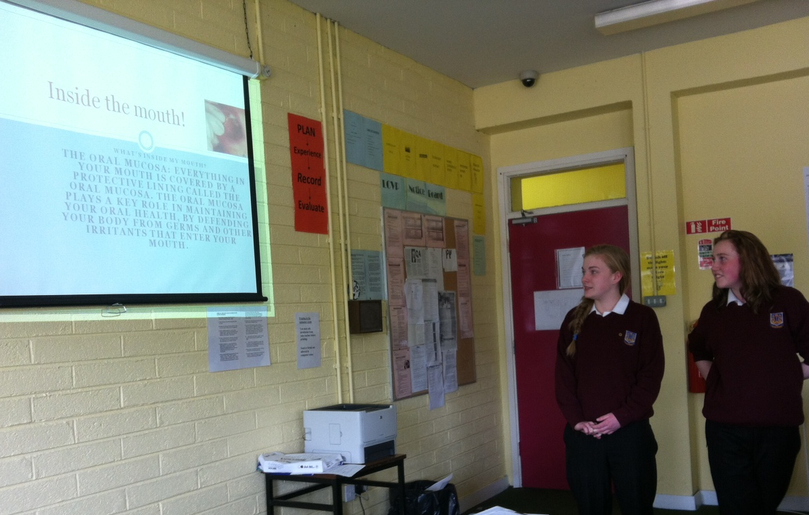
Students presenting their PowerPoint presentations to the class

Results of Student Activities
Students spent a lot of their time researching on the internet during this module. Some of the information they had to research include what structures were in their mouths, the reasons for adding alcohol to mouthwash and some of the advantages and disadvantages of adding alcohol to mouthwash.

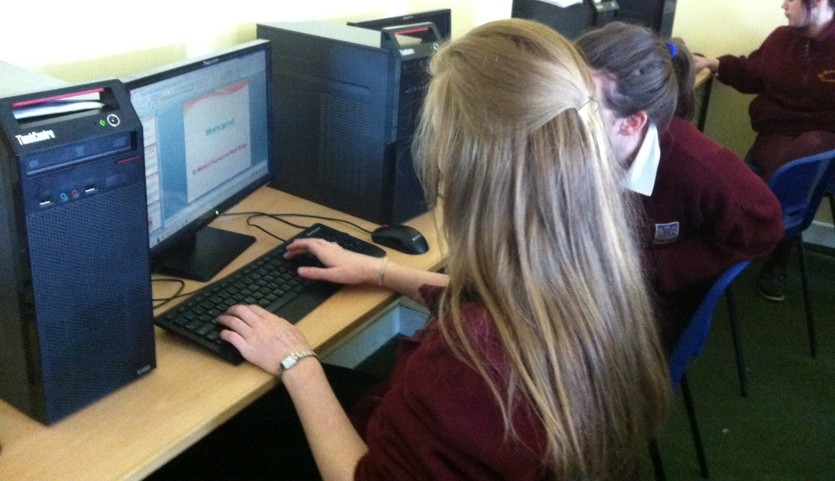
Students researching on the internet

Sample Results obtained by students
Alcohol Based Mouthwash
 | Before | After
Number of small boxes | 858 | 858
Number of small boxes covered by microorganisms | 106 | 21
Percentage cover by microorganisms | 12.4 % | 2.5 %
Percentage killed by mouthwash | 9.9 %
Results obtained from the alcohol based mouthwash.

Non Alcohol Based Mouthwash
 | Before | After
Number of small boxes | 858 | 858
Number of small boxes covered by microorganisms | 429 | 11
Percentage cover by microorganisms | 50 % | 1.3 %
Percentage killed by mouthwash | 48.7 %
Results obtained from the non alcohol based mouthwash.

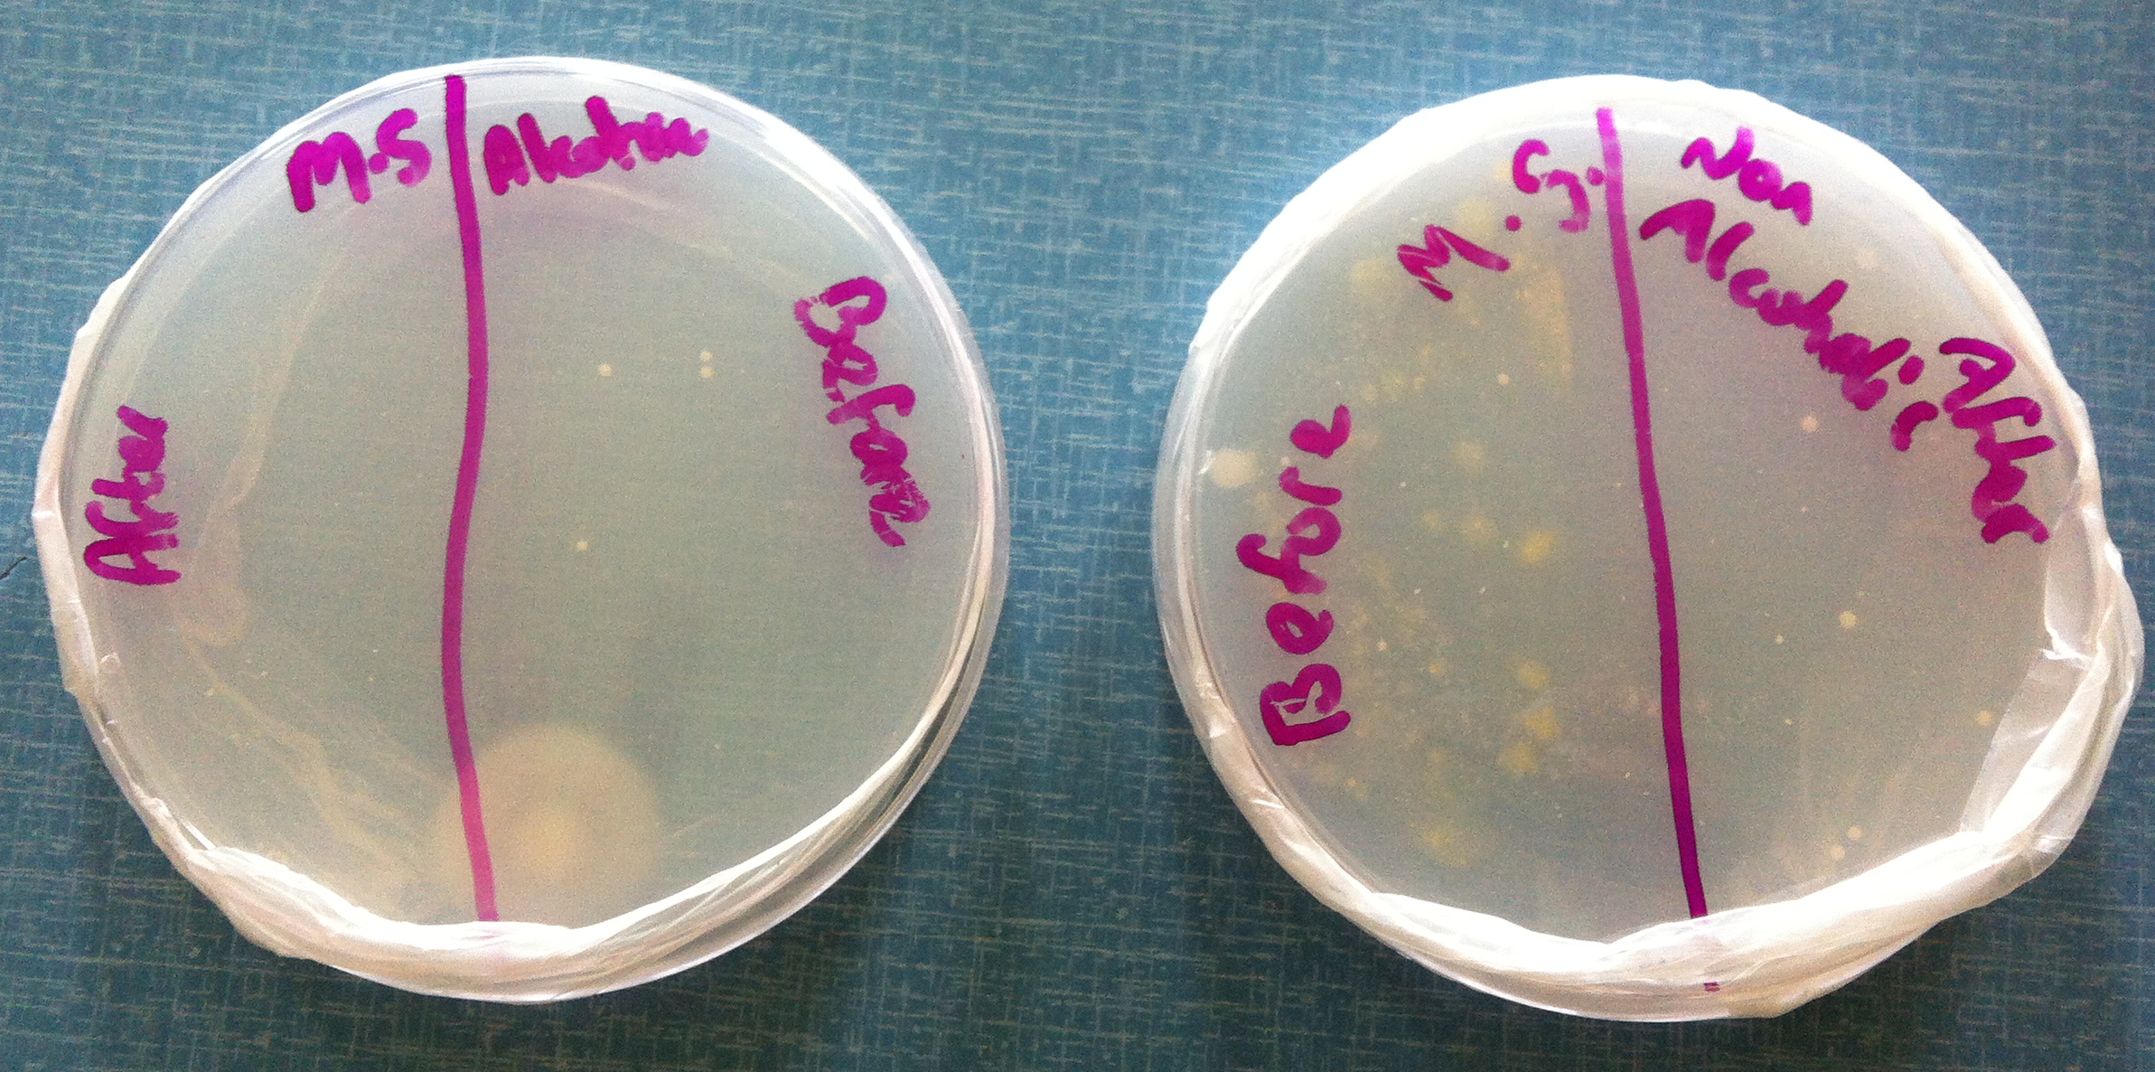
Agar plates illustrating the results given in Tables 9.5.1 and 9.5.2.
This group of students was able to conclude that the non alcohol based mouthwash was better at killing bacteria that the alcohol based mouthwash as there were a higher percentage of microorganisms killed after a student rinsed with the non alcohol mouthwash.

Mouthwash – Does alcohol really make a difference?

Assessment

Both students and teachers are tasked with assessing students’ work throughout this module.

Formative Assessment of laboratory investigation:
Students are asked to complete a self assessment of their progress throughout the experiment section by completing table 1 as honestly as possible.

Formative assessment of Mouthwash module:
Teachers will observe the students during the entire module and complete table 2 for each student. Teachers can give comments and/or grades to each student.
Students have to present a report at the end of the module for correction by the teacher that should include the following:
- Report for task 1 and 2
- Experimental write up (including the results and conclusions)
- Presentation of findings

Summative Assessment:
It is suggested that summative assessment should be based on learning outcomes and students should complete a small test at the end of the module (See test below).
Mouthwash – Does alcohol really make a difference?
Name __________________________________ Class______________
- Name any structure found in the mouth and give its function.
___________________________________________________________________

- In your opinion is alcohol in mouthwash essential for good oral health? Why?
___________________________________________________________________
___________________________________________________________________
___________________________________________________________________
- Why are agar plates used in the mouthwash experiment?
___________________________________________________________________
___________________________________________________________________
- What possible errors occurred during the experiment?
___________________________________________________________________
___________________________________________________________________
- How could you reduce these errors for future experiments?
___________________________________________________________________
___________________________________________________________________
- In your opinion should alcohol be banned in mouthwash?
___________________________________________________________________
Alcohol vs. non alcohol mouthwash activity:
When you are finished your activity, please complete the following table as honestly as possible.
Name __________________________________ Class______________
How much help did you need to: | a lot | a little | none
Design a procedure for the experiment
Discovering the possible problems with the experiment
Familiarise yourself with all procedures before starting
Listen to the teacher’s instructions
Risk Assessment
Ensure that all steps were carried out safely.
Correct manipulation of apparatus
Labelling the petri dish
Sectioning the petri dish
Swab your teeth and gums
Opening the petri dish
Transferring the swab to the petri dish
Rinsing your mouth with mouthwash
Transferring the second swab to the petri dish
Recording
Write up the procedure
Write up the results table
After the incubation period complete the table below:
Observation
The appearance of the agar after incubation for a week
Interpretation
Draw reasonable conclusions from your observations and results
Application
Become aware of any other applications of what you learned in this activity

Table 1
Student Evaluation of module based on Teacher Observation
Student Name____________________________ Class________________
Teacher Comment/ Mark/Grade
Research and group work
Works well with researching sections
Shows team work when comparing different mouthwash products
Thinks in a creative manner and exhibits vision
Experiment
Contributes to discussion about experimental procedure and possible difficulties associated with it.
Shows enthusiasm to perform experiment
Successfully carries out experimental procedure.
Presenting the activity orally
Presents the findings in a clear and practical manner
Presents knowledge and understanding of the subject
Uses precise and proper scientific language
Worked as part of a team to complete the presentation
Final Report
All reports for tasks included
Experimental write up
Presentation completed
Any other comments
Table 2
Ref: The Weizmann Institute of Science, Rehovot, PARSEL

Summary and Conclusions
In general students enjoyed this module. At the beginning of the module students found it difficult to design an experiment suitable for the science classroom. When they saw the equipment they needed to use, it made it easier for them to come up with an appropriate method.
When performing the experiment, an alternative to sterile swabs is cotton buds (Q tips) that are freshly opened. A supply of straws is useful to allow students a taste of the mouthwash. The students found the alcohol based mouthwash had a stronger more unpleasant taste. The favoured one was by far the non alcohol based mouthwash.
The agar plates should be kept in the fridge before being used by the students. Condensation may form on the lid of the agar plate so it’s very important to incubate the plates upside down. This way any condensation that may form will not drop down on the agar and kill any bacteria that may be growing affecting the results.
Taking a picture of the labels of the mouthwash bottles and photocopying them for the students proved a success, as it saved buying mouthwash bottles for everyone in the class. These pictures were also projected up onto the screen but the students relied more on the photocopies to complete the task successfully.
The student results from the ‘Mouthwash – Does alcohol really make a difference?’ module were mixed. Some students felt that alcohol based mouthwash was better at killing bacteria as comparing it to the non alcohol agar plate there was less area of the agar covered with bacteria after they rinsed with the mouthwash than before rinsing. Their research also helped them come to this conclusion as alcohol is a natural antiseptic.
Other students concluded that non alcohol based mouthwash was better at killing bacteria as it had more chemicals in it to compensate for the lack of alcohol. There were more bacteria present in the agar plates testing the alcohol based mouthwash than the non alcohol based mouthwash.
In general they all agreed that both types of mouthwash kill bacteria.

