A spoonful of yoghurt for depression
Probiotic yogurt is not only good for digestion. Apparently he indirectly affects our mood. Researchers have found an interaction between gut and brain.
From Brigitte Röthlein
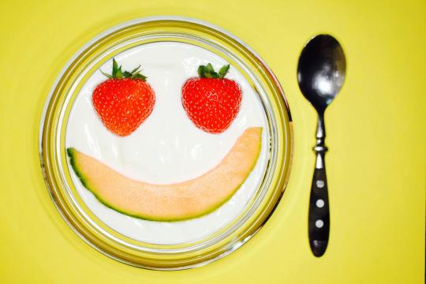
Photo: Martin UK Lengemann with specific probiotic yogurt can affect mood
John F. Cryan is a rounded, lively man, and blessed with a robust Irish humor. The one needs perhaps in his profession: The 41 - year old professor of anatomy and neuroscience studied at University College Cork (UCC) the intestinal flora. Every day he has to do with the excreta of humans and animals.
But the study of the intestinal flora, the investigation of stool samples is only one part of Cryans research. Although he also examines which bacteria there are, and how their presence affects the metabolism of humans and animals. But even more interesting to him whether the microbiome not also affects mood.
Ten years ago Cryan would have been still considered funny by his colleagues for this idea. The more studies are published, the more clearly recognize researchers that the 100 trillion microbes in the human intestine affect the psyche. Therefore, experts believe that the future can alleviate mental suffering with yoghurt products containing such bacteria even.
The bacteria of the intestine to produce a number of enzymes that help to break down the food. They also provide vitamins and short-chain fatty acids. Only thanks to these microorganisms man can digest juicy steaks and vegan burger. In addition, scientists will always find new evidence of how diverse is the remit of the intestinal flora.
Especially our immune system is essential to rely on the bacteria. John F. Cryans theory but once again opening up a completely different field. If the intestinal flora to be really responsible for elation or depression ?

The emotional health
Probiotics
- Prehistory
The Frenchman Louis Pasteur discovered the first scientist that the souring of milk is caused by bacteria. He showed that the killing of the bacteria leads by brief heating, the milk stays fresh for longer. The pasteurization of substances is his invention.
- Discovery
At Pasteur Institute in Paris and the principle of probiotics has been discovered - but not by him but by a Russian: The Nobel laureate Elie Metchnikoff noticed that Caucasian farmers and herdsmen are very old. He dealt with their lifestyle and found that their diet consists largely of dairy products. He drew the conclusion that the bacteria from dairy products have a positive effect and can lead to a longer life. His knowledge is considered the birth of the probiotics.
- Definition
According to the World Health Organization is today understood " probiotics " living organisms that bring a health benefit. Among other things, include bacterial strains in yoghurt - or milk beverages, in food supplements or drugs in it. The bacteria survive the attack of gastric acid in the stomach and colonize the intestines.
- Application in medicine
In some diseases probiotics are used as therapy, such as chronic - inflammatory bowel inflammation and diarrhea. Allergies and eczema preventing, apparently.
Time and again, researchers had expressed in the past few decades the assumption that intestinal bacteria might have something to do with the mood of their hosts. Mostly they were but dismissed as cranks. Since one part of the human microbiome project of the US National Institutes of Health began in 2008 to identify the bacteria in the human gut and counting, gradually began to rethink.
Because it quickly became clear that in the intestine not only a wide variety of bacteria live, but also how important they are to human health - not only for physical health, but apparently also for the emotional. The California microbiologist Sarkis Mazmanian even speaks of a "paradigm shift in neuroscience".
That it took so long, until the researchers have recognized the diverse impacts of micro-organisms, is also recalled that the investigation of the human digestive system is not trivial. This indicates a somewhat bizarre experiment in medical history: The US - military doctor William Beaumont treated in the 19th century a patient with abdominal gunshot. This was healthy despite his serious injury, but kept a hole in the abdominal wall back.
All his life he had with this compound, which resulted from the stomach to the outside, to cope. William Beaumont recognized the opportunity for science. He attached to various foods cords, and let her through the hole in the patient's stomach. After a while he pulled the half-digested chunks out again and examined it. He became a pioneer of digestion research and discovered also that the digestion was always disturbed when the patient angry.

It also applies to the reverse
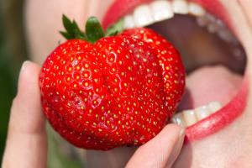
Allergies
These foods do not tolerate any
Related that feeling and stomach tight, knows the vernacular. It does not speak in vain of "gut feeling", "butterflies in the stomach" or "stomach ache". Fear can accelerate digestion. But obviously affects not only the psyche on digestion - digestion can conversely change the emotional state.
John F. Cryan is one of the first to have recognized this and scientifically researched. Six years ago, he made ​​with his colleague Javier Bravo and researchers of the McMaster - University in Canada an experiment which has brought it to prominence.
The researchers wanted to know how stress-resistant mice are. The animals were to put in a glass vessel which was filled with water. Nowhere the mice could stand on the vertical edges of the vessel they could not climb. Quick recognized the animals that they had no chance to escape.
Not all mice responded identically in this hopeless situation. Some floated briefly and then gave up. They drifted and simply waited if anything she rescued. Other mice gave not beat as fast. They swam and swam - to the point of exhaustion.
Cryan and his team arranged the mice into two groups: the adventurous and the fearful. They repeated the test water - but they gave the anxious mice psychotropic drugs, such as antidepressants. With Success. The mice fought and kicked off longer than without the influence of a mood enhancer.

The influence of the microbiome
In another experiment, the UCC could - researchers then actually prove that the intestinal flora of the mice can virtually act as mood enhancers. They had mixed the mice for several weeks lactic acid bacteria of the species Lactobacillus rhamnosus in the food. They found that the animals were swimming then longer and tasks later, as if they had taken an antidepressant.
These lactic acid bacteria found in the human intestine researchers. After his experiments John F. Cryan is convinced: "The intestinal flora is the conductor of the immune - neuroendocrine communication. " Is this microbiome disturbed, advised the defenses and the neurotransmitter system of nerves out of balance.
With many more researchers began experiments worldwide, the thing to get to the bottom. They wanted to know exactly how the communication between the intestinal bacteria and the neurons in the brain works. They bred mice without intestinal flora and found that they showed some of the symptoms that are reminiscent of autism.
They gave their experimental animals bacteria or antibiotics to eat, or led by chair transplants. Other studies in children have shown that the formation of the intestinal flora in babies affected brain development decisively. The animals endured more or less stress - depending on whether they had a healthy or disturbed microbiome after birth. Apparently the bacteria even influence the social behavior of the mice.

Interplay between gut and brain
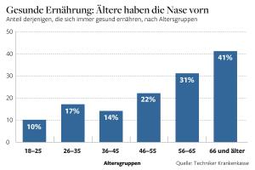
to eat and drink
So the Germans feed
"A timid or adventurous default there is also in humans," says Cryan. He believes that the influence of intestinal flora on the mood of the people is crucial. So could show 2010 French researchers found that subjects who had eaten for 30 days certain lactic acid bacteria were less anxious and depressed.
Two years later, researchers found the University of California in Los Angeles that the regular consumption of probiotic yogurt in healthy women resulted in changes in the part of her brain that processes emotions.
To explore the chemical interplay between the gut and the brain, it is not enough to feed humans or mice with bacteria. Really bat - and puncture resistant medical results only if you can explain how something works. Therefore Cryan and his team devote intensive research into the chemical messengers that trigger joy or fear in the brain, and its relationship to the intestinal bacteria.
They found this out first that probiotics GABA - receptors change in many areas of the brain. GABA stands for gamma - aminobutyric acid, their receptors are needed for the transmission of stimuli and play a fundamental role in the nerves and the brain.

Epigenetic mechanisms
The recently published results are even indications that the composition of the intestinal flora may play a role in causing autism. "That works probably epigenetic mechanisms," says the German researcher Roman Stilling, who carried out the project together with Cryan and Ted Dinan. "That is, for example, that environmental factors specific genes - can or off, in our case, which is caused by intestinal bacteria. "
Bacteria as a drug, that's a whole new way. "While one learned in the 20th century to fight bacteria with antibiotics, we learn in the 21st century that many bacteria have a beneficial effect on our health," said Cryan. Of course, not all.
Although many preparations advertise today with positive health effects, the psychologist Ted Dinan recommends a cautious assessment of the promise of salvation: "Most probiotic supplements do not help us, they do not even survive the stomach acid." But some probiotics could get an enormous importance in the treatment of psychiatric disorders.
So hopefully the results of Mikrobiomforscher are - John F. Cryan it considers always with a wink. That he proves with a cartoon from the London newspaper "Daily Mail", the most like him. There professes a woman on the couch of a psychiatrist: "The depression began when I made ​​it clear to me how much money I spent on my yogurt."

