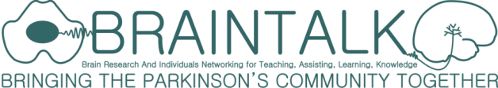

PARKINSON'S COMMUNITY
Meeting and Exhibition

Monday 7th September 2015
10.00-4.00pm
Lewis Glucksman Gallery, University College Cork.

REGISTRATION FORM
If you are bringing a companion(s) please give us their detail too on a separate form.

Personal Details:
Forename: |  | Phone number
Surname: |  | Email address:
Address:

Please select which category you will be attending as: (tick box for yes)
Person with Parkinson’s ☐ | Family or carer of person with Parkinson’s ☐ | Healthcare professional ☐
Academic/researcher ☐ | Student/researcher ☐ | Other ☐
Dinner:
Will you be attending the Meeting Dinner at the Kingsley Hotel at 6.00pm?
Tickets for dinner available on the day cost €30 each (tick box for yes) ☐

Please return completed registration forms

Email: braintalk.ucc.ie

or post to: Professor Aideen Sullivan,
Department of Anatomy & Neuroscience,
Room 3.85, Western Gateway Building,
University College, Cork, Ireland.
Or register online at the Meeting and Exhibition Website http://www.ucc.ie/en/braintalk/

