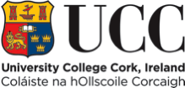

CANDIDATE INFORMATION

LECTURESHIP IN LAW

CONTENTS

Information for Candidates

- Welcome from the President

- About Cork

- University College Cork

- University Strategic Plan

- University Organisational Structure

- Information on the School / Department

- Job Description

- Equality of Opportunity Statement

- Housing, Education, Medical Insurance & Tax Information

- Useful Web Links

Additional Information for Shortlisted Candidates

- Interview Format

- Directions to UCC

- Expenses for Candidates Attending for Interview

- Campus Maps

- WELCOME FROM THE PRESIDENT

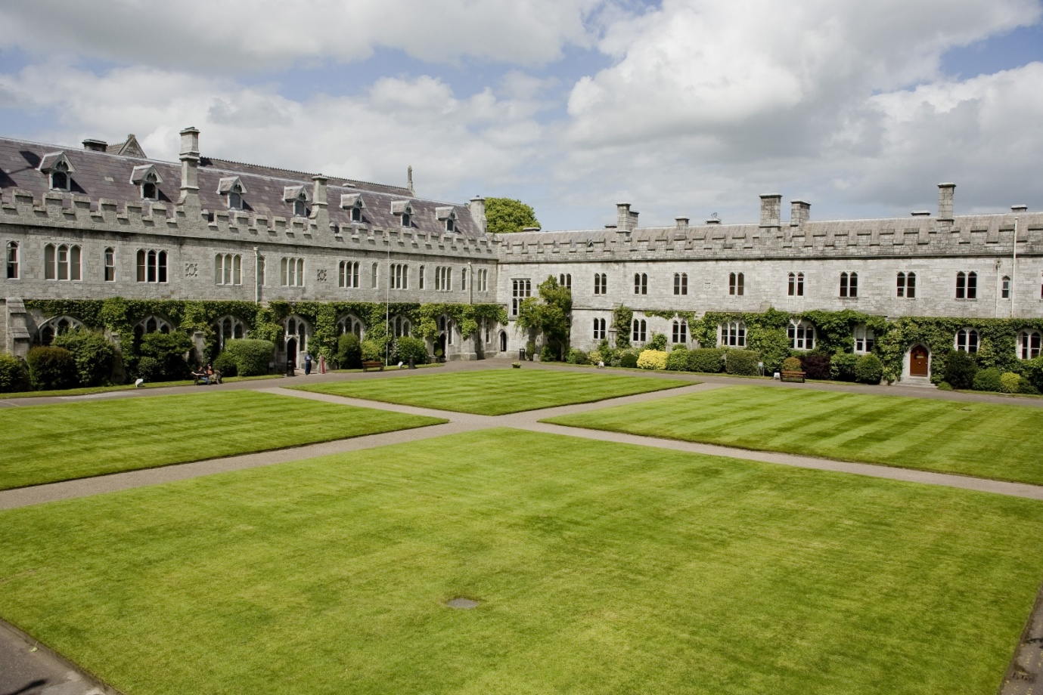

Now that you are considering a career at University College Cork (UCC), let me thank you for your interest and introduce you to our University.

Originally founded in 1845 as "Queen's College Cork", UCC is one of Ireland's oldest institutions of higher education. Ranked in the top 2% of universities worldwide, UCC was named as Ireland’s Sunday Times University of the Year in 2011, the third time in 10 years to receive this designation. In 2011, UCC became Ireland’s first Five Star University (under the QS ranking system) and was named the World’s First Green University Campus (Federation for Environmental Education, Copenhagen).

UCC boasts a spectacular campus in a compact university situated in a global tourist destination. The University serves a community that is both local and global. We are a comprehensive, multi-disciplinary university. During our 160 year history, staff or students here have invented the logic on which computer programming is based (George Boole, Professor of Mathematics 1849-54), discovered the cause of the tropical disease, leishmaniasis (Charles Donovan, medical student during the 1880’s) invented the world’s first junction-less transistor (Professor Jean-Pierre Collange, 2010) became Supreme Court Judges (Liam McKechnie, 2010) and much more. We have nurtured composers, poets and playwrights. We have taught over 100,000 alumni who lead and serve society throughout the world.

Today, UCC’s student body of some 20,000 includes over 2,800 from 100 countries across all continents. We employ 2,700 professionals. Over one third of our academic staff have come from overseas. We enjoy many accolades as a high quality employer. The true strength of our university lies in the people who work and study here. The diversity of our workforce and our students is our competitive edge in realising our mission to “create, preserve, and communicate knowledge and to enhance intellectual, cultural, social and economic life locally, regionally and globally.”

Our vision - UCC a contemporary Irish University with a global outlook will, I trust, prove attractive to you. This briefing pack contains information which I hope will be useful and informative should you be selected to attend for interview here in Cork.

I trust that your experience of our recruitment process will be a positive one and I thank you, again, for considering a career at University College Cork.

Dr Michael Murphy

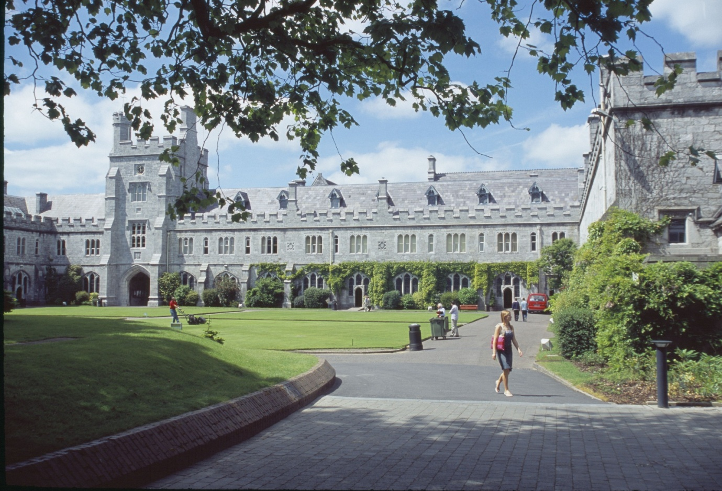

- ABOUT CORK

Recently identified as one of the top ten destinations to visit by the Lonely Planet guide, Cork is a place not just to visit, but to live; offering a quality of life and an academic and cultural experience which reflects positive Irish values. Cork city has a population of some 150,000, with a further 100,000 in the city’s hinterland. Further details can be found at http://www.corkcity.ie/

- UNIVERSITY COLLEGE CORK [UCC]

UCC was established in 1845 as one of three Queen’s Colleges at Cork, Galway and Belfast. The site chosen for the college is particularly appropriate given its connection with the patron saint of Cork, St Finbarr. It is believed his monastery and school stood on the bank of the river Lee, which runs through the lower grounds of the University. The University’s motto is ‘Where Finbarr Taught, let Munster Learn.’ University College Cork (UCC) is the principal university in the province of Munster and the largest outside Dublin
UCC, which has a current enrolment of close to 20,000 students, provides over 120 degree and professional programmes through some 60 Disciplines and offers a research-led curriculum that attracts the highest calibre of students. UCC attracts a large number of international students currently in excess of 2,800.

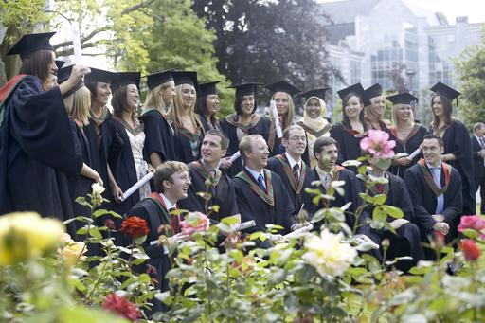

The University offers an innovative, research-led curriculum, taught by world-class academics that consistently attracts a quality student intake. The University has a recurrent budget of €280 million. UCC has established four Colleges to enhance the University’s research and teaching efforts:

  - Arts, Celtic Studies and Social Sciences
  - Business and Law
  - Medicine and Health
  - Science, Engineering and Food Science

Colleges are managed by Heads of College and supported by College Managers, Financial Analysts, HR Managers as well as dedicated administrative support. College-level committees are aligned to Academic Council Committees to enhance decision making, policy implementation and information flow.

UCC employs some 2,700 staff. UCC is committed to building its capacity to carry out research of the highest international quality, and to providing research-lead teaching across the breadth of disciplines and specialisms typical of a traditional university. UCC also prides itself on close connections with the professions, industry and the local community. Further information on UCC including information on Academic and Administrative Departments can be found on the UCC web site. The UCC home page address is www.ucc.ie.

The University budget is in the order of €280m. The University is directly funded by the Higher Education Authority (HEA), receives grant, fees and other income, and also generates levels of research income which for many years have been the highest in the State (in 2010-11 €80m). The University budgetary strategy continues to focus on decreasing its reliance on Exchequer income and promoting income generation through increasing post graduate and international fee income.

UCC consistently delivers a globally significant contribution in research and in teaching and learning, which has secured the University a place in the top 2% of Universities worldwide in the QS World University Rankings (2010). UCC is committed to building its capacity to carry out research of the highest international quality and to providing research-led teaching across the breadth of disciplines and specialisms typical of a traditional university. UCC was the first Irish university to conduct an institution-wide research quality review in 2009.

The University has benefited very substantially over the past ten years from national programmes aimed at developing research infrastructure, capacity and output, mainly funded through the National Development Plan and in line with the Government’s Strategy for Science, Technology and Innovation. It has in this way developed its key role in plans for the long-term economic and social development of the region and the country, the city of Cork being a primary gateway in Ireland’s Spatial Strategy. These developments have also been substantially supported through private funding raised by the University.

The University contains a number of highly prestigious research centres including the Alimentary Pharmabiotics Centre – www.ucc.ie/research/apc and the Tyndall National Institute. See http://www.tyndall.ie/

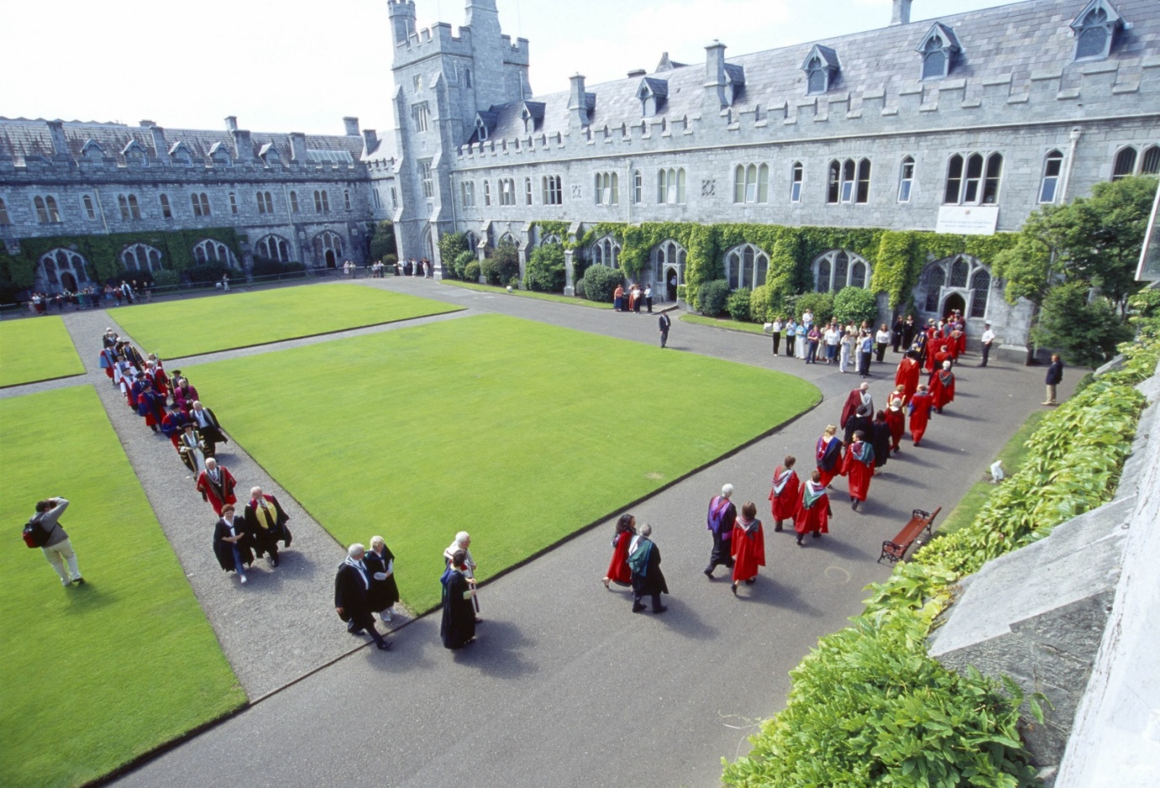
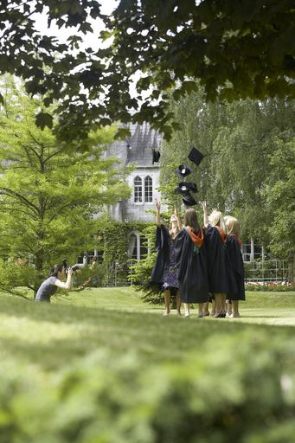

The functions of the University are performed under the direction of the Governing Body. The Academic Council, subject to the financial constraints determined by the Governing Body and to review by it, controls the academic affairs of the University. The main executive management group is the University Management Team, which works in support of the President.

University College Cork (UCC) has been selected as Ireland’s University of the Year 2011/12 by The Sunday Times. This award has been given for a number of reasons which include recognition of the University’s position as the leading research institution in Ireland; the University’s cosmopolitan character which encompasses an admirable student mix; the excellence of UCC’s teaching and academic standards and the University’s links with business and industry.

The Sunday Times award, which is the third occasion UCC has received this award, follows on the heels of UCC becoming the only Irish university to achieve the unique status of Ireland’s first five star university.

UCC is also the first university campus to be awarded the Green Flag for an environmentally friendly campus in a student-led innovation. UCC is proud of its achievement as the world’s first university to achieve the ISO 50001 standard in energy management systems

Tours of the University & School/Departmental Visits

A virtual tour of UCC is available on http://www.ucc.ie/en/visitors/see-do/

For some positions, you will also be offered an opportunity to tour the relevant department/school.

- UNIVERSITY STRATEGIC PLAN

Details of the UCC Strategic Plan can be found on http://www.ucc.ie/en/strategicplanning/strategic/

- UNIVERSITY ORGANISATIONAL STRUCTURE

Governing Body
President
Academic Council
Arts Celtic
Studies &
Social Sciences
Science
Engineering &
Food Science
Medicine
&
Health
Business
&
Law
Registrar
Senior VP
Academic
Bursar
&
CFO
Academic Secretary
VP
Research &
Innovation
VP
Teaching &
Learning
Head
Student
Experience
-School of Applied Psychology
-School of Applied Social Studies
-School of Asian Studies
-School of Education
-School of English
-School of History
-School of Geography & Archaeology, Human Environment
-School of Irish Learning
-School of Languages, Literature & Cultures
-School of Music & Theatre
-School of Sociology & Philosophy
-School of Asian Studies
-Classics
-Study of Religion

-Computer Science
School of Mathematical Science
-Biological, Earth & Environmental Sciences (BEES)
-Engineering
-Food Science
-Chemistry
-Physics
-Biochemistry
-Microbiology
-School of Medicine
-School of Dentistry
-School of Nursing & Midwifery
-School of Clinical Therapies
-School of Pharmacy
-Accounting Finance
And Information Systems
-Economics
-Food Business & Development
(Centre for Cooperative Studies)
-Government
-Management & Marketing
-Centre for Policy Studies
-Law
Director
Quality
Promotion
Corporate
Secretary
&
Dir. HR
Director
Inf Services
& Librarian
Director
Estates &
Infrastructure
Director
Planning &
Inst Research
VP External
Relations &
Development
COLLEGES

- INFORMATION ON THE DEPARTMENT OF LAW

- Background/ History

First established in 1845, the Department and Faculty of Law combine as a modern academic unit with committed, research active staff and a range of law programmes at undergraduate and postgraduate level. The Department is based in Áras na Laoi on the beautiful UCC campus in a recently refurbished building with modern teaching facilities - including a Moot Court room - meeting rooms, dedicated research student work spaces and social space. Its library facilities are based in the modern Boole library with a dedicated law librarian.

- Law Strategic Plan

The Law Strategic Plan was developed through a process of consultation and engagement with staff, students and other stakeholders, which took place between May and November 2012 and the Plan was approved by staff on December 11th 2012. An operational plan has also been agreed, outlining the actions required to ensure goals are met.

The mission statement of the Department and Faculty of Law is to be:

A modern Law School where students benefit from education that is relevant, challenging and skills-based, with committed staff who conduct research that is innovative and has impact and are engaged with law and society, nationally and internationally.

In order to achieve this mission, Law will:

1. Provide quality legal education at all levels with innovative programmes and curricula that meet the needs of a diverse body of students and are responsive to the demands of employers and society;

2. Produce and disseminate excellent research that has impact and standing at local, national and international levels;

3. Offer supports to ensure that staff and students are enabled to maximise their potential;

4. Strengthen governance structures, procedures and systems that ensure the Department/Faculty operates in a fair, efficient and cost-effective manner;

5. Pursue a wide range of external engagement activities at local, national and international levels that contribute to law and to society.

- Current Data, Undergraduate, Postgraduate numbers and staffing

Law currently has 657 students on a wide range of programmes – including six BCL (undergraduate) programmes, a graduate LLB and five (taught) LLM programmes – with a mix of specialist and general degrees, some of which are unique in Ireland. The student body is diverse with increasing numbers of students from mature years, part-time, non-traditional entry and international cohorts. Programmes combine traditional law curricula with a focus on legal skills and clinical education. Students enjoy a range of placement and study abroad opportunities, especially on the specialist programmes and there is an active placement programme available to all students. We have a strong graduate school and the majority of our PhD students are independently funded. Law staff are research active, engage in research led teaching, and contribute to the University and to society in multiple ways.

Law is a medium size academic unit with 37 full-time staff – eight professors including four Professors (scale 1) and four Professors (scale 2), five Senior Lecturers, twelve College Lecturers, two postdoctoral researchers and nine support staff in managerial, administrative, clinical and technical roles. In addition, the College of Business and Law Student Recruitment and Liaison Officer works with both the Faculty of Commerce and the Faculty of Law. There are also 23 part-time staff who lecture and tutor on Law programmes, many of whom are also PhD students. Law has one Emeritus Professor and several adjunct professors, including members of the judiciary.

- Current Programmes, Teaching and Research Specialisations

The Department and Faculty of Law offer programmes at Levels 6, 7, 8, 9 and 10 of the National Framework of Qualifications (NFQ). At Level 6, Law offers a Certificate in Legal Studies as a one-year course, which is delivered at night through the Centre for Adult Continuing Education (CACE). At Level 8, there are six undergraduate programmes – all of which are recognised by the Law Society of Ireland and King’s Inns (the professional bodies) – and one postgraduate programme, the LLB. Specifically, the undergraduate programmes are as follows:

- BCL - three year, core law degree;
- BCL Evening – a part-time, four year programme run (every second year) at night. Students who successfully complete two years of study can choose to graduate with a Diploma in Law (NQF Level 7);
- BCL (Law and French) - a four year, joint honours programme run with the Department of French. Students spend third year studying Law through French in France or Canada;
- BCL (Law and Irish) - a four year, joint honours programme run with the Department of Irish. Students spend their third year on placement or at our partner institution (University of Montana) in the US;
- BCL (Clinical) - a four year programme with an emphasis on legal and clinical skills where students spend their third year on placement;
- BCL (International) - a four year programme where students spend their third year studying abroad in the US, China or Europe;
- LLB – a one year programme which allows law graduates to take undergraduate modules, combined, if they choose, with a dissertation (10 credits).

At Level 9, the Department and Faculty of Law offer six LLM programmes. With the exception of the LLM (Practitioner), these are offered on a full-time (12 months) or part-time (normally 24 months) basis, and include 60 credits of taught modules and 30 credits of a minor thesis or dissertation. Specifically, the LLM programmes offered are as follows:

- LLM – a general and long-standing Masters programme which enable students to tailor the degree to their interests;
- LLM (Criminal Justice) – a programme open to those with experience of the criminal justice system, as well as law graduates, with a core clinical component which brings students into contact with the courts, prisons, police, victim organisations and the legal professions;
- LLM (Intellectual Property and E-Law) – redesigned in 2010, this degree capitalises on the special connection between these two areas of legal specialty;
- LLM (International Human Rights Law and Public Policy) – introduced in 2011, this degree combines specialist education in human rights law with a focus on human rights in practice;
- LLM (Child and Family Law) – introduced in 2011, this unique programme provides a grounding in child and family law with exposure to the application of the law through the Child Law Clinic;
- LLM (Practitioner) – this programme is tailored to legal professionals who can combine formal LLM modules with reflective practice through a credit accumulation model.

The Department and Faculty of Law also offer graduate research opportunities through the LLM (Research) and PhD programmes at Level 10. Law has significantly expanded its graduate research student population over the last decade, creating a dynamic and international community of researchers. There are currently 43 research students, including 30 full-time students on the PhD programme. A series of supports for graduate students (including fee scholarships, tailored training, a postgraduate forum, conference/travel grants and career supports) has been established, with clearly positive effect. Supervisors are also provided with dedicated supports and training courses, most of which are provided by the University’s Graduate Studies Office. Law has enjoyed particular success in securing IRCHSS (now Irish Research Council) and other prestigious scholarship awards reflecting the high quality of PhD students in the Faculty and the supports (practical and academic) that they receive.

The Department and Faculty of Law are committed to excellence in teaching at all levels.
Several staff have formal qualifications in teaching and learning (Certificate, Diploma or MA) and a significant number of staff have been honoured with awards for teaching and learning excellence. Law staff regularly attend teaching and learning seminars both in the Department and in the wider University. To support development a Director of Teaching and Learning has recently been appointed, although other staff also provide leadership in this area. For example, seminars are held for teaching staff on different aspects of teaching: the use of learning technologies, assessment techniques; good teach practices, the use of portfolios.

Many modules, particularly at undergraduate level, are taught in the traditional format of two hours lectures per module per week, and examined at the end of the academic year
(ten credits). Five credit modules are gradually being introduced at BCL and LLM levels, and have increased the range of subjects on offer. Modules are also taught at night, for the purposes of the BCL Evening degree. Tutorials enable small group teaching in many of our undergraduate modules and continuous assessment – including essays and other coursework – is increasingly part of the undergraduate curriculum. All LLM modules are examined using a variety of methods including essays, moot court assignments, class presentation and participation, and oral exams. There is an increasing use of modern technology, innovative and interactive teaching methods, and continuous assessment. Law has increased its offerings available on-line, especially at LLM level and this is an area of our activity which we hope to develop in parallel with the University’s e-Learning Strategy. In November 2012, the post of Director of e-Learning was established to lead this area of Law’s development.

Skills-based learning has been a hallmark of our legal education for many years and various compulsory modules at both undergraduate and postgraduate level aim to develop the competencies of legal research, writing and analysis, oral advocacy/Moot Court and presentation. Clinical education – exposing students to law in practice with reflective learning – is a key feature of our approach, especially in the BCL (Clinical) degree, the LLM (Criminal Justice), the LLM (Practitioner), the LLM (Child and Family Law) and the LLM (International Human Rights and Public Policy). The relationship between law and languages is strong at the Faculty of Law and in addition to underpinning our undergraduate programmes, it is becoming a feature of our legal education more generally with some modules, open to all students, being delivered through the medium of Irish and French.

In addition to the education we provide to law students, we contribute in a significant way to other academic programmes in the University. For instance, we play a particularly strong role in the areas of social work (BSW and MSW), criminology (MA), nursing, planning and environmental law (MPlan), international development, commerce (BComm and MBA), and in the areas of health law, ethics and technology. These teaching areas fit very well with our inter-disciplinary research activities, and the provision of specialist legal education to various non-law disciplines is an area we plan to develop in the years ahead. We already provide specialist legal information and education to professional audiences – both in Ireland and abroad – in other areas such as intellectual property, maritime law, environmental law, human rights, property law, medical ethics and children’s rights.

- Research

All academic staff are research-active and publish monographs and textbooks, publish in journals and edited collections, undertake commissioned research and engage in law reform and consultancy in a wide variety of areas. Almost all staff have a PhD or other doctorate. We have a significant research profile, both nationally and in some areas internationally, we engage actively in law reform, public policy and media activities and we contribute significantly, through consultancy and pro bono work, to the work of statutory bodies and civil society both in Ireland and internationally. Our research strengths have emerged through our individual and collaborative research activity. Specialisations or strengths exist in several areas including: banking, consumer and corporate law, constitutional, European and international law; child and family law; criminal justice, environmental, maritime and natural resources law; private law; human rights, and e-commerce, information and technology law. A research centre – the Centre for Criminal Justice and Human Rights – was established in 2006, and there are several other less formal research groupings such as the Constitutional Project @ UCC (an inter-disciplinary research group), the Child Law Clinic (involving LLM students, PhD students and staff), the Environmental Law Group, the Law and Language Interest Group and the Gender, Law and Sexuality Initiative. Some of these groupings have emerged through the support of the Law Strategic Fund, launched in May 2012.

In the Research Quality Review conducted in 2009, the Department and Faculty were given a rating of 4 (out of 5). The reviewers commented that ‘a significant amount of excellent work’ is produced in the Department. The contribution to law and policy reform was said to be ‘significant’ and our international research activities were described as ‘extremely impressive’. Aspects of our graduate programme – the scale of which was commended – were described as a ‘model of good practice’. We consider research to be the intellectual lifeblood of the Department/Faculty and that research at the highest level is essential to sustain the national and international reputation of the Faculty and to ensure that teaching is both research-led and informed. Research funding can provide opportunities to engage in research that is targeted, context specific or applied, and research funding is an important source of income generation for the Faculty and the University. Our goal is to support all researchers to undertake excellent research that is innovative, relevant and has international standing. We strive to continue to attract PhD students of the highest calibre and we will consider the strategic recruitment of academic staff to develop and build on areas of expertise, as appropriate.

- Contribution – internal and external, public/community/industry engagement

Staff at the Department/Faculty of Law are nationally and internationally focused and externally engaged pursuing a wide range of activities in the local, national and international communities. This includes work in law and policy reform, supporting non-governmental organisations, membership of state boards and government appointed committees/boards/groups and consultancy. Law has a strong relationship with the legal professions and the judiciary and formal and informal contact with its graduates. A significant number of academic staff contribute actively to the national media and public debate on a wide range of topics. The Department/Faculty have strong links with international partners, including law schools in China, North America and Europe and international mobility is strong among both staff and students. Many staff work closely with European and international institutions. The Department and Faculty actively engages with the public and has a full programme of events, including continuing professional education, seminars and conferences tailored to both specialist and public audiences. The staff of the Department/Faculty of Law are well connected with and contribute actively to a whole range of activities designed to benefit Cork, Ireland and the world.

- Recent Developments

Our new Dean of Faculty and Head of Department was appointed in April 2012 and in 2012/2013 the Department and Faculty completed a process of quality review which endorsed the strength and quality of our programmes and our research. In addition to the many appointments and successful events and other achievements highlighted on our website, facebook and twitter pages, other developments include:

- Two new LLM programmes will commence in 2013-14 academic year, namely LLM (Business Law) and LLM (Health and Care Law), reflecting, Law’s specialist expertise in these areas.
- A review of the BCL, with a view to enhancing its attractiveness to students through the introduction of pathways, increased options and skills/clinical education, while the feasibility of new undergraduate programmes is also currently being explored.
- New student, teaching and research supports have been put in place in 2012-13, with programme directors confirmed for each programme.
- A staff research colloquium provides staff and students with the opportunity to present and discuss their research and administrative and financial support was made available to support research and its dissemination.
- On governance, a new Student Council, a Management Team and an Advisory Board are all new developments.

- JOB DESCRIPTION

POST OF LECTURESHIP IN LAW

Duties of the Post: In accordance with the University’s strategic objective as a research led institution, the duties of all academic staff will include research, research-led teaching and contributions to the university, the discipline and the community. The academic staff member shall teach and examine, undertake administrative duties and carry out other duties appropriate to the post under the general direction of the Head of the Department of Law

The roles and responsibilities outlined below are to be interpreted in the context of the relevant Statutes and where there is any difference arising from interpretation, that statutory provisions take precedent. For the sake of clarity, the relevant elements of the statutes not already incorporated in the numbered sections are appended in italics under each subheading.

Teaching and Examining

- Contribute to and assist in the delivery of research led teaching, assessment and examining on courses at undergraduate and postgraduate level and where appropriate adult and continuing education courses;

- Supervise research projects for undergraduate and postgraduate programmes;

- Undertake the development and regular evaluation of modules with reference to content, delivery and assessment;

- Participate in the development of new curricular initiatives;

- Demonstrate excellence in teaching and learning and apply innovative teaching and learning methodologies within the Department of Law and within other academic units in the University, as appropriate;

- Contribute towards the maintenance of academic standards within his/her discipline;

to give the students attending his/her ordinary lectures assistance in their studies, by advice, by informal instruction, by occasional and periodic examination, and otherwise, as s/he may judge to be expedient; also, to make such arrangements as s/he sees fit to make to meet students who have individual queries;

to give instruction to his/her students and assist them in the pursuit of knowledge

to hold, or assist at, all University examinations in the subjects with which s/he is an examiner;

Research

- Engage in productive research and scholarship and contribute to the advancement of knowledge, participate in research activities and publish the research in appropriate peer-reviewed publications, creative works or other forms of scholarship appropriate to the discipline;

- Supervise postgraduate research students

- Undertake initiatives in generating research income as appropriate to the discipline;

- Engage in other scholarly activities relevant to the research discipline;

Contributions

- Participate in the administrative activities of the department/school and the academic life of the Faculty, College and University;

- Act as a member of such committees as may be required by the University;

- Develop links with professional bodies and external agencies, where appropriate;

- Promote the discipline both inside and outside the University and contribute to the overall intellectual life of the University and society;

- Carry out other duties appropriate to the post as may be assigned by the Head of Department;

to carry out administrative and other appropriate duties lawfully allocated to them within their department or other academic unit;

if a member of the Academic Council, to attend its meetings;

to serve upon all the committees to which s/he may be appointed by the Governing Body or the Academic Council, and to assist and co-operate with the Governing Body in such other reasonable ways as the Governing Body may prescribe, for the maintenance of discipline and good conduct among the students, or for the general business of the University;

The above listing is not exclusive or exhaustive and the post holder may be required to undertake duties as can reasonably be expected. All staff are required to be flexible, co-operative and professional within the needs of the post and the Discipline/Department/School, College and University. The University is undertaking a major reform of its internal structures which may necessitate possible future changes in the organisation of its activities.

Selection Criteria.

The successful candidate will be expected to have:

Qualifications

Essential

- A doctorate, equivalent professional qualification or research experience leading to publication in the relevant discipline (law);

Teaching and Examining

Essential

- Relevant teaching experience or evidence of teaching potential;

- An ability to contribute across a range of undergraduate and postgraduate teaching programmes both in and outside the area of research specialisation;

Desirable

- Evidence of a commitment to excellence in research led teaching;

- Evidence of an understanding of and willingness to use modern teaching technologies and potential for innovative teaching and curriculum development;

- Evidence of an ability to teach, inspire and supervise students, communicate ideas and concepts in a teaching and learning environment;

Research

Essential

- Evidence of appropriate research achievement as indicated by published work and other research outputs appropriate to the discipline;

Desirable

- Potential to attract funding through competitive research grants or other sources as relevant;

- Experience of or potential for research supervision (particularly PhD students);

- Evidence of other relevant scholarly activity;

- Ability and willingness to collaborate with colleagues on research projects, as appropriate to the discipline;

Contributions

Desirable

- Administrative experience or evidence of ability to contribute to academic administration;

- Experience in or potential to participate in relevant academic and professional associations/bodies as appropriate;

- The potential to participate in and contribute to the overall intellectual life of the University, the academic discipline and society at large;

Other

Essential

- Good communication and interpersonal skills;

- Evidence of ability to work on own initiative as well as part of a team;

- Ability and willingness to work in a collaborative environment;

- An understanding of, and empathy with, the concerns of students;

- A commitment to the long term development of the discipline;

Conditions of Employment

- The post is a permanent post. The appointee to the post shall work under the direction of the Head of the School /College and shall discharge such duties as are assigned to them.

- The current remuneration – [2011 new entrants] – is as detailed below*. The appointment to the post of Lecturer will be made below the bar.

 | € |  | €
Minimum | 31,821 | Seventh Point | 42,873
Second Point | 33,626 | Eighth Point | 44,753
Third Point | 35,692 | Ninth Point | 46,716
Fourth Point | 37,470 | Tenth Point | 48,211
Fifth Point | 39,337 | Eleventh Point | 49,738
Sixth Point | 41,304 | Maximum | 51,270

The salary includes a premium of 1/19th for pensionable staff paying contributions. Class A1 rate of Pay Related Social Insurance (PRSI) applies to the post. Salary payment is also subject to deduction of PAYE, Pension and Statutory Levies.

* As required by public pay policy for the higher education sector, new appointments to a direct entry recruitment grade will generally be at the minimum (1st point) of the relevant scale.

For existing public servants, the restriction to the first point on scale may be varied where a person is appointed to the same or an analogous grade, role or position as their previous public service employment.

The rate of remuneration for all appointments may be adjusted from time to time in line with government policy.

- A comprehensive Annual Leave and Sick Leave scheme is in operation, details of which will be sent on appointment. Annual leave will be in accordance with the University’s custom and practice but ordinarily shall not be more than a total of seven weeks per annum inclusive of Christmas and Easter College Closure days. All leave arrangements must be agreed in advance with your Head of School.

- Pension: The appointee will become a member of the Single Public Service Pension scheme, which provides personal retirement benefits as well as benefits for spouses and children. The contribution rate comprises 3% of pensionable remuneration and 3½% of net pensionable remuneration. Tax relief is accrued on these payments.

- Membership of the Income Continuance Plan is mandatory. This provides additional payment where salary is reduced or ceased because of long-term illness or injury. Contributions, which are tax-allowable currently, amount to 0.8% (gross) of salary

- Membership of the Group Personal Accident Scheme shall apply to all employees, subject to individual acceptance by the Insurance Company. The salary quoted is subject to a deduction from salary at the rate of .06%

- All employees University College Cork (UCC), are governed by UCC employment policies and procedures as detailed on the Human Resources website. All staff members are required to adhere to and cooperate with the University at all times with regard to these policies and procedures. In particular staff members requested to familiarise themselves with the Disciplinary and Grievance Procedures, the Duty of Respect and Right to Dignity Policy, and the Acceptable Use Policies. UCC reserves the right to make changes to these policies or to introduce new policies from time to time. Notification will be given to all staff of any such new policies or changes to existing policies.

- Voluntary Health Insurance: A VHI/Laya/ Hibernian Health/ HSA group scheme is in operation and contribution may be deducted from salary, with effect from the Scheme’s renewal date (May of each year).

- Additional benefits: We offer progressive employment and training policies including opportunities for further studies. Staff can avail of membership of a variety of clubs and societies and a wide range of facilities on campus, including a leisure centre.

- The "Provisions relating to full-time posts as Lecturer" as set out in the attached document also apply to the post.

- Shortlisted candidates for posts shall be required to appear in person before a Board of Assessors in Cork, in which case travelling and subsistence expenses at approved rates will be paid.

- A successful candidate will be required to submit a birth certificate, documentary evidence confirming academic qualifications and to undergo a medical examination.

- References will be sought in relation to all candidates invited to attend for interview.

- An offer of appointment to a candidate who does not have EU nationality is subject to the granting of a Work Permit by the Department of Enterprise Trade & Employment.

- Candidates may be required to produce documentary evidence to support any statements made by them on their application form or any supporting documentation. Candidates should note that the submission of any inaccurate information will invalidate their application.

- Each candidate must complete an application form for the post. Application forms must be completed and returned to: Department of Human Resources, University College Cork. Tel: +353-21-4902757 (Email: recruitment@per.ucc.ie. Fax. +353-21-4271568.

- Completed application forms must reach the Recruitment Office, Department of Human Resources, University College Cork, Cork, Ireland, before 5.00 pm on Tuesday 4th June 2013.

- For informal discussion regarding the post contact Professor Ursula Kilkelly, Head of Department of Law. E-mail u.kilkelly@ucc.ie

UNIVERSITY COLLEGE CORK IS AN EQUAL OPPORTUNITIES EMPLOYER

Please note that an appointment to posts advertised will be dependent upon University approval, together with the terms of the employment control framework for the higher education sector

- EQUALITY OF OPPORTUNITY STATEMENT

University College Cork is an equal opportunities employer actively working towards full equality of opportunity in all aspects of University life.

- HOUSING, EDUCATION, MEDICAL INSURANCE AND TAX INFORMATION

Housing

Renting in Cork

Houses - family homes €750 to €1,400 per month depending upon quality and location.
Apartments - €600 to €1,200 per month. The best source of information for people seeking to rent accommodation are Letting Agents, Auctioneers, National and Local Press.
A selection of Cork Auctioneers is listed below:

O’Mahony Walsh & Associates Tel: 021 4278606
James G. Coughlan & Assoc. Tel: 021 4251500
Sherry Fitzgerald Tel: 021 4273041

Buying and Renting Property in Cork

Information on renting and buying a property in Cork can be found on the following websites:

Staff accommodation pages on the UCC Accommodation and Student Activities webpages
www.ucc.ie/services/asa/

Comprehensive Irish Property websites for sales and lettings
www.daft.ie/

Cork based auctioneers, estates agents and property management company
www.choices.ie

Residential lettings and sales
www.sherryfitz.ie

Irish Auctioneers & Valuers Institute (IAVI) - Site containing a comprehensive listing of property and real estate from a selection of IAVI members.
www.ipav.ie

Irish property News - Online publication providing property listings and information relating to buying a property in Ireland.
www.irishpropertynews.com

Property website and home portal providing property, services, home and garden products and online mortgages.
www.myhome.ie

Education– Schools in Cork
There are several excellent schools in Cork City, located near the University, primary and post primary. The Department of Education, Communications Section, Dublin will provide further information on any queries in this connection Tel +353 1 8896400. The Department of Education also have an Inspectors Office in Cork +353 21 4906011

Medical Insurance
There is no state run statutory medical insurance scheme in Ireland. Hospital medical treatment is generally speaking, free while visits to general practitioners cost around €60 each and all prescription medicines must be paid for. However many people choose to avail of private medical insurance to cover the cost of upgraded hospital treatment and to avoid sometimes lengthy waiting lists. There are three established medical insurance companies active in Ireland at present as follows:-

VHI - www.vhi.ie

Laya Healthcare - www.layahealthcare.ie

Aviva Health Insurance - www.avivahealth.ie

These companies offer tailor made health care plans which can be selected by employees according to their requirements. Subscriptions can be deducted from salary payments. Competitive rates are available to UCC staff. Further information is available on these providers via the Department of Human Resources.

The differences in cover between the various plans are highly complex. Contacting each company to assess which plan may be most suitable for your individual needs is best.

Personal Taxation

Income tax is deducted from employees’ wages by their employers under a Pay as You Earn (PAYE) scheme and is calculated according to the annual salary received. For further and complete information concerning your own personal taxation situation, you are advised to contact the Revenue Commissioners directly. Information for those new to the Irish personal taxation system is available on the Irish Revenue website www.revenue.ie

- USEFUL WEB LINKS

You Tube www.youtube.com/uccireland

Facebook www.facebook.com/universitycollegecork

UCC Virtual Tour www.ucc.ie/virtualtour

UCC Strategic Plan http://www.ucc.ie/en/strategicplanning/strategic/

www.movetoireland.com
Comprehensive website providing specific information for those relocating to Ireland from abroad.

www.cork-guide.ie
For general information on accommodation, restaurants, shopping, transport and weather in Cork.

www.citizensinformation.ie
Information on living and working in Ireland and information on public services. This website is a gateway to many Irish services.

www.emigrant.ie
Basic Information on Living and Working in Ireland including information on income tax and Pay Related Social Insurance (PRSI), housing, health services, citizenship and naturalization, the cost of living and education.

www.corkcity.ie
General interest site from Cork City Council providing information on Cork City.

www.cso.ie
Statistical information from the Government body responsible for compiling Irish official statistics on the economy, employment, trade, industry, population and the national accounts.

INFORMATION FOR CANDIDATES CALLED TO INTERVIEW

- INTERVIEW FORMAT

Academic Appointments

Candidates for Academic posts are ordinarily interviewed by a Selection Board consisting of a number of internal staff members of the University and at least one external member.

Interviews for Academic posts are of approximately forty-five minutes’ duration depending on the seniority of the position.

Candidates can expect to be questioned on their teaching experience, research record and academic administration and contributions to date. They would also most likely be asked to outline their interest in the particular post and their future plans in the area.

It should be noted that candidates will also be expected to give a presentation prior to the interview (probably on the preceding day). Such presentations are organised by Human Resources together with the relevant school/department and information relating to these will be forthcoming from a named staff member within that department.

Candidates can normally expect to be informed of the outcome of the interview within ten working days.

Should you require further information, then please contact the Department of Human Resources, via e-mail to recruitment@per.ucc.ie or by telephone on 021 490 3603.

Non Academic Appointments

Candidates are ordinarily interviewed by a Selection Board consisting of a number of internal staff members of the University and for certain posts additionally, an external member.

The duration of interview is as detailed in the candidates invitation to interview letter.

Candidates could expect to be questioned on their work experience, skills and education and training record to date. They would also most likely be asked to outline their interest in the particular post and their future plans in the area.

Candidates can normally expect to be informed of the outcome of the interview within ten working days.

Should you require further information, then please contact the Department of Human Resources, Recruitment Office via e-mail to recruitment@per.ucc.ie or by telephone on 021 490 3603.

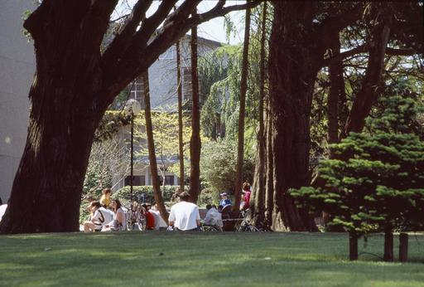

- DIRECTIONS TO THE MAIN CAMPUS [See Campus Map – 14]

The main campus of UCC is half a mile west of Cork city centre, about 15 minutes’ walk along Washington Street. The College Gates on Western Road are ceremonial (foot access only): the entrance to the main campus is on College Road, and there are side entrances on Donovan’s Road, Gaol Walk and other entrances on College Road. Other UCC locations around the city tend to have a single main entrance.

There are usually plenty of taxis in the city and at the airport, rail and bus stations, but check the location of the interview and make sure you give the driver the correct address. Taxis from the city centre cost about €8. ABC Taxis (021) 4961961 and Cork Taxi Co-op (021) 4272222 are two taxi firms that operate throughout the city and surrounds.

By Car

From the city centre, follow the signs to Killarney and West Cork: Go west out of the city along Washington Street; go through the first two traffic lights. Pass the River Lee Hotel on your left. Turn left at the third traffic lights by the old College gates (if you are walking you can enter the campus here or through the next gates up Donovan’s Hill). Go up Donovan’s Road, past the Honan Chapel on your right; At the top of the hill, turn right onto College Road; For the main entrance to the College go 200m further down College Road, on your right.

Parking – See Maps, Section 14

Parking on the main campus is EXTREMELY restricted and is limited to permit holders, deliveries, those on official business and cars with disabled stickers. Other UCC
locations have very limited visitor parking particularly during term time. Some visitor parking may be found in Perrott’s Inch and Perrott Avenue car parks on an hourly charge (see separate map provided).

Perrott’s Inch car park is located on Gaol Walk and may be reached by passing the main UCC entrance on Western Road and turning left at the next traffic lights. The car park is located on the left hand side before the bridge.

To get to the Perrott Avenue car park, drive to the top of Donovan’s Road and turn right into College Road. Perrott Avenue car park will be immediately on your left. If you are driving to UCC for interview, please allow yourself plenty of time to find parking.

By City Bus

UCC is served by two City Bus routes (No.205 and No.208) connecting the campus to Cork City Centre via Washington and St Patrick Streets. Bus stops are located on College Road/ O’Donovan’s Road (Route No.205—about four buses each hour) and Western Road (Route No. 208—about every 15 minutes). Route No 210 buses serve Bandon Road at close walking distance to the Main Campus.

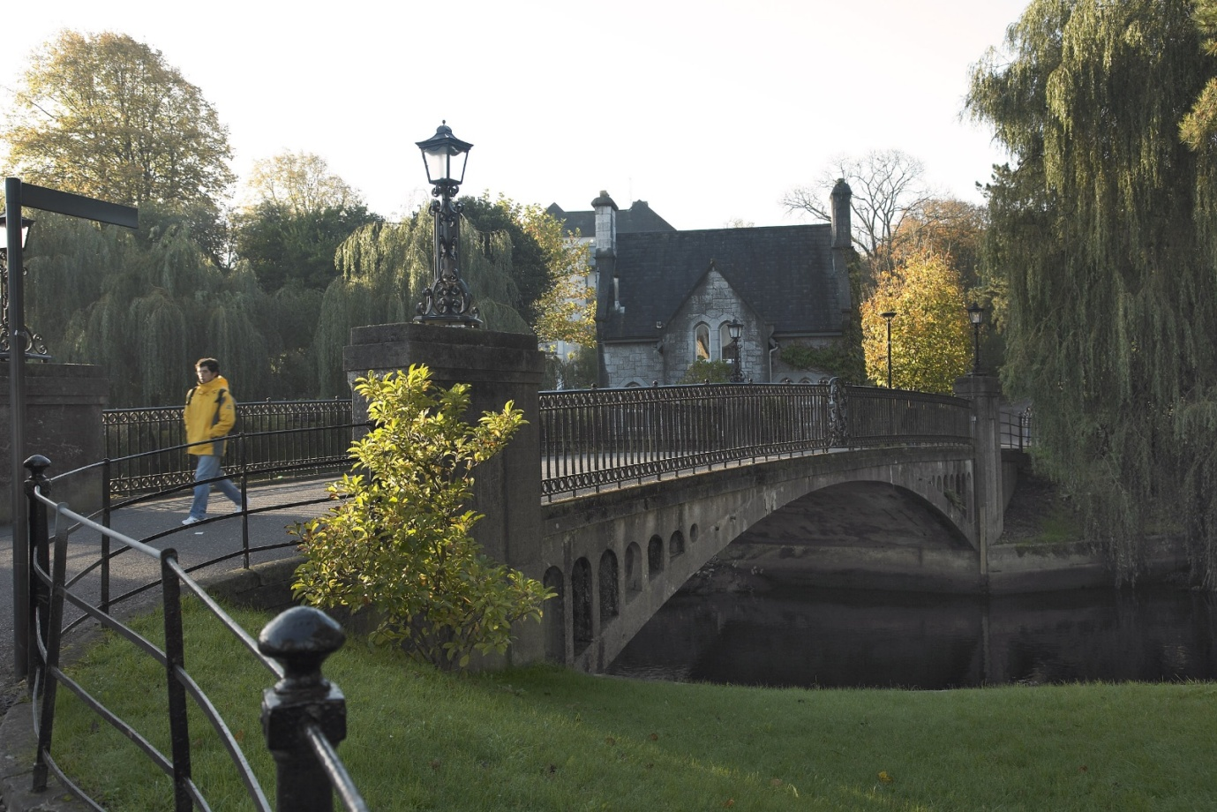

By Train

From Dublin (Heuston), about 8 trains a day, journey time about 3 hours. See Iarnrod Éireann’s timetables. Trains stop at Mallow for connections with Killarney, and at Limerick
Junction for connections with Limerick (for Shannon Airport). Taxis from the rail station cost about €15 and there is also a city bus meeting some trains.

Iarnrod Éireann

Rail Passenger Enquiries 021 4557277
www.irishrail.ie

By long-distance bus

From Dublin (Busaras), about 6 buses a day, journey time about 5 hours. (See Bus Éireann’s timetables.)
Taxis from the bus station cost about €12 and most city buses also stop at the bus station, which is about 300m from Patrick Street in the city centre. There is an overnight coach to and from London (Victoria Bus Station) which travels via the ferry service between Rosslare (Co Waterford) and Fishguard or Milford Haven (Wales).

Bus Éireann 021 4508188

Bus Station Parnell Place, Cork.
www.buseireann.ie

By air

Cork Airport has frequent flights to Dublin and London with Aer Lingus (Heathrow and Gatwick) and RyanAir (Stanstead and Gatwick) and to a wide range of other UK and European destinations. See AerRianta’s web site pages for details of movements. Taxis from the airport cost about €18 and there is also an airport bus every hour during the day. All the major car rental companies have desks at the airports.

Travellers coming via Europe change at Dublin, or London where there is no direct flight to Cork. Travellers coming via North America change at Dublin, or Shannon (there are no flights between Cork and Shannon as it is so close; see the rail and bus timetables).

Cork Airport

www.corkairport.com 021 4313131

Entry Visas

People from certain countries need a valid Irish entry visa before they can land in the country. You do not need a visa to land in Ireland if you are a citizen of one of the countries listed on the following link http://www.foreignaffairs.gov.ie/home/index.aspx?id=8605
If you are not from one of the countries listed above you will require an entry visa. To apply, contact the Irish embassy or consulate in the country where you live. It may also be possible to apply online if you live in a country where the online facility is available. Please see HERE for more information on applying for a visa.
Please note: The standard non-refundable visa application processing fee is €60 for a single-journey visa. This will be valid for one entry into the State within 90 days of issue. If you then wish to leave the State (this includes travel to Northern Ireland) you will then need a re-entry or multiple-entry visa to re-enter the State.

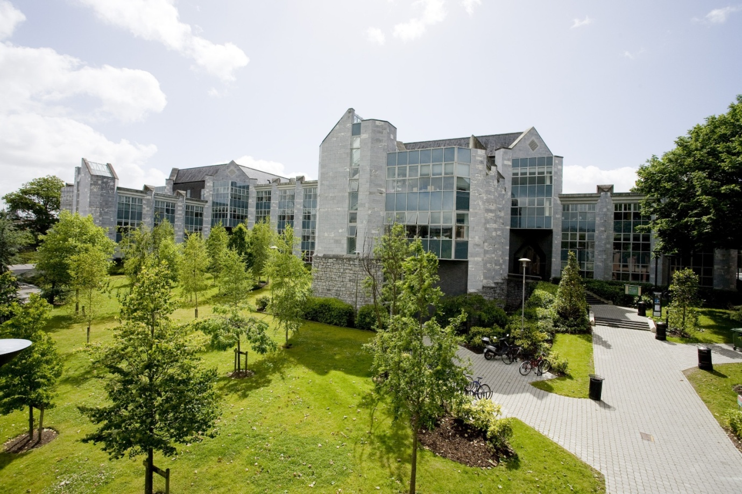

The O’Rahilly Building, Business and Humanities

- EXPENSES FOR CANDIDATES ATTENDING FOR INTERVIEW

Candidates travelling from outside Cork are entitled expenses for travelling to Cork, on production of original and complete receipts in accordance with the following allowance limits.

Other than in exceptional situations as agreed by the University, the maximum allowances available to candidates are as follows

Candidates travelling from within the island of Ireland €125

Candidates travelling from mainland Europe and the UK €500

Candidates travelling from USA or any other location €1,000

Candidates should always choose the most economical means of travel. Public transport should be used where feasible and public transport costs at the standard class train rate will be re-imbursed, irrespective of car usage where such direct public transport exists.

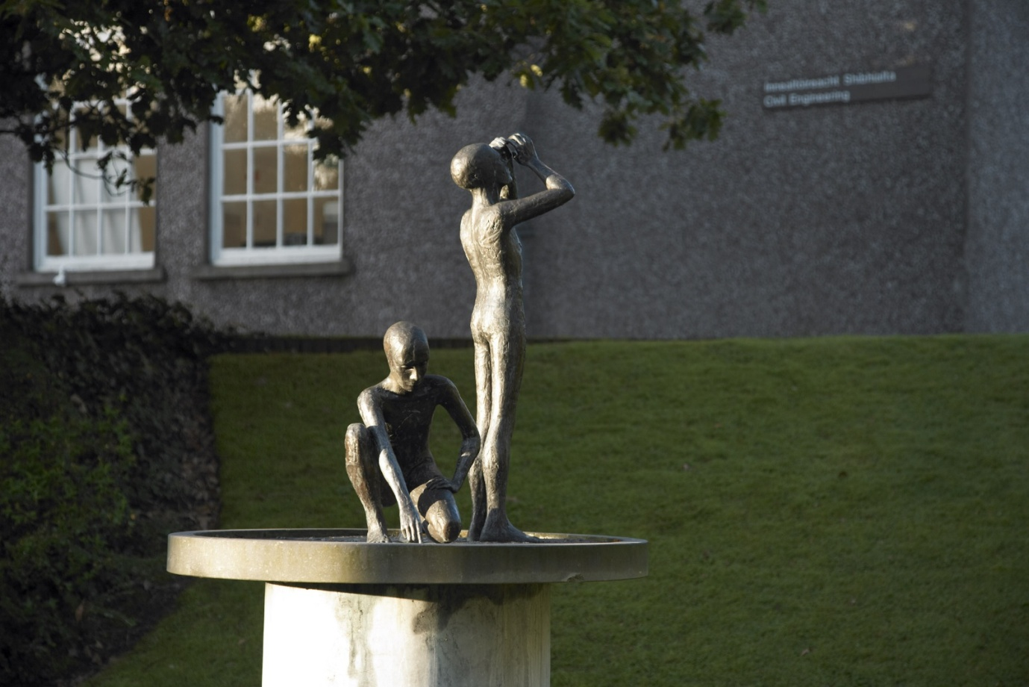

A Tradition of Independent Thinking

Accommodation
Costs of accommodation should be borne out of the allowance available as detailed. There are a number of suitable guesthouses in the vicinity of the University as follows:

Garnish House, Western Road (Tel +353 21 427 5111)

Crawford House, Western Road (Tel +353 21 427 9000)

Prices: Approximately €60 for a single room.

Further accommodation listings can be provided by the Recruitment Office. Candidates requiring assistance in booking accommodation should contact the Department of Human Resources, Recruitment Office on 021 490 3603 or e-mail: recruitment@per.ucc.ie

Administration
An expenses form (http://www.ucc.ie/en/hr/policies/forms/misc/Candidate-Expenses-Form.xls) should be completed and receipts must be submitted in respect of costs claimed and should be securely attached.

Please forward the completed expenses form to the Recruitment Office for approval following interview.

Payment will be made directly into a candidate’s bank account on completion of the required bank details on the expenses form.

Expenses Claims, once submitted, will normally take a minimum of six weeks to process.

Should you have any queries concerning this expenses policy or require any further assistance or additional information, please contact the Department of Human Resources, Recruitment Office on 021 490 3603 or e-mail: recruitment@per.ucc.ie

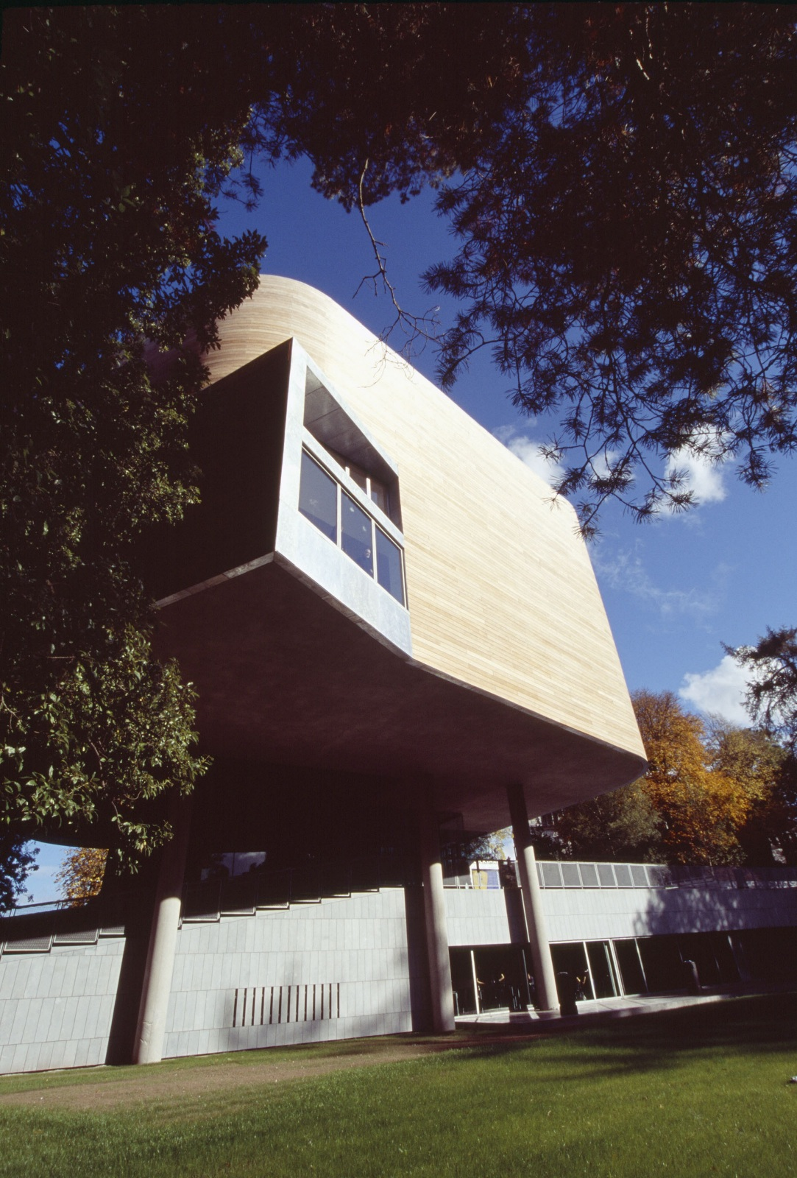

The Glucksman Gallery

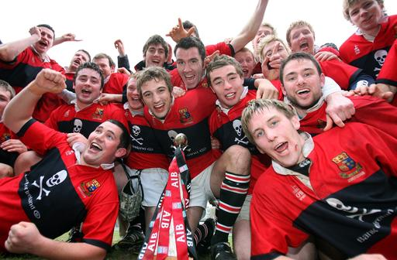

A proud sporting tradition

- CAMPUS MAPS

Download:

Main Campus Map at: http://www.ucc.ie/en/media/UCC_campus_map_Edition1_2010new.pdf

Visitor Parking Map at: http://www.ucc.ie/en/media/visitor-parking.pdf

Places to Eat on Campus: http://www.ucc.ie/en/media/places-to-eat.pdf

See also: http://www.ucc.ie/en/about/UCCHistory/
For alumni of UCC see: http://www.ucc.ie/en/alumni/who/

