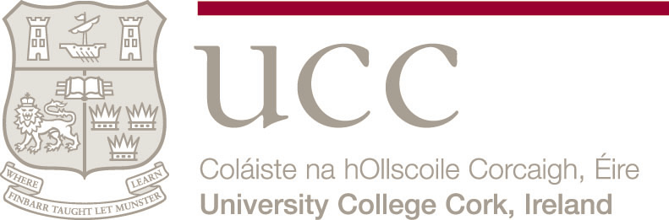

Cork Centre for Architectural Education
Room G.21, Electrical Engineering Building
College Road Cork
Tel 021 490 2862

CK606 Architecture

Mature Student Selection Procedure
The BSc Architecture programme (CK606) welcomes applications from Mature Students*. Their contribution to the academic community is valued, and previous experience has led to a recognition that mature students often exhibit a higher than average level of commitment to the discipline. A quota of approximately 10% of places will be available for suitably qualified mature students on the programme.

All applicants should be aware of the long period of study required if the initial BSc Honours Degree is intended to form the first step in the process of registration as a professional Architect: after the degree programme a further one year of full-time study and at least two years of professional practice followed by an examination for a certificate in professional practice will be necessary. The whole process generally takes from seven to nine years. Candidates should also be aware that Architecture is learnt through the design studio, as well as through lectures and seminars. This places greater demands on the timetables of architectural students compared with students in many other disciplines.

Each mature applicant, who has applied for the BSc Architecture (CK606) through the Central Applications Office (CAO) before 1 February, will be considered on an individual basis. For entry in 2007, academic qualifications, work/life experience, motivation and overall potential for the programme of study will be evaluated in a two stage process. Stage I will involve a portfolio submission and Stage II will involve candidates who have passed the portfolio assessment proceeding to interview.
Portfolio
All mature applicants will receive a letter from UCC before the end of March 2007 with exact details of the procedure for portfolio submission. The portfolio will have to be submitted by post or (during normal office hours) by hand, to the Centre for Architectural Education in UCC during the week of 23- 27 April 2007. The portfolio has two parts:
(a) a detailed CV (b) evidence of creativity, skills, motivation and potential to succeed in the field of architecture.

The CV component must include a chronological record of educational qualifications, educational activities, employment and other relevant experience (maximum 10 pages). The record of relevant work experience should include details about the nature and level of responsibilities.

The evidence of creative ability and skills should be contained in not more than 8 pages of A3 or A4 in size. These pages can include sketches, paintings, illustrations, photography, and photographs of original 3-D works. They should not include technical drawing. The emphasis should be on quality not quantity.

Applicants who wish to have their portfolios returned to them will be required to collect them from the Cork Centre for Architectural Education, UCC on either 30 or 31 May. The Centre will not accept responsibility for any portfolios which are not collected on these dates.

Interviews
Applicants who are deemed by the mature student selection committee to have passed the portfolio stage of the selection process will be invited for an interview. It is expected that these interviews will be held around mid-May 2007. As there are a limited number of mature student places applicants will be ranked on the basis of the panel’s evaluation of ability to succeed in the course, based on portfolio assessment and interview performance.

Offers
UCC will communicate its decisions regarding offers on the BSc (Hons) Architecture Degree to the CAO. It is expected that the first round of CAO offers to successful mature applicants will be made at the beginning of July 2007.

*Mature Students:
For entry to UCC in 2007, mature applicants are those who have reached 23 years of age by 1 January 2007 or hold a degree or equivalent at the time of application.

