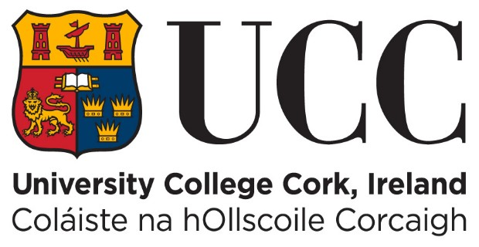
REQUEST PERMISSION TO SUBMIT AN APPEAL AGAINST AN EXAMINATION RESULT LATE
Students wishing to appeal an examination result must submit a completed Appeal Application Form to the Student Records and Examinations Office within TWO WEEKS of the issuing of the student’s examination results (see www.ucc.ie/en/exams/results/ for details of the specific release dates of examination results).
Please note: Completed Appeal Application Forms will not be accepted after this two-week period.
In exceptional circumstances, students may apply for permission to submit a completed Appeal Application Form after this two-week period. The Examination Appeals Committee (EAC), at its sole discretion, may waive the two-week deadline for submission of an appeal.
Students requesting that the EAC waive the two-week deadline must complete the following form.

Please type your answers beside each question below.

Name: Click or tap here to enter text.

Student ID number: Click or tap here to enter text.

Examination number: Click or tap here to enter text.

Phone Number: Click or tap here to enter text.

E-mail address: Click or tap here to enter text.

NB: Please note your UCC student email address will be used for formal communications, as per UCC policy. If you supply a second address we will also copy information to that address.
The outcome of the appeal will be sent by email as soon as possible after the decision is made.

Title of Degree Programme: Click or tap here to enter text.

Year of Programme (e.g. first, second, third): Click or tap here to enter text.

School/College (e.g. Arts, Engineering, Law): Click or tap here to enter text.

Examination period for which appeal is made: Choose an item.

Set out the reason(s) why you did not submit a completed appeal application form within two weeks of the release of your examination results.

Date of release of examination results: Click or tap to enter a date.
(see www.ucc.ie/en/exams/results/ for details of the specific release dates of examination results)

Date of Application: Click or tap to enter a date.

Please email this completed form to the Examinations Appeals Officer, Mr Michael Delargey, at m.delargey@ucc.ie

Guidelines:
Request Permission to Submit an Appeal Against an
Examination Result Late

- An Appeal Application Form must be completed and submitted with supporting documentation within TWO WEEKS of the date of issue of a student’s examination results.

- Students requesting a waiver on the two week deadline for submission of appeal must complete and submit a ‘Request Permission to Submit an Appeal Against an Examinations Results Late’ form.

- Students must submit the completed form set out in (ii) above by email to the Examinations Appeals Officer (EAO).

- The EAO will send an acknowledgement of receipt of a completed ‘Request Permission to Submit an Appeal Against an Examinations Results Late’ form to the student’s UCC student email address and any other email address identified by the student in the completed form.

- The EAO will initially review the application form and will either:

    - Recommend approval of the request to the Chair of the Appeals Committee who will either i) confirm the EAO’s recommendation to the Examination Appeals Committee or ii) recommend that the request be tabled for discussion at the next scheduled Examination Appeals Committee meeting
Or
    - Table the request for discussion at the next scheduled Examination Appeals Committee Meeting

- The EAO will communicate the outcome of (v) above to the student’s UCC student email address and any other email address identified by the student in the completed form.

- The decision of the Examination Appeals Committee is final.

