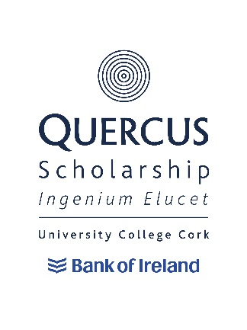
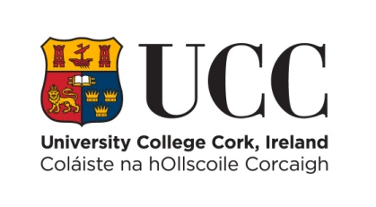

Quercus Sport Scholarships
2024/25
Criteria and Terms of Reference

- General Criteria

University College Cork is pleased to announce that up to 5 Quercus Scholarships for Sport will be awarded to students registered on an undergraduate/level 8 programme in 2024/25 who can demonstrate an exceptional level of excellence in their chosen Sport and who have successfully been selected by the Scholarship Panel for a Quercus Scholarship.

Quercus Scholarships for Sport will be awarded by a Scholarship Panel composed of both internal UCC staff members and invited external experts.

Those applicants shortlisted for interview may submit a portfolio of their sporting achievements, submitted in any suitable format beforehand.
(Submitted materials may not be returned to applicant)

It is hoped that all interviews will take place in April/May 2024.

Scholarships will be offered to applicants who satisfy the Scholarship Panel (and in turn UCC) as to their suitability to the Quercus Talented Students’ Programme and who can demonstrate excellence in the field of Sport. The panel’s decisions will be final.

The Scholarship can be renewed for subsequent years subject to the Scholar meeting the requirements of the Retention and Discontinuation Document and progression to the next level of study in their academic programme.

Scholars may not hold a Scholarship during an academic year spent abroad or on work placement. Renewal will be decided at the end of the academic year spent abroad or on work placement and will be determined by the individual’s involvement in their sport whilst on placement, fitness levels, etc.

Scholars will be expected to act as ambassadors for UCC in terms of their participation in sporting activities and in their participation in activities designed to promote the Quercus Scholarship Programme.

- Applying for a Quercus Scholarship

To apply for a Quercus Scholarship, you must:

- Be either a registered UCC student or apply through the CAO for a place on an undergraduate/level 8 programme at University College, Cork in 2024/25.
- Read the Criteria and Terms of Reference of the Quercus Sport Scholarship.
- Apply through the online application process for a Quercus Sports’ Scholarships and submit it by 4:30pm on Wednesday, 7th February 2024. Remember to include the two required references.

Successful applicants will:

- Meet the minimum entry requirements (matriculation) of their desired undergraduate degree/level 8 programme, while currently registered students will need to have attained higher honours in their end of year examinations to be eligible. Applicants do not need to be pursuing a related programme to be deemed eligible.
- Participate in a sport recognised by Sport Ireland.
- Be able to provide evidence that they are competing at the highest available level in their chosen sport and have identifiable potential for further improvement.
- Be expected to act as ambassadors for UCC and the Quercus Talented Students’ Programme in terms of their participation in their chosen sport.

Where there are equivalent levels of excellence, applicants deemed able to contribute most to UCC and to UCC sport will be selected. UCC also reserves the right to select scholars based on their strategic importance to Sport in UCC.

Please note that the Quercus Scholarships are open to students applying for any undergraduate/level 8 programme offered by UCC.

Please also note that an applicant will only be able to take up a Scholarship after accepting an offer of a place at University College Cork through the CAO.

Quercus Sport Scholarships
MEMORANDUM OF UNDERSTANDING

Scholars can expect:

- A letter confirming the award of this prestigious Scholarship.
- The opportunity to work with a mentor from within or outside the University to help the development of their unique sporting talent.
- The opportunity to work with a mentor from within the University to help ensure that a healthy and appropriate lifestyle balance is maintained whilst at University College Cork.
- The renewal of the Scholarship on an annual basis (except years spent abroad or on work placement) subject to your adherence to the terms and conditions below.

As a Quercus Scholar of UCC you must agree to abide by the following terms and conditions. Failure to abide by the following terms and conditions may result in your Scholarship being revoked with immediate effect.

Scholars will be required to:

- Engage with, and participate in, the activities of the Quercus Talented Students’ Programme as advised to them from time to time.
- Be available to meet potential undergraduate applicants at one University Open Day per academic year.
- Be available as a peer mentor where required.
- Support the University’s overall student recruitment strategy.
- Be fit to participate in their chosen sport by 15th October of the year of the awarding of a scholarship or by a date assigned by the Head of Sport & Physical Activity and the club in question.
- Pass at least 2 fitness tests by the university exercise physiologist annually during the tenure of the scholarship.
- Undertake a Cardiac Screening Examination in the first term unless they have completed such an examination in the previous two years.
- Always display an appropriate standard of conduct and sportsmanship. Awardees shall never engage in any activity which may potentially bring the College into disrepute.
- Commit themselves to the relevant sport club at the university and participate in all activities and competitions as required.
- Please note all Quercus Soccer scholars must be available to play/compete as required for the UCC Soccer club (men/women) for the duration of the term of their scholarship. Also note that an applicant can play and register for a league of Ireland team and play 3rd level competitions for UCC, where selected. Quercus Soccer Scholarship students must join and commit themselves to the relevant UCC soccer club (men or women) and represent UCC in relevant competitions as agreed with the Soccer Development Officer, Coach and/or Head of Sport & Physical Activity.
- Participate in Intervarsity’s, where eligible, unless otherwise agreed with the Head of Sport & Physical Activity
- Be always a positive ambassador for UCC including the promotion of UCC in any external interviews or publications associated with your sport.

In order for the scholarship to be renewed, the scholar must fulfil their obligations as per the Retention and Discontinuation Document and must progress to the next level of study.

Withdrawal or Suspension of Studies and Repeat Years

Withdrawal

Scholars who withdraw from their scholarship commitments or from UCC will have all future scholarship payments/benefits cancelled.

If you withdraw, at any point during the teaching term, scholarship payments/benefits which have already been made will be reclaimed on a pro rata basis. Under exceptional circumstances, this decision can be reviewed by the Chair of the Panel and approval given for the student to retain any overpayments.

Suspension of Studies

Scholars who suspend their scholarship commitments or academic studies will have all future scholarship payments/benefits cancelled.

If you suspend your studies at any point during the teaching term, scholarship payments/benefits which have already been made will be reclaimed on a pro rata basis. Under exceptional circumstances, this decision can be reviewed by the Chair of the Panel and approval given for the student to retain any overpayments. Mitigating circumstances for the re-instatement of the scholarship may be put forward for consideration by the Chair of the Panel. The remaining yearly balance will become payable on resumption of academic and scholarship commitments.

Repeating an Academic Year

Scholars who are required to repeat an academic year will not receive scholarship payments/benefits during the repeat year of study. Scholarship payments/benefits would recommence once the recipient has progressed to the next level of study, is meeting their scholarship commitments and has shown that their sporting careers are at the required standard.

Exceptional Circumstances

Students withdrawing from, suspending or repeating their studies, due to illness, bereavement or other exceptional circumstances will be dealt with on a case-by-case basis.

