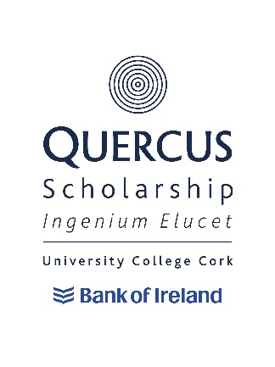
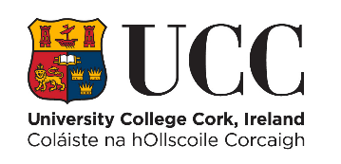

Quercus University (Academic) Scholarship Retention & Discontinuation

1. Retention
To retain the Scholarship throughout the programme of study recipients must:
a) Meet the progression requirements of the programme of study.
b) Successfully pass the Annual Review Process and the specific Review Processes referred to in Appendix 1.
c) Attend the required Quercus events each academic year. These events will be communicated to Scholars by the Quercus Programme.
d) Fulfil, where required ambassadorial duties deemed appropriate, e.g. at RDS Higher Options and UCC Open Days.
e) Agree to and abide by the Quercus Terms of Reference and Memorandum of Understanding.
f) Act as ambassadors of the University and the Quercus Programme and behave in an appropriate and respectful manner at all times, aligned to the provisions of the UCC Student Rules and UCC’s Graduate Attributes and Values.
g) Demonstrate active engagement with the Quercus Programme.
h) The Scholar must annually complete the Quercus Programme End of Year Statement & Impact Form (Appendix 3). The Impact information from this may then be used when communicating with past, current and potential donors. It may also be used publicly by UCC and the Quercus Programme via their publications, websites and social media channels.
i) Fulfil any specific retention requirements stipulated by the Quercus Programme.

2. Discontinuation of Quercus University (Academic) Scholarship
Discontinuation of a Quercus University (Academic) Scholarship may occur where a Scholar is deemed no longer eligible, including where:
a) A Scholar withdraws from the University.
b) A Scholar has failed to pass the annual review.
c) A Scholar is found to be in breach of the Student Rules.
d) A Scholar does not meet the agreed progression requirements of the programme of study.
e) A Scholar is found to be in breach of the Quercus Terms of Reference.
f) A Scholar is judged not to meet the criteria set out in section 1 above (Retention).

2.1 Discontinuation Outside of Annual Review
Decisions to discontinue Quercus Scholarships may occur outside of the annual review process.
Examples for discontinuation are listed in, but not limited to, the scholarships Terms and Conditions document. Where it is brought to the attention of the Quercus Programme that a Scholar may no longer be eligible, the Review Group (see Appendix 1) will be asked to convene to make a decision regarding the student’s eligibility to continue as a Quercus Scholar. Scholars wishing to appeal the decision to discontinue a Quercus Scholarship should refer to the appeal process that is detailed in Appendix 2.

Appendix
Appendix 1: Annual Review Process
a) An appropriate Review Group (“The Group”) will be established.
b) The Group will receive annual progress reports for each Scholar, compiled by the Programme Manager, made up of the scholar’s End of Year Statement & Impact Form and also, where required, additional information from sources such as mentors, relevant academic departments, UCC professional services and other associated parties.
c) The annual review may include a discussion with the Quercus University (Academic) Scholar where required, with the Quercus programme manager.
d) The Group will determine if the Quercus University (Academic) Scholar has fulfilled the terms and conditions of membership, in particular relating to academic progress, academic progression and engagement with the Programme.
e) Scholars who, in the opinion of the Group, have not fulfilled the conditions of membership, will be informed of this in writing, and will be invited to attend a meeting with the Review Group.
f) Following that meeting there are two possible outcomes;
(f1) – the student remains on the programme,
(f2) – the student is exited from the programme.
g) Scholars who are exited will be notified of their right to appeal the decision of the Group, the procedure for lodging an appeal and the time limit for lodging an appeal.
h) A written record of the review meeting process shall be kept and submitted to the Appeals Committee where an appeal arises.

Appendix 2: Annual Review Appeals Procedures
Quercus University Scholars may appeal a decision of the Review Group to the Appeals Committee on specified grounds, see c) below.
a) The Appeals Procedure is not available to Scholars that have withdrawn from the University; or Scholars that have been suspended or excluded from the University.
b) An appeal may be made to the Appeals Committee within 10 working days from the date of issue of the Review Group’s decision.
c) Appeals may be made on the following grounds:
- New evidence: Information directly relevant to the decision, which for good reason was not available to the Review Group.
- Procedural irregularity: There is evidence that the procedures relating to a decision were not followed properly, which may have impacted on the Review Group’s decision.
d) The Student Appeals Committee may:
- Uphold the Appeal.
- Reject the Appeal.

Appendix 3: End of Year Statement and Impact Form
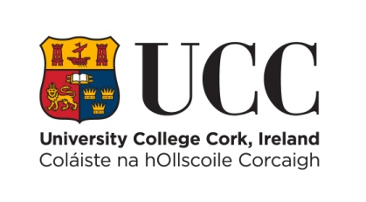

Quercus University (Academic)
End of Year Statement & Impact Form for the Period June 2022 – May 2023

Name | Click or tap here to enter text.
Student Number | Click or tap here to enter text.
Programme of Study | Click or tap here to enter text.
RECENT EXAM RESULTS  Please list most resent college exams and include subject and grade | Click or tap here to enter text.

ACADEMIC EXPERIENCE 2022/2023
To be complete by all (300 words max)
Please give details of the academic achievements that you have had over the past year from June 2022 to May 2023. Examples can include publications, oral presentations, poster presentations, undergraduate research, engagement with/mentoring of peers etc. In this section please indicate also any awards you may have received over this time period.

Click or tap here to enter text.

HOW HAVE YOU MET THE TERMS AND CONDITIONS OF BEING A QUERCUS SCHOLAR

- Please give examples of how you have acted as a positive ambassador for UCC/Quercus in the period from September 2022 to May 2023, including, for example, the promotion of the University in any external interviews or publications (200 words max)

Click or tap here to enter text.

- Please give examples of events that you have volunteered to do both for Quercus and for the University in the period September 2022 to May 2023 (200 words max)

Click or tap here to enter text.

- Please indicate how you have contributed to the academic and/or cultural/sporting/ etc. life of the University in the period September 2022 to May 2023 (200 words max)

Click or tap here to enter text.

ACADEMIC PLANS
To be completed by all applicants (300 words max)
Please outline your academic and other plans and ambitions for the coming year

Click or tap here to enter text.

IMPACT OF THE QUERCUS PROGRAMME
(To be completed by all applicants. 300 words max)
Please outline the impact that the scholarship has had on you during the period September 2022 to May 2023 (The Impact information from this may then be used when communicating with past, current and potential donors. It may also be used publicly by UCC and the Quercus Programme via their publications, websites and social media channels.)

Click or tap here to enter text.

Please submit this form by 20th April, 2023 at 4:30pm.

Contact Details:
353 21 4904877 mpower@ucc.ie www.ucc.ie/quercus
*All data collected under the application form will be subject to the data protection policy of UCC. A full copy of the policy is available on our website: http://ocla.ucc.ie/dataprotection/index.asp. All queries in relation to this policy and its provisions can be made to the Information Compliance Officer: catriona.osullivan@ucc.ie or 021-4903949

