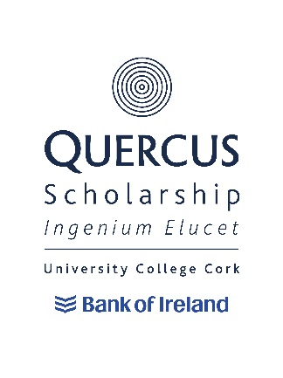
POLICY TITLE: QUERCUS SCHOLARSHIP APPLICANT FEEDBACK AND COMPLAINTS POLICY

POLICY OWNER: DIRECTOR OF RECRUITMENT AND ADMISSIONS

POLICY OPERATOR: UCC QUERCUS PROGRAMME

DATE APPROVED : March 2022

PURPOSE

This Quercus Scholarship Applicant Complaints and Feedback Policy and Procedure reflects University College Cork’s (UCC) commitment to providing an excellent, fair, and equitable experience for its Quercus Scholarship Applicants and acknowledges that Applicants may, on occasion, feel the need to seek feedback on their Application and/or make a complaint in respect of the processing of their Application.

A Quercus Application may be unsuccessful under a number of grounds to include where an Applicant does not meet the specific eligibility requirements for the relevant scholarship or where there are a limited number of awards available, and the relevant Application was ranked below the selected scholarship recipient(s).

It should be noted that requesting feedback and/or raising a complaint will not give rise to a different outcome in relation to eligibility for a scholarship and/or outcome of the Quercus Application. Where a complaint is raised, an Applicant is assured that this will have no effect in respect of any possible future applications.

SCOPE

This Policy is an important part of the University’s Quality Assurance mechanisms, providing a forum for an Applicant to seek feedback and/or raise a complaint about the Quercus Programme Admission Process. The University is consistently seeking to improve its processes and will use learnings from the annual admissions process on an ongoing basis.

This Policy is intended to assist both Quercus Scholarship Applicants and Quercus Programme staff in enabling individuals to seek constructive feedback on their Application and, where necessary, resolve any complaints arising therefrom, promptly and fairly. This Policy only applies to feedback and complaints in respect of the Quercus Admissions procedure. It does not relate to any other complaints process.

PROCEDURE

Where possible, all Applicant requests for feedback and/or complaint should be raised with the Quercus Programme Coordinator involved in the decision. Where feedback is sought, the Applicant should, where possible, identify the areas of feedback sought.

If an Applicant would like to receive feedback on any unsuccessful application, please email your feedback query to quercus@ucc.ie and the Quercus Programme Coordinator will review and endeavour to revert to such queries within 15 working days of receipt of same.

Where the Quercus Applicant wishes to raise a complaint in respect of the Application Process, the Applicant can email the complaint (and any desired outcome) to quercus@ucc.ie. Where the complaint cannot be resolved by the relevant Quercus Programme Coordinator, the complaint will be provided to the Quercus Programme Manager for review/consideration.

In the event there is a conflict of interest (perceived or actual) between the Applicant and the Quercus Programme Coordinator or Quercus Programme Manager, the complaint will be reviewed/considered by the Director of Recruitment & Admissions.

The outcome will be communicated in writing within 15 working days (unless exceptional circumstances arise) whereupon the final stage of this complaints policy shall be complete. Requests for feedback and complaints will only be considered when sought by the applicant themselves, and communication related to the complaint will only be with the applicant themselves and not with a third party.

