University College Cork
[Type the document title]
[Type the document subtitle]
Click here to enter version number.
[Pick the date]

[Type the abstract of the document here. The abstract is typically a short summary of the contents of the document. Type the abstract of the document here. The abstract is typically a short summary of the contents of the document.]
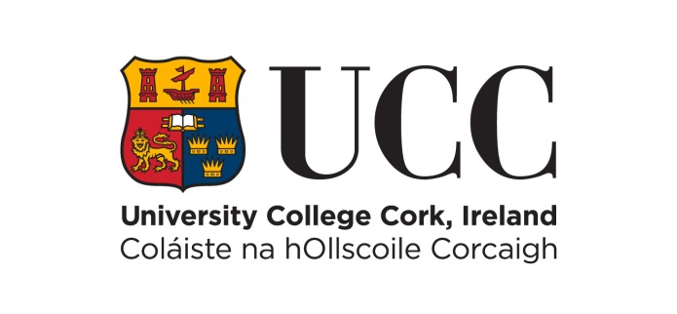

Table of Contents
Policy Information 2
Document Location 2
Revision History 2
Consultation History 2
Approval 2
Revision Cycle 2
Purpose 3
Definitions 3
Scope 3
Hierarchy of Compliance 4
Supporting Standards and Procedures 5
The Policy 5
Policy Violation 5
Further Information 5

Policy Information

Document Location

Revision History

Date of this Revision | Date of Next Review

Version Number/Revision Number | Revision Date | Summary of Changes

Consultation History

Revision Number | Consultation Date | Names of Parties in Consultation | Summary of Changes

Approval
This policy document requires the following approvals:
Name | Title | Date

Revision Cycle
This policy shall be reviewed and updated every X years

Purpose

Definitions

Scope

Hierarchy of Compliance
Level One
Irish and European Legislation

Level Two
Policies
Policies which, amongst other things, give effect to legislation within the University, may warrant Level One compliance.

Level Three
Standards & Procedures
The University standards and procedures provide the implementation framework for the University’s polices. However it should be acknowledged that even where practices do not adhere to every specific element of a standard or procedure overall policy compliance may still be achieved.
In addition, the University may provide end user guidelines which aim to provide detail on good processes and practices.

Supporting Standards and Procedures

The Policy

Policy Violation

Further Information

