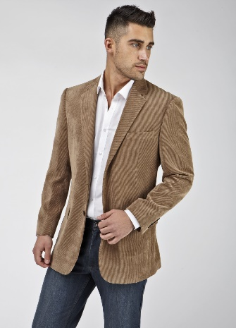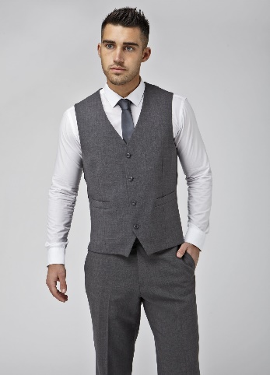

Exclusive UCC Discount

***Simply Suits***

***Unit 4 Kinsale Road Retail Park***

***Kinsale Road***

***Cork***

*Next to Smyths Toys*

[***www.simplysuits.ie***](http://www.simplysuits.ie)

[***info@simplysuits.ie***](mailto:info@simplysuits.ie)

***021 464 9023***



Full smart casual range available including jeans, chinos, shirts, jumpers and Sports Coats.

Full formal range available: Various fits and styles from very small to very big sizes.

Offer valid off full retail prices.

Simply mention that you are UCC employee

15% Discount