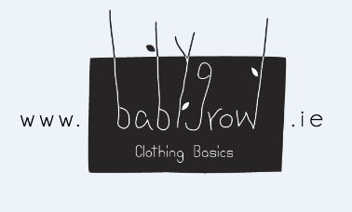

Babygrow Clothing Basics

Web: www.babygrow.ie

Email: hello@babygrow.ie

Babygrow Cothing Basics is a new Irish online babygrow & baby basics shop.

Our aim is to provide high quality choices for baby. With funky, colourful & playful designs for baby alongside the beautiful classics. Good quality and original designs are what we love most.

We offer beautiful babygrows, vests, blankets, bibs, toys and more.

We responsibly source these luxury baby products for the Irish market. Most of our collections are Organic and produced at fair trade to the highest standards of quality. Most are GOTS (Global Organic Textile Standard) certified.

Discount – 10%

Discount code 'LUCC10'

