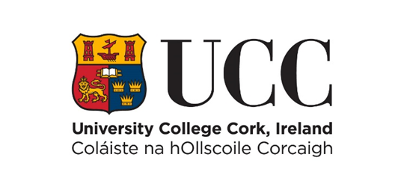

Internal Progression Process Scheme
Form Prog1(FULL) Progression Across the Merit Bar 2022

COVER PAGE – PLEASE READ CAREFULLY
Name: Year of appointment to current post:
School: Discipline:
Please indicate whether part-time or full-time:
Link to IRIS profile (or equivalent):
Typed forms must be submitted online using this template only via e-recruitment using Employee Self Service (ESS) – handwritten forms will not be considered. Please use font type Calibri, Size 11, single spaced, portrait orientation only, on this form.
The closing date for receipt of CV’s is strictly 12 noon (Irish Local Time) on 16th September 2022. No applications will be accepted for consideration after this time. Before proceeding, please ensure that you have carefully read the Policy on Progression across the Merit Bar.
Please ensure that the information and summary of achievements listed in each section of this form can be supported by indicative evidence. You must indicate here how you have satisfied the relevant essential criteria requirements as found in Appendix 2 of the Policy to establish a case for Progression.
The Board reserves the right to verify the information supplied by applicants. Candidates should note that any inaccurate or surplus information will render the application null and void.
Details submitted as part of this Progression Process will be shared with the College Committee Board members and the Lecturer Progression and Establishment Board members, the Human Resources Department and where applicable, members of the Appeals Board.

NB: This template may not be altered. CVs exceeding the specified page limit will not be considered.

- Learning and Teaching (Font Calibri, size 11, single spaced only)
This should reflect teaching activity and be organised in sections corresponding to the Learning and Teaching criteria detailed in Appendix 2. Answers must not exceed the three-page limit.

Research and Innovation (Font Calibri, size 11, single spaced only)
This should reflect the research approach and profile of the candidate and be organised in sections corresponding to the Research and Innovation criteria detailed in Appendix 2. Please link to your top 5 publications/outputs on page 11 of this form. Answers must not exceed the five-page limit.

Contribution to Academic Citizenship and Engagement (Font Calibri, size 11, single spaced only)
This should be reflective of the level of contribution made by the candidate to academic citizenship and should be organised in sections corresponding to the Contribution to Academic Citizenship and Engagement criteria detailed in Appendix 2. Answers must not exceed the two-page limit.

Top Five Research Publications /Outputs
Please provide links for your top five research publications or outputs below. In exceptional circumstances, where links cannot be made available, hardcopies may be considered. Please email progression@ucc.ie to arrange same.

