Appendix B

Self-Reflection Review: Year 1

Health Promoting University

Self-Reflection Review of Health Promoting University Process

End of Year One Review

A Health Promoting University aspires to create a learning environment and organisation culture that enhances the health, well-being and sustainability of its community and enables people to achieve their full potential.

The heart of any Health Promoting University (HPU) initiative must be a top level commitment to embedding an understanding of, and commitment to sustainable health within the organisation in its entirety.

The main aims of the HPU initiative are:
- to integrate within the university's culture, and structures, a commitment to health and to developing its health promoting potential and
- to promote the health and well-being of staff, students and the wider community.

The Health Promoting University setting approach provides a more integrated and cohesive mechanism for addressing multiple health issues. The strategic focus is on the whole campus community and its population, policies and environments.

The following self-reflection review tool is intended to allow the UCC Health Matters to reflect on progress to date, acknowledge those achievements and establish the direction for future work. This review will form part of the self-evaluation for official recognition as a Health Promoting University by HSE South. It is intended as a guide and any other relevant documentation may be included.

Self-Reflection Review Tool

Administrative Information
University Name | University College Cork
Address | University College Cork, Western Road, Cork.
No of Staff | 2,500 full time staff
No of Students | 19,277 (as of 2012/13)
President Name | Dr Michael Murphy
HPU Co-ordinator(s)  Name  Title  Department  Name  Title  Department | Dr Michael Byrne  Head of Student Health Department  Student Health Department  David Berry  Students Union Welfare Officer  Students Union
HPU Project Officer (s)  Name  Title  Department | Deirdre Griffin  Health Promotion Project Worker  Student Health Department
Steering Committee Members  Name  Title  Role (Chair /member …)  Department | Ivan Perry  Professor Epidemiology & Public Health  Chair  Michael Byrne  Student Health  HPU Co-Ordinator  Ian Pickup  Head of Student Experience  VPSE  Dave Berry  SU Welfare Officer  HPU Co-Ordinator  Colin Bradley  Professor, General Practice  Cork Healthy City Representative  Mary Buckley  Student Health  Maria Harrington  HSE representative  Josephine Hegarty  Professor, School of Nursing & Midwifery  ACCSE  Padraig Rice  President, Societies Guild  Catherine Maguire  HR  HR Advisor on Staff Welfare & Development  Tom McCarthy  Media & Communications  VPER  Karen McNulty  Occupational Science & Occupational Therapy  Paul Moriarty  Student Counselling and Development  HLG  Mary O'Grady  DSS SSG  Jim McEvoy  President, Clubs Executive  Annie Hoey  SU Deputy President  Frances Shiely  Department of Epidemiology & Public Health  Deirdre Griffin, Student Health  Health Promotion Project Worker  Emer O' Driscoll VPSE
Process of Developing as a Health Promoting University

Stage 1: Expression of Interest

The concept of UCC becoming a Health Promoting University was first proposed as far back as 2010 to the UCC Healthy Living Group (HLG). The UCC HLG had been set up under the Chairmanship of the Vice-President for the Student Experience in 2009 to consider how the university might best promote healthy living and responsible alcohol use among students. Its membership consisted of representation from student bodies, the Student’s Union, senior university management, a Health Service Executive (HSE) representative, and the student support professional services, including health, counselling and disability services. The operations of the HLG demonstrated UCC's commitment to a long term plan for improving health on campus. To further develop the work of the HLG and to help to change the culture in the university, all members supported the proposal to express an interest in becoming a Health Promoting University. This proposal was developed in 2011. ^{Appendix A (i)}

What worked well
- The nature of the university setting meant that there was an established committee structure in existence. This provided a good template on which the HPU Initiative could be established, with clear reporting lines to ensure approval and oversight by Senior Management of the University.
- There was already a deep sense of responsibility in the University in relation to the health and wellbeing of both students and staff, and that was evident from the existence of the HLG.
- There was strong support from the academic community in UCC, especially Professor Ivan Perry, Head of the Department of Public Health and Epidemiology. Prof Perry is one of the leading experts in public health nationally and his influence was instrumental in developing the HPU initiative.

What were the challenges/barriers
- One challenge at this time was that there was no staff member appointed to work exclusively on this initiative and drive it forward. Therefore the process at the beginning was relatively slow as members of the steering committee were all extremely busy with their own roles in the university.
With no national framework in place for Health Promoting Universities the process was quite challenging. This meant that UCC had to organically develop the process from the ground up. Although this was a challenge and a barrier, it was also an opportunity.

Recommendations for the future

- A national framework needs to be developed to guide universities in the steps that they need to take to work towards becoming health promoting universities.
- It is also recommended that there is clearer shared understanding between the university and any recognising formal body in relation to the parameters and timeline of the framework.
- It would have been useful in the development of the initiative if there was a Health Promotion Officer appointed during the early stages to build these relationships with staff and students, thus building partnerships early in the process.

Stage 2: Contract of Agreement
The UCC Health Matters Action Plan was completed in November 2012. This Action Plan was approved by the Steering Committee and developed in consultation with the HSE-South. The plan was submitted to the President and the Senior Committee of the university, the University Management Team (Strategy), and Academic Council of the university for approval. The plan was launched at a formal ceremony, and a Memorandum of Agreement was jointly signed by UCC and HSE-South. ^{Appendix A(ii)}

What worked well
- The development of the plan and the agreement with the HSE-South were positive stepping stones.
- The Healthy Living Group (HLG) had a proven track record and had many achievements, particularly in the area of alcohol and healthy living, and was already held in high esteem when it became the Steering Committee of HPU.

What were the challenges/barriers
- The lengthy process of the HPU initiative, while recognised as an important aspect of the journey, can be a challenge in itself as maintaining the support of senior management without clear timelines may be a difficulty.
- It was a challenge to find a date for the signing of the Memorandum of Agreement suitable for both the President and the HSE representative.
- While the proposal for the HPU was approved in 2011 the Memorandum of Agreement was not signed until December 2012. In terms of actually delivering on the initiative it is felt that this worked to the university’s advantage, as prior to signing the agreement substantial ground work was done, thus ensuring the university was more likely to succeed before committing to the process.

Recommendations for the future
- It is recommended that the order of the HPU stages in the HSE guidelines be reviewed. It should be considered that the “signing of the Memorandum of Agreement” is not marked as the official beginning of the process as this overlooks the previous work carried out. The signing of the contract should be encouraged at the early stages so that work carried out prior to the contract is not overlooked in the evaluation process. This in itself, however, does carry a risk that the University may commit to something that they cannot deliver on.

Stage 3: Appointment of HPU Co-ordinator(s)

Initially one HPU co-ordinator was appointed by the Steering Committee; Dr Michael Byrne, Head of the Student Health Department. In taking a whole system approach it was decided by the Steering Committee that an additional student co-ordinator would benefit the initiative, therefore, Dave Carey, UCC Students Union Welfare Officer was officially appointed in October 2012. A part-time Health Promotion Project Worker (HPPW), Deirdre Griffin, was also appointed in July 2012 to support the initiative in an administrative and operative role. ^{Appendix B(iii)}

What worked well
- The appointment of two co-ordinators, one staff representative and one student embodied the whole system approach that the Steering Committee was taking. Each of the co-ordinators appointed already played key roles in the university in the area of health and wellbeing, with Dr Byrne as Head of the Student Health Department and Dave Carey as the SU Welfare Officer for the second consecutive year. Thus a high level of responsibility was accepted and a significant amount of work carried out by both.
- The appointment of the HPPW ensured that the work being carried out on the HPU initiative was consistent and this allowed the initiative to gain momentum. The HPPW was able to carry out administrative tasks which would be very time consuming for other Steering Committee members, considering their other roles in the university. In addition elements of the HPU process, such as brand development, awareness and report writing could be undertaken by the HPPW.
- These appointments demonstrated the university’s commitment to becoming a health promoting university.

What were the challenges/barriers
- Considering the economic climate, there certainly was, and continues to be, a challenge in relation to resources and funding to maintain the HPPW position, and by extension the full-time commitment to the initiative.
- The membership of the Students Union changes annually so the student Co-ordinator of UCC Health Matters will also change each year as a new student takes up the role of Welfare Officer. This can be a challenge as each Welfare Officer’s understanding of the initiative, prioritisation of health promotion, and what they bring to the initiative will differ.

Recommendations for the future
- A full time post for a Health Promotion Project Worker would greatly benefit the initiative and further demonstrate the University’s commitment to the health and wellbeing of both students and staff.
- The appointment of student leaders in the HPU process is essential. In our experience to date we have found that student engagement can be a challenge and it is paramount that student leaders are embedded in the HPU process to encourage wider student participation. It is essential that the new Welfare Officer be briefed comprehensively at the beginning of their new role as HPU co-ordinator and engaged with consistently throughout.
- The University Staff Welfare Officer (Department of Human Resources) should be included as a co-coordinator to ensure support and representation from the staff welfare support services.

Stage 4: Establishment of HPU Steering Committee

The Steering Committee (SG) was established by the Healthy Living Group and had its first official meeting in October 2012. The role of the Steering Committee is to guide and support the UCC Health Matters initiative in working towards fulfilling the requirements of the agreed framework for recognition as a Health Promoting University. The Chair appointed was Prof. Ivan Perry, Head of Epidemiology and Public Health Department. Two Coordinators were appointed, Dr Michael Byrne, Head of the Student Health Department, UCC and Dave Carey, UCC Students Union Welfare Officer. Membership of the Steering Committee included members of the HLG, a HSE representative and a representative from the Cork Healthy City Committee.

What worked well
- The fact that the HLG was already established meant that there was an existing group of key stakeholders available to become members of the Steering Committee.
- Members of the Steering Committee were drawn from across the university, from different departments, each with their own expertise and credibility.
- The HSE representative in the group also ensured that we were working closely with and receiving the support of the relevant local authority.
- The fact that many members of the Steering Committee occupy senior positions within the University strengthens the influence that HPU initiative has, as well as ensuring that this work is aligned with the wider aims and strategic direction being pursued by the university.
- The meetings and the communication within the Steering Committee is coordinated by the Administrator for the Vice President for the Student Experience (VPSE). This mechanism works well and all documents in relation to SG meetings are stored on the UCC Intranet.
“With various professionals in the group from different departments it means that the best of UCC are working together to help make UCC Health Matters a major brand.”
“The group gives a voice to staff and students.”

What were the challenges/barriers
- As the members of the Steering Committee are all in highly demanding positions elsewhere in the university it can be difficult to schedule meetings that all can attend. There was also difficulty in attempting to gain traction on the importance of the group before the official HSE signing ceremony. This was tackled by managing the meetings closely, arranging them well in advance, and confirming attendance prior to the meeting.

Recommendations for the future
- Continue to draw membership from across the university including external representatives where appropriate.
- Ensure that the Health Promotion agenda has a prominent position in the next Strategic Plan for the Student Experience Area.
- Ensure bi-annual review of the operations and effectiveness of the Steering Committee.

Stage 5: Establishment of HPU Working Groups

In June 2012 all staff and all students of UCC received an e-mail invitation to join the UCC Health Matters Working Group. Two “Town Hall” style meetings followed and 11 different “Action Areas” were identified, and membership of the Working Group was expanded to form Working Group to target each specific Action Area. Over time these Action Areas (and corresponding Working Group) were consolidated into 8 Area. ^{Appendix B(iv)}

What worked well
- The Town Hall style meeting worked particularly well for staff and resulted in a highly interactive and engaging meeting with lots of feedback about developing the Action Plan.
- The “Town Hall” meetings also allowed the opportunity to develop the brand, and logo of the initiative. Ideas were discussed at these meetings and the name and logo of the initiative were ultimately voted on by the working group.
- It was useful to identify key people in the university and engage with them at the Town Hall meetings, to facilitate the emergence of networks of like-minded people with shared interests and expertise
- Volunteer Network-Group Convenors were identified for each of the Working Group to help to coordinate activity. An agreed role-description was developed for these Group Convenors ^{Appendix B(v)}

What were the challenges/barriers
- The engagement of students during the establishment of the working (Action) groups was a challenge. We engaged well with the Students Union, Clubs, Societies and students who were generally active however we did find it difficult to engage with the general student body.
- In establishing the working groups it can be difficult to engage some staff/students who are working in the identified action areas. This in part may be due to existing activists feeling a strong sense of ownership of their own work or “project” acting as a barrier for a whole system approach. Activists may see UCC Health Matters as a threat rather than an opportunity. This can result in the existing approach of ad-hoc projects continuing, that may be more successful as part of the joined up approach under the umbrella of the UCC Health Matters initiative.
- There is a risk that, in trying to be inclusive and democratic, too many action areas can lead to over stretching the resources of the project.

Recommendations for the future
- It is useful to map work currently being carried out in the University and acknowledge what is already being done to promote the health and wellbeing of students and staff. By engaging directly with key persons carrying out this work and building good relationships with them, collaboration is likely to lead to greater success and avoid duplication of effort.
- Initial contact with students should occur at a time that takes account of the academic calendar. An annual launch at orientation has the potential to recruit incoming 1st years which would lead to a definite boost in numbers.

Stage 6: Raising Awareness & Review of Health Related Activity

i) Raising Awareness

It was felt to be important that there would be a high degree of awareness of UCC Health Matters throughout UCC, among both students and staff. This was achieved as follows:
- We developed a logo for the initiative and worked extensively on brand recognition.
- We utilised social media and on the day of the signing ceremony launching a Facebook page and Twitter account. We connected with other UCC groups online to increase our visibility. ^{Appendix B(vii)}
- We developed and launched UCC Operation Transformation 2013 in conjunction with the food outlet on campus (Kylemore Services Group). ^{Appendix B(vii)}
- We developed an E-zine covering UCC specific events/news/articles that are all related to health and wellbeing. Staff, students and UCC Groups are invited to submit materials for this. This was subsequently disseminated to all staff and students through their email and through UCC & Health Matters social media. ^{AppendixB(viii)}
- We held a UCC Health Matters Day on October 9th in collaboration with UCC Clubs Exec and Staff HR. This day put emphasis on engaging a wide range of stakeholders including local community organisations, internal departments, and student groups.
- We developed good working relationships with other individuals, groups and departments in UCC through meetings and sharing information about UCC Health Matters. We built partnerships and invited these stakeholders (both staff and students) to join the working group.
- We acknowledged good work already being carried out in UCC in relation to health and wellbeing and supported this while bringing it collectively under the UCC Health Matters banner.

What worked well
This element of the process “Raising Awareness” has resulted in many benefits for UCC Health Matters.
- One particular activity was instrumental in the promotion of UCC Health Matters was UCC Operation Transformation. This allowed the initiative to build partnerships with stakeholders in UCC and achieve a high degree of visibility among staff and students.
- Our use of social media has also benefited the initiative as we have been able to connect with other groups with the same goals- not just within UCC, but also locally, nationally, and indeed internationally.
- The e-zine has created a forum for students and staff to share information, relevant news and activities that will improve health but in a new and interactive medium.
- The UCC Health Matters Day was a significant step in establishing the Initiative on campus as an active and engaging one.

What were the challenges/barriers
- Large scale operational projects like Operation Transformation and the UCC Health Matters Day can be very time consuming for the UCC Health Matters team and requires someone to take responsibility for its success, a challenging task with no full time staff member dedicated to the initiative.
- Time constraints also make it difficult to continue to put consistent effort into implementing the strategic element of the Action Plan as well as the operational activities.

Recommendations for the future
- Using internal resources to support projects as outlined above and engaging stakeholders to lead on such projects is essential. There is a huge amount of work being carried out in UCC in relation to health and wellbeing. Many of those doing this work are collaborating with each other and joining together under the wider umbrella of UCC Health Matters, with the common goal of creating a Health Promoting University. However, this is not the case for all activities and many are still taking place as ad-hoc projects and interventions. UCC Health Matters must continue to promote the whole-system vision in UCC.
- The challenges faced in organising and running the two major large scale annual events (Health Matters Day and Operation Transformation) must be acknowledged and resourced appropriately if we are to build on their future reach and success.

ii) Review of Current Health Related Activity

At the Town Hall meeting, Action Working Group were established and tasked with mapping all of the health promoting activities occurring on campus for/by both staff and students.

What worked well
- The input from the various members, who come from a variety of backgrounds within the University, allowed for a more comprehensive understanding of the health promoting activities which were taking place.
- A template for case studies was developed to collect information on health related activity, which was disseminated to various stakeholders to be used whenever an activity or event was happening, and returned to the Health Promotion Project Worker.

“So many different ideas and opinions came together from the staff and the student body. This allowed for good discussions and a shared contribution to any ideas put forward.”

What were the challenges and barriers
- A more formal mapping exercise of current health related activity would require considerable resources in terms of staff and budget, which was not available due to financial constraints.
- A lot of health related activity on campus is not recorded and evaluated in any way by those who organise the activity. Therefore it is difficult to record and evaluate all activity.
- Encouraging and promoting the use of the case-study template by other staff and students carrying out health related activity is an on-going task, and often the template is used in hindsight for reporting the material back to UCC Health Matters.
- Getting buy-in from the groups who were identified as ‘Health Promoting’ was not always easy to achieve

Recommendations for the future
- The development of a central data bank for health related activity should be prioritised. Case study templates could be disseminated through the members of the action areas to their particular focus groups/societies/clubs/staff & students who are undertaking health promoting activity.
- UCC Health Matters webpage should be developed in order to have the case study template available online for downloading, and should be attached to other relevant health related webpages.
- The social media should be also used as a tool for collecting data from students and staff regarding activities. Brand building is important to encourage buy in from health promoting groups to contribute to the initiative.

Stage 7: Consultation/Needs Assessment

An original needs assessment was carried out back in 2010 prior to the setup of Health Matters. ^{Appendix B(ix)}. In order to capture the correct information, a meeting methodology was set out in advance of the Town Hall meetings in 2012. ^{Appendix B(x)} During the Town Hall, a needs assessment was undertaken by each group to understand the level at which UCC was at, and where it needed to be. Group members for each action area carried out a brainstorming session regarding the needs of the university which was to be used for the development of the subsequent action plan. Each group presented their needs assessment to the other groups in order to gather any additional areas which had not been identified. ^{Appendix B(xi)}

What worked well
- The group members’ diverse backgrounds and experiences in the University allowed for a more comprehensive identification of needs.
- Having focus groups initiated a greater level of communication and understanding among group members regarding needs of staff/students.
“I certainly felt heard with any ideas I put forward”

What were the challenges/ barriers
- A major barrier to conducting the consultation was time constraints. Carrying out the needs assessment is time consuming and, to truly undertake a meaningful needs assessment in the University, there would need to be much more formal approach taken, with buy-in from every Department.
- A greater number of students taking part in the assessment would have been preferable, as their input is invaluable.

Recommendations for the future
- The needs assessment should be reviewed annually, to examine what progress has been made and whether any needs in particular have arisen, which should to be focused on by the Working Groups for the following academic year.
- An on-going and common issue throughout the process is the difficulty of attracting students to become involved with the process. Ideas to increase student involvement are necessary for 2014.

Stage 8: Action Plan

To date (December, 2013) UCC Health Matters has developed and implemented one Action Area Action Plan in the area of alcohol-related harm. As the year has been heavily focusing on brand development through significant events such as UCC Operation Transformation and UCC Health Matters Day, the time to give to other groups who needed structure and leadership was limited. It was also deemed appropriate to work on one group first, and to stretch out to three or four more next year, resulting in all groups in action within three years i.e. 2015.
In 2010, UCC produced a report entitled Effective Management of Alcohol Issues in UCC ^{Appendix B(xii)} which laid out a range of action areas for the academic year 2010 to 2011. The content of this report was refined further during the years 2011 and 2012 and provided us with the current UCC Alcohol Action Plan ^{Appendix B(xiii)}. The current version of the Alcohol Action Plan consists of five distinct Strategy Areas, within which are twenty specific Action Points that identify tasks that need to be undertaken to reduce the alcohol-related harm amongst students. A set of Key Performance Indicators (KPIs) was also developed to help monitor the progress made.
The Action Plan is subject to regular review and since 2012 has been reviewed twice. Strategy Areas and Action Points can be deleted or modified to maximise the impact of the Action Plan. Monitoring of the implementation of the Action Plan is the responsibility of the Alcohol Working Group, a subgroup of the wider UCC Health Matters initiative.

What worked well
- The UCC Health Matters Alcohol Working Group has been one of the great successes of the UCC Health Matters initiative to date. The group consists of several key members of the university’s staff and student body who are fully committed to their group-specific mission, to reduce alcohol related harm in UCC students.
- A PhD research area specific to the subject of alcohol use in students was created and has provided a wealth of important evidence-based information which has helped guide much of the group’s activities.
- The introduction of an alcohol-free housing option for students was introduced in September 2013. It was the first initiative of its kind to be introduced to an Irish University.

What were the challenges/barriers
- A major challenge to success in the area of alcohol reduction at a population level is the drinking culture. Changing the drinking culture would be an enormous step in the reduction of alcohol-related harm in the university. Time and persistence is required to achieve this cultural change.
- For members of the Alcohol Working Group to meet and to carry out specific duties requires time. As each of these members carry out their duties in the area on their own free time, it is often quite difficult to schedule times that suit all, or at least the majority, of the group to meet due to work and other commitments.

“The biggest challenge for me was time constraints during term time as I am so busy with my everyday work.”

“I am conscious of the limitations upon me and was hesitant to take on task I could not realistically complete. I am sure this is true of many people and this factor could have impacted on implementation of parts of the action plan.”

Recommendations for the future
- It is important for the group to continue the momentum that it has gathered and to continue making reductions in alcohol-related harm among UCC students.
- The reviewing and modification of the Action Plan to suit changing trends should continue. This should allow for maximising of benefits due to the Action Plan.
- Efforts should be increased to encourage more student involvement in this area. It is quite often the students themselves that hold alcohol-free events such as Off the Booze and On the Ball. It is with their involvement that more such events could be planned, giving students an alternative option to enjoy themselves without alcohol.
- The template used for the development of the UCC Alcohol Action Plan can be used by other action area Working Group to develop action plans for their areas.

Stage 9: Implementation Plan

As earlier addressed in Stage 8, the only group meeting up on a consistent and formal basis in 2013 was the Alcohol & Substance Misuse Working Group. Therefore, the implementation of one plan is discussed below.
The Alcohol Action plan began its implementation phase in late 2012. The plan incorporated a section which addressed progress being made on each focus area. Key Performance Indicators (KPIs) were set for each action item of the action plan, and the status of each item was updated when progress was made. ^{Appendix B(xiii)} The action plan had been reviewed towards the end of 2013, however, the reviewed copy was not completed until January 2014 and is, therefore, not included in this review.
What worked well
- Regular monthly meetings were held. This ensured a list of actions was developed at each meeting and named individuals were given responsibility to follow up on specific actions.
- Progress and success was evaluated at each meeting by reviewing the status of KPIs

What would you do differently and why

- Give people more responsibility within the group. Although members of the group are very proactive, there needs to be an even distribution of the work, and every member should be motivated to take on the responsibility of tasks where suitable.

Recommendations for future

- Make contact with other working groups – the Alcohol group often think of interesting suggestions for other groups or ways that they could collaborate on an action point. There should be an annual get together for members of all groups to idea share, and showcase work to other groups.
- There should be more emphasis, willingness and able-ness with group members to ‘step up’ to roles. Perhaps the creation of the role of communications officer in the Alcohol and substance misuse group would be a good idea, for the increased efficiency and effectiveness of the group.

Final Comments:

The journey to UCC becoming a Health Promoting University began well in advance of the formal launch date, and will continue indefinitely beyond the final date when UCC is first officially recognised as a Health Promoting University. Much has been achieved, with very modest financial cost, by harnessing internal expertise and the personal and professional passions of students, staff and key professionals. The principal challenges identified in Year 1 include the tensions created by trying to be truly democratic and inclusive, whilst needing to be swift, agile and effective in our actions. Furthermore the challenge to continually be strategic in our vision and operations whilst also delivering on visible projects and initiatives is at the heart of many population-based health promotion projects
Appendix 1
Template for Review of implementation of each Action Plan area under each of the key health promotion elements.

Action Plan Priority Area 1: Alcohol and substances

Health Promotion Key Elements | Qualitative Response | Additional Information (not required but some commentary can be included to briefly qualify response)
Policy Development | Good progress achieved | UCC has an Alcohol Policy in place, and was revised in November 2013 (see attached)  On-going lobbying of local and national politicians in conjunction with IUSSN- meeting with Minister of State.  Sharing of best practice at national & international conferences.
Environment | Good progress achieved | Zero tolerance policy to anti-social behaviour  Recording and reporting mechanism developed for encouraging the reporting of abuse of local licensing laws, and inappropriate promotion of alcohol on campus  Option of Alcohol free accommodation initiated Sept 2013  Promoting of increased awareness of alcohol related harm in the student body e.g. orientation talks.  On-going work on developing alcohol free spaces
Community Action | Good progress achieved | Establishment of forum involving students, residents and local Gardaí to reduce alcohol related harm and anti-social behaviour- twice yearly meetings  CCTV cameras placed along College Rd outside the main campus, to reduce anti-social behaviour.
Personal Skills | Good progress achieved | E-Pub- online brief alcohol intervention tool promoted to all incoming students.  Alcohol Awareness promoted through programmes and events such as Health Matters Day, Off the Booze and On The Ball etc.  Training of Peer support leaders (150+) in Peer Led Alcohol Education.
Health Services | Some progress achieved | Screening and Brief Intervention Therapy implemented by Student Health Department & Student Counselling & Development Department Professionals  On-going development of guidelines for staff for the referral of students at risk of alcohol-related harm.  Annual meeting with Southern Region Drugs Alcohol Task Force.

Action Plan Priority Area 2: Sexual Health

Health Promotion Key Elements | Qualitative Response | Additional Information (not required but some commentary can be included to briefly qualify response)
Policy Development | No progress made, but planning it next year
Environment | Some progress made, but official action plan to be drawn up in the next year | Annual Sexual Health Awareness & Guidance Week  Promotional leaflets on sexual health outside libraries.  Free condoms provided by the Students Union- year round.
Community Action | Some action, but official action plan to be drawn up next year | Events such as Health Matters Day spreading awareness.
Personal Skills | Some progress achieved but official action plan to be drawn up in the next year | Student Sexual Health Counsellor position opened up, to work on behaviour change of students presenting with STIs at UCC Sexual Health clinic.
Health Services | Good progress achieved | UCC Sexual Health Clinic operating efficiently and well regarded.  Screen presentations re sexual health awareness in waiting rooms

Action Plan Priority Area 3: Mental Health and Wellbeing

Health Promotion Key Elements | Qualitative Response | Additional Information (not required but some commentary can be included to briefly qualify response)
Policy Development | Some progress achieved but not as planned | UCC Mental Health Policy available to students (see attached)  Mental Health Group in process of developing the mental health action plan
Environment | Some progress achieved but not as planned | Annual Mental Health and Wellbeing Awareness Week expanded and developed.
Community Action | Some progress made, but planning it further next year | Received Amber Flag by Suicide Aware for work on mental health awareness raising
Personal Skills | Some progress made, but planning it further next year | Stress management workshops provided to students.
Health Services | Some progress achieved but not as planned- further developments next year | Counselling working at full capacity.

Action Plan Priority Area 4: Food and Nutrition

Health Promotion Key Elements | Qualitative Response | Additional Information (not required but some commentary can be included to briefly qualify response)
Policy Development | No progress made, but planning it next year
Environment | Good progress achieved | Kylemore Services Group contractors for UCC’s main restaurants - provision of meals with lowered salt and fat, and provision of calorie count and gluten free symbol (if relevant) under each meal option.
Community Action | Little progress made, but planning it next year | UCC Health Matters Day- nutrition awareness. UCC Health Matters Social Media raising awareness also.  Health Matters quarterly e-zine features nutrition education aimed at staff and students
Personal Skills | No progress made, but planning it next year
Health Services | Some progress achieved but not as planned | Running of UCC Operation Transformation with weigh ins and nutritional advice by doctors

Action Plan Priority Area 5: Physical Activity and Active Transport
Health Promotion Key Elements | Qualitative Response | Additional Information (not required but some commentary can be included to briefly qualify response)
Policy Development | No progress made, but planning it next year
Environment | Some progress achieved but not as planned | Campus Bikes Scheme fully operational. Increased number of bicycle parking stations provided across campus.  Designated Sli na Slainte walking route through campus.
Community Action | Some progress made, but planning it further next year | UCC Operation Transformation 7 week programme raised awareness of benefits of physical activity and healthy lifestyle.
Personal Skills | Some progress achieved but further plans next year | UCC Operation Transformation contributed to behaviour change  Unlimited free classes in Mardyke Arena (College Sports Complex) provided for all students
Health Services | Some progress made, but planning it further next year | ELEVATE - GP referral to Mardyke Arena for peer-led exercise programme, in development stages.  Physiotherapy service provided for students by Student Health Service

Action Plan Priority Area 6: Safety

Health Promotion Key Elements | Qualitative Response | Additional Information (not required but some commentary can be included to briefly qualify response)
Policy Development | No progress made, but planning it next year | Safety falls under remit of other policies already implemented e.g. alcohol, mental etc.
Environment | Some progress achieved | Changed surface of main campus walkways to non-slip paving.  CCTV cameras along College Road.
Community Action | Some progress achieved | Forum between Students Union, residents and Gardaí for anti-social behaviour.  Student Patrols during major events on campus.
Personal Skills | Some progress achieved but further plans next year | First Aid training, defibrillator training provided to staff and security.
Health Services | Some progress achieved but further plans next year | UCC Health Service and Counselling Department provide preventive and curative interventions for the various dimensions of harm which can affect students

Action Plan Priority Area 7/8: The Built Environment/Sustainable Development

Health Promotion Key Elements | Qualitative Response | Additional Information (not required but some commentary can be included to briefly qualify response)
Policy Development | No progress made, but planning it next year
Environment | Some progress made, action plan yet to be drawn up. | UCC was 1st in world to achieve Green Campus status.  Increased availability of recycling bins.  Turn of light signs  Light respondent motion sensors in modern campus buildings.  Bike to Work scheme
Community Action | Some progress made, but planning it next year | Annual Green Week.  UCC Polytunnels
Personal Skills | No progress made, but planning it next year | Green Campus signage promoting increased awareness and social responsibility on campus.
Health Services | No progress made, but planning it next year

b(i): Proposal to Establish the HPU Steering Committee

b(ii): Memorandum of Agreement between HSE and UCC
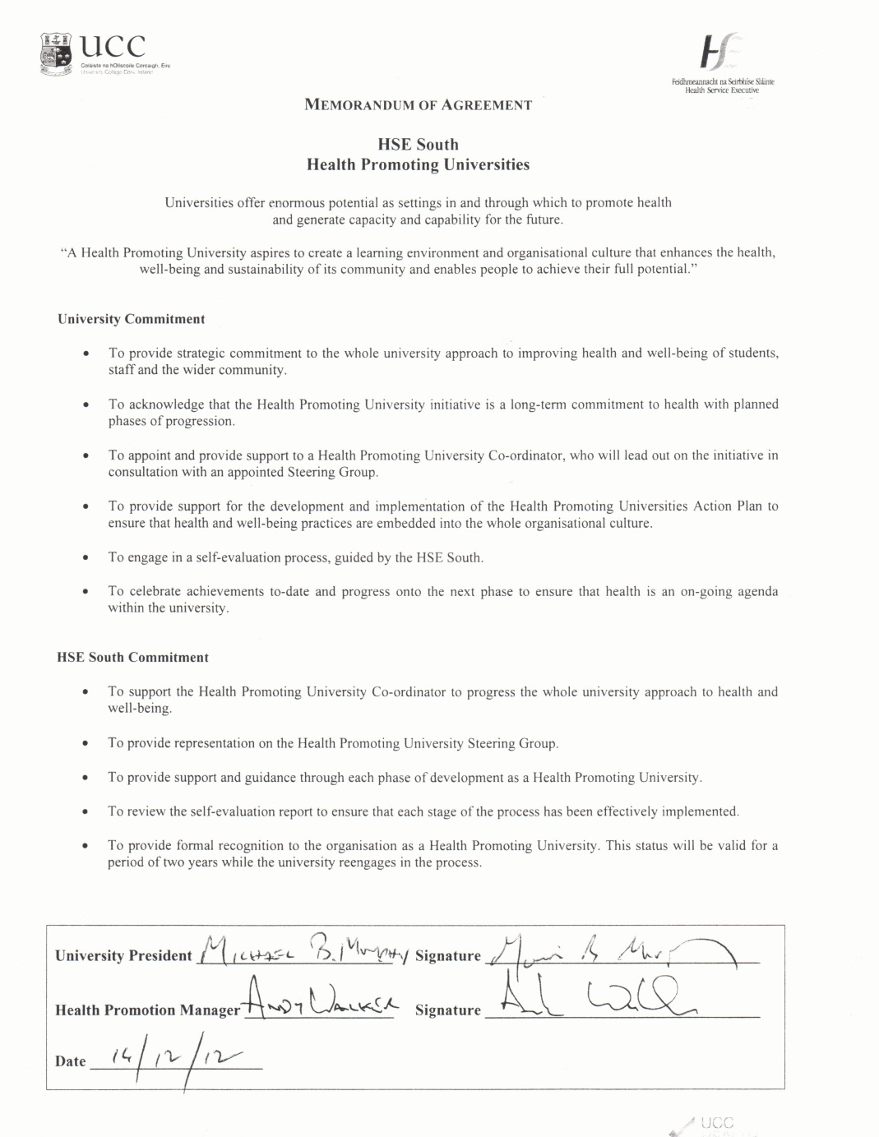

b (iii): Job Description of Health Promotion Project Worker
Student Health Centre UCC
Job Description Form
Department: Student Health UCC
Location: Student Health Centre Ardpatrick College Road Cork
Job title: Student Help; Health Promotion Project Worker
Reports to: Head of Student Health Service
Level: Student Help | Type of position:  Part time  Fixed term | Hours 14 hrs/week
General Description of Health Promotion Tasks:
- Begin the groundwork involved in the project aimed at making UCC Ireland’s first Health Promoting University
- Develop the UCC Health and Wellbeing Calendar for 2012-13 academic year,
- Support the UCC Alcohol Action Plan.
- Other Health Promotion activities as decided by the Head of Student Health Department

Hours of Work:

9:15:-1:00 and 2:15 – 5:00

Education Requirements/Experience
- BSc Health Promotion.
- Prior experience on Health Promotion Project work preferably as part of multidisciplinary team

Salary; Student Help rate of pay as per UCC Dept. HR

€9.11 per hour

Leave entitlement
8% of hours worked.

b (iv): Action Areas of HPU

11 Originally Identified in the Action Plan Nov 2013

1. Mental Health and Wellbeing
2. Alcohol
3. Food and Nutrition
4. Physical Activity and Active Transport
5. Sexual Health
6. Substance Abuse
7. The Built Environment
8. Sustainable Development
9. Safety
10. Evaluation and Reporting
11. Research Arm of UCC Health Matters

Over time some of these were merged and others removed as specific “Action Areas” and reassigned within UCC Health Matters. Revised Action Areas below;

1. Mental Health and Wellbeing
2. Alcohol and substances
3. Food and Nutrition
4. Physical Activity and Active Transport
5. Sexual Health
6. The Built Environment
7. Sustainable Development
8. Safety

b (v): The role of a Working Group Convenor
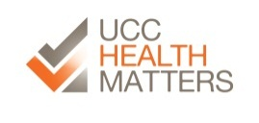
UCC Health Matters
The Role of the Working Group Convenor(s)

The UCC Health Matters Initiative has identified a number of Action Areas. Working Group were established to work within and across these areas with the aim to identify current work, discuss further needs, facilitate communication between partners and develop future strategy and activity. Each Working Group will have at least one convenor to manage communication, evaluation and promotion. More specifically the role of the convenor(s) will be to;
1. Facilitate communication within their Working Group and across the groups.
- Manage the online mailing list for that Working Group by encouraging dialogue and discussion.
- Acting as a liaison between the other Working Group and also with the Health Promotion Project Worker.
- Collating ideas and feedback from the Working Group for use in strategic planning (e.g. the Action Plan).
2. Coordinate the evaluation process and reporting mechanism
With the support of the Health Promotion Project Worker the convenors will promote and coordinate the use of the Self Review Tool to monitor progress and evaluate the initiative. This tool is online and available to us as a resource.
3. Spread the word and support the UCC Health Matters Initiative
The convenor will also increase the awareness of the Initiative in UCC by promoting among colleagues and peers and in addition invite any persons who may be interested or working in a relevant field.

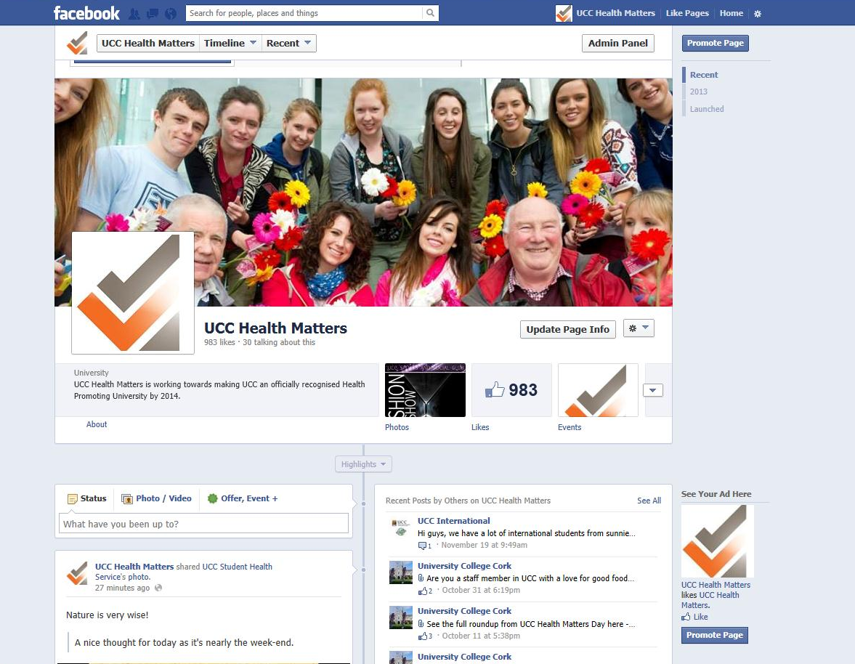
b (vi): Raising Awareness of UCC Health Matters


b (vii): UCC Operation Transformation

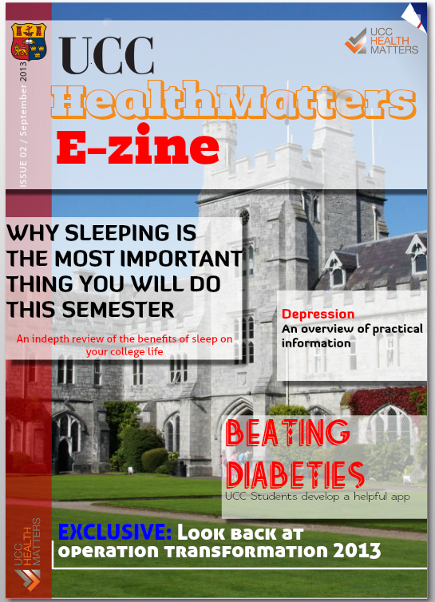
b (viii) UCC Health Matters E-zine

b (ix): UCC Needs Assessment
Proposed Outline for UCC Needs Assessment

The vision
'A health promoting university is not one that has achieved a certain level of health; it is one that is conscious of health and striving to improve it'
Health Promoting Universities; concept, experience and framework for action, WHO, 1998
The Project
A needs assessment to inform UCC’s healthy living committee on the establishment of UCC as a Health Promoting University.

Aim of the needs assessment:
To create a profile of the health of staff (?) and students in UCC and to make evidence based recommendations on actions to improve health within the University.

Objectives:
- Appointment of project coordinator/researcher
- Creation of subgroup of key stakeholders to oversee the project
- Create consultation groups and explore different mechanisms for consultations e.g. group consultations, twitter online discussions boards etc. to include, students and staff (?)
- Defining health and the scope of the needs assessment
- Literature review of other national and international literature on health promotion colleges to include needs assessments and health promotion activity.
- Review of work carried out in other Universities.
- Analysis of current health data on Irish Students and more specifically any data on UCC students.
- Review the evidence in relation to effective methods of promoting health in the college setting.
- Map out/audit of existing resources within UCC e.g. Services, committees, health promotion activities and opportunities.
- Carry out consultations
- Make recommendations to be incorporated into an action plan for a health promoting college.
- Identify resources required to implement a UCC health promoting colleges’ action plan.

b (x): Town Hall Methodology

Town Hall meeting Plan
11am – 1pm Room 405 Western Gate Building.
28th Sept 2012

Item 1. Presentations
11am – 11.30am
- Ivan Perry
- Colin Bradley
- Sam/Dave/Brian and Jamie
- Catherine Maguire
- Michael Byrne

Item 2. Group work – Identifying the Thematic Action Areas.
Description
- In groups discuss current initiatives and activities that are on-going on campus, that the group feels are health promoting.
- Write as many as possible on post-its (one initiative per post it)
- Each group feedback ideas to the larger group and place the post-it’s on the relevant flipchart under the Action headings.
- Once we can see what the group has produced we will supplement it with any initiatives left out on PowerPoint screen.
- We will discuss these as a group and allow people to put themselves forward to be part of each action area.
- We will suggest to the group that there is a nominated contact person to help coordinate.
Outcomes
- We will then have a visual representation of all of the on-going activities and initiatives in UCC that fall under the HPU remit.

- For each action area we will have people who will work on any issues or deficits raised.

- This will also allow for networking within areas of interest and also across action areas.

Item 3. Branding

Description
- We are hoping to create a memorable and catchy logo and slogan for the HPU initiative in UCC so as to promote the initiative.

- Each group will receive a list of possible ideas/names etc, as well as some flashcards of imagery and wording. These will be discussed in small groups and ideas fed back to the larger group.

- We will do the same exercise with a student group so as to get a broader view of ideas.

- We will ask for a person to volunteer to collate these ideas and also work together with the designated person from the student group to come up with some options for logos.

- We will hopefully come back to the group at a later time with the ideas collated and some options for the group to choose from.

Outcomes
- An eye catching logo and slogan which will encompass the HPU initiative and to use as a promotional tool.

- A sense of ownership of the initiate - A logo that was created internally by the people who are on the ground and driving the HPU.

Item 4. Methodology and Operation Transformation
Description
Presenting of the toolkit and also the case studies to the group. Looking at the methodology applied to each initiative and can we apply it to what’s going on here in a coordinated approach?
Presentation of self-evaluation tool to the group and discussion on how we can use it.
Operation Transformation Proposal. Discuss with the group the idea and where it originated; how can we move forward with this?

Outcomes
- A general understanding on how initiatives should be carried out and how we can apply the toolkit to our take on the HPU.
- Perhaps a commitment to the Operation Transformation Idea and how we as a group can make this a successful initiative in UCC.

b (xi): Results of the Town Hall Mapping Exercise- Sept 2012

Town Hall Meeting 28th September 2012
Summary of meeting

Presentations
Ivan Perry
Colin Bradley
Catherine Maguire
Sam Ryan
Michael Byrne

All available on the Intranet

Identifying current Initiatives

The group was split into five groups of 4-5 people. As a group they identified as many initiatives and activities that are on-going in UCC and that are health promoting or contributing to health in some way.

There were 12 categories and under each category we identified the following;

- Physical Activity and Active Transport
- UCC Campus Bikes - Bikes available for staff for short term rental in order to encourage cross campus cycling rather than driving
- Cycle to Work (Government Scheme)
- UCC Sports Clubs (60+)
- Slí na Sláinte - Heart Foundation designated walking routes. One leads through UCC Campus
- Lunchtime Walking routes
- Mardyke Arena facilities – offering staff discount as part of HPU
- Mardyke Arena Recreation Programme
- Staff Sports and Social Committee
- Student Centre Bikes
- Students Union Sports day
- Pedometer Challenge 2012 - 4 week challenge 12Sept-9Oct
- Heart screening for sports scholarship students
- Sports talks organised by Clubs exec
- Information screen – health messages
- Family sports days

- The Built Environment
- Walkway for Walking and Cycling - City council improvements to paths and cycle lanes around campus to encourage walking and cycling
- Southern Route(Greenway through Donovan Rossa Road) - New walking/cycling route from St. Finbarr's through Donovan Rossa Road along by the river.
- Green Campus Initiative

- Sustainable development
- Carpooling service - Database of those offering and searching for lifts, priority spaces offered to those carpooling.
- Park and Ride
- GoCar Service – short term car rentals
- Green Campus Initiative - Series of initiatives regarding emissions, waste and the environment.
- Energy Awareness – Buildings and Estates

- Food and Nutrition
- College dinners – Ingredients and recipes for four healthy dinners for €10
- Healthy Food Promotion – Calories displayed in Kylemore
- Eating disorder programme between Student Health and Counselling Department.

- Mental Health and Wellbeing
- First Year Experience Coordinator
- Staff Health & Safety Training
- Chaplaincy
- Hour of Stillness & Healing - Lunchtime meditation in Honan Chapel
- Lunchtime Meditation Course
- Meditative Morning Prayer
- Staff Meditation Group
- Zen Buddhist Meditation
- Life Matters - Elective courses to help people with stress management, coping mechanisms etc.
- Disability Support Service
- Uplift Programme (Peer support for students)
- Student Mental Health Policy
- HR Welfare Officer
- Staff Wellbeing Survey
- Support Officer for International Students
- Vice President for the Student Experience
- Nightline - Helpline run by UCC students providing a non-judgemental listening service
- ULink Peer Support
- Finance and Budgeting Advisory Service
- CALM - Computer Aided Lifestyle Management
- Student Counselling & Development
- Ways Forward (student counselling)
- Safetalk – Suicide awareness
- Healthy Weekend Study Facilities
- SU Disability Awareness Week [3rd-7th December]
- SU Exam Stress Campaign [April]
- SU Mental Health Campaign [12-16th Nov]
- SU Welfare Officer
- LGBT Ally week
- Free Staff counselling sessions
- Employee Assistance Programme
- HR Mindfulness Initiatives
- Stress management Survey
- Exam stress talks
- On-going surveys by the Dept. of Psychology

- Alcohol
- Hot Beverages Appreciation Society - Social evenings. Specific alternative to alcohol
- Student Alcohol Policy - University-wide policy regarding alcohol and students
- PhD Fellowship - Fully funded PhD in alcohol research (ePUB)
- E-Pub - Online self-assessment of alcohol use
- Joint CIT-UCC Approach to Alcohol - Collective work in relation to city wide issues
- No alcohol policy in student execs
- Talks to staff around use of alcohol among students
- Brief intervention training for students around alcohol use

- Substance Abuse
Nothing Identified

- Sexual Health
- STI Clinic at the Student Health Centre
- SU Sexual Health Awareness and Guidance (SHAG) Week [Feb] – SU Campaigns Officer
- Condom Shop – SU Welfare Officer
- LGBT awareness

- Safety
- Campus Watch - University-wide committee responsible for the safety of staff and students in the University area
- Safety Team - Students contracted by clubs/societies and other organisation to help ensure safe running of balls, mystery tours etc.
- Safety Policy
- Student Community Patrol
- Student Community Support
- Road Safety Campaign
- VDU training (Visual Display Unit)
- CCTV Cameras on College Road
- Nightbus

- Other Health related
- Clinical Therapies Society
- Dental Society
- Medical Society
- Slainte Society
- Surgical Society
- Degree and Masters in Public Health and Health Promotion
- Healthy Living Committee
- Facebook page for Healthy Living
- Healthy Living Calendar
- Student Health e-Zine
- Healthy Living Orientation Module
- Automated External Defibrillators
- Student Health Centre
- UCC Staff Advantage Scheme

- Evaluation and Reporting
- Healthy Universities toolkits – Available on the Intranet

- Research Arm of HPU
- There were expressions of interest at the Town Hall meeting to use the Health Promoting University Initiative as an opportunity on which to base some research within the University.
Actions: Michael to email relevant departments to discuss this idea further.

These were the twelve Action Areas identified at the Town Hall Meeting. Different Individuals have expressed interest in these Action Areas. The Document Action Working Group on the Intranet will give a list of the different Action Areas and who is interested in each.

Branding
At the Town Hall flashcards with well-known logos and some other branding ideas were looked at by the group. The following were comments and ideas which resulted from this activity;
- The logo must encompass all aspects of HPU i.e. not just represent physical health.
- A good visual with few words works best.
- The Quad could be depicted in the logo to make it more specific to UCC. The four sections could work as a good visual and represent different aspects of HPU.
- UCCHealth
- HealthySelf
- ULife
- UCCHealthMatters
- Lifelong Living, Lifelong Learning
Volunteers are now coming forward to help collate ideas and present some options for the Working Group to look at. Volunteers are encouraged to contact Deirdre at hppw@ucc.ie if they feel they would be interested in getting involved with this. Expertise in this area is also welcome.

Table : 1 Example of use of the 5 elements of the Ottawa Charter to map and evaluate activity in one Action Area (Food and Nutrition) during Town Hall Meeting September 2012.
Ottawa Charter | Possible Areas for Action |  | Comments |  | Action |  | Key Networks/Key People
Build Healthy Public Policy | Are there university policies/strategies in relation to food and Nutrition?  If no, does there need to be?  If yes, are they adequate? |  | No not that we are aware of but there is a need for one. |  | There needs to be a University wide approach taken to the inclusion of healthy choices and the promotion of making those healthy choices.  University policies for staff and students.  There needs to be an integration of the decision making process of users and providers.  Corporate responsibility needs to be taken. |  | University representatives must be liaised with as well as the catering providers.  Identify what staff and students need to network and develop communication methods.  Involve sports clubs and societies e.g. Slainte
Create Supportive Environments (physical and social) | Is the physical environment in UCC supportive healthy food and healthy eating?  All the student and staff settings should be considered, e.g. academic buildings, cafés, libraries, sports facilities, green areas, walkways etc.  Is the social environment supportive?  E.g. are people aware and in support of this issue? |  | Some areas need improvement.  Timetables are an issue e.g. lectures taking place during main meal times and then restaurants closed.  Opening and closing times are an issue e.g. healthy food not available when students are studying in the library in the evenings etc.  Walkways/cycle paths are successful and abundant. Good access for people with disabilities.  Some awareness but may be hampered by constraints. |  | Is this an issue with Contractors?  Can there be any influence from students/staff/university?  Calories to be displayed all over campus.  Raise awareness of ingredients/calories/nutritional value of food.  Opening and closing times of restaurants should be looked at.  Availability of venues to eat if students and staff bring their own food.  Continue to raise awareness |  | Representative from Buildings and Estates involved and other buildings e.g. Mardyke  Healthy and Safety Officer  Use website, social media to reinforce.  A poster Campaign
Strengthen Community Action | Are there opportunities for students to make a difference in the community within this Action Area? |  | Possibly as students use some of the same food providers as the community. |  |  |  | Students Union/ Clubs/ Societies
Develop Personal Skills | Do those in power have the necessary skills to make change?  Do our students and staff have the skills to make better choices in relation to food and nutrition? |  | There are a lot of constraints.  Also disparity across university buildings.  Equipped with skills in some disciplines. |  | Broad campaign  Promote a balance between food and physical activity. |  | Who is responsible for this?
Reorient Health Services | Does the health service promote healthy eating?  Is the health service working with relevant services and agencies to promote healthy eating? |  | Yes, video promotion/leaflets/doctors and health promotion officers
Other aspects to consider for each Action Area

Are there any other gaps? |  |  |  | - If policies are there, they are unclear.  - Staff and students do not know who is responsible.  There is a lack of information and availability of choice.  There are time constraints (opening hours of when good food is available)  Obvious link between budget constraints and healthy choices. |  | Must find out if there are policies and what they are.  Can changes be made in restaurants?  - So many different culture groups – can we mobilise their involvement (i.e. their ethnic dish)  Information needs to be available – calories/portion size etc. |  | Who do we need to liaise within the university, restaurant committee?  Caterers
Can we co-ordinate efforts by introducing a common framework? |  |  |  | Can we introduce common policy across the food providers? |  | Certain information needs to be available in all food outlets e.g. calories etc.

b(xii): Effective Management of Alcohol Issues in UCC 2010-2011

 |  | Table of Contents
 |  |  |  |  |  | Page
1. | Introduction . . . . . . . . . . . . . . . . . . . . . |  | . . . . . . . . . . . . . . . . . . . . . |  |  | 1
2. | Drivers that have increased the use and misuse of alcohol. . . . |  |  |  | . . . | 2
 | 2.1 | Supply Pricing and Availability. . | . . . . . . . . . . | . . . . . . |  | 2
 | 2.2 | Changes in Society . . . . . . . . . . | . . . . . . . . . . | . . . . |  | 2
 | 2.3 | Changes at the level of the Individual . . . . . . . |  | . . . . . . . . |  | 3
3. | Interventions to reduce alcohol related harm. . . . . |  |  | . . . . . . .. . . . | . . | 3
 | 3.1 | Interventions shown to be effective. What works? . . . . . . |  |  |  | 3
 | 3.1.1 | Individual Level . . . . . . . . . . . . | . . . . . . . . . . | . . . . . . . . . . |  | 4
 | 3.1.2 | Whole Student Body . . . . . . . . . | . . . . . . . . . . . . . . . . . . |  |  | 4
 | 3.1.3 | Greater Environment . . . . . . . . . | . . . . . . . . . . . . . . . . . . |  |  | 5
 | 3.2 | Interventions shown to be ineffective. What doesn’t work? |  |  |  | 5
4. | Action Areas identified in 2010. . . . . . . |  | . . . . .. . . . . . | . . . . . . . .. . | . . . | 6

- Key actions with an internal focus

- Key actions with an external focus

. . . . . . . . . . . . . . . . . . . . 6
. . . . . . . . . . . . . . . . . . . . 7

5. Conclusion . . . . . . . . . . . . . . . . . . . . . . . . . . . . . . . . . . . . . . . . . . . . . 8

References . . . . . . . . . . . . . . . . . . . . . . | . . . . . . . . . . . . . . . . . . . . . . . . |  | 9
Appendix 1: Key Outcome Indicators for overall evaluation |  | . . . . . . | 10
Appendix 2: Key Outcome Indicators to evaluate each action point. |  |  | 11
Appendix 3: Data Collated from e-PUB responses . . . . . . |  | . . . . . . | 11

Effective management of alcohol issues in University College Cork
1. Introduction

Concerning levels of alcohol related harm have been reported in the literature, both for students in Ireland¹ and for students in UCC². Incidents of anti-social behaviour, drunkenness, alcohol related injuries and even assaults have been noted in the University community and the local environs around the UCC campus. The adverse consequences of the misuse of alcohol amongst our students are very real, all too common, and occasionally have been very serious, up to and including devastating injury and death. Given these very visible and serious consequences of the misuse of alcohol amongst our students it is perhaps understandable if a view exists that

“nothing is being done in UCC to address this problem”. As this report will show however there is considerable work on-going in UCC to try to get to grips with this issue. Initiatives to try to reduce the adverse consequences of alcohol use and misuse have been identified as the number one priority of the Health Living Group, a sub-group of the Academic Council Student Experience committee.

This report identifies some of the drivers that have led to an increase in the use and misuse of alcohol in Ireland. The report summarises the evidence for interventions that have been shown to be effective and lists those interventions shown to have little or no effect. The report then summarises the current status of the full range of initiatives on-going in UCC to help address the issue of alcohol related harm, and details (where available) measures whereby the effectiveness of these initiative may be evaluated in a series of related Key Performance Indicators (KPIs).
The material in this report, including the action areas identified for UCC arises from the conclusions and recommendations contained in a report submitted to the IUSSN following a seminar in NUIG in 2010, entitled Effective Management of Alcohol issues in Irish Universities, written by Dr Ann Hope, International expert and former National Alcohol Policy Advisor to the Department of Health and Children
Dr Michael Byrne

October 2011

1

2. Drivers that have increased the use and misuse of Alcohol in Ireland

2.1 Supply; Pricing, Availability and Marketing

The supply side of alcohol has been transformed by changes in the price, availability and marketing of alcohol in Ireland over the past 20 years. Alcohol is now more affordable than ever before in Ireland, facilitated by the abolition of the Groceries Order in 2006 allowing below cost selling of alcohol, with very cheap alcohol promotions by the off-trade such as bulk buying offers (supermarkets, garages, grocery shops and specialists off-licences) and by the night time economy outlets (nightclubs and late pubs) with offers of free shots and other promotions. The local economy in Cork depends on student drinkers to maximise sales and profits.

The increase in the number and density of outlets selling alcohol has created competition between alcohol outlets, which results in cheaper alcohol. The differential in price between on-trade (in Pubs) and off-trade (off-licences/shops etc.) has also contributed to more off-trade alcohol sales with off-trade selling cheaper alcohol brands and attractive deep cut price offers. The results are that students „pre-load‟ at home (with cheap alcohol bought in off-licences) and go directly to nightclubs to continue drinking, with already large amounts of alcohol consumed. The risk of harm substantially increases in such circumstances.

The strong association between alcohol and sport, sexual success and a marketing gender bias for different products effectively targets students. There are also many below the radar (not measured/less visible) marketing practices which are employed by the drinks industry to sell alcohol to students such as fliers/promotional leaflets, home delivery through phone or internet sales, insider promotions working with pubs and clubs and outsiders on campus selling substances.

2.2 Changes in Society

The growing social norm of excessiveness, the value placed on alcohol as a social lubricant for all social occasions in Ireland and the Irish cultural tolerance of drunkenness strongly influence the collective drinking environment in Ireland. Within such a social milieu, students reflect the collective drinking environment in a more extreme way.

2

2.3 Changes at the level of the individual

Many Irish students come to University as experienced drinkers due to their early induction into alcohol. There appears to be increased signs of intentional drinking to get drunk or “drinking to be out of it‟, as the normal drinking behaviour for students. Another worrying trend reported is for students to save their money for long binges which can last for several days, usually in someone’s house. This reflects a very serious high risk and dangerous drinking pattern. Some students feel pressurised to conform to binge drinking or risk marginalisation and isolation. In particular, international students are bewildered, afraid and isolated with such risky drinking patterns, so culturally different from their own. A basic lack of self-respect (promiscuity and drunkenness) may also be as an issue.

3. Interventions to reduce alcohol related harm
3.1 Interventions shown to be effective: What Works?

Much of the evidence of what works is based on published material produced by those considered as experts in evaluating the effectiveness of alcohol interventions^{3, 4}. Interventions may target the individual student, the whole student body, or the greater environment.
This multi-component view of drinking is known as the Social Ecological model⁵.
Individuals


Greater Whole
Environment Student Body

The most effective approach is to include elements from all three domains.

3.1.1. Individual level
The most effective individual approach is a screening and brief intervention (SBI) programme, using motivational interviewing with principles of empathy, non-confrontation, non-judgemental listening, developing an awareness of discrepancies and encouraging students to resolve ambivalence about changing their drinking behaviour. This can take place in the student health centre, counselling service, or even in an academic or disciplinary counselling situation. SBI and other individual level interventions have been found to reduce consumption as well as alcohol-related harms, but the effects tend to decline over time, particularly when they are not
used as part of a multi-component strategy⁶. Such approaches require trained staff and can therefore be expensive and time consuming, and have limited likelihood of being capable of meeting the demand in the University setting, unless it is to be delivered by a new cohort of personnel not usually identified as part of the welfare support services. Using an on-line computer-delivered programme, such as e-PUB, has the capacity to reach huge numbers, with the same material, at very little cost, making it a potentially very cost effective addition and alternative to the resource intensive one-to-one SBI A number of studies have found e-CHUG (US version of ePUB) to be effective
3.1.2 Whole student body
It is important to consider strategies that impact on the whole student body, such as controlling marketing of alcohol on or near campus, providing alcohol-free social opportunities, and strict, consistent enforcement of regulations.
The provision of substance-free accommodation is common in the U.S., where more than 80% of colleges provide it. While it predominantly impacts on those who live there, it may also contribute to changing the social norms. Students living in these residences are less likely to drink heavily or experience harms from other students’drinking⁸. The provision of substance-free accommodation is also desirable and supportive for both underage students, international students and students who may be recovering from alcohol or drug dependency.

4

3.1.3 Greater environment

Effective policies and strategies that affect the whole population, such as pricing and
taxation, density of alcohol outlets, restrictions on marketing, drink driving laws and random breath testing checkpoints, will also impact on student behaviour¹. Training in responsible serving practices of bar staff and off licence sales staff, combined with enforcement of regulations by police, has shown some effectiveness, esp. in reducing sales to underage drinkers⁸.
Campus–community alliances or partnerships involving key groups, including law
enforcement, the business community, residents‟ associations, health services,
university representatives, and others, can be beneficial. They can reframe student drinking as a community issue, rather than just a university issue, encouraging a more comprehensive approach that will have a greater impact on changing the broader environment⁸.
To summarise, measures that impact on the whole student body such as limiting availability, restricting advertising and marketing, alcohol-free alternatives, substance-free housing, consistent enforcement of policy and eliminating the 3 day weekend have been shown to be effective in reducing alcohol related harm among college students. At the individual level, screening and brief intervention is effective, as is the use of on-line interventions such as e-PUB. Policies that are effective in reducing consumption in the wider community, and consequently alcohol-related harms, will also benefit students.
3.2 Interventions shown to be ineffective. What doesn’t work?
Interventions shown to have no effect include; Campaigns advising “Just saying No” to alcohol, educational programmes not linked to other methods, advertising campaigns using guilt or shame or fear, inconsistent policies and procedures or inconsistent application of policies and procedures, or requiring or compelling students to do alcohol education courses. Interventions such as these have the double whammy of being ineffective in themselves, whilst also diverting resources away from delivering other more effective interventions.
It is important not to do the wrong thing, essentially because it prevents us from doing the right thing.

5

4. Action areas identified following Seminar in NUIG 2010

In 2010, Action areas (1) internal and (2) external to UCC were identified to address

the adverse consequences of alcohol as follows;

  - Internal Action Areas: To recognise all levels of the university as stakeholders in the issue of alcohol use and misuse and so to actively collaborate in countering the binge drinking culture among students.

  - External Action Areas: To seek to influence local, regional and national policy makers to enforce existing agreements/ legislation with regard to the promotion, sale, distribution and use of alcohol and to lobby policy makers for the introduction of further legislation in this area.

- Key actions with an Internal Focus

- Provide well-appointed, alcohol-free social spaces as an alternative to campus pub

- Provide front line UCC staff (academic advisors, tutors, residencies, security, student union, etc.) with training in „brief advice‟ approaches on alcohol issues.

- Develop guidelines for referrals within UCC to in-house support services for those in need of help due to harmful drinking.

- Access and use expertise in the local community and University to adequately respond to the issues of alcohol and drugs usage and their consequences – sexual assault, aggression, anti-social behaviour.

- Promote and increase uptake of e-Pub amongst students esp. incoming 1st years.

- Have annual alcohol awareness events to increase knowledge on the impact of alcohol on sporting fitness, weight gain, risks to academic/career prospects and risk to visa and travel opportunities.

- Use trained student peers as disseminators of health information and education

- Gather information in the following areas

- Risks and harms of the binge drinking culture among students in particular from health, housing, student union and security services.

o Identify key outcome indicators to monitor action plan implementation

- Evaluate measures/strategies implemented to see if effective in reducing alcohol related problems, in particular SBI and e-PUB.

- Monitor license renewals and use objection procedures with deviant traders.

- Include specific reference within the University Strategic plan to the promotion of personal respect and responsibility.

- Publicise and promote alcohol policy to staff and students.

- Publicise university discipline procedures.

- Review disciplinary protocol so that it includes the alcohol policy aims.

- Establish a Healthy Living/Alcohol Issues Management and Response Group. This group to provide regular briefings to senior management on issues, outcomes of response actions and proposals for additional actions if required.

- Embed alcohol awareness into college orientation each year.

- Provide some level of substance-free housing in student residences.

4.2 Key actions with an External focus

At National level

- Have the Irish University Association (IUA) or IUSSN lobby nationally for more effective policies to address alcohol problems.

- Influence policy makers by making written proposals based on the seminar’s action plan to the National Substance Strategy Steering Committee for inclusion in the new Substance Misuse strategy.

- Lobby political parties for action to reduce the Irish culture of binge drinking.

- Call for a zero tolerance approach to alcohol law enforcement.

- Enforce current agreements in relation to stricter sales and marketing codes.

- Call for targeted change on price control (minimum price and unit price), increase in off-sale prices (increase license fee and base on turnover alcohol sales), density of outlets (use planning laws to restrict number of outlets), hours of opening and alcohol advertising of sports (break link between alcohol and sport).

- Push for mandatory RSA training for all in the retail sector selling alcohol and link to enforcement.

- Strengthen inter-university collaboration between disciplinary staff and student accommodation.

- Work with other third level institutes through the existing structure of the National Working on the Consumption of Alcohol in Higher Education or other similar.

- Establish the economic cost of harmful drinking and problems among college students and its impact on the economic development of Ireland.

At Local level

- Lobby local councillors for enforcement of by-laws.

- Form local community strategy groups with Gardaí, community groups, local media, local authority, university, other third level colleges, students union, HSE, local vintners and traders, in particular for high risk time periods (R+G week, fresher week etc.)

- Have a defined remit for a community strategy group with a specific action plan and clear outcome indicators.

- Apply social pressure through local media for those traders who deviate from agreed actions.

- Work with neighbourhood residents associations, gain their support and explain complaints procedures.

- Lobby local political student groups (FF, FG, Labour, Greens etc.) within university for support for effective policies.

5. Conclusion

In conclusion, the top ten most effective actions based on the evidence are:

Internal Focus

- Screening and brief intervention for binge drinkers

- e-Pub, interactive internet based intervention with required evaluation

- Senior management in University taking collective responsibility for ownership of alcohol action plan.

- Development of campus-local community coalition

- Monitoring progress based on key outcome indicators

External Focus

- Stronger price controls

- Lower density of alcohol outlets

- Stricter marketing regulations

- Mandatory RSA training with enforcement

- Lobbying policy makers/politicians for leadership and effective action

The present status of the action points listed above is outlined in Appendix 2.

References.

- Hope A, Dring, C, Dring J (2005). College Lifestyle and Attitudinal National (CLAN) survey. In The Health of Irish Students. Dublin: Department of Health and Children.

- Cahill L, Byrne M (2010) Alcohol and Drug Use in Students attending a Student Health Centre. Irish medial Journal 103. 230 -233

- Babor et al (2010) Alcohol no ordinary commodity research and public health: Second Edition. New York, Oxford University Press.

- Wechsler H & Nelson T (2008). What we have learned from the Harvard School of Public Health College Alcohol Study: Focusing attention on college student alcohol consumption and environmental conditions that promote it.

Journal of Studies on Alcohol and Drugs, 69, 481-490.

- McLeroy, K., Bibeau, D, Steckler, A., & Glanz, K. (1988). An ecological perspective on health promotion programs. Health Education Quarterly, 15, 351-377.

- Carey, KB, Scott-Sheldon, LAJ, Carey, MP, De Martini, KS (2007) Individual-Level Interventions to Reduce College Student Drinking: A Meta-Analytic Review. Addictive Behaviours, 32, 2469-2494.

- Hustad, J. T. P., Barnett, N. P., Borsari, B., & Jackson, K. M., (2010). Web-based alcohol prevention for incoming college students: A randomized controlled trial, Addictive Behaviours, 35, 183-189.

- Toomey, T.L., Lenk. K.M. & Wagenaar, A.C. (2007) Environmental policies to reduce college drinking: An update of research findings. J. Stud. Alcohol Drugs 68: 208-219.

Appendix 1

Key Outcome Indicators to evaluate the overall effectiveness of the programme to reduce the adverse consequences of alcohol amongst students

In addition to the tracking of the Internal and External Action points adopted and being implemented since 2010 described above and listed in Appendix 2 below, it is proposed to endeavour to measure the overall effectiveness of the actions and iniatives taken. The KPIs listed here in Appendix 1 are considered to be a proxy measure
It must be acknowledged however that the issue of alcohol use and misuse is a society wide problem. UCC whilst strongly engaging with the challenges posed by addressing this issue is not in a position to undo the harm and protect our students from attitudes and practices that are now deeply ingrained in Irish society and Irish culture.
It is to be hoped however that some of our students, as future leaders of society may be positively influenced by the efforts undertaken in UCC and so shape future social, political and public health policy and ensure Ireland has a much healthier relationship with alcohol than that which operates at the moment.

KPIs to evaluate the overall effectiveness of action plan implementation
Student focus

- Proportion of students who engage in regular binge drinking

- Number of students presenting to health centre/services with alcohol related issues

- Number of students arrested for alcohol related offences

- Number of students presenting with alcohol related injuries in local hospital

- Number of students accessing e-PUB

- Number of students provided with screening and brief intervention

- Number of students involved in college disciplinary procedures, related to alcohol issues

Environment focus

- Density of alcohol outlets with a 5 km radius of campus (map location, if possible, of off-trade and on-trade)

- Quantity and quality of high risk marketing practices in local environment.

- Quantity of alcohol sponsorship local events

- Price of cheapest can of beer in off-trade

- Cheap price promotions in local nightclubs and late pubs

- Document the use of new media in promoting alcohol to students

Appendix 2

Key Outcome Indicators to evaluate implementation of individual components of UCC Alcohol Plan. Status as of October 2011

Arising from the previously described seminar on Alcohol held in NUIG in 2010, the UCC Healthy Living Group developed a list of actions in each of the 2 principal areas, area (1)identified as having principally an internal focus, local to UCC and area (2) with actions identified as having principally a focus external to UCC. Some of these actions do not lend themselves to the development of Key Performance Indicators and have not been developed or recorded for these actions.

B (xiii): UCC Alcohol Action Plan

Foreword
Concerning levels of alcohol related harm have been reported in the literature, both for students in Ireland1 and for students in UCC2. Incidents of anti-social behaviour, drunkenness, alcohol related injuries and even assaults have been noted in the university community and the local environs around the UCC campus. The adverse consequences of the misuse of alcohol amongst our students are very real, all too common, and occasionally have been very serious, up to and including devastating injury and death. Given these very visible and serious consequences of the misuse of alcohol amongst our students it is perhaps understandable if a view exists that “nothing is being done in UCC to address this problem”. This report shows the considerable work on-going in UCC to try to get to grips with this issue. Initiatives to try to reduce the adverse consequences of alcohol use and misuse have been identified as the number one priority of the Health Living Group, a sub-group of the Academic Council Student Experience committee.
It must be acknowledged however that the issue of alcohol use and misuse is a society wide problem. UCC whilst strongly engaging with the challenges posed by addressing this issue is not in a position to undo the harm and protect our students from attitudes and practices that are now deeply ingrained in Irish society and Irish culture.
It is to be hoped however that some of our students, as future leaders of society may be positively influenced by the efforts undertaken in UCC and so shape future social, political and public health policy and ensure Ireland has a much healthier relationship with alcohol than that which operates at the moment.

Introduction
This report summarises the current status of the range of initiatives on-going in UCC to help address the issue of alcohol related harm. This is a follow–up report on the first report entitled Effective Management of Alcohol Issues in UCC3, which described the range of action areas for the year 2010 to 2011. The list of action areas were first identified following a seminar in NUIG in 2010, entitled Effective Management of Alcohol issues in Irish Universities.
The initiatives first described in 2010 have been refined somewhat in the light of the experience of the first 12 months of effort and have been distilled into 5 distinct Strategy Areas (SA) with accompanying specific 20 Action Points (AP) as tasks to be undertaken to help reduce the alcohol related harm amongst our students.
A set of Key Performance Indicators (KPIs) is in development to monitor the implementation of the Action Points and where these have been developed they are shown in the tables on pages 3 and 4 below, with current status of the KPI also shown. Some of the Action Points do not lend themselves to being assessed using a Key Performance Indicator tool. In these cases the status of the Action Point is reported in simple descriptive terms.
It is proposed that these Strategy Areas and Action Points be reviewed at least annually with the addition of further Strategy Areas or Action Points as and when appropriate. Strategy Areas and Action Points may also be deleted if judged ineffective or unattainable.
Monitoring of the implementation of these Action Points is the responsibility of the Healthy Living Group, a sub-committee of the Academic Council Student Experience Committee. Anyone interested in helping in the effort to minimise alcohol related harm amongst our students is invited to contact the Chair of the Healthy Living Group.

Dr Michael Byrne
Chair Healthy Living Group UCC

Proposed Strategy Areas (S) &Action Points (AP) for UCC Alcohol Action Plan

S1. Provide education, information and training for students and staff
S2. Put in place effective screening, referral and treatment services
S3. Make the campus and the local environment safer from alcohol related harm
S4. Influence local, regional, national, and sectorial alcohol policies and practices
S5. Research alcohol use and monitor progress and effectiveness of strategies

S1. Provide education, information and training for students and staff
To understand the physical psychological and social effects of harmful use of alcohol, students and staff need to have accurate information from a credible source, not influenced by vested interests from within the drinks industry. There is a considerable body of evidence however that confirms that access to information alone is not sufficient to change individual behaviour4,5,6. Training in how to recognise and advise a student or colleague with alcohol related harmful behaviour is therefore also vital.

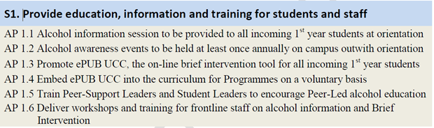

S2. Put in place effective screening, referral and treatment services
Early identification of students who are drinking at a high-risk or a harmful level increases the likelihood that the student will be directed towards appropriate help. It is important that treatment services available to the student utilise cost-effective evidence based measures that are known to work

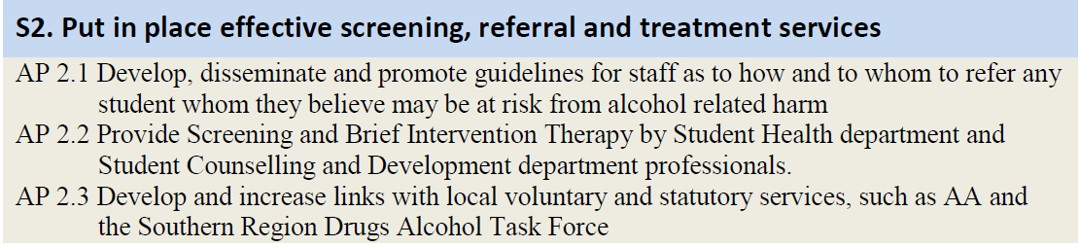

S3. Make the campus and local environment safer from alcohol related harm
There is evidence that the social and physical environment can influence personal and group drinking habits, (Social Norms Theory). Harm can occur to the individual who is drinking to excess, but also to others around him/her and indeed to the local physical and social environment

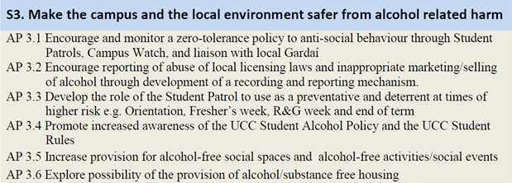

S4. Influence local, regional, national, & sectoral alcohol policies and practices
Alcohol related harm is a considerable threat to our society. UCC has a responsibility to provide leadership at local, regional and national levels on issues of pressing social concern, and can also seek to promote a sector-wide approach along with other 3rd level institutions to dealing with the problem of alcohol use and misuse by our students.

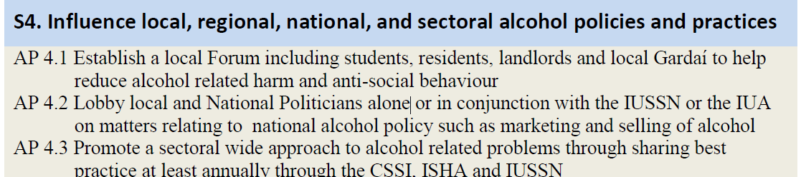

S5. Research alcohol use and monitor progress and effectiveness of strategies
It is important that alcohol use and alcohol related harm in UCC be researched and reported. It is also of importance to monitor and evaluate the effectiveness of the strategies and action points contained in this plan.

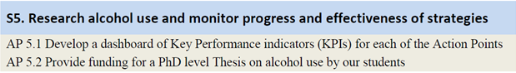

Item 12: UCC Alcohol Action Implementation Plan
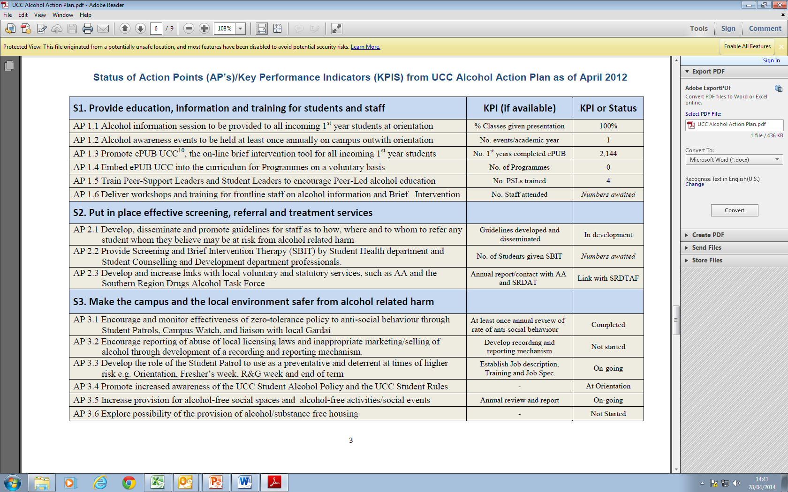
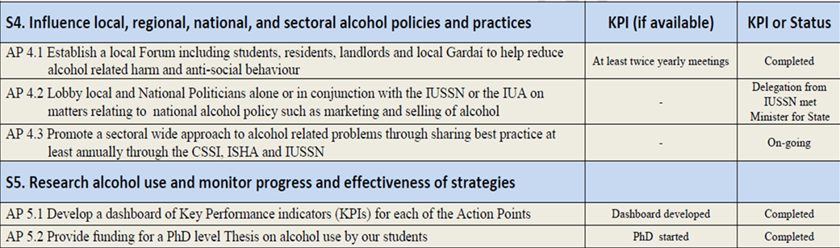

B (xiv) UCC Alcohol Policy (Updated 2013)

