Introduction
There are two (2) elements to the Risk Analysis Reconciliation, the Department RA Reconciliation 2016 and the FA Summary. The pages highlighted below correspond to each element regarding completion guidelines.
FA Risk Assessment 2016 Summary Workbook: Section B (FA Manager only) User guidelines – Pg.6-7
Department Risk Assessment Reconciliation Workbook 2016: Section A – User guidelines – Pg. 2-5
When each Dept. has completed the comprehensive RA Reconciliation by using the template provided, it should then be returned to the relevant FA Manager, who should then extract the summaries for inclusion in the overall FA Summary Workbook and return same plus all supporting Dept. RA workbooks (Submit all via Dropbox or shared Google Drive) as part of their overall FA Annual Safety Report 2016 return)

Please Note: In some areas (Labs, etc.) there may be one overarching RA for a process, task or complex experiment. In reality this may constitute a number of sub risk assessments e.g. manual handling, use of hazardous substances, use of equipment.
When compiling the overall RA reconciliation, Departments may wish to take account of same and take due credit for the existence of such sub risk assessments by hazard/risk category using the template provided. (note: This template is fairly comprehensive but is not exhaustive)
The attached will also inform Dept. management of the extent of RAs that they should have in place to cover their areas of responsibility and work activities per SHWW Law and UCC Safety Policy – should a H.S.A. Inspector have cause to visit/inspect unannounced or on foot of a serious accident or dangerous occurrence.
In all cases the legal situation is that an adequate risk assessment and number of RAs must be in existence for each activity or variants thereof before the work commences and include for each task, each area occupied and the place where the work is actually conducted, including the circumstances/environment/local conditions (if variable or different). These must be updated as necessary to remain current to their work area and scope of work. Staff must be informed, consulted and trained on the contents of the RA and local Dept. risk controls (SHWW Act Mgt. Obligations.)

Footnote:
This Reconciliation must relate to the work activities of employees under the SHWW Act/Regulations and all places where employees conduct their work (both within UCC and external to UCC).
Students undertaking a course of study at UCC (undergraduate and postgraduate) are not employees of the University as per SHWW Act.
UCC Students on placements with third party companies would be employees of said companies for the duration of said placements as per SHWW Act.

Section A

- Department Risk Assessment Reconciliation Workbook 2016
There are 8 tabs within the Excel book. Varying on your Department Type you may not have to complete all sheets or may only have to answer one or two questions in a tab.
Quick Overview/ Summary
Contents /Tab list – 8 tabs
- Info Sheet
- Physical Risks/Hazards
- Fire & Flammable Risks/Hazards
- Ergonomic - Psychosocial - Human Factor Risks/Hazards
- Exposure to Hazardous Substances
- Work with Biological Risk/Agents (Human Health Implications) Risks/Hazards
- Additional information
- Department Summary

- Info Sheet
This sheet requires information regarding Functional Area, Department Type, Size etc.
Information from this sheet automatically populates other cells within the Excel Book so it is vital that this sheet is completed first.
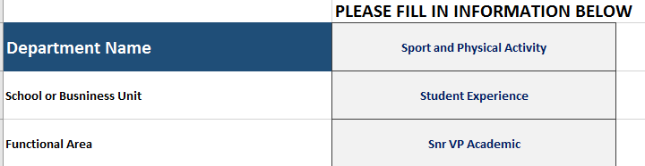
The information in this section will be automatically repeated throughout the Docs. so should be completed first

- Risks/Hazard Tabs

- There are 5 Different primary Risk Categories to Consider. These are set out on Separate Sheet Tabs. We do however recommend you to read through ALL tabs.
Click on EACH tab in turn to open up the relevant Primary Risk Category. (5 tabs to consider in turn)
Each Primary Risk Category has a sub Hazard type List (by rows) which are set up under 2 colour coded panels. (White and Orange).
- On the Right hand side (RHS) of each Hazard row there is Column B (Blue Column) to consider:
  - If the Hazard IS Relevant to the work of the Dept. (enter ‘Y’) OR
  - if the Hazard is Not Relevant (enter ‘N’).
(please only enter 1 response on a row by row basis in Column B for each Hazard).
- When you have completed the Column B (Blue Column) you can then filter the results to show only the ‘Y’ hazard which are applicable.

In this way users in low /normal risk Depts. may easily exclude the hazards that may not apply to them

- Then proceed to enter a Numerical value (for the Question sought) into the corresponding column cell to the right hand side for each row remaining (with a ‘Y’ relevant designation).

- Numerical values entered will auto sum to the final row at the end of each primary Risk tab and also into the final tab/sheet – the Department summary.

- The Dept. summary workbook should then be sent to the Head of Functional Area for including in their overall return (via a Dropbox link or a shared Google Drive)

- FA Mgt. should then cut and paste each Dept. summary output into the overall FA summary sheet and repeat for every for constituent Schools/Business units, having first checked that the Depts. Have submitted a comprehensive return!

Please see pages following below for illustrated Steps by Step in more detail
Encl.

Steps by Step in more details – Illustrated
To Commence please complete the INFO SHEET first
Then proceed to the Hazard Category Sheets, 5 in total.
- A1. Preliminary – Hazard /Risk Tabs
The Hazard Category cells which are WHITE are hazards/risks which may be applicable relevant to 90 to 100% of Departments. (both normal and Variable risk departments).
The cells coloured Orange would be more relevant (additionally) to variable risk departments such as Colleges or Research Institutes in SEFS, M&H and also to Central Service Units (such as B&E, ITS, Student Experience, etc.) We do however recommend for users to read through them all.
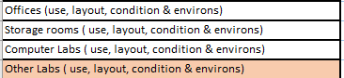

- By clicking on the cells,users can see Safety Statement Documents relevant to the hazard/ risk.
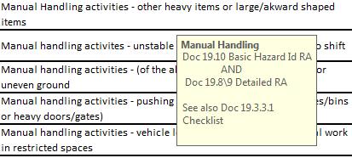
- Each Risk Type page has a BLUE column (B), which should be completed first.

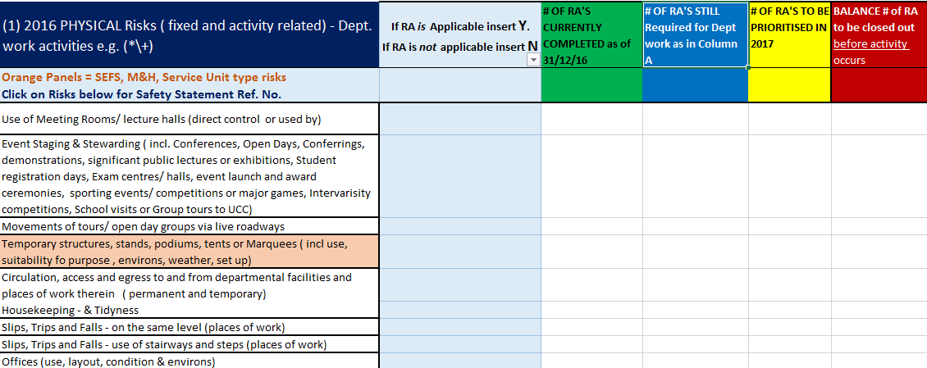

- A2 – Step 1: Use
Consider each row in turn.

- If the risk is applicable to your Department insert ‘Y’ in Column B (Blue Column)
- If the risk is not applicable to your Department insert ‘N’ in Column B (Blue Column)
See example below.
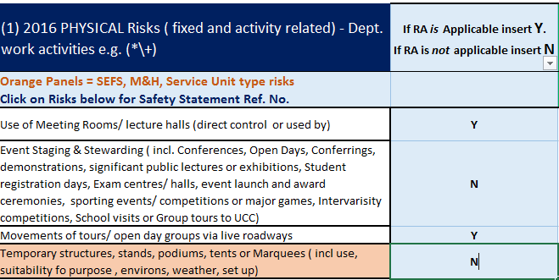

Note
- If there is a risk relevant to your Department that has not been listed in the Column A (non exhaustive listing), Please enter ‘Y’ in the Column B adjacent to the row ‘OTHER’ at the end of Column A for them to be recorded.
See example below

In this instance, then please provide further information for these risks/hazards in the Additional Information Tab. See circled below
Each risk category has an accompanying text box where information regarding each of the ‘other’ RAs should be expanded upon. Please ensure that the number of RAs within the ‘other’ category are equal to the number of descriptors subsequently entered within the accompanying text box.
- A2 – Step 2: Use

- Once Step 1 has been completed, if the risks are relevant to your Department or not, then use the filter option to eliminate the unnecessary rows. E.g reduce list to the ‘Y’ category.
See circled below
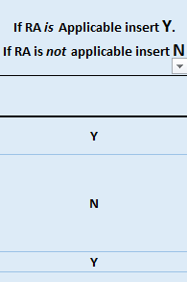

- Now click on the filter option in the Blue (B) Column.
- See circled below
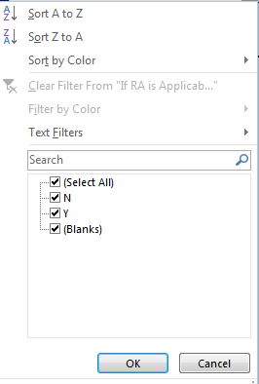
Untick the ‘N’ box and then press ‘OK’
- This will refine the listings to the risks applicable to the Department
See below for example.

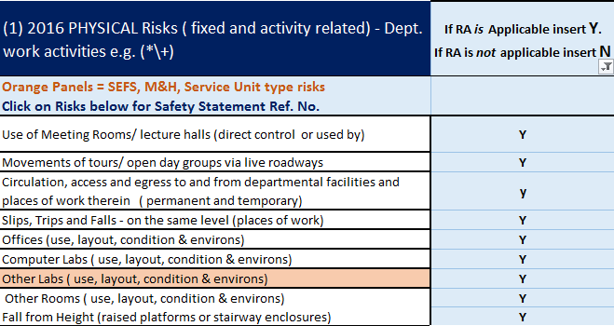
Note: If there are any blanks at this stage please correct before proceeding further.

- A2 – Step 3: Use

- Now proceed to enter data for the RA type concerned, filling in the amount of RA’s within each cell according to column heading.
See below for example
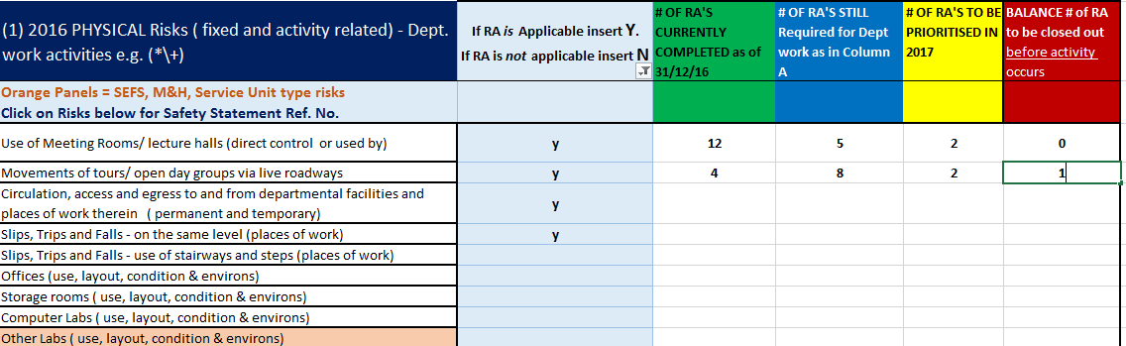

- A2 – Step 4: Use

- Repeat these steps for each applicable row and per risk tab. Note – 5 tabs in all are to be addressed.
Note: Please refer to the note given in the Introduction page of these guidelines, when determining the no. of RAs required to cover the work activities of the Department.
- A2 – Returning RA Book (To the relevant Functional Area Manager)

The information has already been automatically filled into this column from the totals of the previous 5 Risk/Hazard tabs.

The last tab is Department Summary Page
See circled below

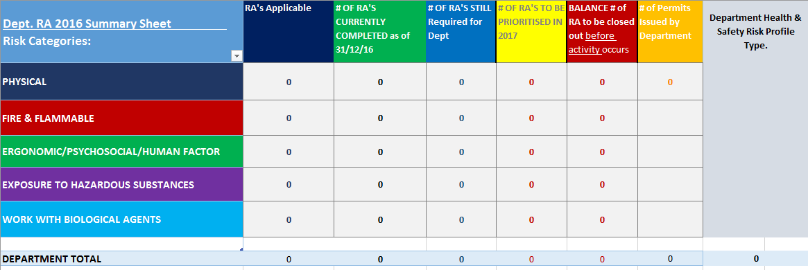

NOTE: Please double check if the totals from the individual risk tabs add up to the Totals in the Department Summary Column.

The Totals Row of the Department Summary Column will be used to complete the FA Summary at the FA Level.

Section B

- FA Risk Assessment 2016 Summary Workbook:(FA Manager only)

  - To complete this, the FA Manager must first send a copy of the Department RA Workbook 2016 and guidelines to each Department within the FA

  - The FA Summary Workbook is for completion by the FA Manager only, on receipt of a comprehensive return from each constituent School/Business unit.

- B2 – Step 1: Completing the FA Summary Workbook

- On return of each Departmental RA Workbook, check that their return is comprehensive, then click on the last tab, “DEPT SUMMARY PAGE”
See circled below

- B2 – Step 2:

- Copy and paste DATA (Line 8) to FA Summary Sheet in the FA Summary Workbook

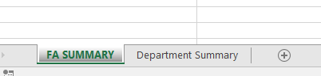

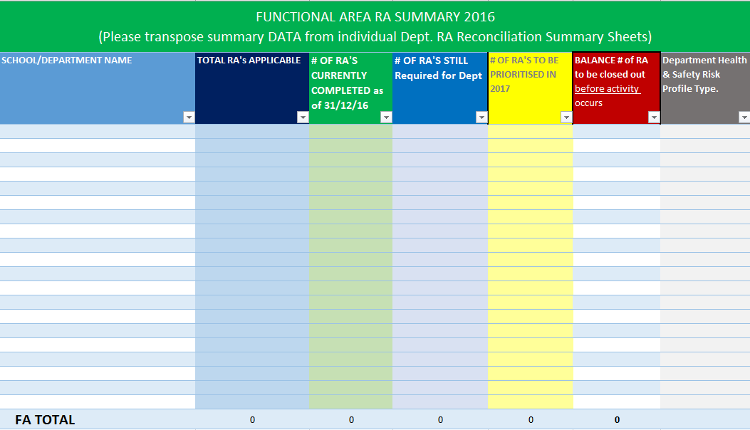
- B2 – Step 3:

  - Copy and Paste the completed Department Table into the FA Workbook (in the Department Summary Tab )

This will show how each FA Summary was compiled.

- B2 – Step 4:

- Ensure each School/Business unit is accounted for & that their RA return is comprehensive and complete.

- Save the FA Summary Workbook under the name of the FA. Ensure each work is correctly named under the name of the Department and return

- The overall FA Summary Work book
and
(B) Each supporting individual Department work book. (Share all with Health & Safety Office via Dropbox or shared Google Drive)

Each FA should return a completed FA Summary Workbook and each individual Department RA Rec 2016 Workbook.

