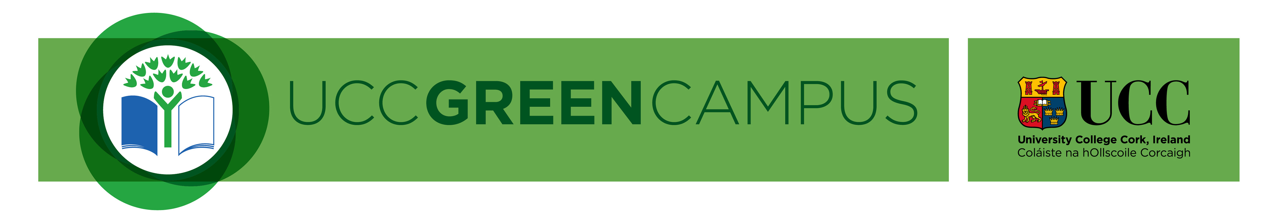 UCC Green Campus Living Laboratory Seed Fund: Local Action, Global Impact

APPLICATION FORM

Please complete and return by email to the Sustainability Officer: m.kirrane@ucc.ie
DEADLINE FOR THE SUBMISSION OF APPLICATIONS
Friday 26th November 2021

1. Project type: | ☐ Masters Project | ☐ Demonstration Project | (Please tick one box)

2. Project title:
(Max. 50 words)

3. Details of Principal Investigator/Project Lead*:
Name:
 | First | Last | Middle Initial(s)
School/Dept./Unit:
Position:
Staff number:
Address:
Email address:
Phone number:
* For correspondence

4. For joint applications:
Please list all co-applicants
 | Name | School/Department/Organisation | Position

5. Keywords describing proposed project:
(Max. 10 words)

6. Abstract:
Please provide a short description of the proposed project (Max. 300 words)

7. Budget Requested:
To include a breakdown of staff, student fees, stipend, equipment, travel (note it is not expected that large equipment items will be funded through this call)

8. Detailed project description:
To include aims, objectives, methods, outputs and impact (Max. 3 pages). Please detail who will undertake the work.

9. Project schedule:
To include a timeline for completion of tasks and details of project management (Max. 1 page)

10. Principal researchers:
Please provide a brief resume of each of the co-applicants including research and other expertise relevant to the proposed project (Max. 2 pages per person)

11. Consent
UCC may wish to use elements of the information provided in this form, anonymously. If you do not wish this information to be used please tick here | ☐

12. Signature:
Signed: |  | Date:
 | Applicant
(Signature is not required if sent from your UCC Email address)

Please complete and return by email to the Sustainability Officer: m.kirrane@ucc.ie by Friday 26th November 2021.

