Metadata Checklist
(Or How to Make Your Content More Findable in Search Engines)
What is Metadata?
- Metadata is ‘information about your information’ – keywords and descriptions relating to your content
- Metadata is used by search engines to categorise your online content and return it as results in relevant searches.
- Each metadata description should be approximately 24 words long and contain words and phrases that sum up the most important aspects of your content.(i.e. leave out words like ‘if’, ‘of’ etc’)
If you don’t add metadata – your content won’t be seen by the widest possible audience
Metadata Process for Text, Video and Photographs:
- Add metadata for your text content on webpages
Step by step video: http://www.ucc.ie/en/media/support/computercentre/cmsdemos2013/AddMetadata.swf

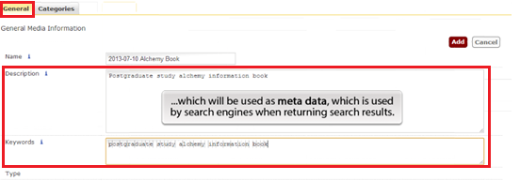
- Add metadata and descriptions to images as you upload to the media library on CMS – step by step video : http://www.ucc.ie/en/media/support/computercentre/cmsdemos2013/MediaLibraryAddImage.swf

UCC Metadata Terms
In order to keep our metadata consistent we recommend that you include the following terms for your content, in addition to the more specific terms
UCC
University College Cork
Study Ireland
Study Cork
Student
Ireland

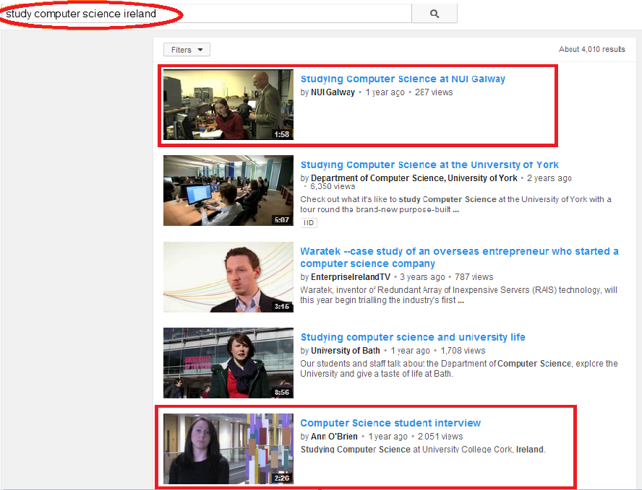
- Add keywords to your video within YouTube

Simply let us know the keywords or search terms that relate to your video, and we can index your video for you – email dewg@ucc.ie

(Wondering why?
YouTube is the second biggest search engine in the world!)

Quick Guide to Search Engine Optimisation
For more information and links to additional tools an resources to help make your content more ‘findable’ – have a look at the following Quick Guide to Search Engine Optimisation http://www.ucc.ie/en/media/support/computercentre/epu/seo-quick-guide.pdf

