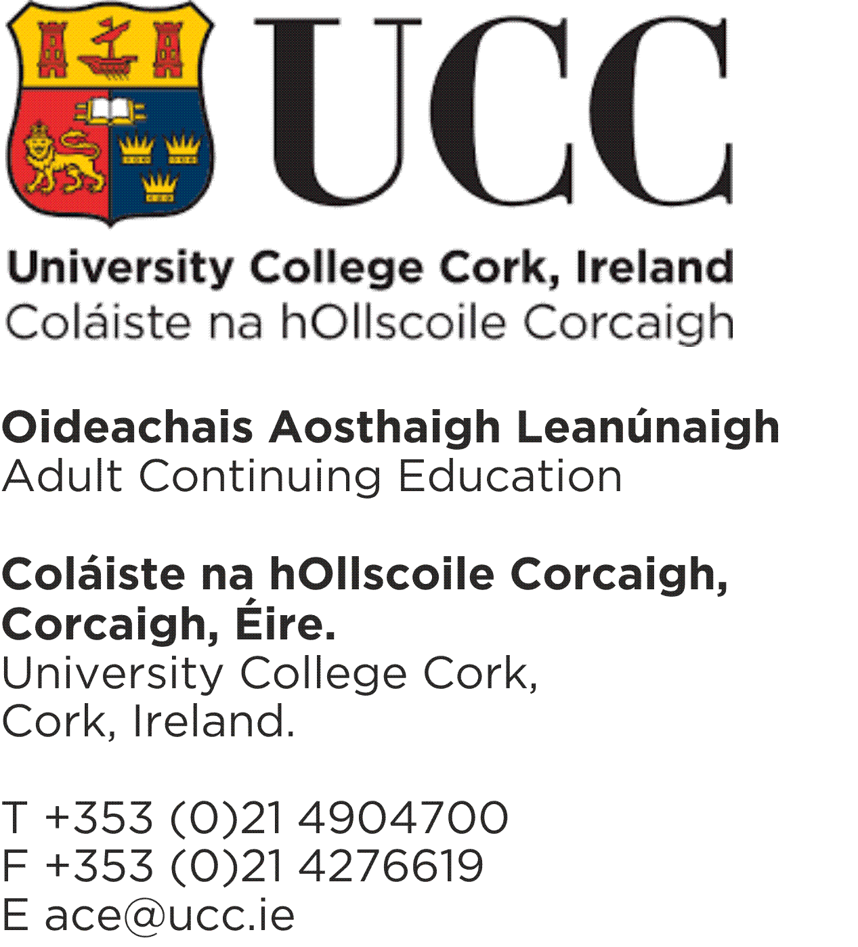

Course Sponsored Payment Form
Sponsorship details must be supplied below. The form must be returned prior to the commencement of your course. On return of form, the sponsoring body will be invoiced for the amount allocated to sponsorship.
It is important to note that responsibility for the prompt and full payment of fees ultimately rests with the student.
Please email your completed form to acefinance@ucc.ie
STUDENT DETAILS: (BLOCK CAPITALS)

Name & Student ID:

Address & Contact No.:

Course Title /Year:
(Year 1 or Year 2)

SPONSORSHIP DETAILS: (BLOCK CAPITALS)

Sponsorship Contact
Person:

Sponsorship Contact
Email: _______________________________________________

Organisation Name:

Organisation Address:

Sponsorship Amount(€) &
PO/Ref if applicable:

Signed: Date:

