‘From a far country’:
Karol Wojtyła, Pope John Paul II: Pole, Priest, Pope

Boole IV Lecture Theatre
University College Cork
Saturday 9th November 2013

 | Boole IV Lecture Theatre
9.30am | Opening remarks  Gabriel Doherty, School of History, University College Cork
9.40am | The moral theology of Pope John Paul II  Dr John Murray, Mater Dei Institute, Dublin
10.40am | Coffee break
10.50am | John Paul II and the People’s Republic of Poland  Dr Marek Lasota, Institute of National Remembrance, Krakow
11.50am | Woman and womanhood in the teaching of John Paul II  Gráinne Doherty, All Hallows College, Dublin City University
12.50pm | Lunch Break
2.15pm | A culture of life in the poems, plays and politics of John Paul II  Ciarán Ó Coigligh, Irish Department, St Patrick’s College, Drumcondra, Dublin
3.15pm | The fortunes of the Catholic church in Ireland during the pontificate of Pope John Paul II  Dr Louise Fuller, National University of Ireland, Maynooth
4.15pm | Coffee break
4.35pm | John Paul II and European politics, 1978-2005  Professor Tadeusz Dmochowsk, Department of Politics, University of Gdańsk
5.35pm | Closing remarks  Gabriel Doherty, School of History, University College Cork

Conference organised by Gabriel Doherty, School of History, University College Cork, with generous assistance from the MyCork Association, the Embassy of the Republic of Poland, Dublin, the Polish chaplaincy, St Augustine’s church, Cork, and the Institute of National Remembrance
Please address any correspondence to: Pope John Paul II conference, School of History, University College Cork.
Conference web site http://www.ucc.ie/en/media/academic/schoolofhistory/documents/Programme.docx

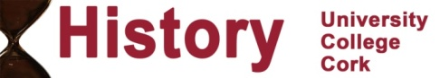
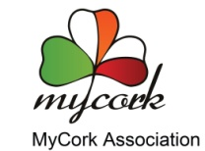 |  | 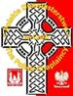 | 