**Department of English**

**Information Booklet**  
**for**

**BA English Third Year**

**2023-2024**

**Department of English – key staff for Third Year**

**Third Year Committee**

Prof. Alex Davis [a.davis@ucc.ie](mailto:a.davis@ucc.ie)

Prof. Lee Jenkins [l.jenkins@ucc.ie](mailto:l.jenkins@ucc.ie)

Dr Ken Rooney (Teaching Officer, semester 1) [k.rooney@ucc.ie](mailto:k.rooney@ucc.ie)

Dr Clíona Ó Gallchoir (Teaching Officer, semester 2) [c.gallchoir@ucc.ie](mailto:c.gallchoir@ucc.ie)

Dr Sinéad Mooney [smooney@ucc.ie](mailto:smooney@ucc.ie)

o-o-o-O-o-o

Deputy Head of English: Dr Heather Laird [h.laird@ucc.ie](mailto:h.laird@ucc.ie)

BA English Programme Director: Dr Miranda Corcoran [miranda.corcoran@ucc.ie](mailto:miranda.corcoran@ucc.ie)

Head of Third Year English (semester 1): Prof. Alex Davis [a.davis@ucc.ie](mailto:a.davis@ucc.ie)

Head of Third Year English (semester 2): Dr Ken Rooney [k.rooney@ucc.ie](mailto:k.rooney@ucc.ie)c.ie

Plagiarism Officer: Prof. Graham Allen [g.allen@ucc.ie](mailto:g.allen@ucc.ie)

Extensions: Apply via [Current Students | University College Cork (ucc.ie)](https://www.ucc.ie/en/english/currentstudents/)

o-o-o-O-o-o-o

**Department of English Office**

O’Rahilly Building, ORB1.57

Office opening times are posted on the door of the Main Office: ORB 1.57

Email: [englishdepartment@ucc.ie](mailto:englishdepartment@ucc.ie)

Telephone: 021 4902664, 4903677, 4902241

The introductory lecture for CK109/BA English students will be held in person at 3.00 p.m., Monday, 11 September 2023 in FSB 322**.**

Registration for seminars will take place remotely using Canvas at the beginning of Semester 1. Students will be given instructions via email on how to use this system.

**Contents**

Department of English: Teaching Policy 2023-24 4

Essay calendar 2023-24 - Semester 1 6

Essay calendar 2023-24 - Semester 2 8

BA English Third Year course requirements for 2023-24 8

Modules designated for BA English 9

Lecture modules and texts 12

Interdepartmental modules 18

Special Studies Seminar module 2023-24 18

Third Year English – List of seminars 2023-24 20

Seminar list 2023-24 – Third Year English 21

Assessment: Policy on Extensions 40

Skills Centre, UCC Boole Library 40

Assignments: guidelines on writing essays 41

Marking Criteria for Assignments 45

Department of English Plagiarism Policy 47

Canvas 52

Turnitin 53

Teaching Council RegistrationCurricular Subject Requirements (Post-Primary) 56

## **Department of English: Teaching Policy 2023-24**

In line with other subjects in the College of Arts, lectures are not recorded in English.

DSS-registered students can contact the individual module coordinator to have recorded lectures made available to them (please note not every lecture course may be able to make recordings available, and seminars and small-group courses are never recorded).

Students not registered with DSS who miss lectures though illness or late registration should contact the individual lecturer to discuss the material taught, but these circumstances will not be deemed grounds for access to recorded lectures.

The Department of English Teaching and Learning committee may consider exceptional cases, with documentation, where there has been prolonged, medically enforced absence, for special release of recorded lectures, but retrospective access to lectures may not be possible in every lecture course.

Please note recorded lectures are not released at autumn examination sittings, except under the criteria stated above.

**Timetable for BA English Third Year**



## **Essay calendar 2023-24 - Semester 1**

(Two assignments per module, titles will be released on Canvas and essays to submitted to Canvas by 11:59pm on dates outlined below)

|  |  |  |
| --- | --- | --- |
| **MODULE** | **Date for release of titles** | **Date for Submission**  **(by 11:59pm)** |
| **EN3065.1**  Romance: Medieval to Renaissance  *(Dr Ken Rooney)* | Thursday 19th October 2023 | Thursday 2nd November 2023 |
| *EN3065.2*  Romance: Medieval to Renaissance  *(Dr Ken Rooney)* | Thursday 30th November 2023 | Friday 5th January 2024 |

|  |  |  |
| --- | --- | --- |
| **EN3073. 1**  Victorian Literature  *(Dr Mary O’Connell-Lenihan)* | Tuesday 17th October 2023 | Tuesday 31st October 2023 |
| **EN3073.2**  Victorian Literature  *(Dr Mary O’Connell-Lenihan)* | Tuesday 28th November 2023 | Friday 5th January 2024 |

|  |  |  |
| --- | --- | --- |
| **EN3075.1**  Contemporary Irish Writing (DRAMA)*  *(Dr Éibhear Walshe)* | Thursday 5th October 2023 | Thursday 19th October 2023 |
| **EN3075.2**  Contemporary Irish Writing (FICTION)*  *(Dr Éibhear Walshe)* | Thursday 9th November 2023 | Thursday 23rd November 2023 |
| **EN3075.1**  Contemporary Irish Writing (POETRY)*  *(Dr Adam Hanna)* | Thursday 30th November 2023 | Friday 5th January 2024 |

*EN3075 **Note:** There are three sections in this module. Students are expected to attend lectures for all three sections but will be required to complete assessments for two sections only. Each student is free to decide which two sections they wish to be assessed. Once you submit the essay for any one section, this will be deemed to be one of your two chosen sections. Therefore, if you have already submitted two essays, you will **not** be permitted to submit for the third section in the hope of achieving a higher mark.

|  |  |  |
| --- | --- | --- |
| **EN3077.1***(FICTION)\**  The Irish Literary Revival and Modernism  *(Dr Sinéad Mooney)* | Friday 6th October 2023 | Friday 20th October 2023 |
| **EN3077.2** *(POETRY)\**  The Irish Literary Revival and Modernism  *(Dr Adam Hanna)* | Friday 10th November 2023 | Friday 24th November 2023 |
| **EN3077.3** *(DRAMA)\**  The Irish Literary Revival and Modernism  *(Dr Eibhear Walshe)* | Friday 1st December 2023 | Friday 5th January 2024 |

*EN3077 **Note:** There are three sections in this module. Students are expected to attend lectures for all three sections but will be required to complete assessments for two sections only. Each student is free to decide which two sections they wish to be assessed. Once you submit the essay for any one section, this will be deemed to be one of your two chosen sections. Therefore, if you have already submitted two essays, you will **not** be permitted to submit for the third section in the hope of achieving a higher mark

|  |  |  |
| --- | --- | --- |
| **EN3108.1**  Modernism  *(Prof Lee Jenkins)* | Friday 20th October 2023 | Friday 3rd November 2023 |
| **EN3108.2**  Modernism  *(Prof Alex Davis)* | Friday 1st December 2023 | Friday 5th January 2024 |

## **Essay calendar 2023-24 - Semester 2**

(Two assignments per module, titles will be released on Canvas and essays to submitted to Canvas by 11:59pm on dates outlined below)

|  |  |  |
| --- | --- | --- |
| **MODULE** | **Date for release of titles** | **Date for Submission (by 11:59pm)** |
| **EN3015.1**  Of Monsters and Men  *(Dr Tom Birkett)* | Friday 16th February 2024 | Friday 1st March 2024 |
| **EN3015.2**  Of Monsters and Men  *(Dr Tom Birkett)* | Friday 12th April 2024 | Friday 26th April 2024 |

|  |  |  |
| --- | --- | --- |
| **EN3048.1**  Modern and Contemporary American Literature  *(Prof Lee Jenkins/Dr Alan Gibbs)* | Tuesday 13th February 2024 | Tuesday 27th February 2024 |
| **EN3048.2**  Modern and Contemporary American Literature  *(Prof Lee Jenkins/Dr Alan Gibbs)* | Tuesday 9th April 2024 | Tuesday 23rd April 2024 |

|  |  |  |
| --- | --- | --- |
| **EN3072.1**  Romantic Literature  *(Dr Cliona O Gallchoir/Prof Graham Allen)* | Thursday 15th February 2024 | Thursday 29th February 2024 |
| **EN3072.2**  Romantic Literature  *(Dr Cliona O Gallchoir/Prof Graham Allen)* | Thursday 11th April 2024 | Thursday 25th April 2024 |

|  |  |  |
| --- | --- | --- |
| **EN3079.1**  Contemporary Culture  *(Dr Miranda Corcoran/Dr Heather Laird/Dr Anne Etienne)* | Wednesday 14th February 2024 | Wednesday 28th February2024 |
| **EN3079.2**  Contemporary Culture  *(Dr Miranda Corcoran/Dr Heather Laird/Dr Anne Etienne)* | Wednesday 10th April 2024 | Wednesday 24th April 2024 |

|  |  |  |
| --- | --- | --- |
| **EN3107.1**  Studies in Shakespeare  *(Dr Edel Semple)* | Tuesday 13th February 2024 | Tuesday 27th February 2024 |
| **EN3107.2**  Studies in Shakespeare  *(Dr Edel Semple)* | Tuesday 9th April 2024 | Tuesday 23rd April 2024 |

## **BA English Third Year course requirements for 2023-24**

**\* Note that it is the responsibility of each individual student to discover and fulfil the exact requirements of the course assessment system, any changes to registration must be approved by the Department of English.**

**BA English Third Year students take 60 credits as follows:**

EN3110 (20 credits);  
***plus*** EN3009 (20 credits)   
**or** EN3109 (10 credits) with the following: EN3003 (10 credits);  
**or**  
EN3112 (10 credits) with the following: EN3003 (10 credits);   
or   
*EN3109 (10 credits) and EN3112 (10 credits)

*plus* 10 credits from Semester 1 and 10 credits from Semester 2.

**Semester 1**EN3065, EN3073, EN3075, EN3077, EN3108 (5 credits per module).

**Semester 2**EN3015, EN3048, EN3072, EN3079, EN3107 (5 credits per module)

**Note:**

* Students who wish to take both EN3109 and EN3112 must secure written permission from the Head of English.
* Students may substitute one module from Semester 1 with LL3002.
* Students cannot take modules that are cross-scheduled.

What follows is an outline list of English courses for the session 2023-2024. Every effort is made to ensure that the contents are accurate. No guarantee is given that modules may not be altered, cancelled, replaced, augmented or otherwise amended at any time.

## **Modules designated for BA English**

**Dissertation EN3110 (20 credits)**

**Module Objective:** The purpose of the Dissertation module is to give students the opportunity to write at length and in detail on a topic of their own choosing within the subject area of English Literature, and of extending their knowledge and ideas through research and self-directed reading. Dissertations must have a bibliography and include a statement that the work submitted is the result of independent study. **The dissertation must not duplicate materials used elsewhere in other modules.**  
  
**Module Content:** Staff will lead timetabled preparatory classes on topic selection and on strategies for research and writing. Students will select and develop a research topic of their choosing in consultation with the module tutor and allocated supervisor(s). Dissertations will normally be 8,000 words long.  
   
**Learning Outcomes:** On successful completion of this module, students should be able to:

* Select an appropriate topic for independent research
* Locate that topic in its scholarly context using a range of appropriate critical literature
* Arrange, develop and present a clear argument about the chosen topic
* Build a controlled argument across a longer piece of work, in a coherent manner.
* Write in correct Standard English, using relevant critical terms and concepts.

**Course schedule** (precise dates on Canvas at the beginning of the academic year)

**Stage 1:** Preparatory classes (early semester 1), **Monday 3–4pm in FSB_322**

**Stage 2:** Proposal submission & allocation of supervisors (mid-semester 1)

Following the conclusion of preliminary classes, students must submit short project proposals of about 50 words on canvas. Students will then be allocated a supervisor by the Department. Students may be asked to alter their proposals before a supervisor is finalised.

**Stage 3:** Meeting your supervisor (late semester 1; all semester 2)

Students will hold **four** meetings with their supervisor to discuss written drafts of their work. The first meeting is to be held immediately after the allocation of your supervisor in semester 1 and the three others at regular intervals in semester 2. **Please note the obligation is on you, the student, to initiate the arrangements for a meeting**; i.e., you must email your supervisor. Supervisors will normally read and give feedback **once** on a completed chapter or section of the dissertation.

**Stage 4: Submitting your dissertation (26th April 2024)**

The dissertation is to be submitted electronically on Canvas, following the conclusion of semester 2 teaching. The dissertation must have a title page listing the title of your thesis, your name, student number, the name of your supervisor(s), and course code (EN3110). It must include a table of contents listing the chapters, and a bibliography. The dissertation should follow the referencing system and style guide contained in *The Modern Language Association Handbook* (9th edition).

Short extensions are granted only for documentable reasons. Dissertations not submitted for the summer exam board are to be submitted at the autumn board and are ordinarily subject to capping.

**Suggested reading (available in the library)**

Eco, Umberto. *How to Write a Thesis*. MIT Press, 2015.

Greetham, Bryan. *How to Write Your Undergraduate Dissertation*. Palgrave Macmillan, 2009.

Murray, Rowena. *How to Write a Thesis*. McGraw Hill, 2011. available on web & in hard-copy.

de Sousa Correa, Delia, and W. R. Owens, eds. *A Handbook to Literary Research*. Routledge, 2009.

Walliman, Nicholas S. R. *Your Undergraduate Dissertation: the Essential Guide for Success*. SAGE, 2004.

Watson, George. *Writing a Thesis: A Guide to Long Essays and Dissertations*. Longman, 1987.

**EN3109 Creative Writing 2 Fiction Workshop (10 Credits)**

|  |  |  |  |
| --- | --- | --- | --- |
| **Module Leader**  Danny Denton | **Semester 1**  **Day** Wednesday | **Time**  12.00-2pm | **Venue**  Cavanagh Pharmacy Building LG_08 |
| **Seminar Content**  This module focuses on developing expertise in the writing of short fiction. The aim of the workshop is to produce sustained pieces of fiction in a workshop setting where student work will be subject to peer review. Students will also analyse the creation of published texts and keep a writing journal. | | | |
| **Learning outcomes**  On successful completion of this module, students should be able to:   * Write and develop works of fiction. * Read and evaluate fiction in terms of its form, style and literary technique. * Discuss issues relating to writers and writing * Demonstrate an awareness of their own writing processes through journal-keeping. | | | |
| **Assessment**  This module is assessed by continuous assessment.  The total number of marks available is 200.  Portfolio of creative work equivalent of c. 3000 words: 150 marks  Writing journal: 30 marks  Contribution and participation: 20 marks  Attendance and participation are compulsory. If a student misses one-third of scheduled classes, without supplying relevant documentation to the module coordinator, they automatically fail the module. | | | |

**EN3112 Creative Writing Poetry Workshop (10 Credits)**

|  |  |  |  |
| --- | --- | --- | --- |
| **Module Leader**  Liz Quirke | **Semester 2**  **Day**  Tuesday | **Time** 3–5pm | **Venue**  Cavanagh Pharmacy Building, room LG_08 |
| **Seminar Content**  Students will learn to read poetry as creative practitioners and how to locate themselves within contemporary Anglophone poetry. Students will produce weekly poem drafts, supported by extensive handouts and prompts, which will be reviewed by their peers in the workshop setting. Students will complete a poetry portfolio and a personal reflective essay on the development of their creative practice. Writers studied on the course include but are not limited to: Kae Tempest, Danez Smith, Jericho Brown, Stephen Sexton, Eavan Boland, Paula Meehan, Paul Muldoon. Texts will be distributed as class handouts. | | | |
| **Learning outcomes**  On successful completion of this module, students should be able to:   * Write and develop poetry across a range of forms * Read and discuss poetry by established writers * Engage in discussion of issues relating to writers and writing * Demonstrate an awareness of their own writing process through a reflective essay | | | |
| **Assessment**  Total Marks 200: Continuous Assessment 200 marks (Portfolio of 10 poems, 100 marks; 1000-word essay, 80 marks; contribution and participation, 20 marks).  Attendance and participation are compulsory. If a student misses one-third of scheduled classes, without supplying relevant documentation to the module coordinator, they automatically fail the module. | | | |

## **Lecture modules and texts**

EN3015 OF MONSTERS AND MEN: OLD AND EARLY ENGLISH LITERATURE: (TB) 5 Credits, Semester 2

Early Medieval literature reveals that horror is by no means a modern phenomenon. This course analyses the heroes, monsters and monstrous human behaviour of early medieval texts (such as Beowulf) as cultural constructions which reveal a society’s values and fears. It places texts that examine humour and horror within cultural and theoretical contexts that challenge the critical status quo, and invites students to explore features of the medieval corpus too often hidden (literally and figuratively) from the light of day. We will take anthropological constructs of the liminal – those outside of a society yet central to its sense of identity – and the theoretical concept of the abject, and consider how these constructs might be used to illuminate medieval concepts of self and other, us and them, acceptable and alien. By examining a range of texts from both the prose and poetic corpus, we will analyse the role and function of the hero and ‘the other’, and ask where authors draw the line between the monster and the man.

Knowledge of Old English is not a pre-requisite for this course.

**Set texts:**

Students are strongly recommended to acquire:

*The Beowulf Manuscript*. Edited by R. D. Fulk. Harvard UP, 2010 [includes *Judith*, *The Wonders of the East*, *The Letter of Alexander* and *The Passion of St Christopher*, alongside *Beowulf* itself]

*The Saga of Grettir the Strong*. Edited by Bernard Scudder. Penguin, 2005.

Other texts will be provided.

**EN3048 MODERN AND CONTEMPORARY AMERICAN LITERATURE: (LJ/AG)**

**5 Credits,** Semester 2

This module explores a selection of American writing from 1900 to the present day, with reference to historical background and contexts, race, gender, and class.

The Harlem Renaissance (poems and essays)*

Larsen, Nella. *Quicksand and Passing*. Serpent’s Tail, 2014.

Fitzgerald, F. Scott. *The Great Gatsby*. Penguin, 2000.

Hemingway, Ernest. “The Snows of Kilimanjaro.” 1936.*

Theodore Dreiser, “Old Rogaum and his Theresa.” 1901.*

Jack London, “To Build a Fire.” 1908.*

Mary Wilkins Freeman, “Old Woman Magoun.” 1905.*

Mamet, David. *Glengarry Glen Ross*. 1983. Methuen, 2004.

Moore, Lorrie. *A Gate at the Stairs*. Faber, 2009.

* These texts will be made available on Canvas.

**EN3065 ROMANCE: MEDIEVAL TO RENAISSANCE (KR)**

**5** **Credits, *Semester 1***

Stories of Arthur and his knights, of exile and of return (sometimes even from death), crises of identity and love, perilous encounters with otherworldly beings: these are some of the recurring concerns of romance, a genre which, in the Middle Ages and Renaissance, served its audiences with exemplary and sensationalist narratives in startlingly varied, and often sophisticated ways. This module will explore the diversified nature of English romance writing from this period, through close thematic study of some the most important examples, both anonymous and authored.

**3065.1 Anonymous Romance**

*Sir Gowther*. Edited by E. Laskaya and E. Salisbury, TEAMS, 1995.

Available online at <http://d.lib.rochester.edu/teams/text/laskaya-and-salisbury->middle-english -breton-lays-sir-gowther-introduction

*Sir Amadace* Edited by E. Foster, TEAMS, 2007.

Available online at <http://d.lib.rochester.edu/teams/text/foster-sir-amadace-introduction>.

**3065.2 Romance and its authors**

Chaucer, Geoffrey. *Sir Thopas* and *The Man of Law’s Tale* from *The Canterbury Tales*. In *The Riverside Chaucer*, ed. L. D. Benson. Oxford: OUP, 1987.

Spenser, Edmund. *The Faerie Queene*, Book I. In *Edmund Spenser’s Poetry*, Eds A.L. Prescott & A. Hadfield. 4th ed. New York: Norton, 2013.

**EN3072 ROMANTIC LITERATURE (CÓG/GA)**

**5 Credits,** Semester 2

This module will develop students’ understanding and experience of literature in English from the Romantic period (1770-1830). It covers a selection of literary texts from the Romantic period. Students are exposed to conflicting definitions of Romanticism and encouraged to critically analyse the selected texts in the light of these theoretical descriptions. Special emphasis is placed on the role of poetryand prose fiction, and on the gendered nature of writing in the period.

Austen, Jane. *Northanger Abbey*. Edited by Susan Fraiman, W. W. Norton, 2004.

Wollstonecraft, Mary and Mary Shelley*. “Maria, or The Wrongs of Woman”* *and “Matilda*.” Edited by Janet Todd, Penguin, 1993.

**EN3073 VICTORIAN LITERATURE (MO’C-L)**

**5 Credits, Semester 1**

Mid to late 19th century English literature responded to a range of political, social, and economic transformations. This is the era which saw Charles Darwin’s publication of his theory of evolution; it is an era of industrialization, of scientific and technological discovery and of advances in publishing which meant greater numbers of books and readers than ever before. This course looks at some of the most famous novels and short stories of the period including Anne Brontë ’s feminist novel about a mysterious widow, George Eliot’s Middlemarch, routinely considered the greatest of all Victorian novels, the first appearance of the world’s greatest detective, and H.G Well’s science fiction novella, The Time Machine.

Anne Brontë, *The Tenant of Wildfell Hall* (1848)

Arthur Conan Doyle, *The Adventures of Sherlock Holmes* (1892)

George Eliot, *Middlemarch* (1871)

H.G. Wells, *The Time Machine* (1895)

**EN3075 CONTEMPORARY IRISH WRITING (EW/AH)**

**5 Credits.** Semester 1

This module gives the opportunity to explore a range of contemporary Irish writing. We study texts in three genres (drama, poetry, fiction) from the 1960s to the present. The module is taught in three segments: contemporary Irish poetry, contemporary Irish fiction and contemporary Irish theatre.

**Contemporary Irish Poetry (AH)**

The opening one-third of the module outlines the main themes developed, and the differing formal tactics adopted, by Irish poets over the last forty years. It will focus on a small number of poets, chosen from among the following:  Derek Mahon, Michael Longley, Medbh McGuckian, Paula Meehan, Sinéad Morrissey, Billy Ramsell and Doireann Ní Ghríofa.

Required Reading

The set poems will be provided.

**Contemporary Irish Fiction (EW)**

Required Reading

O’Brien, Edna. The Country Girls. Faber, 2007.

Tóibín, Colm. The Empty Family Penguin, 2010.

Ni Dhuibhne, Eilis. The Dancers Dancing. Blackstaff Press, 1989.

McLaughlin, Danielle, Dinosaurs on Other Planets. The Stinging Fly, 2105.

**Contemporary Irish Theatre (EW)**

Required Reading

McGuinness, Frank. *Observe the Sons of Ulster Marching Towards the Somme*. Faber, 1985.

Friel, Brian. *Translations*. Faber 1980.

**EN3077 THE IRISH LITERARY REVIVAL AND MODERNISM (SM/AH/EW)**

**5 Credits,** Semester 1

This course will give students a foundation in Irish writing, Irish cultural history and Irish literary criticism in the modernist period. It will explore a range of texts drawn from various forms (fiction, poetry, drama and/or film) from the late nineteenth century up to the 1960s.

Bowen, Elizabeth*. The Last September*. 1929. Vintage, 1998.

Beckett, Samuel. *Murphy*. 1938. Faber, 2008.

Harrington, John P., editor. *Modern and Contemporary Irish Drama*. 2nd ed., W. W. Norton, 2008.

Further poetry of the period will be provided.

**EN3079 CONTEMPORARY CULTURE (MC/HL/AE) 5 Credits, Semester 2**

This module introduces students to a selection of post-1980s cultural texts. These could include works produced for the theatre and other kinds of performance, electronic literature and popular fiction. The texts studied may vary from year to year. The plays selected challenge traditional dramatic narratives and explore their contemporary British and Irish societies. In tackling different decades, topics and dramaturgies, we will question how theatre language and form has evolved within the contemporary period and addressed (or ignored) political issues. The works of fiction studied in the course span a range of genres and literary forms. Incorporating everything from contemporary literature to science fiction and the graphic novel, these texts engage in unique ways with the social, political and cultural contexts of the early twenty-first century. In doing so, these works demonstrate the diversity and variability of modern literary production, and illustrate how different generic forms can be employed to explore a host of complex issues, including modern politics, gender and race.

Carroll, Emily. *Through the Woods*. Faber, 2014.

Whitehead, Colson., *The Underground Railroad*. Doubleday, 2016.

Byers, Sam, *Perfidious Albion*. Faber, 2018.

Churchill, Cary. *Top Girls*. 1982. In *Modern Drama: Plays of the ‘80s and ‘90s*. Edited by Sarah Kane and Terry Johnson, Methuen, 2007.

Kane, Sarah. *Blasted*. 1995. In *Modern Drama: Plays of the ‘80s and ‘90s*. Edited by Sarah Kane and Terry Johnson, Methuen, 2007.

Crimp, Martin. *Attempts on Her Life*. 1997. Faber, 2007.

**EN3107 STUDIES IN SHAKESPEARE (ES) 5 Credits,** Semester 2

This module explores a selection of plays spanning Shakespeare’s writing career. Our analysis will employ close study of the plays’ context, handling of generic conventions, and audience expectations, and the content of ideas and themes embodied within these acted worlds. The chosen texts span a range of genres and showcase both the innovations made by Shakespeare and how he worked within inherited dramatic traditions.

**For 2023-2024, the plays on the module will be:** *Richard III, A Midsummer Night’s Dream, Pericles, Prince of Tyre, and Antony and Cleopatra.*

Recommended edition: Shakespeare. *The Norton Shakespeare*. Edited by Greenblatt et al. 3rd ed. Norton, 2015.

**EN3108 MODERNISM (LJ/AD)**

**5 Credits, Semester 1**

This module introduces students to literary modernism through an analysis of a range of experimental texts from the early to mid-twentieth century.

Eliot, T.S. *The Waste Land*. <https://wasteland.windingway.org/poem>; <http://eliotswasteland.tripod.com/>

Lawrence, D. H. *Lady Chatterley’s Lover*. Wordsworth Classics, 2005.

Pound, Ezra*. Selected Poems, 1908-1969*. Faber, 1977.

Woolf, Virginia. *Mrs Dalloway*. Wordsworth Classics, 1996

**STAFF MEMBERS**

GA = Professor Graham Allen

TB = Dr Tom Birkett

MC = Dr Miranda Corcoran

AD = Professor Alex Davis

DD = Danny Denton

AE = Dr Anne Etienne

AG = Dr Alan Gibbs

AH = Dr Adam Hanna

LJ = Professor Lee Jenkins

HL = Dr Heather Laird

SM = Dr Sinéad Mooney

MO’C-L = Dr Mary O’Connell-Lenihan

COG = Dr Clíona Ó Gallchoir

KR = Dr Kenneth Rooney

ES = Dr Edel Semple

EW = Dr Éibhear Walshe

## **Interdepartmental modules**

Students may substitute **one** module with LL3002:

**LL3002:  Travel Writing:  5 Credits in Semester 2**

***Course Coordinator:*** *Silvia Ross (Department of Italian) –* ***Email****:*[***s.ross@ucc.ie***](mailto:s.ross@ucc.ie)

**Semester 2: Tuesdays 1-2pm in Elect_L2 and Thursdays 3-4pm in Elect_L2**

This module examines the theory and practice of travel writing. Students will read a set of texts (in English and in English translation) that range from literature of the nineteenth century to contemporary writing. We will be looking at writers who have travelled to such places as Italy, Spain, North Africa and the Middle East, among others. We will consider issues such as the nature of the genre, the relationship between writing and travelling, and the conceptualization of foreign cultures.

## **Special Studies Seminar module 2023-24**

**EN3003 SPECIAL STUDIES SEMINAR: Semester 1 or Semester 2**

**10 Credits, taken by assessment**

**EN3009 SPECIAL STUDIES SEMINARS: Semesters 1 and 2.**

**20 Credits, taken by assessment (NOTE: EN3009 consists of any two seminars from those offered in EN3003, and is only available to BA English and BAS (50 credits) English Students.)**

This seminar module is designed to develop students’ skills in reading, writing and critical practice through closely directed study and constructive discussion of a range of selected texts. Students must choose one from the wide range of topics offered by the staff of the Department of English. The range of topics will cover a variety of forms, genres and periods. Once a student has signed on for a seminar, attendance is required.

**ATTENDANCE**

Attendance at seminars is mandatory and student participation in seminars constitutes 15% of the seminar mark.  Students cannot miss more than eight hours (one third) of seminar classes without presenting documentation in relation to absences. Students who miss more than one third of classes on medical grounds may be asked to complete an additional short assignment – an exercise in lieu of participation - to aid their learning in the seminar course, at the discretion of the seminar leader. This exercise can only be assigned where the other components of the seminar have also been completed.

Students without medical evidence to account for absence from more than one third of classes in the seminar automatically fail the seminar and must complete this exercise in lieu, with any other work not completed for the seminar, in the autumn exam session in late July / August.

A student who has failed a seminar due to unexplained non-attendance may continue to attend and hand in assignments, but this work will be held over for the autumn exam session. The result for the module will be capped at 40% unless the student applies for and is granted mitigation by University Exams Records (SREO).

.

[Mitigation | University College Cork (ucc.ie)](https://www.ucc.ie/en/student-records/exams/appeal-mitigation-recheck/mitigation/).

**ASSIGNMENT of MARKS in SEMINAR MODULES**

1. Participation 15%

2. Oral presentation (or equivalent) 15%

3. Shorter assignment(s) 20%

4. Essay work* 50%

*not exceeding 4,000 words in total

**WRITTEN OUTLINE OF ASSESSED WORK**

At the start of the semester each coordinator will give a written outline of the work expected for nos. 2, 3 and 4 to students in each seminar.

**ASSIGNMENT OF MARKS EXPLAINED BY CATEGORY**

**1. Participation: 15%**

Students can gain these marks by contributing actively to each class. This means carrying out all tasks assigned, being ready and willing to discuss the material and the topics addressed in class, and cooperating with other class members and the coordinator.

**2. Oral presentation or equivalent: 15%**

Marks awarded here for committed, organized and effective preparation and delivery of set oral assignment(s), e.g. discussion of a text, author or topic, or another type of project assigned by the coordinator.

**3. Shorter assignment(s): 20%**

These may take various forms, e.g. a quiz or exercise, short essay, or discussion of a text or excerpts from texts.

**4. Essay work, not exceeding 4,000 words in total: 50%**

This may consist of one, two or more essay(s) or other assignments, of varying lengths, e.g. a write-up of the oral presentation, or another type of project as assigned by the coordinator.

**CONSULTATION AND ADVICE ON TAKE-HOME WRITTEN WORK**

Seminar coordinators **will** offer individual consultations to students concerning their performance in the seminar module. Coordinators may

▪ respond to students’ questions or difficulties about the material

▪ explain marks given for assignments

▪ give students advice about how to improve their written style

▪ help students with essay planning.

Coordinators **will not**

▪ Read or correct drafts of essays or other assignments or offer detailed advice about their improvement, in advance of their being handed in for marking.

**SEMINAR REGISTRATION INFORMATION**

NB* It is your responsibility to ensure that the seminar you choose does not clash with your other modules.

Enrolment for seminar courses will take place on canvas at the beginning of semester 1. Instructions to students will be issued on canvas.

* Students wishing to register a change of module must do so at <https://mystudentadmin.ucc.ie/> no later than **two** working weeks after the formal start date of each Semester.
* Semester 1 modules **cannot be changed** in Semester 2.

However, **if you wish to withdraw from a seminar or transfer to a different seminar**, you must contact the Department of English at english@ucc.ie.

## **Third Year English – List of seminars 2023-24**

## **Seminar list 2023-24 – Third Year English**

|  |  |  |  |  |  |
| --- | --- | --- | --- | --- | --- |
| **Seminar Leader** | **Semester** | **Module**  **Code** | **Seminar**  **code** | **DAY & TIME** | **VENUE** |
| Prof Graham Allen | 2 | EN3003 | SMR 3.01 | Wednesday 11-1pm | ORB_1.65 |
| Dr Sarah Bezan | 1 | EN3003 | SMR 3.02 | Thursday 11-1pm | ORB_1.65 |
| Dr Tom Birkett | 2 | EN3003 | SMR 3.03 | Thursday 10-12 noon | AL_G19 |
| Dr Miranda Corcoran | 2 | EN3003 | SMR 3.04 | Wednesday 9-11am | BL4_G01 |
| Dr Anne Etienne | 1 | EN3003 | SMR 3.05 | Wednesday 10-12 noon | ORB_1.65 |
| Dr Alan Gibbs | 1 | EN3003 | SMR 3.06 | Tuesday 2-4pm | ElderWood 3_G01 |
| Dr Alan Gibbs | 2 | EN3003 | SMR 3.07 | Thursday 2-4pm | West Wing 8 |
| Dr Micahel Booth | 1 | EN3003 | SMR 3.08 | Friday 9-11am | ORB_3.26 |
| Prof Lee Jenkins | 2 | EN3003 | SMR 3.09 | Thursday 10-12 noon | ORB_1.65 |
| Dr Heather Laird | 1 | EN3003 | SMR 3.10 | Tuesday 3-5pm | ElderWood 5_G01 |
| Dr Sinéad Mooney | 2 | EN3003 | SMR 3.11 | Tuesday 11-1pm | ORB_1.65 |
| Dr Mary O’Connell-Lenihan | 1 | EN3003 | SMR 3.12 | Thursday 9-11am | ElderWood 3_G01 |
| Dr Clíona Ó Gallchoir | 2 | EN3003 | SMR 3.13 | Thursday 10-12 noon | ORB_2.44 |
| Dr Liz Quirke | 2 | EN3003 | SMR 3.14 | Thursday 2-4pm | West Wing 4 |
| Dr Ken Rooney | 2 | EN3003 | SMR 3.15 | Thursday 11-1pm | ElderWood 2 _G01 |
| Dr Edel Semple | 1 | EN3003 | SMR 3.16 | Monday 4-6pm (Screening)  Wednesday 11-1pm (Seminar) | West Wing 7  AL_G32 |

**Venues: AL** – Aras Na Laoi; **BL4 –** Bloomfield Tce., Western Rd.; **ELD** – Elderwood, College Road;

**ORB** – O’Rahilly Building; **WW**- West Wing

|  |  |  |  |
| --- | --- | --- | --- |
| **Module Code**  **EN3003** | **Seminar Code**  **SMR 3.01** | **Seminar Title**  The New AI (Artificial Intelligence) cinema and television | **Seminar Leader**  Professor Graham Allen |
| **SEMESTER**  2 | **Day**  Wednesday | **Time**   11.00 - 1.00 pm | **Venue**   ORB 1.65 |
| **Seminar Content**  Students will watch, study and analyse the following films, which they will discuss in terms of the tradition of sci-fi in cinema and contemporary debates about artificial intelligence:  *AI. Artificial Intelligence* (dir. Steven Spielberg)  *Blade Runner* (dir. Ridley Scott)  *Ex Machina* (dir. Alex Garland)  *Her* (dir. Spike Jonze)  *Westworld* Season One (Joy and Nolan, 2016-)  *Blade* *Runner* (Scott, 1982)  *Blade Runner 2049* (dir. Denis Villeneuve, 2017)  *I am Mother* (Sputore, 2019)  *Chappie* (dir. Neill Blomkamp, 2015) | | | |
| **Primary texts**  As above. All films will be chosen because of their ease of accessibility. Students are responsible individually for accessing all films discussed in class. | | | |
| **Learning outcomes**  By the end of this seminar, students will be able to:     * Discuss critically and culturally contemporary examples of the new AI cinema * Analyse cinema’s representation of a set of contemporary scientific ideas * Evaluate these films in terms of the following: gender representation; the idea of the Uncanny Valley; the Sublime; transhumanism; ecological contexts. | | | |

|  |  |  |  |
| --- | --- | --- | --- |
| **Module Code**  **EN3003** | **Seminar Code**  **SMR 3.02** | **Seminar Title**  Literature and Extinction | **Seminar Leader**  Dr Sarah Bezan |
| **SEMESTER 1** | **Day**  Thursday | **Time**  11:00 - 1:00 pm | **Venue**  ORB_1.65 |
| **Seminar Content**  How do we make sense of the overwhelming scale of the sixth mass extinction? As you will learn in this module, storytelling presents us with ways to meaningfully engage with environments that are rapidly changing as a result of human-accelerated species losses. Through an exploration of contemporary representations of extinction - from literature and film to digital arts and natural history museum exhibits - we will examine the global and local scope of extinctions as well as their aesthetic, literary, natural historical, and socio-political contexts. In particular, our analysis of extinction fictions will illuminate the ways in which racial, colonial, and sexual/gendered violence has indelibly shaped the future of biological and cultural life on earth. This analysis takes into consideration the repurposing of aesthetic traditions like the Romantic sublime along with genres including science fiction, the ecogothic, and zombie comics. Through in-class exercises and an ‘Extinction Show and Tell,’ you will be offered an opportunity to critically and/or creatively reflect on extinct species such as the Hawaiian ‘ō’ō bird, Tasmanian tiger (thylacine) and great auk, as well as endangered and extinct species native to the Irish landscape. | | | |
| **Primary texts**  Atwood, Margaret. *Oryx and Crake.* McLelland and Stewart, 2002.  Erdrich, Louise. *Future Home of the Living God.* HarperCollins, 2017.  Leigh, Julia. *The Hunter.* Faber & Faber, 1999. (accompanied by film screening, *The Hunter*, Dir. Daniel Nettheim)  Maria Lux, *Famous Monsters.* Work Press & Publication, 2019. (Comic book provided as PDF doc)  Page, Jeremy. *The Collector of Lost Things.* Pegasus, 2013.  Bradley, James. *Ghost Species*. Penguin, 2020. | | | |
| **Learning outcomes**  On successful completion of this course, students will be able to:   * analyze primary texts in relation to their aesthetic, literary, natural historical and socio-political contexts. * compare differences between genre, style, form, and creative adaptation. * critically engage with secondary literature. * evaluate your own and others’ academic writing. * draw upon and effectively implement theoretical tools and concepts. * utilize digital methods and conservation/curatorial tools. * display evidence of both independent and collaborative critical-creative thinking. | | | |

|  |  |  |  |
| --- | --- | --- | --- |
| **Module Code**  **EN3003** | **Seminar Code**  **SMR 3.03** | **Seminar Title**  Poetry of the Vikings | **Seminar Leader**  Dr Tom Birkett |
| **SEMESTER 2** | **Day**  Thursday | **Time**  10.00 - 12.00 | **Venue**  AL_G19 |
| **Seminar Content**  The popular image of the Vikings is one of bloodthirsty pagan warriors, with the recent series *Vikings* depicting a world of blood, sex and sacrifice. But Norse society also gave us the first parliament and an extraordinary body of saga literature, whilst the peoples we call by the shorthand ‘Vikings’ granted sexual and inheritance rights to women, were the first Europeans to set foot in North America, served as the bodyguard to the Byzantine Emperor, and founded the city of Cork! The Norse skalds also composed some of the most extraordinary poetry to survive from the medieval world, documenting their beliefs, venerating their powerful patrons, and voicing their concerns about love, life and death.  In this course we will study a range of poetic genres dealing with legendary characters, heroic battles and domestic troubles – from the poetic account of Odin’s discovery of runes, to Guðrún’s awesome revenge on her devious husband – learning about Norse mythology and the stories that inspired Tolkien’s Middle-earth. We will also consider poetic responses to the Vikings, and literary depictions of Norse culture, including a viewing of selected scenes from the Vikings series which reconceive Norse poetry for a modern audience. | | | |
| **Primary texts**   * *The Poetic Edda.* Trans. Carolyne Larrington, 2nd ed., Oxford UP, 2014. * Birkett, Tom. *The Norse Myths*. Quercus, 2018. * North, T., et al., editors. *Longman Anthology of Old English, Old Icelandic, and Anglo-Norman Literatures*. Longman, 2011. [Texts from this volume will also be made available as PDFs.] | | | |
| **Learning outcomes**  By the end of this course students should be able to:   * Critically read and analyse a selection of Old Norse and Old English poetry, recognising different genres, themes and styles. * Understand the historical, social and political contexts in which these texts were produced and circulated. * Discuss the different facets of Old Norse society, customs and codes of behaviour. * Relate the poetry to the material culture and artwork of medieval Scandinavia. * Appreciate the ways Norse poetry has influenced literary traditions to the present day. | | | |

|  |  |  |  |
| --- | --- | --- | --- |
| **Module Code**  **EN3003** | **Seminar Code**  **SMR 3.04** | **Seminar Title**  Twentieth- and Twenty-First- Century American Science Fiction | **Seminar Leader**  Dr Miranda Corcoran |
| **SEMESTER 2** | **Day**  Wednesday | **Time\***  9.00 - 11.00 am | **Venue**  BL4_G01 |
| **Seminar Content**  In the decades immediately following World War II, the science fiction genre enjoyed an unprecedented level of popularity amongst the American public. Not only did its highly speculative subject matter appeal to a culture preoccupied with technological advancement, but its imaginative themes provided a means for authors and filmmakers to address a broad array of social issues in new and interesting ways. Incorporating a wide variety of cinematic and literary texts, this module will introduce students to a diverse range of twentieth- and twenty-first-century American science fiction. Students will be encouraged to consider the ways in which such texts adapted the tropes and conventions of the sci-fi genre in order to comment upon and critique many of the major social and cultural concerns of the past century. These include issues surrounding science and technology, gender, sexuality, race and identity. | | | |
| **Primary texts**   * Bradbury, Ray. *The Martian Chronicles*. 1950. Harper, 2014. * N.K. Jemisin, “Non-Zero Probabilities.” 2009 (made available on Canvas). * Levin, Ira. *The Stepford Wives*. 1972. Corsair, 2011. * Roanhorse, Rebecca. “Welcome to Your Authentic Indian Experience™” 2017 (made available on Canvas). * Tiptree, Jr., James (aka Alice Sheldon), “The Girl Who Was Plugged In.” 1973 (made available on Canvas). * *Invasion of the Body Snatchers*. Directed by Don Siegel. 1956. * *Alien*. Directed by Ridley Scott. 1979. * *Aliens*. Directed by James Cameron. 1986. * *Get Out*. Directed by Jordan Peele. 2017. | | | |
| **Learning outcomes**  Upon successful completion of this course students should be able to:   * Critically read and analyse a selection of twentieth- and twenty-first-century American science fiction texts. * Compare the manner in which these texts utilise the thematic conventions of the science fiction genre in order to comment upon a wide variety of social and political issues. * Discuss the cultural and historical context which framed the development of the science fiction genre as a vehicle for social commentary and criticism. * Define terms and concepts central to relevant aspects of genre theory. * Apply these terms and concepts to the set texts. * Understand the vital role of genre fiction and popular entertainment as a mode of reflecting and critiquing broader social and cultural concerns. | | | |

|  |  |  |  |
| --- | --- | --- | --- |
| **Module Code**  **EN3003** | **Seminar Code**  **SMR 3.05** | **Seminar Title**  Research in Drama | **Seminar Leader**  Dr Anne Etienne |
| **SEMESTER 1** | **Day**  Wednesday | **Time**  10.00 - 12.00 noon | **Venue**  ORB_1.65 |
| **Seminar Content**  This seminar provides an opportunity for advanced research in modern and contemporary drama. It enables students to develop methods of enquiry through work carried out individually and in groups as well as supervision meetings.  Through a selection of texts spanning the 20th century we will study the critical and cultural background of the plays in order to apply historiographical, dramaturgical, and conceptual principles to assignments. The seminar will involve a visit to the library and its collections to explore and interrogate secondary and archival sources. The seminar will include writing workshops where students will work in groups on research questions related to the plays studied, and present a portfolio that will show the context of their research and articulate the research questions and methodology. Students will do an oral presentation on their work-in-progress (as a way to share ideas and questions for their individual project). Students will also complete an individually-written essay on a research topic of their choice and based on their investigation of primary and secondary sources. | | | |
| **Primary texts**  George Bernard Shaw. *The Shewing Up of Blanco Posnet*  Noel Coward. Tbc  Joe Orton. *What the Butler Saw*  Edward Bond. *Saved*  Top Stoppard. *Arcadia* | | | |
| **Learning outcomes**  By the end of this course students should be able to:   * demonstrate in written and/or oral assignments their knowledge and critical understanding of 20th-century drama; * carry out a research project in drama; * organise and structure research findings; * demonstrate engagement with the cultural context and issues of the plays; * show development of analytical skills through textual analysis and research work; * adapt research and critical skills through different types of group and independent exercises. | | | |

|  |  |  |  |
| --- | --- | --- | --- |
| **Module Code**  **EN3003** | **Seminar Code**  **SMR 3.06** | **Seminar Title**  Experimental Fiction and Narratology | **Seminar Leader**  Dr Alan Gibbs |
| **SEMESTER 1** | **Day**  Tuesday | **Time**  2.00 - 4.00 pm | **Venue**  ElderWood 3_G01 |
| **Seminar Content** This module has a two-part aim. Firstly, to explore works of contemporary experimental fiction, in particular how they operate through innovative forms of narrative. Second, to use examples of contemporary fiction as a means to find out more about narratology, the study of narrative. The seminar thus aims to reinforce and extend students’ knowledge of ideas to do with narrative and narratology first broached in lectures on the First Arts Theories module (EN1004). Classes will look at the way in which contemporary authors experiment with narrative elements such as the treatment of time, and the perspective of the narrating voice.  Although several examples from both literature and visual media are used, the course pays particularly detailed attention to Anna Burns’ extraordinary 2007 novel, *Little Constructions*, as a way of exploring different narrative concepts. This novel conducts numerous diverse experiments with elements of narrative: flashbacks and flash-forwards, gaps in the narrative, digressions, events later erased, shifts in narrating voice etc. Students will consider the effect of these experiments in narrative and speculate in class as to why the author chose to write the novel in this way. Here, discussion will pay particular attention to the interrelationship between this experimental form and the novel’s challenging content, focusing as it does on traumatic events, including gender-based violence. As such, Burns’ novel forms a case study for students to learn about advanced concepts in narratology, and to become more confident discussing particular components of narrative and their effect on us as readers. An array of other texts – including short stories, excerpts from novels, and visual media – are also discussed in relation to their experimental narrative strategies. | | | |
| **Primary texts**  Anna Burns, *Little Constructions* (Graywolf Press, 2019 [2007])  Selected excerpts from experimental fictions (made available via Canvas)  Selected theoretical readings on narrative/narratology (made available via Canvas) | | | |
| **Learning outcomes**  By the end of this course students should be able to:   * Critically read and analyse a selection of contemporary experimental fiction/visual media * Comment critically and knowledgeably on the novel *Little Constructions* by Anna Burns * Relate the set texts to one another and to other experimental narratives * Define terms and concepts central to narratology, and discuss them with confidence * Discuss the interrelationship of experimental narrative form and particular subject matter * Apply these terms and concepts to the set texts, and to other literary and visual media texts * Participate in class and group discussions * Write clearly structured essays in correct Standard English that adhere to the Department of English style sheet | | | |

|  |  |  |  |
| --- | --- | --- | --- |
| **Module Code**  **EN3003** | **Seminar Code**  **SMR 3.07** | **Seminar Title:**  No such thing as a life without bloodshed: Selected Novels of Cormac McCarthy | **Seminar Leader**  Dr Alan Gibbs |
| **SEMESTER 2** | **Day**  Thursday | **Time**  2.00 - 4.00 | **Venue**  West Wing 8 |
| **Seminar Content** One ofAmerica’smost celebrated contemporary authors, Cormac McCarthy, passed away in June 2023, at the age of 89. This seminar exists in part to mark that passing, and to analyse a range of McCarthy’s output, including plays, adapted films, and novels. As the seminar title suggests, McCarthy’s work is characterised by its unflinching examination of humankind’s existence in an indifferent universe, and his texts broach key themes in American literature including the individual’s capacity for both violence and compassion. The novels of McCarthy are also marked by numerous technical and formal innovations, stretching our understanding of what the novel can achieve. This seminar examines a range of McCarthy’s prose through a variety of cultural, political, historical, literary, and philosophical contexts, also taking account of diverse formal attributes of his work. The seminar will consider the question of McCarthy’s place in American literary history, and address key questions regarding his work, including his conception of the place of violence in American life, and the relative marginalisation of female characters in his work. Above all, the seminar aims to introduce students to the uncompromising richness of McCarthy’s body of work. | | | |
| **Primary texts**  Cormac McCarthy, *Outer Dark* (Picador, 2010 [1968])  ---. *Blood Meridian* (Picador, 2010 [1985])  ---. *No Country for Old Men* (Picador 2010 [2005])  ---. *The Road* (Picador, 2022 [2006])  ---. *The Sunset Limited* (Picador, 2011)  ---. *The Passenger* (Picador, 2022)  ---. *Stella Maris* (Picador, 2022) | | | |
| **Learning outcomes**  By the end of this course students should be able to:   * Critically read and analyse a selection of novels, plays, and adapted screenplays of Cormac McCarthy * Comment critically and knowledgeably on key themes in the work of Cormac McCarthy * Comment critically and knowledgeably on key formal attributes and innovations in the work of Cormac McCarthy * Relate McCarthy’s work to a range of contexts, including twentieth- and twenty-first-century American literary practices and movements * Critically compare McCarthy’s work to that of American authors, both those who preceded him and his contemporaries * Participate in class and group discussions * Write clearly structured essays in correct Standard English that adhere to the Department of English style sheet | | | |

|  |  |  |  |
| --- | --- | --- | --- |
| **Module Code**  **EN3003** | **Seminar Code**  **SMR 3.08** | **Seminar Title**  Poetry and Conceptual Blending | **Seminar Leader**  Dr Michael Booth |
| **SEMESTER 1** | **Day**  Friday | **Time\***  9-11am | **Venue**  ORB_3.26 |
| **Seminar Content**      The current century has brought not only remarkable technological innovations, but also new developments in the scientific understanding of many subjects including the human mind; literature and literary study have always been in dialogue with new ideas of all kinds, but the fact that we tend to experience and even define literature as something that engages our *minds* means that new insights about the mind are inevitably going to have some implications for how we think about literature. That is why the general field of “cognitive approaches” has grown rapidly within literary studies and has been for ten years a division of the MLA (Modern Language Association—the professional organization of literary scholars and teachers).  One interesting new focus of study is “conceptual blending.” Works of art and literature, indeed examples of creative thinking of any kind, tend to be striking because they have found an original way of combining things—ideas, scenarios, situations. Artists and poets put in the foreground, or call our attention to, something that our minds are accustomed to doing quietly in the background without our particularly noticing it.  One of the strengths of literary study is that its rich vocabulary of analytical terms—from *metaphor, metonymy* and *catchresis* to *identity*, *margin* and *centre*—is perfectly suited to (because it was in fact developed for) the careful and precise description of the subtle dynamics of conceptual blending. This seminar will be spent discussing a collection of particularly amazing poems, and we will ask ourselves: to what extent are the findings and insights of conceptual blending theorists useful to us in articulating our own responses to these poems? I personally have found them very useful, and hope that you may too. On the other hand, a nuanced argument about why they are not useful, if it is well reasoned and soundly supported, could be just as good in an essay for the class. | | | |
| **Primary Texts**    Poems by: Emily Dickinson; Walt Whitman; Anne Sexton; Sylvia Plath; Ted Hughes; James Merrill; Mark Doty; Maura Stanton; Richard Wilbur; Linda Pastan; W.B. Yeats; Billy Collins; Elizabeth Barrett Browning; Paul Muldoon; Seamus Heaney; Eavan Boland; Greg Delanty *et al.* (available online).  Book: *The Way We Think: Conceptual Blending and the Mind’s Hidden Compexities,* by Gilles Fauconnier and Mark Turner (for reference, on reserve in Boole library) | | | |
| **Learning outcomes**  On successful completion, students should be able to:   * Critically read and analyse a selection of poems. * Relate course texts to one another, and to their wider historical and cultural contexts. * Define terms and concepts central to the seminar. * Apply these terms and contexts to the texts given. * Deliver fluent written and oral responses to the assigned readings. * Engage with secondary material pertinent to issues raised in the course. | | | |

|  |  |  |  |
| --- | --- | --- | --- |
| **Module Code**  EN3003 | **Seminar Code**  **SMR 3.09** | **Seminar Title**  The Lost Generation and the Jazz Age | **Seminar Leader**  Professor Lee Jenkins |
| **Semester**  2 | **Day**  Thursday | **Time**  10.00 - 12.00 noon | **Venue**  ORB 1.65 |
| **Seminar Content**  This seminar explores the cultures of the ‘Jazz Age’ of the 1920s with reference to the writing of members of the ‘Lost Generation’ (F.Scott Fitzgerald, Ernest Hemingway, Jean Rhys, Getrude Stein and others). We will also explore the reconstruction of the Twenties and the theme of nostalgia in Woody Allen’s film *Midnight in Paris*. Issues explored include: the relationship between modernism and modernity; gender, sexuality and race; the ‘Modern Girl’; the avant garde; the Twenties in its historical context and in retrospect. | | | |
| **Primary texts**  Hemingway, Ernest. *Fiesta. The Sun Also Rises* [1926] Arrow, 1994  Allen, Woody (dir.). *Midnight in Paris* [2011]  Primary texts on Canvas:  Fitzgerald, F. Scott. ‘Echoes of the Jazz Age’ [1931], ‘The Crack-Up’ [1936] (essays); short stories  Hemingway, Ernest. Excerpts from *A Moveable Feast* [1964]  Stein, Gertrude. ‘Picasso’ [1906], ‘Portraits and Repetition’ [1935]  Hope Mirrlees, *Paris: A Poem* [1920]  Jean Rhys, short stories from *The Left Bank and Other Stories* [1927]  Langston Hughes, seelcted jazz poems | | | |
| **Learning outcomes**  On successful completion, students should be able to:   * Critically read and analyse a selection of texts, in various genres, representing the 1920s * Relate the set texts to one another, and to their wider historical and cultural contexts * Discuss the cultural and historical backgrounds which framed and informed these texts * Define terms and concepts central to the topic * Apply these terms and contexts to the set texts * Deliver fluent written and oral responses to the set texts | | | |
| **Module Code**  **EN3003** | **Seminar Code**  **SMR 3.10** | **Seminar Title**  Reading *Ulysses* | **Seminar Leader**  Dr Heather Laird |
| **SEMESTER 1** | **Day**  Tuesday | **Time**  3.00 - 5.00 pm | **Venue**  ElderWood 5_G01 |
| **Seminar Content**  “Come on, you winefizzling ginsizzling booseguzzling existences!”  If any novel deserves to have a whole seminar course devoted to it, it is James Joyce’s *Ulysses. Ulysses* is considered by many to be the greatest novel ever written. It may also be the funniest – and the most difficult. This seminar offers students the opportunity to acquire a detailed and intimate reading knowledge of a selection of episodes from *Ulysses*. In closely reading these episodes, the seminar will provide an in-depth analysis of Joyce’s formal and stylistic innovations. Additionally, as each week will focus on a particular theoretical or historical debate surrounding Joyce’s text, students are introduced to a variety of critical readings that have emerged in Joyce studies over the years. | | | |
| **Primary texts**  James Joyce, *Ulysses*. Ed. Jeri Johnson. Oxford: Oxford UP, 2008 | | | |
| **Learning outcomes**  On successful completion of “Reading *Ulysses*”, students should be able to:   * Critically read and analyse a selection of episodes from *Ulysses* * Provide detailed analyses of short passages taken from these episodes * Discuss the cultural and historical background which framed the writing of *Ulysses* * Define terms and concepts central to a reading of *Ulysses* * Apply these terms and concepts to the text * Participate in class and group discussions * Prepare and present an oral paper * Write clearly structured essays in correct Standard English that adhere to the Department of English style sheet. | | | |

|  |  |  |  |  |  |  |
| --- | --- | --- | --- | --- | --- | --- |
| **Module Code**  **EN3003** | **Seminar Code**  **SMR 3.11** | | **Seminar Title**  Gendering the Nation: The Body, the State and Contemporary Irish Women’s Fiction | | **Seminar Leader**    Dr Sinéad Mooney | |
| **SEMESTER** **2** | **Day**  Tuesday | | **Time**  11.00 – 1.00 pm | | **Venue**  ORB_1.65 | |
| **Seminar Content**  The past decades have not only witnessed a remarkable literary renaissance in women’s writing on the island of Ireland, but also a growth in critical considerations of it. This module explores the transformed literary landscape of Irish fiction by women in relation to the accelerated processes of cultural, political and social change in contemporary Ireland, concerning in particular the Republic’s economic boom in the 1990s, the Peace Process in Northern Ireland, the excavation of institutional abuse of women and children by State-sponsored institutions.    Each of the writers examined on the module strategically collapses the boundaries between the personal and the political in an attempt to capture the fractured, conflicted nature of contemporary Irish experience, and to explore the gap between lived realities and inherited narratives of belonging, identity and origin. Each of these authors considers the gendered nature of this lived experience, renegotiates the received meanings of Irishness and creates a space for a new or revised rhetoric of Irishness, just as each seeks a new language, rhythm, form etc in which to do so. Topics to be considered include memory, sexual and emotional abuse, girlhood, embodiment, nuclear familial and sexual relationships, stylistic disruptions, psychic collapse, sibling and parental relationships, sectarian violence. | | | | | | |
| **Primary texts**  Edna O’Brien, *Down by the River* (1996)  Anne Enright, *The Gathering* (2007)  *Eimear McBride,* A *Girl is a Half-Formed Thing* (2013)  Louise Kennedy, *Trespasses* (2022). | | | | | | |
| **Learning outcomes**  By the end of this module students should be able to:    Critically read and analyse a variety of novels by contemporary Irish women writers  Discuss the social, political, and cultural contexts in which Irish women’s writing of the late 20th and early 21st centuries arises, and how these authors respond to these contexts  Discuss approaches to key preoccupations, themes, and motifs  Engage in textual analysis which aims to unravel how these topics are reflected and expressed in contemporary Irish women’s fiction  Define terms and concepts central to the topic  Apply these terms and contexts to the set texts  Deliver fluent, considered written and oral responses to the set texts | | | | | | |
| **Module Code**  **EN3003** | | **Seminar Code**  **SMR 3.12** | | **Seminar Title**  Five Great Detectives: An Introduction to Crime Fiction | | **Seminar Leader**  Dr Mary O‘ Connell |
| **SEMESTER 1** | | **Day**  Thursday | | **Time**  9.00 - 11.00 am | | **Venue**  ElderWood 3_G01 |
| **Seminar Content**  Detective fiction is one of the most popular and bestselling genres of fiction – it has been since it originated in the 19th century. Taking five great detectives (C. August Dupin, Sherlock Holmes, Hercule Poirot, Sam Spade, and Armand Gamache), this course introduces students to detective fiction from the Victorian period through to the modern day. We will explore the origins of the genre and some of its most famous figures and while analysing the texts we will examine both the massive popularity of crime fiction and the objections to it. Is it a guilty pleasure? Something more? | | | | | | |
| **Primary texts**  Essays and short stories will be provided via Canvas.  · Poe, Edgar Allan Poe. “The Murders in the Rue Morgue.” 1841. “The Purloined Letter.”  1844.  · Doyle, Arthur Conan. *The Return of Sherlock Holmes*. 1905.  · Christie, Agatha. *The Murder of Roger Ackroyd*. 1926.  . Chandler, Raymond. *The Big Sleep*.  · Penny, Louise. *The Brutal Telling*. 2009. | | | | | | |
| **Learning outcomes**  On completion of the course students will:  · Be able to critically read and analyse the texts on the course.  · Relate the texts, and the figure of the detective, to one another and to the wider cultural and  historical context.  · Engage with relevant critical material.  · Understand the reasons for the intense and continuing popularity of crime fiction.  · Improve skills in essay writing and in presenting work | | | | | | |

|  |  |  |  |
| --- | --- | --- | --- |
| **Module Code**  **EN3003** | **Seminar Code**  **SMR 3.13** | **Seminar Title**  Radicalism, Reaction and Reform: British and Irish Women’s Writing in the Romantic Period | **Seminar Leader**  Dr Clíona Ó Gallchoir |
| **SEMESTER 2** | **Day**  THURSDAY | **Time**  10.00 - 12.00 noon | **Venue**  ORB_2.44 |
| **Seminar Content**  This seminar focuses on women’s literary and cultural activity in the decades immediately after the French Revolution, a period characterized by intellectual and political radicalism, but also by reaction and repression. Through the works of writers such as Mary Wollstonecraft, Maria Edgeworth, Jane Austen, Mary Robinson and Anna Barbauld we will explore the ways in which women engaged in debates around gender equality, social and political reform, and slavery and abolition, as well as the contributions they made to the development of literary genres in the context of a rapidly expanding reading public. | | | |
| **Primary texts**  Wollstonecraft, Mary. *A Short Residence in Sweden*. Penguin, 2005.  Austen, Jane. *Pride and Prejudice*. Penguin, 2014.  Texts by Robinson, Barbauld, More, and Edgeworth will be made available on Canvas. | | | |
| **Learning outcomes**  By the end of this course students should be able to:   * Demonstrate knowledge and understanding of women’s writing of the romantic period * Demonstrate skills of close textual reading. * Discuss the course texts in relation to one another and to other works of the period * Relate the course texts to appropriate literary, historical and cultural contexts * Apply appropriate conceptual, literary and theoretical frameworks to the course texts * Write analytically and discursively about the course texts * Develop and improve skills of oral and written expression | | | |

|  |  |  |  |  |  |  |
| --- | --- | --- | --- | --- | --- | --- |
| **Module Code**  **EN3003** | **Seminar Code**  **SMR 3.14** | | **Seminar Title**  Queer Kinship in Contemporary Literature | | **Seminar Leader**  Dr Liz Quirke | |
| **SEMESTER 2** | **Day**  Thursday | | **Time**  2.00 - 4.00 pm | | **Venue**  West Wing 4 | |
| **Seminar Content**  This seminar will examine contemporary queer literature by exploring critical questions around queer kinship and the ways it is represented in contemporary writing. Students will focus on writing from the last forty years by queer-identified writers, while examining the cultural and political contexts which underpin the texts. Students will be introduced to theoretical frameworks around queer kinship and learn how to utilise these methods to gain a deeper understanding of course literature. Key topics will include: **queer love, queering family, fictive kin, social movements towards equality, queer (in)equalities, silences and erasures; death and dying, and queer resilience.** Texts under discussion include work by some of the most important queer writers of the contemporary moment such as **Colette Bryce, Jackie Kay, Mary Dorcey, Ocean Vuong, Saeed Jones, Torrey Peters, Danez Smith, Kae Tempest, Alison Bechdel, Carmen Maria Machado, Minnie Bruce Pratt, Leslie Feinberg, and other**s. Theoretical readings and secondary material will be circulated on Canvas. | | | | | | |
| **Primary texts**   * Dorcey, Mary. *Moving into the Space Cleared by Our Mothers*. Salmon Poetry, Galway, 1991. * Feinberg, Leslie. *Stone Butch Blues. (available online for free from the estate of Leslie Feinberg)* * Jones, Saeed. *How We Fight For Our Lives.* Simon & Schuster, New York, United States, 2020. * Kay, Jackie. *The Adoption Papers.* Bloodaxe Books, Hexham, Northumberland, 1991. * Machado, Carmen Maria. *In The Dream House.* Profile Books, London, UK, 2020. * Peters, Torrey. *Detransition, Baby.* Profile Books, London, United Kingdom, 2021. * Pratt, Minnie Bruce. *magnified.* Wesleyan University Press, Middletown, CT, United States, 2021. * Tempest, Kae. *Running Upon The Wires.* Picador, UK, 2018. * Vuong, Ocean. *On Earth We’re Briefly Gorgeous.* Vintage, London, UK, 2020. | | | | | | |
| **Learning outcomes**  By the end of this course, students should be able to:   * Critically read and analyse set texts, recognising different genres, themes and styles * Define terms and concepts central to the topic of queer kinship in literature * Apply these terms and contexts to the set texts * Understand queer theories around kinship and be able to apply this area of critical thinking in their own work * Demonstrate an awareness the cultural and political contexts underpinning set texts * Discuss their own understandings of the set texts and their contexts in a seminar scenario and in their coursework * Synthesize a range of material to produce a coherent analysis of texts on the course | | | | | | |
| **Module Code**  **EN3003** | | **Seminar Code**  **SMR 3.15** | | **Seminar Title**  Tolkien’s Middle English | | **Seminar Leader**  Dr Ken Rooney |
| **SEMESTER**  2 | | **Day**  Thursday | | **Time**  11.00 – 1.00 pm | | **Venue**  Elderwood 2_G01 |
| **Seminar Content**  This is not a course about *The Lord of the Rings*. However, the three texts taught in this seminar - *Sir Gawain and the Green Knight, Pearl,* and *Sir Orfeo,* are some of the most fascinating examples of medieval writing that have come down to us, and J. R. R. Tolkien worked with them throughout his scholarly life as teacher, critic, editor, translator, and novelist.  Tolkien’s modern English translation of these texts, published in 1975, will be the set textbook of this course. Students who wish to work with some or all of these texts in the original Middle English will be able to do so too, but familiarity with Middle English language is not a prerequisite.  The course will read the three medieval poems with Tolkien’s responses to them as just one of our critical perspectives. Overall, the course will explore how *Sir Gawain, Pearl* and *Sir Orfeo,* rerpresenting a flowering of fourteenth-century English writing, allow us fascinating insights into the medieval understanding of death, the otherworldly, and into questions of human relationships and obligations. We will consider the conditions and literary conventions that shaped them, and explore some of their literary analogues and legacies in modern reception. | | | | | | |
| **Primary Text** J. R. R. Tolkien, trans., *Sir Gawain and the Green Knight, Pearl and Sir Orfeo*. Ed. by Christopher Tolkien. London: Unwin, 1977. 978-0261102590 (**please acquire this book**; order through any retailer).  **Suggested preliminary secondary reading**  Tom Shippey, *The Road to Middle Earth*. London: Unwin, 1982. 2nd ed., 2005.  John M. Bowers, *Tolkien’s Lost Chaucer*. Oxford: OUP, 2019.  Stuart Lee, ed. *A Companion to J. R. R. Tolkien*. Oxford: 2014; rpr. 2020. (available online in Boole Library) | | | | | | |
| **Learning outcomes**   * Critically read and analyse a range of medieval narratives in translation * Relate the set texts to one another * Discuss the cultural and intellectual background which framed the emergence of this writing * Define terms and concepts central to this literature and its critical reception * Apply these terms and concepts to the set texts. | | | | | | |

|  |  |  |  |
| --- | --- | --- | --- |
| **Module Code**  **EN3003** | **Seminar Code**  **SMR 3.16** | **Seminar Title**  Shakespeare on Screen | **Seminar Leader**  Dr Edel Semple |
| **SEMESTER 1** | **Day**  Screening: Mon 4-6pm  Seminar: Wed 11-1pm | **Time**  Screening: Mon 4-6pm  Seminar: Wed 11-1pm | **Venue**  West Wing 7  AL_G32 |
| **Seminar Content**  This module examines Shakespeare – the afterlives of his plays and the man himself – on the small and big screen. The chosen films cover a range of periods and genres (from war movies to rom coms) and address each of Shakespeare’s main dramatic genres (comedy, tragedy, history). Exploring the complex relationship between the different media of film and playtext, we will consider issues such as language, genre, cinematic techniques and conventions, audience and reception, and the moment of the film’s production. Each generation remakes Shakespeare in its own image and Shakespeare is considered to be, in the words of TV’s Doctor Who, “the one true genius” whose works transcend time and space. The module closes by analysing screen biofictions of Shakespeare’s life. This section of the module examines constructions of Shakespeare as an author and authority, and the cultural prestige and social, literary, and economic value of Shakespeare for its producers and consumers. | | | |
| **Primary texts**  Required textbook: Maurice Hindle’s *Studying Shakespeare on Film* (2nd edition.  Palgrave, 2015). The first edition (2007) is also acceptable.  In addition to the films, each of the plays are mandatory reading. Any edition of the  plays is suitable but all of them are available in *The Norton Shakespeare*, ed. Stephen  Greenblatt et al. 3rd ed. Norton and Co., 2015.  Primary texts (screenings):  *Henry V* (Olivier, 1944)  *Henry V* (Branagh, 1989)  *Romeo and Juliet* (Zeffirelli, 1968)  *William Shakespeare’s Romeo+Juliet* (Luhrmann, 1996)  *Much Ado About Nothing* (Branagh, 1993)  *Much Ado About Nothing* (Whedon, 2012)  *Shakespeare in Love* (Madden, 1998)  BBC *Doctor Who* episode “The Shakespeare Code” (2007)  *Anonymous* (Emmerich, 2011)  BBC *Upstart Crow* series 1 episode 1 “Star crossed lovers” (2016) | | | |
| **Learning outcomes**  On completion of this module students will be able to:   * critically assess the filmic afterlife of a range of Shakespearean plays * analyse the historical, social, and cultural factors informing the interpretation and reinterpretation of Shakespeare * identify and apply a range of critical theories as well as film and TV genres, styles, and techniques to screen adaptations of Shakespeare’s plays and his life * demonstrate how appropriations of Shakespeare claim, use, and debate his cultural authority * assess the complex relationship between playtext and film * demonstrate analytical, communication, and collaborative skills through class discussion and group work * produce critically-informed written and oral work on at least two films | | | |

## **Assessment: Policy on Extensions**

ALL applications for extensions must be submitted via the link found on our webpage:[Current Students | University College Cork (ucc.ie)](https://www.ucc.ie/en/english/currentstudents/) **This is the only pathway through which extension requests will be processed.** In general, applications should be made ahead of the submission date and must be accompanied by supporting documentation (medical certificate, etc.) Extensions without loss of marks will normally only be allowed where there is a relevant medical certificate or written evidence of other significant difficulties that have interrupted work.

Requests for extensions will be responded to via your student email account. An initial request, if agreed, will generally amount to a one-week extension. On a discretionary basis, a further extension may be sanctioned. In such cases, students will be required to present further evidence of a compelling reason for late submission. A separate application will have to be made via our webpage: [Current Students | University College Cork (ucc.ie)](https://www.ucc.ie/en/english/currentstudents/)

Where an extension has not been agreed in advance, or where a student submits an essay after agreed extensions have expired, the appropriate penalties for late submission will be imposed.

* In cases where work is submitted up to and including 7 days later than an agreed 7 day extension, the mark achieved will be subject to a deduction of 20% of the total marks available.
* Work that has received a 14 day or longer extension will be assigned a mark of zero if it is submitted later than the agreed extension date.

## **Skills Centre, UCC Boole Library**

The Skills Centre in the Library provides a dedicated learning space for the enhancement of study skills and is committed to contributing to a positive and successful student experience here in UCC. The Skills Centre provides free, customised workshops and sessions to help students improve their study skills, writing technique, and presentation skills.

Peer tutors and staff facilitate group sessions, one-to-one appointments, and drop-in sessions. The topics of these sessions include, for example, note-taking, how to approach an assignment, proof-reading, critical thinking, and presentation skills. See: <http://skillscentre.ucc.ie/>

## **Assignments: guidelines on writing essays**

**Section l. Basic Procedure**

1. Essays should be about 1,500 words in length for Second and Third Years, unless differently specified.

2. List the title of your essay, your name, the course, your lecturer’s/tutor’s name, and the date on a title page. Use a simple, easily read typeface such as **Times New Roman** font size **12**, and double-space your work, using only one side of the page. Pages should be numbered at the bottom in the centre.

3. Leave a reasonable margin on the left-hand side of the page. A minimum of 1-1½” is recommended. Indent your paragraphs 5 spaces.

4. A good essay is a carefully organized argument dealing with a text or texts.

Developing an argument requires a careful consideration of the topic, a familiarity with the text(s) to be discussed and with some relevant criticism. Please remember that this is **your** essay and that the material you present is evidence in support of your argument. Quoting long passages of texts or retelling stories is not what is required. The material you use is there to illustrate your argument and to demonstrate your developing ability as a critic.

5. In general, use the present tense when considering a writer’s work. For example, you say: ‘Hamlet is unable to murder Claudius as the king prays’ and not, ‘Hamlet was unable to murder Claudius as the king prayed.’

6. Keep your prose active whenever possible. Replace ‘A rewriting of *Dr Jekyll and Mr Hyde* is achieved by Valerie Martin’ with ‘Valerie Martin rewrites *Dr Jekyll and Mr Hyde*.’

7. Do not be afraid to use ‘I’ in an essay. However, be careful not to use it so often that it becomes annoying for your reader. Used sparingly it brings life to your essay; over- indulged it will irritate your reader.

8. Avoid long and convoluted sentences because the more complex the directions, the more likely the fog, and the more likely the fog, the more difficult it becomes for the reader to grasp your intentions, and it is the reader’s attention you need, and so on and so on. Keep your sentences in hand!

**Section II. Technical Points**

As a piece of scholarly work, an essay must conform to certain technical requirements. The writing conventions adopted by this English are those set out in the following book:

*MLA Handbook for Writers of Research Papers*. 7th ed. New York: Mod. Lang. Assn., 2009.

Copies are available in the library on Q+3, # 808 GIBA but make sure you only refer to the 2009 edition. An online version may be accessed at [www.mla.org,](http://www.mla.org/) then choose the MLA Style option.

Listed below are just some of the main points to note. Please consult the *MLA Handbook* for further guidance or examples.

1. **Titles**

Italicise the titles of books, journals, plays, newspapers, films, and television or radio programmes - in short, anything that is a complete publication on its own. For example:

*Madame Bovary* - (book) *Death of a Salesman* - (play) *Wild Strawberries* - (film)

*The Waste Land* - (long poem published as a book)

*North* - (collection of poems)

*A Modest Proposal* - (pamphlet)

*Eire-Ireland* - (periodical)

*The Irish Examiner* - (newspaper)

If you are hand-writing your essay or writing an exam, underline titles as you won’t be able to italicise. It is

important to do this as you will need to differentiate between, say, Hamlet the character and *Hamlet* the play.

Titles of articles, essays, short stories, poems and chapters in a book, in other words all works that appear in larger works, should be enclosed in quotation marks. For example:

“The Pattern of Negativity in Beckett’s Prose” - (article)

“The Dead” - (short story)

“Kubla Khan” - (poem)

“The American Economy before the Civil War” - (chapter in a book)

2. **Quotations**

If you quote **up to** three lines of poetry or four lines of prose, you should incorporate the material into the body of your text. Use quotation marks to indicate that they come from a different source. Never use a quotation as a sentence on its own, or separate a short quotation from your own text. For example:

When the ghost first informs Hamlet that he has been murdered and must be avenged, Hamlet states he will act accordingly. He vows that he will ‘[h]aste, haste me to know it, that I with wings as swift / As meditation or the thoughts of love / May sweep to my revenge’ (1.5.32-5).

AND NOT

When the ghost first informs Hamlet that he has been murdered and must be avenged, Hamlet states he will act accordingly. ‘Haste, haste me to know it, that I with wings as swift / As meditation or the thoughts of love / May sweep to my revenge’

(1.5.32-5).

A virgule (slash) should be used to signify the line breaks in poetry. In general, your quotation is complete

when you include a parenthetical citation that lists the page number, in brackets, from which the quoted material is taken. For example, your essay might read as follows:

In the concluding lines of “After Dark”, Adrienne Rich uses some startling imagery: “your fears blow out, / off, over the water. / At the last, your hand feels steady” (30).

Quoted material beyond the three-line/four-line rule, must be indented ten spaces and does not need to be enclosed within quotation marks. This applies to prose as well as poetry. A colon generally introduces a quotation displayed in this way. For example:

Rich concludes “After Dark” with some startling imagery:

but – this is the dream now - - your fears blow out,

off, over the water.

At the last, your hand feels steady. (30)

Notice the accuracy of both quotations and the way in which the final full stop is used: after the page reference in the integrated quotation and before the page reference in the indented quotation. If you want to make any alteration to quoted material you must use square brackets to alert your reader to the change. For example:

Rich makes some peace with her father when she says, “[a]t the last, [his] hand feels steady” (30).

3. **Parenthetical Citation**

When you quote from or refer to a text, list the relevant page number in parentheses (brackets) at the end of the quotation/reference. This is not for the convenience of the reader alone. It is also the means by which you declare that this material is not of your making. Not to do so constitutes plagiarism, and, as such, will cost you some marks or even be the cause of failing your assignment.

Generally, a page reference will suffice for quotations from novels, plays or some poems. For example, if you wish to quote from page 12 of the novel *Mary Reilly* by Valerie Martin, and the text and author are obvious to your reader, you simply list (12) after the quotation. If there is the possibility of confusion about either author or text, you list (Martin 12), or (*Mary Reilly* 12), or (Martin *Mary Reilly* 12) depending on which gives your reader the necessary information. Note the punctuation, or lack of, within the brackets. So if you are considering two books by the same author, you must make it clear that the quotation or reference comes from book X and not book Y. In the same way you must make clear which author you are referring to if there is more than one.

For verse plays, cite acts, scenes and lines. For example, (*Hamlet* 3.1.5-6) or (*Hamlet* III.i.5-6) informs your reader that you have quoted lines 5-6 from scene 1 in act 3 of *Hamlet*. If it is clear what play you are discussing, you simply list (3.1.5-6) or (III.i.5-6). Note use of spaces and/or punctuation.

If you are quoting from poetry, which lists line numbers, use line references. For example if you quote lines 10 -14 from Donne’s “A Nocturnal Upon St. Lucy’s Day” list (“A Nocturnal Upon St. Lucy’s Day” 10-14) or (10-14) if the title of the poem is clear.

The same convention of citation applies whether you are referring to a primary or secondary text. For example an essay on Synge using two critical works might read like this:

In *The Well of the Saints,* the Saint is not a sympathetic figure. As Toni O’Brien Johnson points out, in a play which is so concerned with physical beauty his “ascetic way of life has markedly impaired his physical vitality” (36), while another critic more bluntly describes him as “a bit of a gom” (Corkery 173).

Here the author of the first book is mentioned by name so the citation only needs a page reference. The second citation clearly requires the name of the author as well as the page reference. The citations here are not complete until you have listed the two books in the Works Cited section (see below).Should you be dealing with a text with more that one writer, list all the authors if they number three or less. For example: (Jain and Richardson 12). For more than three writers, list them as follows: (Abrams et al. 12).

4. **Works Cited**

At the end of your essay, you must give a list of works you have cited. This should be fairly brief, and should list only those works on which you have drawn directly in the writing of the essay. It includes not only print but also non-print sources, such as films and the internet. Creating this listing means ordering your primary and secondary texts in alphabetical order on the basis of authors’ surnames. The form is simple. Give it the title: Works Cited. Note this is neither underlined nor italicised but has capital letters. Each significant piece of information gets its own full stop:

Last Name, First Name. Title of Book. Publisher, Publication Date.

Example: Martin, Valerie. *Mary Reilly*. Black Swan, 1990.

Note that the author’s name is reversed because this makes it easy to find in an alphabetical list. All other authors’ names in the citation appear in the usual way (see ‘Harrison’ in the example below).

**Books and articles**

Some books require a little more information e.g.

Shakespeare, William. *Hamlet*. Edited and introduced by G.B.Harrison. Penguin, 1955.

Here you tell your reader that you are listing a Shakespeare play and that you are using an edition published by Penguin in 1955, edited by and containing an introduction by G.B. Harrison. Get all your information from the title page of the book itself.If an entry goes on for more than one line, indent the second and subsequent lines to make alphabetical reading easy.

Articles are listed by the same principles:

Murray, Christopher. “Irish Drama in Transition, 1966-1978.” *Ētudes Irlandaises* no. 4, 1979, pp. 278-289.

This lists the title of an article by Christopher Murray, published in 1979 on pages 278-289 in number 4 of the journal *Études Irlandaises*. Note the form of page numbers and date.

A short list of works cited for an essay on Synge would look something like this:

Corkery, Daniel. *Synge and Anglo-Irish Literature*. Cork University Press, 1931.

Eckley, Grace. “Truth at the Bottom of a Well: Synge’s *The Well of the Saints*.”

*Modern Drama*, no. 16, 1973, pp. 193-198.

Hunt, Hugh. “Synge and the Actor - A Consideration of Style.” *J.M. Synge: Centenary Papers*

*1971*, edited by Maurice Harmon, Dolmen Press, 1972, pp. 12-20.

Johnson, Toni O’Brien. *Synge: The Medieval and The Grotesque*. Colin Smythe, 1982.

Synge, J.M. *Plays, Poems and Prose*. Everyman, 1985.

In the list of works cited above, the first and fourth are examples of books, the second is an article in a journal, the third is an essay in a collection, and the fifth is the edition of the primary text used. “J.M.” is used in the last entry because “J.M.” is listed on the title page of the text. You must use initials if the title page does.

**Electronic and online sources**

Most works on the Web have an author, a title, and publication information, and are thus analogous to print publications. Electronic texts, however, can be updated easily and at regular intervals and may also be distributed in multiple databases and accessed through a variety of interfaces. You therefore need to record the date of access when citing sources from the Web as the information may be different on different days. Include a URL or web address to help readers locate your sources.

Example: Aristotle. *Poetics.* Translated by S. H. Butcher. *The Internet Classics Archive.* Web Atomic and Massachusetts Institute of Technology, 13 Sept. 2007. Accessed 4 Nov. 2008.

This is a book by Aristotle, translated by S. H. Butcher, found on the website, *The Internet Classics Archive* (website italicised), published by Web Atomic and Massachusetts Institute of Technology (name of publisher not italicised) on 13 September 2007, and accessed on 4 November 2008. Note punctuation and spacing.

**Film**

At its simplest the entry for a film begins with the title (italicised) and includes the director, the distributor and the year of release.

Example: *It’s a Wonderful Life*. Directed by Frank Capra. RKO, 1946.

**Performance**

This citation is similar to a film: begin with the title, follow with the director, musical director or choreographer, the place performed, the date witnessed and the medium.

Example: *The Habit of Art.* By Alan Bennett, directed by Nicholas Hytner, 22 April 2010, Littleton Theatre, London.

**Visual art**

For visual art works cite the artist, name, date (if known), medium (sculpture, painting, photograph etc.), institution that houses the work (although this may be a private collection – in which case state ‘Private collection’, minus the quotation marks).

Example: Evans, Walker. *Penny Picture Display.* 1936. Photograph, Museum of Modern Art, New York.

**Medium**

You have probably noticed that the medium is put last in all citations except the web, where it comes before the date accessed, and visual art where it comes before the housing institution. The following are the usual media used in scholarly citations: Print, Web, Film, DVD, Performance, Radio, Television, Lecture, as well as visual art forms.

**Section III. Assessment**

All modules and all seminars are by continuous assessment. The standard for passing a module is 40%. Essays **must** be uploaded to Canvas by 11:59 pm on the date of submission (see essay calendar on page 3 for submission dates).

Where work is submitted up to and including 7 days late, 10% of the total marks available will be deducted from the mark achieved. Where work is submitted up to and including 14 days late, 20% of the total marks available will be deducted from the mark achieved. Work submitted 15 days late or more will be assigned a mark of zero.

If you are **dissatisfied with your mark** you are entitled to a re-consideration. First discuss your essay with the person who marked it and, if you’re still not satisfied, ask for it to be re-marked. The marker will then give the essay to a nominated member of staff with expertise in the same area, for consideration, and the second mark will be deemed to be the final mark. Please remember that the result may go down as well as up. This is a long standing practice in the Department of English.

**Marks Bands:**

First Class Honours: 70%+

Second Class Honours: 60-69% 2.1

50-59% 2.2

Third Class: 45-49%

Pass: 40-44%

Fail: 39%-

## **Marking Criteria for Assignments**

**These marking criteria are intended as a guide and may be adapted to specific written tasks.**

|  |  |  |  |  |
| --- | --- | --- | --- | --- |
| **Mark** | **Argument and Understanding** | **Responding to Assignment** | **Sources, Reading and Critical Capacity** | **Written Expression** |
| 85  (1H)* | A work of genuine cogency and originality | Sophisticated understanding, directly and thoroughly addressed to the question | Exemplary range of sources, demonstrating excellent research and analytical skills; originality in choice and application of material | A sustained combination of intellect and elegance; exemplary citation and bibliography according to English guidelines |
| 80  (1H) | Considerable originality; very coherent synthesis of ideas; very high level of subject mastery | Depth of understanding directly and effectively addressed to the question | A very wide range of sources consulted, demonstrating excellent research and analytical skills; sources used with discrimination; independence of judgement | Elegance in expression, including an accurately applied sophisticated vocabulary; structured appropriately to the purposes of the assignment; exemplary citation and bibliography according to English guidelines |
| 75  (1H) | Coherent and original synthesis of ideas; critical and thorough understanding of key concepts | Depth of understanding directly addressed to the question | A wide range of sources consulted; sources used with discrimination; sound analysis of evidence | Lucid expression; no errors of grammar; sophisticated vocabulary; structured appropriately to the purposes of the assignment; exemplary citation and bibliography according to English guidelines |
| 70  (1H) | Some originality; well argued and well considered; critical and thorough understanding of key concepts | Depth of understanding directly addressed to the question | Well selected range of sources; some signs of sophisticated usage | Predominantly lucid expression; wide and well-deployed original vocabulary; very few errors of grammar; exemplary citation practice according to English guidelines |
| 65-69  (2H1)  60-64  (2H1) | Good synthesis of ideas; goodunderstanding of key concepts  Competent synthesis of ideas; good understanding of key concepts | Good understanding directly addressed to the question  Good understanding directly addressed to the question | Well selected range of sources consulted; careful assessment of evidence; good use of examples  Well selected range of sources consulted; generally careful assessment of evidence; good use of examples | Effective expression; few errors of grammar; appropriate use of vocabulary; well-structured; accurate and full citation and bibliography according to English guidelines  Generally good expression with few errors of grammar; some structural inconsistencies; accurate and full citation and bibliography according to English guidelines. |
| 55-59  (2H2)  50-54  (2H2) | Fair understanding of key concepts; some weaknesses of understanding and knowledge  Faulty synthesis of ideas; tendency to describe rather than analyse; significant lapses in understanding and knowledge | Competent understanding addressed to the question  Competent understanding addressed to the question | A range of sources consulted; some careful assessment of evidence; some appropriateexamples  Some good source material which is not analysed or integrated in great depth; limited use of appropriate examples | Expression such that meaning is understandable; few serious errors of grammar; inconsistent citation and bibliography with significant omissions  Some grammatical errors and loose, wordy or repetitive expression. |
| 45-49  (3H)  40-44  (Pass) | Lacking in synthesis of ideas; tendency to description rather than analysis; limited understanding of key concepts  Lacking in synthesis of ideas, but some understanding of key concepts; largely descriptive rather than analytical | Some understanding addressed to the question  Partially addressed to the question | Restricted range of sources consulted; only basic understanding of evidence; limited range of examples, sometimes inappropriate ones  Very limited use of sources and understanding of evidence; poorly chosen and predominantly irrelevant examples | Poor typography and layout; considerable number of grammatical errors; limited vocabulary; inaccurate citation and bibliography with significant omissions  Poor presentation; basic vocabulary; minor errors in spelling and punctuation; faulty paragraph structure |
| 35  (Fail) | Considerable misunderstanding of key concepts; failure to synthesise ideas | Only marginally addressed to the question | Minimal range of sources consulted; inadequate understanding of evidence; minimal use of examples | Errors of organisation so that essay has very little obvious focus or argument; numerous and significant grammatical errors; significantly restricted vocabulary; inadequate citation and bibliography |
| 30  (Fail) | Misconceived in its approach; fundamental misunderstanding of key concepts | Largely irrelevant to the question | Little evidence of independent reading; no relevant critical examples | Poor presentation; significant grammatical errors; highly restricted vocabulary; little or no citation and incomplete bibliography |
| 25 and below  (Fail) | Fundamental misunderstanding of key concepts; only fragmentary arguments | Almost entirely irrelevant to the question | Little or no attempt to support assertions; no use of sources beyond direct paraphrase of lectures | Poor grammar and vocabulary makes it difficult to decipher any intended meaning;no citation; no relevant bibliography |
| 0 | No work submitted or extensive plagiarism and/or collusion* |  |  |  |

* Please note that honours are not formally awarded to second-year students, and that grade bandings (1H, 2H1 etc) for these students are intended as a guide only.

## **Department of English Plagiarism Policy**

**Academic Integrity**

Academic integrity is generally understood as a commitment to honest, moral, and ethical behaviour in academic settings. Students are expected to actively engage in their education, ask questions to clarify anything they may not understand, and ultimately complete their own work honestly so as not to create an unfair advantage for themselves or disadvantage for other students. Academic staff also play a role in supporting academic integrity by providing clear and transparent guidelines, policies, rubrics, and expectations for assessments, and by applying these equitably to students.

The University offers a range of resources to support students towards an understanding of academic integrity and to develop the necessary skills to complete their work within a framework of academic integrity.

We recommend for example the resources on Academic Integrity from the [Skills Centre](https://www.ucc.ie/en/skillscentre/academic-integrity/) and the [Library Guide to Academic Integrity](https://libguides.ucc.ie/academicintegrity) as good places to start in order to develop the skills and awareness that you need. Your lecturers are also obviously committed to supporting your academic integrity and will offer guidance and advice in relation to specific modules and topics.

**Academic Misconduct**

The [National Academic Integrity Network](https://www.qqi.ie/sites/default/files/2021-11/academic-integrity-guidelines.pdf) outlines academic misconduct as follows: “all actions which contravene academic integrity. These include breaches of examination regulations, cheating, plagiarism, impersonation, purchase of examination material, data falsification and other acts which dishonestly use information to gain academic credit.” Academic misconduct such as plagiarism can result in serious consequences for students, so it is very important to be aware of what academic misconduct is and to avoid it.

The Department of English follows UCC’s Plagiarism Policy:

[**https://www.ucc.ie/en/media/support/academicsecretariat/policies/examinations/PlagiarismPolicy2021v4.pdf**](https://www.ucc.ie/en/media/support/academicsecretariat/policies/examinations/PlagiarismPolicy2021v4.pdf)

**What is plagiarism?**

Plagiarism is the presentation of work for credit without appropriate attribution. Types of plagiarism include:

1. Presenting someone else’s work or ideas as your own without appropriate attribution.
2. Copying one’s own work for one assignment and resubmitting it for another module is known as ‘self-plagiarism’. Self-plagiarism is where a student’s assignment is identical to an assignment previously submitted as part of their university studies. Even if cited correctly, it is still presenting work for credit more than once and cannot be accepted.
3. Collusion between students, where work is permitted to be copied and presented as the work of one individual.
4. Buying a paper from the Web or elsewhere and presenting it as your own work.

**How to avoid it?**

Be sure and follow standard referencing practices for English as set out in the Handbook. Incorrect referencing in assignments may be construed as plagiarism: *you MUST USE QUOTATION MARKS to indicate precisely what you are quoting from secondary sources listed in your Works Cited.*

If you are unsure about what plagiarism means or confused by any aspect of the policy, please contact your lecturer prior to submitting any essays. You are responsible both for knowing what constitutes plagiarism and for ensuring that you have not plagiarised. You will be required to complete and submit a cover sheet with each essay declaring that your submitted work is in accordance with the plagiarism policy.

**Procedures and outcomes**

**If** a lecturer, examiner, invigilator, external examiner or other identifies a potential case of plagiarism, they will raise it with the Plagiarism Officer for consultation. The Department then follows these steps:

1. If the Plagiarism Officer determines that the allegation does not amount to plagiarism, this will be notified to the student.
2. If the Plagiarism Officer suspects that a breach of academic conduct has occurred, s/he will inform the student, in writing, of the allegation and prior findings, if any, of plagiarism and provide the student with an opportunity to provide an explanation via a meeting (in person or online). The Plagiarism Officer will consider the allegation, any personal statement made and any information available, including the student’s examination records, to take one of the following options:
   1. Make a full report in writing to the Student Records and Examination Officer, which will trigger the procedures for Breach ofExamination Regulations and Procedures (see <https://www.ucc.ie/en/media/support/academicsecretariat/policies/examinations/UCCGuidetoExaminationsandAssessmentPGResearchAppeals_v9.pdf>
   2. Exercise discretion to pursue the matter independently of the Student Records and Examination Office, and impose an appropriate penalty, which will not exceed assigning a mark of zero for the piece of work to which the offence relates. Where a sanction results in a FAIL judgement for the module, capping will be applied to marks achieved at the Supplemental Examination.
3. If the student agrees with the sanction of the Plagiarism Officer, the student will formally accept the outcome as a final decision in writing, and all documentation will be forwarded to the Student Records and Examination Office.

4. If the student believes they have been treated unfairly then they have the right to formal appeal through the standard UCC Examination Appeals process. See Section 19 of University’s Guide to Examinations and Assessment for Staff and Students, found here: <https://www.ucc.ie/en/media/support/academicsecretariat/policies/examinations/UCCGuidetoExaminationsandAssessmentPGResearchAppeals_v9.pdf>

**Coversheets**

Before you submit an assignment, complete the Plagiarism Declaration coversheet (available on the Department’s website under “Current Students”), and copy and paste it on the first page of your essay. The coversheet looks like this:

Plagiarism is the substitution of other people’s work for one’s own including the unacknowledged use of somebody else’s words or ideas.

I understand this definition of plagiarism, I have read the School’s Policy on Plagiarism, and I state that this essay does not contain any plagiarised material. I have not copied any of it from anywhere or anyone else. I have acknowledged all the sources that I consulted when writing it and I have employed proper citation when using somebody else’s words or ideas.

This essay complies with Department of English regulations and guidelines: YES ___

NO ___

(Please tick ü **one** of the above.)

Signed . . . . . . . . . . . . . . . .

**PENALTIES FOR PLAGIARISM AND OTHER UNACCEPTABLE REFERENCING:**

Plagiarism (including the unacceptable practices listed above) is a serious offence. When done deliberately, it is ‘cheating’, as specified in the UCC Plagiarism Policy.[1] Whether deliberate or inadvertent, plagiarism attracts serious penalties:

1. An essay which contains plagiarised material (or commits another offence as listed above) will automatically attract a fail grade. Whether the student submits for Semester 1 or 2 assessment, s/he will be required to resubmit another essay from the list, **for the autumn examinations board** (at a date that will be specified by the main office). In such cases, the English reserves the right to re-evaluate any work previously submitted by the student in that academic year, and to notify the school, department or unit in which the student is taking another subject.
2. Depending on the judgement of the English, where an essay contains a negligible amount of plagiarised material the student will be asked to submit another essay from the list of titles for a capped mark of 40%. This must be done before the commencement of the Summer exam period.
3. If the student is found to have plagiarised assignments for more than one module, her/his case may be referred to the University Examinations Officer under Regulation 14 of the UCC Regulations for the Conduct of Examinations. Penalties imposed may involve suspension or expulsion from the University.

Where a case of plagiarism is suspected, an oral examination may be held to determine the extent of the student’s knowledge of the subject. Any such oral examination will be conducted in the presence of the module coordinator/seminar leader and the English Plagiarism Officer.

**Appeals Procedure**

All students have a right of appeal to the Head of School. Students may appeal only on the grounds that the allegation of plagiarism is unfounded, and appeals must be made in writing in the first instance. Medical, personal, or other circumstances do not constitute a defence in cases of plagiarism. In the case of an unsuccessful appeal to the Head of School, students have a right of appeal to the Examination Appeals Committee.

**Students are advised that any proven case of plagiarism will be reflected in references sought from the English.**

**HOW CAN YOU AVOID PLAGIARISING?**

Acknowledge all sources. If you don’t, intentionally or not, it is plagiarism.

**Some tips on avoiding plagiarism:**

Part of your work as a student of literature is to read and engage with the critical discussions written by others and published in books, articles, and on the Internet. When you come to write your own essays, however, it is essential that you distinguish between your own ideas and insights, and those of others.

**Time Management**

Start preparing for your essay **well in advance** of its due date so that you have enough time to research, take notes, write and revise your essay, and proof-read and cross-check your essay.

**Taking Notes for Your Essay**

1. When you are taking notes from secondary sources in preparation for an essay, always note the following details:

**Book:** Author, Title, Publisher, Place and Year of publication

**Periodical:** Author, Title of Article and Periodical, Year, Volume, Issue and Page Numbers

**Internet:** URLs/Web address, Author, Title, and the Date site was accessed

1. If you copy out material word for word from a secondary source, make sure that you identify it as quotation (by putting quotation marks around it and marking it with a big **Q** for **quotation**) in your notes. This will ensure that you recognise it as such when you are reading it through in preparation of your written work.
2. Always note the page numbers of any material that you do copy word for word from secondary sources. This will make it easier for you to check back if you are in doubt about any aspect of a reference. It will also be a necessary part of the citation.
3. A paraphrase is a restatement **in your own words** of someone else’s ideas. If you paraphrase an idea from a secondary source, make sure that you identify it as a paraphrased idea (by marking it with a big **S** for **source**) in your notes and note the page numbers. You can mark your own insights **ME**.

**WRITING YOUR ESSAY**

When you are writing your essay, always make sure that you identify material quoted from critics, or ideas and arguments that are particularly influenced by them. Make clear - if necessary in the body of your text (i.e., According to Edward Said, . . .) - the extent of your dependence on the arguments of a critic and, ideally, how your views develop or diverge from this influence.

**Proof-reading and Cross-checking your Essay**

Proof-read and cross-check your essay with your notes and sources to make sure that everything coming from outside sources has been acknowledged according to the guidelines contained in the Department of English style sheet.

Collusion (jointly writing an individual assignment) is a form of plagiarism. For example, if students have set up study-groups to work on an individual assignment, they should take note that material submitted for grading must represent the work of the individual author. If such work duplicates, in whole or in part, work submitted by another student, it will constitute collusion. This applies to all kinds of assessment, e.g., an essay, a translation exercise from Old or Middle English, a short commentary. If you allow someone to copy your work, this is also collusion and both parties are guilty of plagiarism.

**Please Note**

It is not acceptable to submit an essay consisting largely of quotations, even if you have acknowledged them correctly.

**If you need additional assistance you can consult** the coordinator of the lecture module, or the English Dept’s Plagiarism Officer. This should be done **well in advance** of your essay’s due date.

## **Canvas**

UCC Canvas is where you may find your course materials, lecture notes, assignments, communications, etc. for each of your registered modules.

A Canvas account will automatically be created for you within 24 hours of completing all parts of the student registration process. Canvas is new to UCC this year and replaces a system called Blackboard.

**How do I logon to my Canvas account?**

1. Go to http://sit.ucc.ie
2. Click the **Canvas** icon
3. Logon using your full student Umail address and Student IT password

Alternatively, you can access Canvas directly at <http://canvas.ucc.ie>. If you are unable to logon to Canvas, please visit Student Computing to manage your student account credentials at [sit@ucc.ie](mailto:sit@ucc.ie).

The **Canvas Student App** is available free for Android and iOS devices. When you open the app you will be asked to search for your Department – enter “University College Cork” and hit the arrow to continue. Enter your Umail address and Student IT password, and then authorise the Canvas app to access your account.

You can also link Canvas with your UCC Umail and Office 365 accounts.

**How do I use Canvas?**

A Canvas Orientation course for students is accessible via your Courses list on Canvas to help you get started. We recommend you pay a visit!

If you need help when using Canvas, click ‘**Help**’ on the left-hand menu once you have successfully logged in. You can access our 24/7 online chat, email and phone support, as well as the Canvas guides.

**How do I see the modules I am enrolled in?**

Once you log in, you will see your ‘Dashboard’, which displays information about your current modules, announcements, and an activity stream that shows recent activity in all your modules.

Not all of your modules may appear in your Dashboard. In order to see all of your registered modules, click the **Courses** link on the left-hand menu, and then click ‘**All courses**’.

* If your module is listed as published, then you can click the link and view the content. You can also ’*star*’ the modules you want to appear on your dashboard.
* If your module is listed as not published, then your lecturer has not yet released the module to students. Please discuss with your lecturer if necessary.

If one or more of your modules is not listed in the All Courses list, you should validate your registration via MyStudentAdmin. Please note it can take up to 24 hours for registration changes to be reflected in Canvas.

## **Turnitin**

In order to help students develop the skills necessary for academic (and later for other professional) writing, the university has signed up to the Turnitin programme. **You are required to run all your essays through this programme.** Here is a brief users’ guide to Turnitin.

**What is it?**

Turnitin is software that scans a typed document, then finds and highlights material in it that has been taken from another source. This material includes quotations (whether or not they have been placed in quotation marks) and all work previously submitted to the Turnitin database. It provides an ‘originality report’ showing the percentage of such material in an essay. If, for example, one quarter of the essay is quotation from another source, the report for that essay will be 25%.

**How does it function?**

Both students and teaching staff are given a password that allows them to access CANVAS (https://www.ucc.ie/en/canvas/). When you have done so, and selected the appropriate course, on the left frame you will see an ‘assignments’ link: click on this. Once you have chosen the appropriate assignment, you can upload your essay – exactly as with any other email attachment – and it is sent to the assigning tutor’s or lecturer’s prescribed Turnitin assignment page.

**What happens then?**

When the deadline for handing in the assessment has passed, the tutor or lecturer accesses this assignment page with the relevant codes in much the same way as the student has done. In the ‘in box’ will be a list of the work submitted by the class.

**Submitting an Essay in Third Year (**see step-by-step demo below**)**

1. Submit the electronic copy of your take-home essay online via CANVAS using Turnitin.

**CANVAS**

Step 1 – Go to <http://sit.ucc.ie>

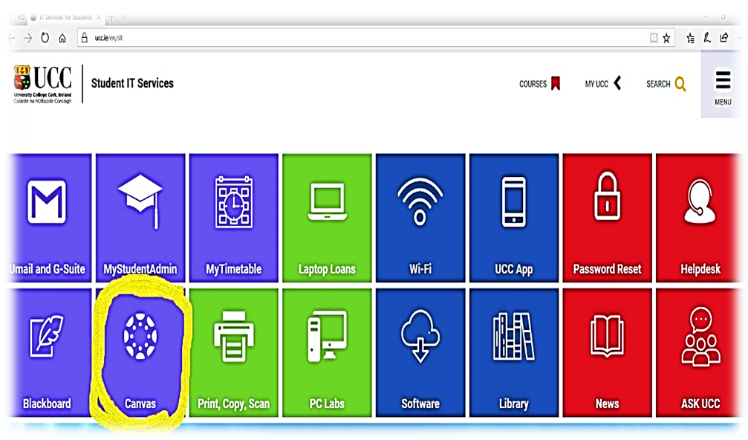Step 2 – Click the **Canvas** icon

Step 3 – Logon using your full student umail address and Student IT password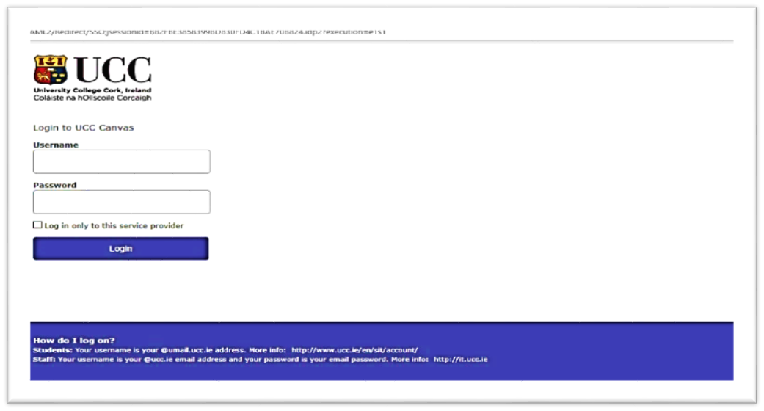

Step 4 – This will bring you to the list of the courses you registered for.

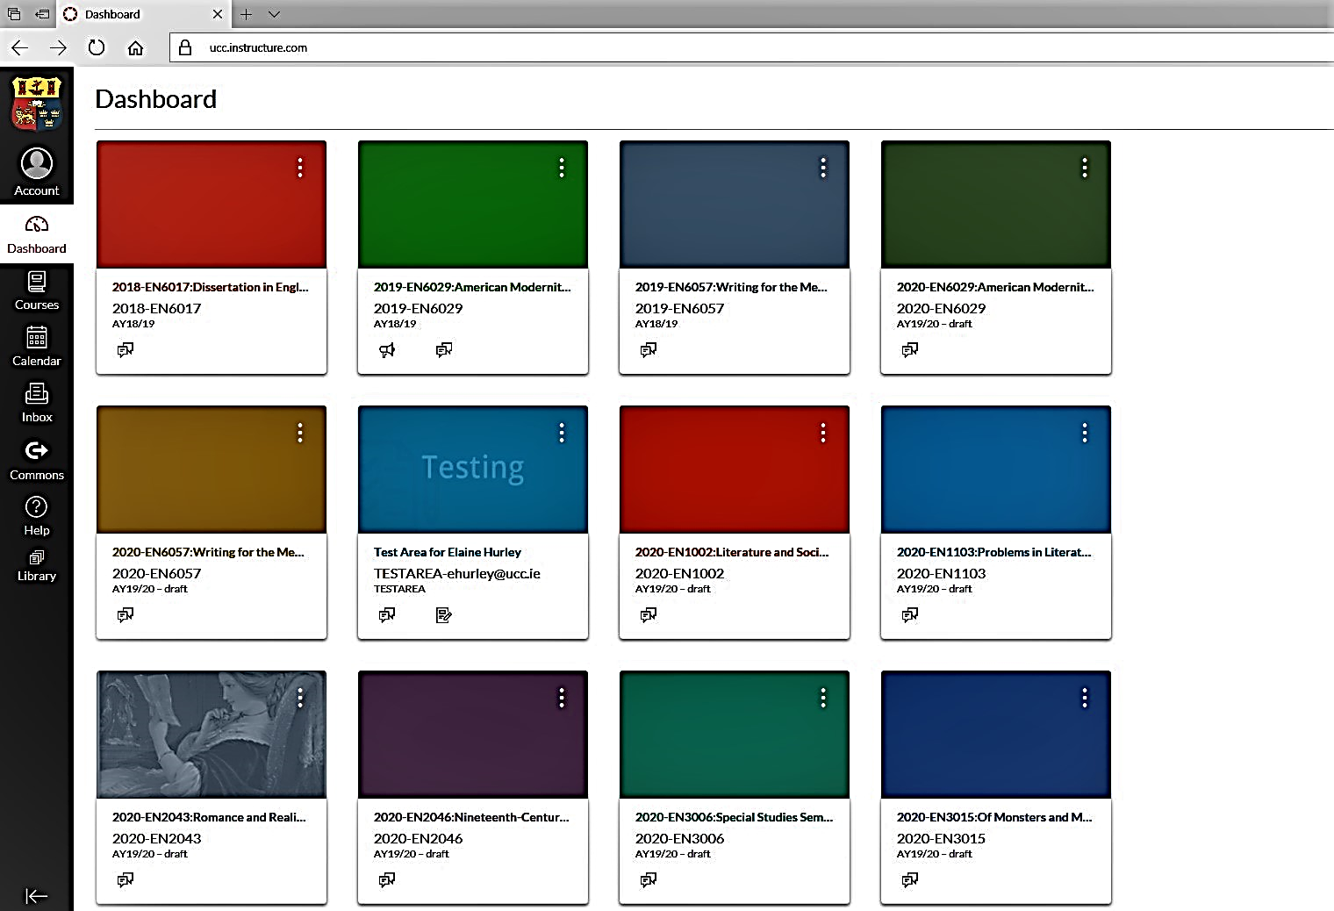

Step 5 – Select the relevant course e.g., EN1001

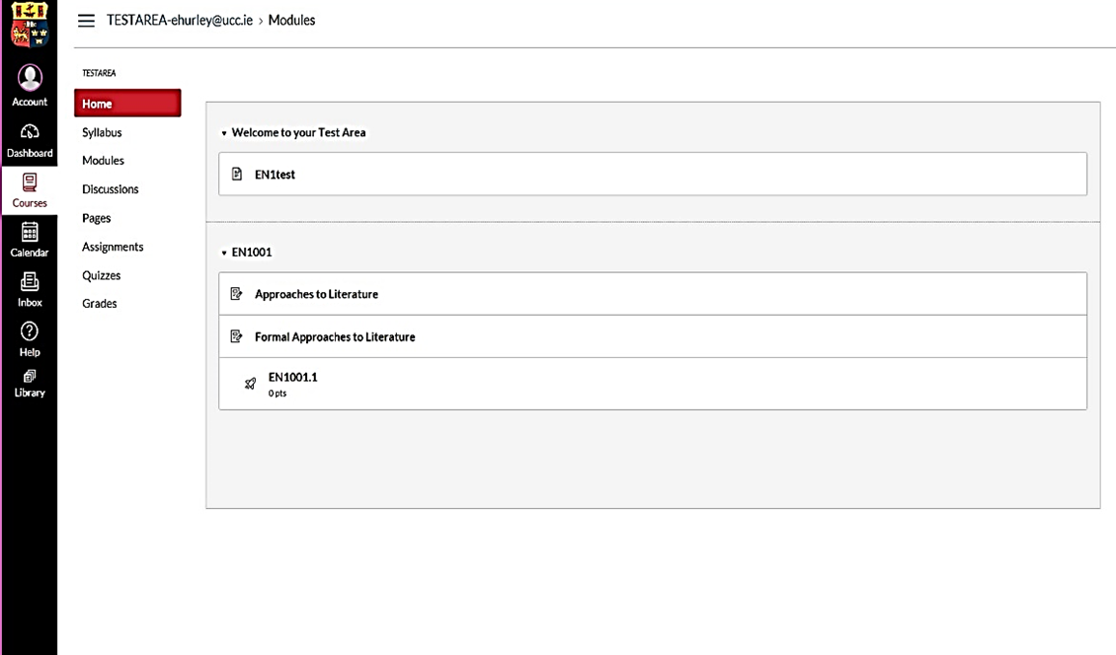

Step 6 – Select ‘Assignment’ on the left-hand column and then select ‘EN1001 Essay’

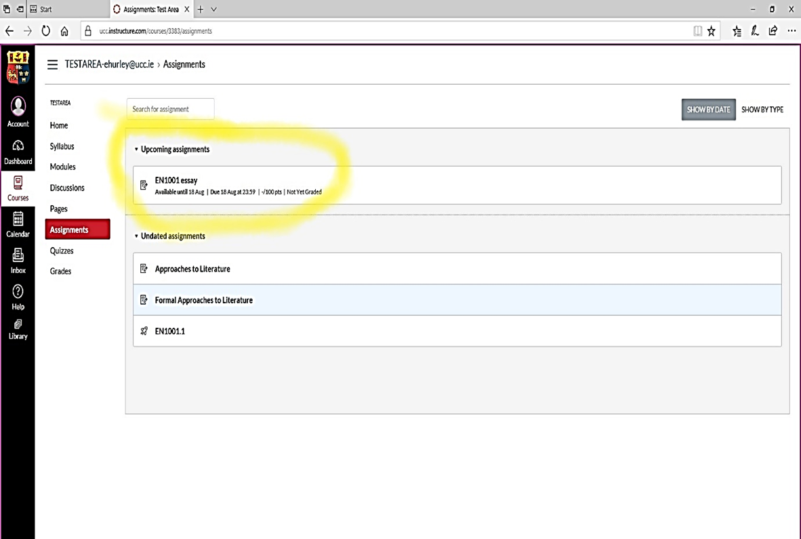

Step 7 – Select Submit Assignment

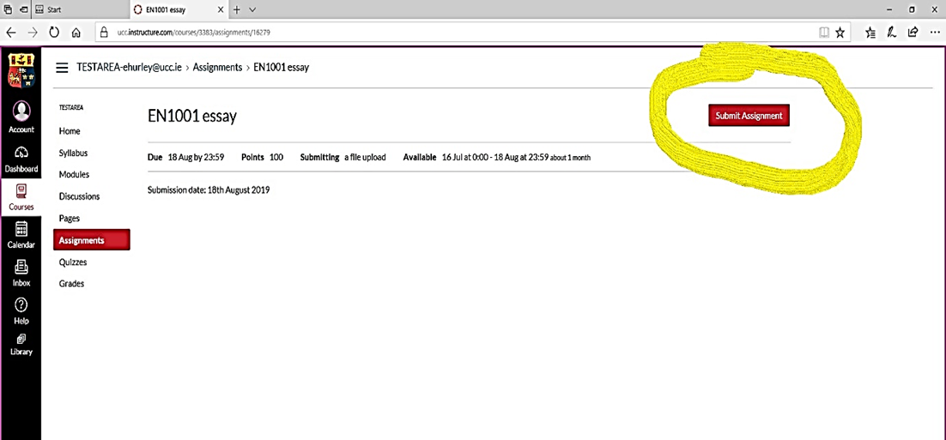

Step 8 – Upload file and submit assignment

## **Teaching Council Registration** **Curricular Subject Requirements (Post-Primary)**

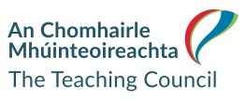

[www.teachingcouncil.ie](http://WWW.TEACHINGCOUNCIL.IE)

**SPECIAL REQUIREMENTS FOR RECOGNITION TO TEACH**

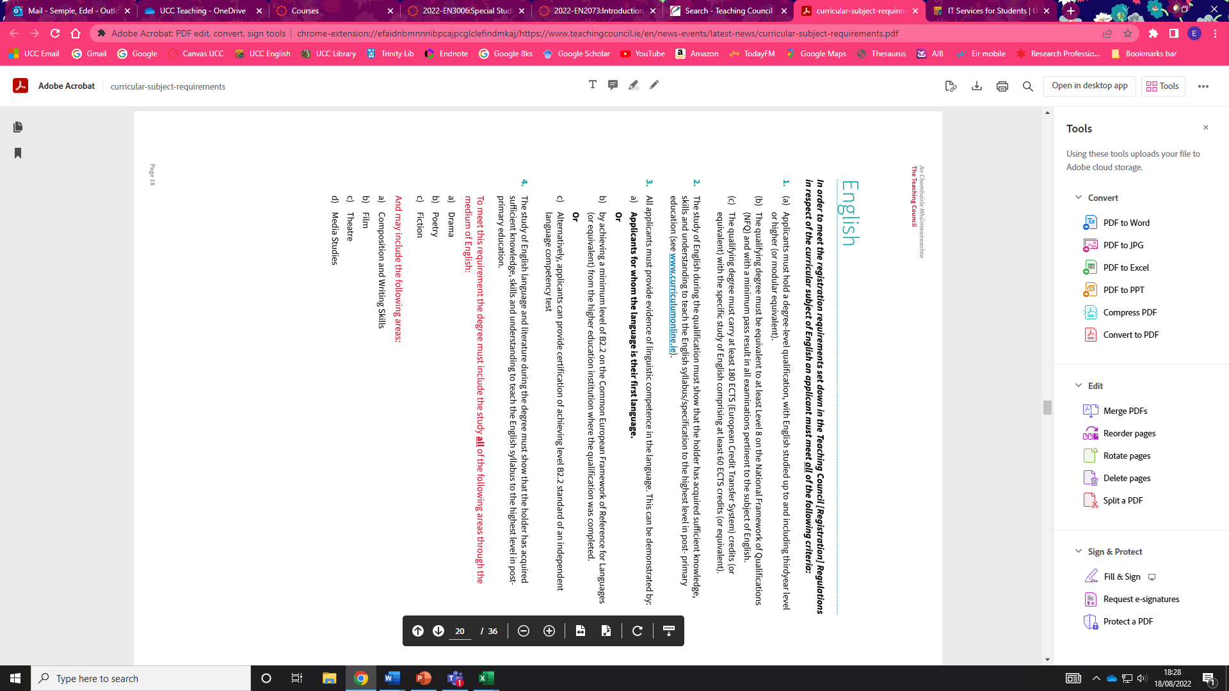

(See Teaching Council website, updated June 2022)

1. . ‘UCC Plagiarism Policy.’ Student Records and Examinations Office. May 2021.

   <https://www.ucc.ie/en/media/support/academicsecretariat/policies/examinations/UCCPlagiarismPolicy-V3.0-May2021(4).pdf>