**DEPARTMENT OF ENGLISH**

**INFORMATION**

**BOOKLET**

**FOR**

**VISITING STUDENTS**

**2023-2024**

**Department of English**

**Co-ordinator Visiting/Erasmus Programmes**

Dr Adam Hanna [adam.hanna@ucc.ie](mailto:adam.hanna@ucc.ie)

O’Rahilly Building, ORB1.76

-o-o-o-O-o-o-o

Plagiarism Officer: Professor Graham Allen [g.allen@ucc.ie](mailto:g.allen@ucc.ie)

Teaching Officer: Dr Ken Rooney [k.rooney@ucc.ie](mailto:k.rooney@ucc.ie)

Extensions: Apply via [Current Students | University College Cork (ucc.ie)](https://www.ucc.ie/en/english/currentstudents/)

-o-o-o-O-o-o-o

**Department of English Office**

O’Rahilly Building, ORB1.57

Email: [english@ucc.ie](mailto:english@ucc.ie)

Telephone: 021- 4902664, 4903677, 4902241

Welcome and Course Information

This will be available online from 5pm on Thursday 14 September [on](https://ucc.instructure.com/courses/37713on) the EN3004 ‘Introduction to Irish Literature’ Canvas page

Registration for Lecture Modules

This will be online via the International

Office. You will receive instructions on how to register for seminars (EN2003 and EN3003; these are smaller classes than lectures) by email.

Table of Contents

Timetable (2nd Year) ..….….….. 5

Timetable (3rd Year) …………… 6

Essay Calendars …………………. 7

EN3004 …………...………..………. 9

Reading List …………...………..… 12

Seminars …………...………..…….. 24

Assessments/Policy on Extensions 28

Essay Guidelines …………...…… 29

Plagiarism Policy ..……..….. 37

Canvas ………..…...…….…..……. 42

Turnitin ……………………………. 43





**SECOND YEAR ESSAY CALENDAR 2023-24**

**Semester 1**

(Two assignments per module. Titles will be released on Canvas and essays to submitted to Canvas by 11:59pm on dates outlined below)

|  |  |  |  |  |
| --- | --- | --- | --- | --- |
| **MODULE** | **Date for release of titles** | | **Date for Submission**  **(by 11:59pm)** | |
| **EN2012.1**  Old English Language  *(Dr Tom Birkett)* | | Wednesday 18th October 2023 | Wednesday 1st November 2023 |
| **EN2012.2**  Old English Language  *(Dr Tom Birkett)* | | Wednesday 22nd November 2023 | Tuesday 5th December 2023 |

|  |  |  |
| --- | --- | --- |
| **EN2043.1**  Romance and Realism  *(Prof Graham Allen/Dr Mary O’Connell-Lenihan)* | Wednesday 18th October 2023 | Wednesday 1st November 2023 |
| **EN2043.2**  Romance and Realism  *(Prof Graham Allen/Dr Mary O’Connell-Lenihan)* | Wednesday 22nd November 2023 | Tuesday 5th December 2023 |

|  |  |  |
| --- | --- | --- |
| **EN2077.1**  Modern Drama  *(Dr Anne Etienne)* | Wednesday 18th October 2023 | Wednesday 1st November 2023 |
| **EN2077.2**  Modern Drama  *(Dr Anne Etienne)* | Wednesday 22nd November 2023 | Wednesday 6th December 2023 |

|  |  |  |
| --- | --- | --- |
| **EN2079.1**  Adaptation, Literature and Culture  *(Dr Miranda Corcoran)* | Wednesday 18th October 2023 | Wednesday 1st November 2023 |
| **EN2079.2**  Adaptation, Literature and Culture  *(Dr Miranda Corcoran)* | Wednesday 22nd November 2023 | Tuesday 5th December 2023 |

|  |  |  |
| --- | --- | --- |
| **EN2080.1**  Introduction to Renaissance Literature *(Dr Edel Semple)* | Tuesday 17th October 2023 | Tuesday 31st October 2023 |
| **EN2080.2**  Introduction to Renaissance Literature *(Dr Edel Semple)* | Tuesday 28th November 2023 | Friday 5th January 2024 |

**THIRD YEAR ESSAY CALENDAR 2023-24**

**Semester 1**

(Two assignments per module, titles will be released on Canvas and essays to submitted to Canvas by 11:59pm on dates outlined below)

|  |  |  |
| --- | --- | --- |
| **MODULE** | **Date for release of titles** | **Date for Submission**  **(by 11:59pm)** |
| **EN3065.1**  Romance: Medieval to Renaissance  *(Dr Ken Rooney)* | Thursday 19th October 2023 | Thursday 2nd November 2023 |
| **EN3065.2**  Romance: Medieval to Renaissance  *(Dr Ken Rooney)* | Thursday 30th November 2023 | Friday 5th January 2024 |

|  |  |  |
| --- | --- | --- |
| **EN3073. 1**  Victorian Literature  *(Dr Mary O’Connell-Lenihan)* | Tuesday 17th October 2023 | Tuesday 31st October 2023 |
| **EN3073.2**  Victorian Literature  *(Dr Mary O’Connell-Lenihan)* | Tuesday 28th November 2023 | Friday 5th January 2024 |

|  |  |  |
| --- | --- | --- |
| **EN3075.1**  Contemporary Irish Writing (DRAMA)*  *(Dr Éibhear Walshe)* | Thursday 5th October 2023 | Thursday 19th October 2023 |
| **EN3075.2**  Contemporary Irish Writing (FICTION)*  *(Dr Éibhear Walshe)* | Thursday 9th November 2023 | Thursday 23rd November 2023 |
| **EN3075.1**  Contemporary Irish Writing (POETRY)*  *(Dr Adam Hanna)* | Thursday 30th November 2023 | Friday 5th January 2024 |

*EN3075 **Note:** There are three sections in this module. Students are expected to attend lectures for all three sections but will be required to complete assessments for two sections only. Each student is free to decide which two sections they wish to be assessed. Once you submit the essay for any one section, this will be deemed to be one of your two chosen sections. Therefore, if you have already submitted two essays, you will **not** be permitted to submit for the third section in the hope of achieving a higher mark.

|  |  |  |
| --- | --- | --- |
| **EN3077.1***(FICTION)\**  The Irish Literary Revival and Modernism  *(Dr Maureen O’Connor)* | Friday 6th October 2023 | Friday 20th October 2023 |
| **EN3077.2** *(POETRY)\**  The Irish Literary Revival and Modernism  *(Dr Adam Hanna)* | Friday 10th November 2023 | Friday 24th November 2023 |
| **EN3077.3** *(DRAMA)\**  The Irish Literary Revival and Modernism  *(Dr Eibhear Walshe)* | Friday 1st December 2023 | Friday 5th January 2024 |

*EN3077 **Note:** There are three sections in this module. Students are expected to attend lectures for all three sections but will be required to complete assessments for two sections only. Each student is free to decide which two sections they wish to be assessed. Once you submit the essay for any one section, this will be deemed to be one of your two chosen sections. Therefore, if you have already submitted two essays, you will **not** be permitted to submit for the third section in the hope of achieving a higher mark

|  |  |  |
| --- | --- | --- |
| **EN3108.1**  Modernism  *(Prof Alex Davis/Prof Lee Jenkins)* | Friday 20th October 2023 | Friday 3rd November 2023 |
| **EN3108.2**  Modernism  *(Prof Alex Davis/Prof Lee Jenkins)* | Friday 1st December 2023 | Friday 5th January 2024 |

**EN3004 Introduction to Irish Literature**  
**Autumn Semester 2023**

This course consists of two lectures per week. The first lecture of the course is on Thursday 21 September and the last lecture is on Friday 1 December. There will be no lectures during reading week, which commences Monday 23 October.

The department of English is teaching in-person in 2023-24. Students are expected to attend all their lectures in English, and attendance at seminars is mandatory.

**Lecture Times:** Thursdays at 5.00pm in Civil Engineering 110 and Fridays at 11.00am in Civil Engineering 110.

**Course Outline:** The course provides an insight into the development of Irish literature from earliest times, with a particular focus on literature written since the Revival period that began in the late nineteenth century. It is divided into the following sections:

1. Contexts 2 lectures
2. Poetry 6 lectures
3. Drama 6 lectures
4. Fiction 6 lectures
5. **Contexts**

This section of the course gives a general introduction to Irish literature and the themes that will be covered in the course. It starts with the origins of the Irish-language tradition in prehistory, and charts its development and its intersection with English literature in the centuries preceding the Revival period that began in the late nineteenth century.

1. **Poetry**

This section of the course looks at the development of Irish poetry between the Revival period and the present day. Except where indicated, the lectures will focus on poems in the *Anthology of Modern Irish Poetry*.

Lecture 1 W. B. Yeats (1865-1939) (readings will be provided)

Lecture 2 John Hewitt (1907-1987)

Lecture 3 Louis MacNeice (1907-1963)

Lecture 4 Seamus Heaney (1939-2013)  
 Lecture 5 Derek Mahon (1941-2020)

Lecture 6 Paula Meehan (1955-)

**Drama**

This section of the course starts with plays by the prominent group of dramatists associated with the Abbey Theatre in Dublin (founded 1904), and concludes with a play that was first produced at this theatre at the turn of the millennium.

Lecture 1 W. B. Yeats and Lady Gregory, *Cathleen Ni Houlihan* (1902)

Lecture 2 J.M. Synge, *The Playboy of the Western World* (1907)

[*Note: Reading Week falls here: there are no lectures in the week after the Synge lecture*]

Lecture 3 Sean O’Casey, *Juno and the Paycock* (1924)

Lecture 4 Samuel Beckett, *Krapp’s Last Tape* (1958)

Lecture 5 Brian Friel, *Translations* (1980)

Lecture 6 Marina Carr, *By the Bog of Cats* (1998)

**4. Fiction**

Lecture 1 & 2 The Irish short story: we will read stories by James Joyce and Elizabeth Bowen (which will be provided)

Lecture 3 & 4 William Trevor, *The Hill Bachelors* (2000)

Lecture 5 & 6 John McGahern, *That They May Face the Rising Sun* (2001)

**Book List**

The following are core texts that you should acquire at the start of the course. You can buy copies online or in the campus bookshop, Lowercase.

Poetry: *An Anthology of Modern Irish Poetry,* ed. by Wes Davis

Drama: *Modern and Contemporary Irish Drama*, ed. by John P. Harrington

Fiction: *That They May Face the Rising Sun* by John McGahern and *The Hill Bachelors* by William Trevor

**Assessment**

Students are required to write three assessment essays for this course: one on poetry, one on drama and one on fiction.

Poetry essay submission date Friday 28 October 2023

Drama essay submission date Friday 24 November 2023

Fiction and Poetry OR Fiction and Drama essay submission date Friday 15 December 2023

Assessments should be c. 1500 words in length. See later in this booklet for the Department of English essay guidelines.

Essay titles will be released two weeks before each submission date.

Dr Adam Hanna,

School of English and Digital Humanities

August 2023

Email: [adam.hanna@ucc.ie](mailto:adam.hanna@ucc.ie)

Room 1.76 ORB

**Second Year English Courses for 2023-24**

This is an outline list of English courses for the session 2023-24. Every effort is made to ensure that the contents are accurate. No guarantee is given that modules may not be altered, cancelled, replaced, augmented or otherwise amended at any time.

**PLEASE NOTE THAT IT IS THE RESPONSIBILITY OF EACH INDIVIDUAL STUDENT TO DISCOVER AND FULFIL THE EXACT REQUIREMENTS OF THE COURSE ASSESSMENT SYSTEM, ANY CHANGES TO REGISTRATION MUST BE APPROVED BY THE DEPARTMENT OF ENGLISH**

**MODULES AND TEXTS**

**EN2011 CHAUCER: *THE CANTERBURY TALES* AND RELATED TEXTS** **(KR)**

**5 Credits, Semester 2. (OMR)**

You may have heard of the Knight’s Tale; you may have heard of the Wife of Bath and her five husbands; you may have heard of the Miller, and how he told his tale. This course introduces students to where they all came from: Geoffrey Chaucer’s *Canterbury Tales,* a late fourteenth-century tale collection, which contains examples of every kind of medieval writing: comic tales, romance and fantasy, stories of human vice and fragility, the philosophical and the downright filthy – all narrated through astonishing varieties of voice and perspective. We will see what makes the *Tales* unique and revolutionary: nothing like it had been achieved before in English literature, and it would remain read, admired, and imitated from its first appearance in the 1390s to the present day. We will study some of the most important and attractive examples from the *Tales*, gauge the importance of the collection’s innovative (and strikingly modern) structure, and explore how the collection presents new questions on authorship and the uses of literature, on religion and human relations (and in particular the role of women in medieval society). We will also consider the *Tales*’ relationships to other aspects of medieval culture, and its recent reception in modern film.

To help us with Chaucer’s English, called Middle English (which can be read by anyone who can read modern English, and requires no prior knowledge) we will use a glossed edition: *The Riverside Chaucer*. Students are also free to use an interlinear translation listed below:

Required textbook:

*The Riverside Chaucer*. Ed. L.D. Benson. Oxford: Oxford UP, 1987.

Online alternative / supplement:

The Harvard Geoffrey Chaucer Website: <https://chaucer.fas.harvard.edu/pages/text-and-translations>

**EN2012 UNLOCKING THE WORDHOARD: AN INTRODUCTION TO OLD ENGLISH (TB) 5 Credits, Semester 1. (OMR) - ONLINE**

**Course description:**

Old English was the language spoken in Medieval England from ca. 500-1100 AD and preserved in manuscripts from ca. 800-1200 AD. This course will provide students with the skills and linguistic competency to read and translate Old English to a high level of proficiency over twelve weeks. This is achieved by following a new online language course developed for UCC students, supported by instructional videos, discussion fora and reading exercises. The course will introduce students to the basics of Old English pronunciation, grammar and vocabulary and invite them, from the first week, to test and improve their language skills by reading and translating original texts, from accounts of battles to obscene riddles.

In addition to teaching the fundamentals of Old English, this course will introduce students to the history of the language and how English evolved over time. It will also provide students with the skills to analyse and discuss the workings of modern English in a critical, academic manner; these skills can be applied to any language, medieval or modern, and will enhance the student’s ability to critically assess the use of language by writers to the present day.

**Set Text:** Access to online coursebook will be provided.

**EN2023 EIGHTEENTH-CENTURY LITERATURE (GA/CÓG)**

**5 Credits, Semester 2.**

This module aims to develop students understanding of the relationship between literature and society in the eighteenth century. The texts included will be drawn from different periods in the eighteenth-century and from a variety of genres, which may include the novel and poetry. Special attention is given to the rise of the novel form, to changes in poetic and literary models, and subsequent changes in notions of literature, authorship and literary meaning. The course may also focus on questions of class, gender, ideology and nation in relation to literary texts.

**EN2023.1**

Defoe, Daniel. *Robinson Crusoe*, 2nd edition*.*  New York:  W.W. Norton & Co., 1993.

Swift, Jonathan. *Gulliver’s Travels.* New York: W. W. Norton & CO., 2002.

**EN2023.2**

            Selected poetry will be provided.

**EN2043   ROMANCE & REALISM (GA/MO’C-L)**

**5 Credits, Semester 1.**

This module introduces students to the main narrative features of the novel tradition from the late eighteenth to the early twentieth century, concentrating on the generic and formal features of the two most dominant narrative forms of the era, romance and realism.  Students are introduced to the formal features of narrative fiction as it developed from the 1790s on, and to the changing historical contexts in which it was produced.  The texts under discussion offer examples of the wide variety of novel forms during this period of literary history, including gothic fiction, domestic realism, industrial fiction, and naturalism.

**EN2043.1**

Godwin, William.  *Caleb Williams*, ed. Pamela Clemit.  Oxford: Oxford UP, 2009.

Shelley, Mary.  *Frankenstein,* ed. J.P. Hunter.  New York: W.W. Norton, 1995.

**EN2043.2**

Collins, Wilkie. *The Moonstone*, ed. Francis O’Gorman. Oxford: Oxford UP, 2019

Haggard, H. Rider. *She*, ed. Daniel Karlin. Oxford: Oxford UP, 2008

Conan Doyle, Arthur. *The Hound of the Baskervilles*. Oxford: Oxford UP, 1998

**EN2046 AMERICAN LITERATURE TO 1900 (AG/LJ)**

**5 Credits, Semester 2.**

The objective of this module is to introduce students to a range of nineteenth-century American texts in various genres. This module is an introduction to the literature of the United States from the American Renaissance of the 1850s to the end of the century. Reading a range of texts in several genres drawn from the relevant period, students will trace developments in American literary aesthetics and explore themes of nation building, race and gender, slavery and the South, focusing on the role of literature in the formation of American national identity.

Emerson*,* Ralph Waldo*.* ‘Nature’ (extract) ‘The American Scholar’ *

Perkins Gilman, Charlotte. *The Yellow Wall-paper \**

Melville, Herman, *The Confidence Man*. Penguin

Douglass, Frederick. *Narrative of the Life of Frederick Douglass*, *an American Slave, Written By Himself.* Oxford World’s Classics.

Walt Whitman, poems*

Mark Twain, *Adventures of Huckleberry Finn*. Collins Classics

*Available on Canvas.

**EN2071 WOMEN AND LITERATURE (HL)**

**5 Credits, Semester 2.**

This module examines literature as a gendered institution in society and discusses the principal ways in which this gendering functions.  During the course of the module, we

* identify the fundamental aims of studying literature from a feminist viewpoint
* outline the principal forms which feminist critique of the institutions of literature has taken
* briefly trace the development of feminist literary criticism
* read three novels comparatively, as case-studies for feminist interpretation

**Required Reading**

For **2071.1,** readings will be provided.

For **2071.2**, you will need copies of two of the following:

Bronte, Charlotte*. Jane Eyre.* 1848. Oxford: Oxford World’s Classics, 2008.

Rhys, Jean. *Wide Sargasso Sea.* 1966. London: Penguin, any reprinting.

Dangarembga, Tsitsi.  *Nervous Conditions*.  1988. Available on canvas.

**EN2077 MODERN DRAMA: (AE)**

**5 Credits, Semester 1.**

This module introduces students to works which transformed drama at the end of the 19th century and inaugurated modern theatre.  We will study how plays by European playwrights and aesthetic experiments by theatre practitioners have revitalized the stage at the turn of the twentieth century, initiated modern theatre, and pioneered social-problem drama. Focusing on European and/or Northern American plays written from the late nineteenth century to the 1960s, we will observe how modern drama has evolved to construct our contemporary theatre. The module will locate selected plays in the cultural contexts of late19th-century to mid-20th century Western societies, and explore their shared and differentiated ideological and aesthetic purposes.

**The precise focus of the module and the dramatists studied may vary from year to year.**

Case studies:

August Strindberg. *Miss Julie*

Henrik Ibsen. *Hedda Gabler*

Frank Wedekind. *Spring Awakening*

Arthur Miller. *Death of a Salesman*

Eugène Ionesco. *The Bald Prima Donna*

Arnold Wesker. *The Kitchen*

**EN2079 ADAPTATION, LITERATURE, AND CULTURE (MC)**

**5 Credits, Semester 1.**

How do literary texts change over time? What features of a novel are transformed when it makes the leap to the screen? Why are film and television adaptations of comic books amongst the most popular forms of contemporary entertainment? Over the course of this module, we will analyse the many ways in which literary texts are transformed by the process of adaptation. Offering students the opportunity to examine a variety of adaptations using key critical theories and approaches, the module explores how texts are reimagined for new audiences, across time and place, and in a range of media. Major themes discussed in this module include issues of authorship, collaboration, audience and reception, genre, and the mechanics of adaptation. Students will also engage with a wide range of literary forms, from comic books and novels to film and theatre.

**Reading list**

**EN2079.1**

Bram Stoker, *Dracula* (any edition)

*Dracula* (Dir. Tod Browning, 1931)

*Bram Stoker's Dracula* (Dir. Francis Ford Coppola, 1992)

Chase Berggrun, *R E D* (Birds LLC, 2018)

**EN2079.2**

Shirley Jackson, *The Haunting of Hill House* (any edition)

*The Haunting* (Dir. Robert Wise, 1963)

Selected episodes from *The Haunting of Hill House* (Netflix, 2018)

Octavia E. Butler, *Parable of the Sower* (any edition)

Damian Duffy and John Jennings, *Parable of the Sower: A Graphic Novel Adaptation* (Abrams Comic Arts, 2021)

**EN2080 INTRODUCTION TO RENAISSANCE LITERATURE (ES)**

**5 Credits, Semester 1. *(OMR)***

This module will introduce English literature of the sixteenth and seventeenth centuries. The module will familiarise students with some of the social, cultural, and intellectual contexts which informed the emergence and development of literature in this period. The module’s set texts will reflect the broad generic range and preoccupations of the era, such as authority, gender, selfhood, and nation. Two or more plays by Shakespeare and his contemporaries, and a variety of poetic and/or prose texts will be studied. The module provides a foundation for further study of Renaissance literature, including Shakespeare. For 2023-24, the set texts will include Shakespeare’s *As You Like It* and *Titus Andronicus*; Jonson’s *Epicoene*, or the *Silent* *Woman*; and Country House poems.

**Recommended editions of module texts**:

Jonson, Ben. *Epicoene*, edited by Roger Holdsworth, A&C Black, 2002. *Epicoene* is also available online in *The Routledge Anthology of Renaissance Drama* through the Library's Proquest E-book Central database.

Shakespeare, William. *The Norton Shakespeare*, edited by Stephen Greenblatt et al. 3rd ed., Norton and Co., 2015.

All shorter texts are available in Greenblatt, Stephen, et al., editors. *The Norton Anthology of English Literature*, vol. B (Package 1). 10th ed., Norton, 2018.

***MODULES AND TEXTS (Third year)***

**EN3015 OF MONSTERS AND MEN: OLD AND EARLY ENGLISH LITERATURE: (TB)**

**5 Credits, Semester 2 (OMR)**

Early Medieval literature reveals that horror is by no means a modern phenomenon. This course analyses the heroes, monsters and monstrous human behaviour of early medieval texts (such as *Beowulf*) as cultural constructions which reveal a society’s values and fears. It places texts that examine humour and horror within cultural and theoretical contexts that challenge the critical status quo, and invites students to explore features of the medieval corpus too often hidden (literally and figuratively) from the light of day. We will take anthropological constructs of the liminal – those outside of a society yet central to its sense of identity – and the theoretical concept of the abject, and consider how these constructs might be used to illuminate medieval concepts of self and other, us and them, acceptable and alien.

By examining a range of texts from both the prose and poetic corpus, we will analyse the role and function of the hero and ‘the other’, and ask where authors draw the line between the monster and the man.

Knowledge of Old English is not a pre-requisite for this course.

**Set texts:**

Students are strongly recommended to acquire:

*The Beowulf Manuscript*. Edited by R. D. Fulk. Harvard UP, 2010 [includes *Judith*, *The Wonders of the East*, *The Letter of Alexander* and *The Passion of St Christopher*, alongside *Beowulf* itself]

*The Saga of Grettir the Strong*. Edited by Bernard Scudder. Penguin, 2005.

* Other texts will be provided.

**EN3048 MODERN AND CONTEMPORARY AMERICAN LITERATURE: (LJ/AG)**

**5 Credits, Semester 2**

This module explores a selection of American writing from 1900 to the present day, with reference to historical background and contexts, race, gender, and class.

The Harlem Renaissance (poems and essays)*

Larsen, Nella. *Quicksand and Passing*. Serpent’s Tail, 2014.

Fitzgerald, F. Scott. *The Great Gatsby*. Penguin, 2000.

Hemingway, Ernest. “The Snows of Kilimanjaro.” 1936.*

Theodore Dreiser, “Old Rogaum and his Theresa.” 1901.*

Jack London, “To Build a Fire.” 1908.*

Mary Wilkins Freeman, “Old Woman Magoun.” 1905.*

Mamet, David. *Glengarry Glen Ross*. 1983. Methuen, 2004.

Moore, Lorrie. *A Gate at the Stairs*. Faber, 2009.

* These texts will be made available on Canvas.

**EN3065 ROMANCE: MEDIEVAL TO RENAISSANCE (KR)**

**5** **Credits, *Semester 1***

Stories of Arthur and his knights, of exile and of return (sometimes even from death), crises of identity and love, perilous encounters with otherworldly beings: these are some of the recurring concerns of romance, a genre which, in the Middle Ages and Renaissance, served its audiences with exemplary and sensationalist narratives in startlingly varied, and often sophisticated ways. This module will explore the diversified nature of English romance writing from this period, through close thematic study of some the most important examples, both anonymous and authored.

**3065.1 Anonymous Romance**

*Sir Gowther*. Edited by E. Laskaya and E. Salisbury, TEAMS, 1995.

Available online at <http://d.lib.rochester.edu/teams/text/laskaya-and-salisbury->middle-english -breton-lays-sir-gowther-introduction

*Sir Amadace* Edited by E. Foster, TEAMS, 2007.

Available online at <http://d.lib.rochester.edu/teams/text/foster-sir-amadace-introduction>.

**3065.2 Romance and its authors**

Chaucer, Geoffrey. *Sir Thopas* and *The Man of Law’s Tale* from *The Canterbury Tales*. In *The Riverside Chaucer*, ed. L. D. Benson. Oxford: OUP, 1987.

Spenser, Edmund. *The Faerie Queene*, Book I. In *Edmund Spenser’s Poetry*, Eds A.L. Prescott & A. Hadfield. 4th ed. New York: Norton, 2013.

**EN3072 ROMANTIC LITERATURE (CÓG/GA)**

**5 Credits, Semester 2**

This module will develop students’ understanding and experience of literature in English from the Romantic period (1770-1830). It covers a selection of literary texts from the Romantic period. Students are exposed to conflicting definitions of Romanticism and encouraged to critically analyse the selected texts in the light of these theoretical descriptions. Special emphasis is placed on the role of poetryand prose fiction, and on the gendered nature of writing in the period.

Austen, Jane. *Northanger Abbey*. Edited by Susan Fraiman, W. W. Norton, 2004.

Wollstonecraft, Mary and Mary Shelley*. “Maria, or The Wrongs of Woman”* *and “Matilda*.” Edited by Janet Todd, Penguin, 1993.

**EN3073 VICTORIAN LITERATURE (MO’C-L)**

**5 Credits, Semester 1**

Mid to late 19th century English literature responded to a range of political, social, and economic transformations. This is the era which saw Charles Darwin’s publication of his theory of evolution; it is an era of industrialization, of scientific and technological discovery and of advances in publishing which meant greater numbers of books and readers than ever before. This course looks at some of the most famous novels and short stories of the period including Anne Brontë ’s feminist novel about a mysterious widow, George Eliot’s Middlemarch, routinely considered the greatest of all Victorian novels, the first appearance of the world’s greatest detective, and H.G Well’s science fiction novella, The Time Machine.

Anne Brontë, *The Tenant of Wildfell Hall* (1848)

Arthur Conan Doyle, *The Adventures of Sherlock Holmes* (1892)

George Eliot, *Middlemarch* (1871)

H.G. Wells, *The Time Machine* (1895)

**EN3075 CONTEMPORARY IRISH WRITING (EW/AH)**

**5 Credits. Semester 1**

This module gives the opportunity to explore a range of contemporary Irish writing. We study texts in three genres (drama, poetry, fiction) from the 1960s to the present. The module is taught in three segments: contemporary Irish poetry, contemporary Irish fiction and contemporary Irish theatre.

**Contemporary Irish Poetry (AH)**

The opening one-third of the module outlines the main themes developed, and the differing formal tactics adopted, by Irish poets over the last forty years. It will focus on a small number of poets, chosen from among the following:  Derek Mahon, Michael Longley, Medbh McGuckian, Paula Meehan, Sinéad Morrissey, Billy Ramsell and Doireann Ní Ghríofa.

**Required Reading**

The set poems will be provided.

**Contemporary Irish Fiction (EW)**

Required Reading

O’Brien, Edna. The Country Girls. Faber, 2007.

Tóibín, Colm. The Empty Family Penguin, 2010.

Ni Dhuibhne, Eilis. The Dancers Dancing. Blackstaff Press, 1989.

McLaughlin, Danielle, Dinosaurs on Other Planets. The Stinging Fly, 2105.

**Contemporary Irish Theatre (EW)**

Required Reading

McGuinness, Frank. *Observe the Sons of Ulster Marching Towards the Somme*. Faber, 1985.

Friel, Brian. *Translations*. Faber 1980.

**EN3077 THE IRISH LITERARY REVIVAL AND MODERNISM (MO’C/AH/EW)**

**5 Credits, Semester 1**

This course will give students a foundation in Irish writing, Irish cultural history and Irish literary criticism in the modernist period. It will explore a range of texts drawn from various forms (fiction, poetry, drama and/or film) from the late nineteenth century up to the 1960s.

Bowen, Elizabeth*. The Last September*. 1929. Vintage, 1998.

Beckett, Samuel. *Murphy*. 1938. Faber, 2008.

Harrington, John P., editor. *Modern and Contemporary Irish Drama*. 2nd ed., W. W. Norton, 2008.

Further poetry of the period will be provided.

**EN3079 CONTEMPORARY CULTURE (MC/HL/AE)**

**5 Credits, Semester 2**

This module introduces students to a selection of post-1980s cultural texts. These could include works produced for the theatre and other kinds of performance, electronic literature and popular fiction.

The texts studied may vary from year to year.

The plays selected challenge traditional dramatic narratives and explore their contemporary British and Irish societies. In tackling different decades, topics and dramaturgies, we will question how theatre language and form has evolved within the contemporary period and addressed (or ignored) political issues.

The works of fiction studied in the course span a range of genres and literary forms. Incorporating everything from contemporary literature to science fiction and the graphic novel, these texts engage in unique ways with the social, political and cultural contexts of the early twenty-first century. In doing so, these works demonstrate the diversity and variability of modern literary production, and illustrate how different generic forms can be employed to explore a host of complex issues, including modern politics, gender and race.

Carroll, Emily. *Through the Woods*. Faber, 2014.

Whitehead, Colso., *The Underground Railroad*. Doubleday, 2016.

Byers, Sam, *Perfidious Albion*. Faber, 2018.

Churchill, Cary. *Top Girls*. 1982. In *Modern Drama: Plays of the ‘80s and ‘90s*. Edited by Sarah Kane and Terry Johnson, Methuen, 2007.

Kane, Sarah. *Blasted*. 1995. In *Modern Drama: Plays of the ‘80s and ‘90s*. Edited by Sarah Kane and Terry Johnson, Methuen, 2007.

Crimp, Martin. *Attempts on Her Life*. 1997. Faber, 2007.

**EN3107 STUDIES IN SHAKESPEARE (ES) 5 Credits,** Semester 2

This module explores a selection of plays spanning Shakespeare’s writing career. Our analysis will employ close study of the plays’ context, handling of generic conventions, and audience expectations, and the content of ideas and themes embodied within these acted worlds. The chosen texts span a range of genres and showcase both the innovations made by Shakespeare and how he worked within inherited dramatic traditions.

**For 2023-2024, the plays on the module will be:** *Richard III, A Midsummer Night’s Dream, Pericles, Prince of Tyre, and Antony and Cleopatra.*

Recommended edition: Shakespeare. *The Norton Shakespeare*. Edited by Greenblatt et al. 3rd ed. Norton, 2015.

**EN3108 MODERNISM (LJ/AD)**

**5 Credits, Semester 1**

This module introduces students to literary modernism through an analysis of a range of experimental texts from the early to mid-twentieth century.

Eliot, T.S. *The Waste Land*. <https://wasteland.windingway.org/poem>; <http://eliotswasteland.tripod.com/>

Lawrence, D. H. *Lady Chatterley’s Lover*. Wordsworth Classics, 2005.

Pound, Ezra*. Selected Poems, 1908-1969*. Faber, 1977.

Woolf, Virginia. *Mrs Dalloway*. Wordsworth Classics, 1996

**CRITICAL SKILLS SEMINAR MODULE 2023-24**

**EN2003/EN3003 Critical Skills Seminar: Semester 1 or Semester 2**

**10 Credits taken by assessment.**

This module is designed to develop students’ skills in reading, writing and critical practice through closely-directed study and constructive discussion of a range of selected texts. Students must choose one from the wide range of topics offered by the staff of the Department of English. The range of topics will cover a variety of forms, genres and periods. Once a student has signed on for a seminar, attendance is required.

**ATTENDANCE**

Attendance at seminars is required.  Students cannot miss more than eight hours (one third) of seminar classes without presenting documentation in relation to absences. Students whose seminar attendance is negatively impacted by a documented and significant medical issue may be offered alternative assessment in lieu of seminar participation in order to make up the 15% of marks allocated for participation. If attendance is lower than two-thirds of seminar classes and activities without documentation, the seminar cannot be passed until the autumn exams.  A student who has failed a seminar due to unexplained non-attendance may continue to attend and hand in assignments but this work will be held over for the autumn exam board in August / September. Work not submitted during the academic year will have to be submitted before a date designated by the Department office, plus an extra assignment in lieu of the participation mark. The student may then pass this module for the autumn exam board, but the result for the module will be capped at 40% unless the student applies for and is granted mitigation. [Mitigation | University College Cork (ucc.ie)](https://www.ucc.ie/en/student-records/exams/appeal-mitigation-recheck/mitigation/).

Where a student misses 4 hours of scheduled classes they will be emailed by the seminar co-ordinator to remind them of the requirement for attendance and penalties (using the student’s official UCC address).

**ASSIGNMENT of MARKS in SEMINAR MODULES**

1. Participation 15%

2. Oral presentation (or equivalent) 15%

3. Shorter assignment(s) 20%

4. Essay work* 50%

*not exceeding 4,000 words in total

**WRITTEN OUTLINE OF ASSESSED WORK**

At the start of the Teaching Period each co-ordinator will give a written outline of the work expected for nos. 2, 3 and 4 to students in each seminar.

**ASSIGNMENT OF MARKS EXPLAINED BY CATEGORY**

**1. Participation: 15%**

Students can gain these marks by contributing actively to each class. This means carrying out all tasks assigned, being ready and willing to discuss the material and the topics addressed in class, and co-operating with other class members and the co-ordinator.

**2. Oral presentation or equivalent: 15%**

Marks awarded here for committed, organized and effective preparation and delivery of set oral assignment(s), e.g. discussion of a text, author or topic, or another type of project assigned by the co-ordinator.

**3. Shorter assignment(s): 20%**

These may take various forms, e.g. a quiz or exercise, short essay, or discussion of a text or excerpts from texts.

**4. Essay work, not exceeding 4,000 words in total: 50%**

This may consist of one, two or more essay(s) or other assignments, of varying lengths, e.g. a write-up of the oral presentation, or another type of project as assigned by the co-ordinator.

**CONSULTATION AND ADVICE ON TAKE-HOME WRITTEN WORK**

Seminar co-ordinators **will** offer individual consultations to students concerning their performance in the seminar module. Co-ordinators may

respond to students’ questions or difficulties about the material

explain marks given for assignments

give students advice about how to improve their written style

help students with essay planning.

Co-ordinators **will not**

Read or correct drafts of essays or other assignments or offer detailed advice about their improvement, in advance of their being handed in for marking.

**SEMINAR REGISTRATION INFORMATION**

NB* It is your responsibility to ensure that the seminar you choose does not clash with your other modules.

**You will receive instructions by email about how to enrol for seminars.**

**CHANGES AND LATE REGISTRATION**

* Students wishing to register a change of module must do so at <https://mystudentadmin.ucc.ie/> no later than **two** working weeks after the formal start date of each Semester.
* Semester 1 modules **cannot be changed** in Semester 2.

However, **if you wish to withdraw from a seminar or transfer to a different seminar**, you must contact The Department of English Office, email [english@ucc.ie](mailto:english@ucc.ie).

**Seminar List 2023-24 – Second Year English**

|  |  |  |  |  |  |
| --- | --- | --- | --- | --- | --- |
| **Seminar Leader** | **Teaching Period** | **Module**  **Code** | **Seminar**  **Code** | **DAY & TIME** | **VENUE** |
| Beth Aherne | 1 | EN2003 | MOD2.01 | Thursday 2-4pm | West Wing 4 |
| Sarah Bezan | 2 | EN2003 | MOD2.02 | Wednesday 11-1pm | CPB_LG08 |
| Maria Butler | 1 | EN2003 | MOD2.03 | Thursday 2-4pm | Askive_G01 |
| Miranda Corcoran | 1 | EN2003 | MOD2.04 | Tuesday 2-4pm | BL4_G01 |
| Anne Etienne | 2 | EN2003 | MOD2.05 | Monday 3-5pm | ORB_G42 (N) |
| Michael Booth | 2 | EN2003 | MOD2.06 | Tuesday 2-4pm | AL_G32 |
| Clodagh Troelstra Heffernan | 2 | EN2003 | MOD2.07 | Monday 2-4pm | WGB_371 |
| Robyn McAuliffe | 2 | EN2003 | OMR2.08 | Monday 1-3pm | WGB_302 |
| Sinéad Mooney | 1 | EN2003 | MOD2.09 | Wednesday 2-4pm | ORB_1.65 |
| Laura Mulcahy | 2 | EN2003 | MOD2.10 | Monday 3-5pm | AL_G32 |
| Dylan Phelan | 1 | EN2003 | MOD2.11 | Monday 2-4pm | AL_G32 |
| Mairead Roche | 2 | EN2003 | MOD2.12 | Tuesday 11-1pm | Safari_G01 |
| Ken Rooney | 2 | EN2003 | OMR2.13 | Tuesday 11-1pm | ELD1_1.01 |
| Elisa Sabbadin | 1 | EN2003 | MOD2.14 | Monday 3-5pm | ELD5_G01 |
| Hope Noonan Stoner | 2 | EN2003 | MOD2.15 | Tuesday 9-11am | ELD1_1.01 |

**Venues: AL** – Aras Na Laoi; **ASK** – Askive, Donovans Rd.; **BL** – Bloomfield Tce., Western Rd., **ELD** -Elderwood, College Rd., **ORB** – O'Rahilly Building, **WW**– West Wing, **WGB** – Western Gateway Building, Western Rd.

## Seminar List 2023-24 – Third Year English

|  |  |  |  |  |  |
| --- | --- | --- | --- | --- | --- |
| **Seminar Leader** | **Semester** | **Module**  **Code** | **Seminar**  **code** | **DAY & TIME** | **VENUE** |
| Prof Graham Allen | 2 | EN3003 | SMR 3.01 | Wednesday 11-1pm | ORB_1.65 |
| Dr Sarah Bezan | 1 | EN3003 | SMR 3.02 | Thursday 11-1pm | ORB_1.65 |
| Dr Tom Birkett | 2 | EN3003 | SMR 3.03 | Thursday 10-12 noon | AL_G19 |
| Dr Miranda Corcoran | 2 | EN3003 | SMR 3.04 | Wednesday 9-11am | BL4_G01 |
| Dr Anne Etienne | 1 | EN3003 | SMR 3.05 | Wednesday 9-11am | ORB_1.65 |
| Dr Alan Gibbs | 1 | EN3003 | SMR 3.06 | Tuesday 2-4pm | ElderWood 3_G01 |
| Dr Alan Gibbs | 2 | EN3003 | SMR 3.07 | Thursday 2-4pm | West Wing 8 |
| Dr Michael Booth | 1 | EN3003 | SMR 3.08 | Friday 9-11am | ORB_3.26 |
| Prof Lee Jenkins | 2 | EN3003 | SMR 3.09 | Thursday 10-12 noon | ORB_1.65 |
| Dr Heather Laird | 1 | EN3003 | SMR 3.10 | Tuesday 3-5pm | ElderWood 5_G01 |
| Dr Sinéad Mooney | 2 | EN3003 | SMR3.11 | Tuesday 11-1pm | ORB_1.65 |
| Dr Mary O’Connell-Lenihan | 1 | EN3003 | SMR 3.12 | Thursday 9-11am | ElderWood 3_G01 |
| Dr Clíona Ó Gallchoir | 2 | EN3003 | SMR 3.13 | Thursday 10-12 noon | ORB_2.44 |
| Dr Liz Quirke | 2 | EN3003 | SMR 3.14 | Thursday 2-4pm | West Wing 4 |
| Dr Ken Rooney | 2 | EN3003 | SMR 3.15 | Thursday 11-1pm | ElderWood 2 _G01 |
| Dr Edel Semple | 1 | EN3003 | SMR 3.16 | Monday 4-6pm (Screening)  Wednesday 11-1pm (Seminar) | West Wing 7  AL_G32 |

**Venues: AL** – Aras Na Laoi; **BL4 –** Bloomfield Tce., Western Rd.; **ELD** – Elderwood, College Road; **ORB** – O’Rahilly Building; **WW**- West Wing

**ASSESSMENTS**

Assessments must be uploaded to Canvas by 11:59pm on date of submission (see essay calendar on page 7.)

**POLICY ON EXTENSIONS**

ALL applications for extensions must be submitted via the link found on our webpage:[Current Students | University College Cork (ucc.ie)](https://www.ucc.ie/en/english/currentstudents/) **This is the only pathway through which extension requests will be processed.** In general, applications should be made ahead of the submission date and must be accompanied by supporting documentation (medical certificate, etc.) Extensions without loss of marks will normally only be allowed where there is a relevant medical certificate or written evidence of other significant difficulties that have interrupted work.

ShapeRequests for extensions will be responded to via your student e-mail account. An initial request, if agreed, will generally amount to a one-week extension. On a discretionary basis, a further extension may be sanctioned. In such cases, students will be required to present further evidence of a compelling reason for late submission. A separate application will have to be made via our webpage: [Current Students | University College Cork (ucc.ie)](https://www.ucc.ie/en/english/currentstudents/)

Where an extension has not been agreed in advance, or where a student submits an essay after agreed extensions have expired, the appropriate penalties for late submission will be imposed.

Penalties (for late submission of Course/Project Work etc.)

* Where work is submitted up to and including 7 days late, 10% of the total marks available will be deducted from the mark achieved.
* Where work is submitted up to and including 14 days late, 20% of the total marks available will be deducted from the mark achieved.
* Work submitted 15 days late or more will be assigned a mark of zero.
* In cases where work is submitted up to and including 7 days later than an agreed 7 day extension, the mark achieved will be subject to a deduction of 20% of the total marks available.
* Work that has received a 14 day or longer extension will be assigned a mark of zero if it is submitted later than the agreed extension date.

**First, Second and Third Year Students**

**Guidelines for the Writing of Essays for Course Assessment**

**Section l. Basic Procedure**

1. Essays should be about 1,500 words in length for Second and Third Years, unless differently specified.

2. List the title of your essay, your name, the course, your lecturer’s/tutor’s name, and the date on a title page. Use a simple, easily-read type-face such as **Times New Roman** font size **12**, and double-space your work, using only one side of the page. Pages should be numbered at the bottom in the centre.

3. Leave a reasonable margin on the left-hand side of the page. A minimum of 1-1½” is recommended. Indent your paragraphs 5 spaces.

4. A good essay is a carefully organized argument dealing with a text or texts.

Developing an argument requires a careful consideration of the topic, a familiarity with the text(s) to be discussed and with some relevant criticism. Please remember that this is **your** essay and that the material you present is evidence in support of your argument. Quoting long passages of texts or retelling stories is not what is required. The material you use is there to illustrate your argument and to demonstrate your developing ability as a critic.

5. In general, use the present tense when considering a writer’s work. For example, you say: ‘Hamlet is unable to murder Claudius as the king prays’ and not, ‘Hamlet was unable to murder Claudius as the king prayed.’

6. Keep your prose active whenever possible. Replace ‘A rewriting of *Dr Jekyll and Mr Hyde* is achieved by Valerie Martin’ with ‘Valerie Martin rewrites *Dr Jekyll and Mr Hyde*.’

7. Do not be afraid to use ‘I’ in an essay. However, be careful not to use it so often that it becomes annoying for your reader. Used sparingly it brings life to your essay; over- indulged it will irritate your reader.

8. Avoid long and convoluted sentences because the more complex the directions, the more likely the fog, and the more likely the fog, the more difficult it becomes for the reader to grasp your intentions, and it is the reader’s attention you need, and so on and so on. Keep your sentences in hand!

**Section II. Technical Points**

As a piece of scholarly work, an essay must conform to certain technical requirements. The writing conventions adopted by this Department are those set out in the following book:

*MLA Handbook for Writers of Research Papers*. 7th ed. New York: Mod. Lang. Assn., 2009.

Copies are available in the library on Q+3, # 808 GIBA but make sure you only refer to the 2009 edition. An online version may be accessed at [w HYPERLINK "http://www.mla.org/"w HYPERLINK "http://www.mla.org/"w HYPERLINK "http://www.mla.org/". HYPERLINK "http://www.mla.org/"m HYPERLINK "http://www.mla.org/"la HYPERLINK "http://www.mla.org/".or HYPERLINK "http://www.mla.org/"g HYPERLINK "http://www.mla.org/", HYPERLINK "http://www.mla.org/"](http://www.mla.org/) then choose the MLA Style option.

Listed below are just some of the main points to note. Please consult the *MLA Handbook* for further guidance or examples.

1. **Titles**

Italicise the titles of books, journals, plays, newspapers, films, and television or radio programmes - in short, anything that is a complete publication on its own. For example:

*Madame Bovary* - (book) *Death of a Salesman* - (play) *Wild Strawberries* - (film)

*The Waste Land* - (long poem published as a book)

*North* - (collection of poems)

*A Modest Proposal* - (pamphlet)

*Eire-Ireland* - (periodical)

*The Irish Examiner* - (newspaper)

If you are hand-writing your essay or writing an exam, underline titles as you won’t be able to italicise. It is

important to do this as you will need to differentiate between, say, Hamlet the character and *Hamlet* the play.

Titles of articles, essays, short stories, poems and chapters in a book, in other words all works that appear in larger works, should be enclosed in quotation marks. For example:

“The Pattern of Negativity in Beckett’s Prose” - (article)

“The Dead” - (short story)

“Kubla Khan” - (poem)

“The American Economy before the Civil War” - (chapter in a book)

2. **Quotations**

If you quote **up to** three lines of poetry or four lines of prose, you should incorporate the material into the body of your text. Use quotation marks to indicate that they come from a different source. Never use a quotation as a sentence on its own, or separate a short quotation from your own text. For example:

When the ghost first informs Hamlet that he has been murdered and must be avenged, Hamlet states he will act accordingly. He vows that he will ‘[h]aste, haste me to know it, that I with wings as swift / As meditation or the thoughts of love / May sweep to my revenge’ (1.5.32-5).

AND NOT

When the ghost first informs Hamlet that he has been murdered and must be avenged, Hamlet states he will act accordingly. ‘Haste, haste me to know it, that I with wings as swift / As meditation or the thoughts of love / May sweep to my revenge’

(1.5.32-5).

A virgule (slash) should be used to signify the line breaks in poetry. In general, your quotation is complete

when you include a parenthetical citation that lists the page number, in brackets, from which the quoted material is taken. For example, your essay might read as follows:

In the concluding lines of “After Dark”, Adrienne Rich uses some startling imagery: “your fears blow out, / off, over the water. / At the last, your hand feels steady” (30).

Quoted material beyond the three-line/four-line rule, must be indented ten spaces and does not need to be enclosed within quotation marks. This applies to prose as well as poetry. A colon generally introduces a quotation displayed in this way. For example:

Rich concludes “After Dark” with some startling imagery:

but – this is the dream now - - your fears blow out,

off, over the water.

At the last, your hand feels steady. (30)

Notice the accuracy of both quotations and the way in which the final full stop is used: after the page reference in the integrated quotation and before the page reference in the indented quotation.

If you want to make any alteration to quoted material you must use square brackets to alert your reader to the change. For example:

Rich makes some peace with her father when she says, “[a]t the last, [his] hand feels steady” (30).

3. **Parenthetical Citation**

When you quote from or refer to a text, list the relevant page number in parentheses (brackets) at the end of the quotation/reference. This is not for the convenience of the reader alone. It is also the means by which you declare that this material is not of your making. Not to do so constitutes plagiarism, and, as such, will cost you some marks or even be the cause of failing your assignment.

Generally, a page reference will suffice for quotations from novels, plays or some poems. For example, if you wish to quote from page 12 of the novel *Mary Reilly* by Valerie Martin, and the text and author are obvious to your reader, you simply list (12) after the quotation. If there is the possibility of confusion about either author or text, you list (Martin 12), or (*Mary Reilly* 12), or (Martin *Mary Reilly* 12) depending on which gives your reader the necessary information. Note the punctuation, or lack of, within the brackets. So if you are considering two books by the same author, you must make it clear that the quotation or reference comes from

book X and not book Y. In the same way you must make clear which author you are referring to if there is more than one.

For verse plays, cite acts, scenes and lines. For example, (*Hamlet* 3.1.5-6) or (*Hamlet* III.i.5-6) informs your reader that you have quoted lines 5-6 from scene 1 in act 3 of *Hamlet*. If it is clear what play you are discussing, you simply list (3.1.5-6) or (III.i.5-6). Note use of spaces and/or punctuation.

If you are quoting from poetry, which lists line numbers, use line references. For example if you quote lines 10 -14 from Donne’s “A Nocturnal Upon St. Lucy’s Day” list (“A Nocturnal Upon St. Lucy’s Day” 10-14) or (10-14) if the title of the poem is clear.

The same convention of citation applies whether you are referring to a primary or secondary text. For example an essay on Synge using two critical works might read like this:

In *The Well of the Saints,* the Saint is not a sympathetic figure. As Toni O’Brien Johnson points out, in a play which is so concerned with physical beauty his “ascetic way of life has markedly impaired his physical vitality” (36), while another critic more bluntly describes him as “a bit of a gom” (Corkery 173).

Here the author of the first book is mentioned by name so the citation only needs a page reference. The second citation clearly requires the name of the author as well as the page reference. The citations here are not

complete until you have listed the two books in the Works Cited section (see below).Should you be dealing with a text with more that one writer, list all the authors if they number three or less. For example: (Jain and Richardson 12). For more than three writers, list them as follows: (Abrams et al. 12).

* **Works Cited**

At the end of your essay, you must give a list of works you have cited. This should be fairly brief, and should list only those works on which you have drawn directly in the writing of the essay. It includes not only print but also non-print sources, such as films and the internet. Creating this listing means ordering your primary and secondary texts in alphabetical order on the basis of authors’ surnames. The form is simple. Give it the title: Works Cited. Note this is neither underlined nor italicised but has capital letters. Each significant piece of information gets its own full stop:

Last Name, First Name. *Title of Book*. Publisher, Publication Date.

For example:

Martin, Valerie. *Mary Reilly*. Black Swan, 1990.

Note that the author’s name is reversed because this makes it easy to find in an alphabetical list. All other authors’ names in the citation appear in the usual way (see ‘Harrison’ in the example below).

**Books and articles**

Some books require a little more information. However, the rule about the full stops remains:

Shakespeare, William. *Hamlet*. Edited and introduced by G.B.Harrison. Penguin, 1955.

Here you tell your reader that you are listing a Shakespeare play and that you are using an edition published by Penguin in 1955, edited by and containing an introduction by G.B. Harrison. Get all your information from the title page of the book itself.If an entry goes on for more than one line, indent the second and subsequent lines to make alphabetical reading easy.

Articles are listed by the same principles:

Murray, Christopher. “Irish Drama in Transition, 1966-1978.” *Ētudes Irlandaises* no. 4, 1979, pp. 278-289.

This lists the title of an article by Christopher Murray, published in 1979 on pages 278-289 in number 4 of the journal *Études Irlandaises*. Note the form of page numbers and date.

A short list of works cited for an essay on Synge would look something like this:

Corkery, Daniel. *Synge and Anglo-Irish Literature*. Cork University Press, 1931.

Eckley, Grace. “Truth at the Bottom of a Well: Synge’s *The Well of the Saints*.”

*Modern Drama*, no. 16, 1973, pp. 193-198.

Hunt, Hugh. “Synge and the Actor - A Consideration of Style.” *J.M. Synge: Centenary Papers*

*1971*, edited by Maurice Harmon, Dolmen Press, 1972, pp. 12-20.

Johnson, Toni O’Brien. *Synge: The Medieval and The Grotesque*. Colin Smythe, 1982.

Synge, J.M. *Plays, Poems and Prose*. Everyman, 1985.

In the list of works cited above, the first and fourth are examples of books, the second is an article in a journal, the third is an essay in a collection, and the fifth is the edition of the primary text used. “J.M.” is used in the last entry because “J.M.” is listed on the title page of the text. You must use initials if the title page does.

**Electronic and online sources**

Most works on the Web have an author, a title, and publication information, and are thus analogous to print publications. Electronic texts, however, can be updated easily and at regular intervals and may also be distributed in multiple databases and accessed through a variety of interfaces. You therefore need to record the date of access when citing sources from the Web as the information may be different on different days. Include a URL or web address to help readers locate your sources.

An example is:

Aristotle. *Poetics.* Translated by S. H. Butcher. *The Internet Classics Archive.* Web Atomic and Massachusetts Institute of Technology, 13 Sept. 2007. Accessed 4 Nov. 2008.

This is a book by Aristotle, translated by S. H. Butcher, found on the website, *The Internet Classics Archive* (website italicised), published by Web Atomic and Massachusetts Institute of Technology (name of publisher not italicised) on 13 September 2007, and accessed on 4 November 2008. Note punctuation and spacing.

**Film**

At its simplest the entry for a film begins with the title (italicised) and includes the director, the distributor and the year of release.

An example is:

*It’s a Wonderful Life*. Directed by Frank Capra. RKO, 1946.

**Performance**

This citation is similar to a film: begin with the title, follow with the director, musical director or choreographer, the place performed, the date witnessed and the medium.

An example is:

*The Habit of Art.* By Alan Bennett, directed by Nicholas Hytner, 22 April 2010, Littleton Theatre, London.

**Visual art**

For visual art works cite the artist, name, date (if known), medium (sculpture, painting, photograph etc.), institution that houses the work (although this may be a private collection – in which case state ‘Private collection’, minus the quotation marks).

An example is:

Evans, Walker. *Penny Picture Display.* 1936. Photograph, Museum of Modern Art, New York.

**Medium**

You have probably noticed that the medium is put last in all citations except the web, where it comes before the date accessed, and visual art where it comes before the housing institution. The following are the usual media used in scholarly citations: Print, Web, Film, DVD, Performance, Radio, Television, Lecture, as well as visual art forms.

**Section III. Assessment**

All modules and all seminars are by continuous assessment. The standard for passing a module is 40%. Essays **must** be uploaded to Canvas by **11:59pm** on the date of submission (see essay calendar on page 7 for submission dates). Where work is submitted up to and including 7 days late, 10% of the total marks available will be deducted from the mark achieved. Where work is submitted up to and including 14 days late, 20% of the total marks available will be deducted from the mark achieved. Work submitted 15 days late or more will be assigned a mark of zero.

If you are **dissatisfied with your mark** you are entitled to a re-consideration. First discuss your essay with the person who marked it and, if you’re still not satisfied, ask for it to be re-marked. The marker will then give the essay to a nominated member of staff with expertise in the same area, for consideration, and the second mark will be deemed to be the final mark. Please remember that the result may go down as well as up. This is a long standing practice in the Department of English.

**Marks Bands:**

First Class Honours: 70%+

Second Class Honours: 60-69% 2.1

50-59% 2.2

Third Class: 45-49%

Pass: 40-44%

Fail: 39%-

**Marking Criteria for Second and Third Year Assignments**

**These marking criteria are intended as a guide and may be adapted to specific written tasks.**

|  |  |  |  |  |
| --- | --- | --- | --- | --- |
| **Mark** | **Argument and Understanding** | **Responding to Assignment** | **Sources, Reading and Critical Capacity** | **Written Expression** |
| 85  (1H)* | A work of genuine cogency and originality | Sophisticated understanding, directly and thoroughly addressed to the question | Exemplary range of sources, demonstrating excellent research and analytical skills; originality in choice and application of material | A sustained combination of intellect and elegance; exemplary citation and bibliography according to Department guidelines |
| 80  (1H) | Considerable originality; very coherent synthesis of ideas; very high level of subject mastery | Depth of understanding directly and effectively addressed to the question | A very wide range of sources consulted, demonstrating excellent research and analytical skills; sources used with discrimination; independence of judgement | Elegance in expression, including an accurately applied sophisticated vocabulary; structured appropriately to the purposes of the assignment; exemplary citation and bibliography according to Department guidelines |
| 75  (1H) | Coherent and original synthesis of ideas; critical and thorough understanding of key concepts | Depth of understanding directly addressed to the question | A wide range of sources consulted; sources used with discrimination; sound analysis of evidence | Lucid expression; no errors of grammar; sophisticated vocabulary; structured appropriately to the purposes of the assignment; exemplary citation and bibliography according to Department guidelines |
| 70  (1H) | Some originality; well argued and well considered; critical and thorough understanding of key concepts | Depth of understanding directly addressed to the question | Well selected range of sources; some signs of sophisticated usage | Predominantly lucid expression; wide and well-deployed original vocabulary; very few errors of grammar; exemplary citation practice according to Department guidelines |
| 65-69  (2H1)  60-64  (2H1) | Good synthesis of ideas; goodunderstanding of key concepts  Competent synthesis of ideas; good understanding of key concepts | Good understanding directly addressed to the question  Good understanding directly addressed to the question | Well selected range of sources consulted; careful assessment of evidence; good use of examples  Well selected range of sources consulted; generally careful assessment of evidence; good use of examples | Effective expression; few errors of grammar; appropriate use of vocabulary; well-structured; accurate and full citation and bibliography according to Department guidelines  Generally good expression with few errors of grammar; some structural inconsistencies; accurate and full citation and bibliography according to Department guidelines. |

|  |  |  |  |  |
| --- | --- | --- | --- | --- |
| 55-59  (2H2)  50-54  (2H2) | Fair understanding of key concepts; some weaknesses of understanding and knowledge  Faulty synthesis of ideas; tendency to describe rather than analyse; significant lapses in understanding and knowledge | Competent understanding addressed to the question  Competent understanding addressed to the question | A range of sources consulted; some careful assessment of evidence; some appropriateexamples  Some good source material which is not analysed or integrated in great depth; limited use of appropriate examples | Expression such that meaning is understandable; few serious errors of grammar; inconsistent citation and bibliography with significant omissions  Some grammatical errors and loose, wordy or repetitive expression. |
| 45-49  (3H)  40-44  (Pass) | Lacking in synthesis of ideas; tendency to description rather than analysis; limited understanding of key concepts  Lacking in synthesis of ideas, but some understanding of key concepts; largely descriptive rather than analytical | Some understanding addressed to the question  Partially addressed to the question | Restricted range of sources consulted; only basic understanding of evidence; limited range of examples, sometimes inappropriate ones  Very limited use of sources and understanding of evidence; poorly chosen and predominantly irrelevant examples | Poor typography and layout; considerable number of grammatical errors; limited vocabulary; inaccurate citation and bibliography with significant omissions  Poor presentation; basic vocabulary; minor errors in spelling and punctuation; faulty paragraph structure |
| 35  (Fail) | Considerable misunderstanding of key concepts; failure to synthesise ideas | Only marginally addressed to the question | Minimal range of sources consulted; inadequate understanding of evidence; minimal use of examples | Errors of organisation so that essay has very little obvious focus or argument; numerous and significant grammatical errors; significantly restricted vocabulary; inadequate citation and bibliography |
| 30  (Fail) | Misconceived in its approach; fundamental misunderstanding of key concepts | Largely irrelevant to the question | Little evidence of independent reading; no relevant critical examples | Poor presentation; significant grammatical errors; highly restricted vocabulary; little or no citation and incomplete bibliography |
| 25 and below  (Fail) | Fundamental misunderstanding of key concepts; only fragmentary arguments | Almost entirely irrelevant to the question | Little or no attempt to support assertions; no use of sources beyond direct paraphrase of lectures | Poor grammar and vocabulary makes it difficult to decipher any intended meaning;no citation; no relevant bibliography |
| 0 | No work submitted or extensive plagiarism and/or collusion* |  |  |  |

* Please note that honours are not formally awarded to second-year students, and that grade bandings (1H, 2H1 etc) for these students are intended as a guide only.

**DEPARTMENT OF ENGLISH PLAGIARISM POLICY**

Academic integrity is generally understood as a commitment to honest, moral, and ethical behaviour in academic settings. Students are expected to actively engage in their education, ask questions to clarify anything they may not understand, and ultimately complete their own work honestly so as not to create an unfair advantage for themselves or disadvantage for other students. Academic staff also play a role in supporting academic integrity by providing clear and transparent guidelines, policies, rubrics, and expectations for assessments, and by applying these equitably to students.

The University offers a range of resources to support students towards an understanding of academic integrity and to develop the necessary skills to complete their work within a framework of academic integrity.

We recommend for example the resources on Academic Integrity from the [Skills Centre](https://www.ucc.ie/en/skillscentre/academic-integrity/) and the [Library Guide to Academic Integrity](https://libguides.ucc.ie/academicintegrity) as good places to start in order to develop the skills and awareness that you need. Your lecturers are also obviously committed to supporting your academic integrity and will offer guidance and advice in relation to specific modules and topics.

**Academic Misconduct**

The [National Academic Integrity Network](https://www.qqi.ie/sites/default/files/2021-11/academic-integrity-guidelines.pdf) outlines academic misconduct as follows: “all actions which contravene academic integrity. These include breaches of examination regulations, cheating, plagiarism, impersonation, purchase of examination material, data falsification and other acts which dishonestly use information to gain academic credit.” Academic misconduct such as plagiarism can result in serious consequences for students, so it is very important to be aware of what academic misconduct is and to avoid it.

**The Department of English follows UCC’s Plagiarism Policy:**

<https://www.ucc.ie/en/media/support/academicsecretariat/policies/examinations/UCCPlagiarismPolicy-V3.0-May2021(4).pdf>

**What is plagiarism?**

Plagiarism is the presentation of work for credit without appropriate attribution. Types of plagiarism include:

1. Presenting someone else’s work or ideas as your own without appropriate attribution.
2. Copying one’s own work for one assignment and resubmitting it for another module is known as ‘self-plagiarism’. Self-plagiarism is where a student’s assignment is identical to an assignment previously submitted as part of their university studies. Even if cited correctly, it is still presenting work for credit more than once and cannot be accepted.
3. Collusion between students, where work is permitted to be copied and presented as the work of one individual.
4. Buying a paper from the Web or elsewhere and presenting it as your own work.

**How to avoid it?**

Be sure and follow standard referencing practices for English as set out in the Handbook. Incorrect referencing in assignments may be construed as plagiarism: *you MUST USE QUOTATION MARKS to indicate precisely what you are quoting from secondary sources listed in your Works Cited.*

If you are unsure about what plagiarism means or confused by any aspect of the policy, please contact your lecturer prior to submitting any essays. You are responsible both for knowing what constitutes plagiarism and for ensuring that you have not plagiarised. You will be required to complete and submit a cover sheet with each essay declaring that your submitted work is in accordance with the plagiarism policy.

**Procedures and outcomes**

**If** a lecturer, examiner, invigilator, external examiner or other identifies a potential case of plagiarism, they will raise it with the Plagiarism Officer for consultation. The Department then follows these steps:

1. If the Plagiarism Officer determines that the allegation does not amount to plagiarism, this will be notified to the student.
2. If the Plagiarism Officer suspects that a breach of academic conduct has occurred, s/he will inform the student, in writing, of the allegation and prior findings, if any, of plagiarism and provide the student with an opportunity to provide an explanation via a meeting (in person or online). The Plagiarism Officer will consider the allegation, any personal statement made and any information available, including the student’s examination records, to take one of the following options:
   1. Make a full report in writing to the Student Records and Examination Officer, which will trigger the procedures for Breach ofExamination Regulations and Procedures (see <https://www.ucc.ie/en/media/support/academicsecretariat/policies/examinations/GuidetoExams-PGResearchAppealsupdate2021.pdf>)
   2. Exercise discretion to pursue the matter independently of the Student Records and Examination Office, and impose an appropriate penalty, which will not exceed assigning a mark of zero for the piece of work to which the offence relates. Where a sanction results in a FAIL judgement for the module, capping will be applied to marks achieved at the Supplemental Examination.
3. If the student agrees with the sanction of the Plagiarism Officer, the student will formally accept the outcome as a final decision in writing, and all documentation will be forwarded to the Student Records and Examination Office.

4. If the student believes they have been treated unfairly then they have the right to formal appeal through the standard UCC Examination Appeals process. See Section 19 of University’s Guide to Examinations and Assessment for Staff and Students, found here: <https://www.ucc.ie/en/media/support/academicsecretariat/policies/examinations/GuidetoExams-PGResearchAppealsupdate2021.pdf>

You will find a video on Canvas that explains what plagiarism is and sets out the English Department’s expectations for clearly attributed and correct academic writing.

**Coversheets**

Please fill in and sign the following declaration, and copy and paste it on the first page of your essay:

Plagiarism is the substitution of other people’s work for one’s own including the unacknowledged use of somebody else’s words or ideas.

I understand this definition of plagiarism, I have read the Department’s Policy on Plagiarism, and I state that this essay does not contain any plagiarised material. I have not copied any of it from anywhere or anyone else. I have acknowledged all the sources that I consulted when writing it and I have employed proper citation when using somebody else’s words or ideas.

This essay complies with Department of English regulations and guidelines: YES

NO

(Please tick ✓ **one** box.)

Signed . . . . . . . . . . . . . . . .

**PENALTIES FOR PLAGIARISM AND OTHER UNACCEPTABLE REFERENCING:**

Plagiarism (including the unacceptable practices listed above) is a serious offence. When done deliberately, it is ‘cheating’, as specified in the UCC Plagiarism Policy.[1] Whether deliberate or inadvertent, plagiarism attracts serious penalties:

1. An essay which contains plagiarised material (or commits another offence as listed above) will automatically attract a fail grade. Whether the student submits for Semester 1 or 2 assessment, s/he will be required to resubmit another essay from the list, **for the autumn examinations board** (at a date that will be specified by the main office). In such cases, the Department reserves the right to re-evaluate any work previously submitted by the student in that academic year, and to notify the school, department or unit in which the student is taking another subject.
2. Depending on the judgement of the Department, where an essay contains a negligible amount of plagiarised material the student will be asked to submit another essay from the list of titles for a capped mark of 40%. This must be done before the commencement of the Summer exam period.
3. If the student is found to have plagiarised assignments for more than one module, her/his case may be referred to the University Examinations Officer under Regulation 14 of the UCC Regulations for the Conduct of Examinations. Penalties imposed may involve suspension or expulsion from the University.

Where a case of plagiarism is suspected, an oral examination may be held to determine the extent of the student’s knowledge of the subject. Any such oral examination will be conducted in the presence of the module co-ordinator/seminar leader and the Department Plagiarism Officer.

**Appeals Procedure**

All students have a right of appeal to the Head of School. Students may appeal only on the grounds that the allegation of plagiarism is unfounded, and appeals must be made in writing in the first instance. Medical, personal, or other circumstances do not constitute a defence in cases of plagiarism. In the case of an unsuccessful appeal to the Head of School, students have a right of appeal to the Examination Appeals Committee.

**Students are advised that any proven case of plagiarism will be reflected in references sought from the Department.**

**HOW CAN YOU AVOID PLAGIARISING?**

Acknowledge all sources. If you don’t, intentionally or not, it is plagiarism.

**Some tips on avoiding plagiarism:**

Part of your work as a student of literature is to read and engage with the critical discussions written by others and published in books, articles, and on the Internet. When you come to write your own essays, however, it is essential that you distinguish between your own ideas and insights, and those of others.

**Time Management**

Start preparing for your essay **well in advance** of its due date so that you have enough time to research, take notes, write and revise your essay, and proof-read and cross-check your essay.

**Taking Notes for Your Essay**

1. When you are taking notes from secondary sources in preparation for an essay, always note the following details:

**Book:** Author, Title, Publisher, Place and Year of publication

**Periodical:** Author, Title of Article and Periodical, Year, Volume, Issue and Page Numbers

**Internet:** URLs/Web address, Author, Title, and the Date site was accessed

1. If you copy out material word for word from a secondary source, make sure that you identify it as quotation (by putting quotation marks around it and marking it with a big **Q** for **quotation**) in your notes. This will ensure that you recognise it as such when you are reading it through in preparation of your written work.
2. Always note the page numbers of any material that you do copy word for word from secondary sources. This will make it easier for you to check back if you are in doubt about any aspect of a reference. It will also be a necessary part of the citation.
3. A paraphrase is a restatement **in your own words** of someone else’s ideas. If you paraphrase an idea from a secondary source, make sure that you identify it as a paraphrased idea (by marking it with a big **S** for **source**) in your notes and note the page numbers. You can mark your own insights **ME**.

**WRITING YOUR ESSAY**

When you are writing your essay, always make sure that you identify material quoted from critics, or ideas and arguments that are particularly influenced by them. Make clear - if necessary in the body of your text (i.e., According to Edward Said, . . .) - the extent of your dependence on the arguments of a critic and, ideally, how your views develop or diverge from this influence.

**Proof-reading and Cross-checking your Essay**

Proof-read and cross-check your essay with your notes and sources to make sure that everything coming from outside sources has been acknowledged according to the guidelines contained in the Department of English style sheet.

Collusion (jointly writing an individual assignment) is a form of plagiarism. For example, if students have set up study-groups to work on an individual assignment, they should take note that material submitted for grading must represent the work of the individual author. If such work duplicates, in whole or in part, work submitted by another student, it will constitute collusion. This applies to all kinds of assessment, e.g., an essay, a translation exercise from Old or Middle English, a short commentary. If you allow someone to copy your work, this is also collusion and both parties are guilty of plagiarism.

**Please Note**

It is not acceptable to submit an essay consisting largely of quotations, even if you have acknowledged them correctly.

**If you need additional assistance you can consult** the co-ordinator of the lecture or seminar module, or the Department’s Plagiarism Officer. This should be done **well in advance** of your essay’s due date.

**Canvas**

UCC Canvas is where you may find your course materials, lecture notes, assignments, communications, etc. for each of your registered modules.

A Canvas account will automatically be created for you within 24 hours of completing all parts of the student registration process. Canvas is new to UCC this year and replaces a system called Blackboard.

**How do I logon to my Canvas account?**

* Go to [http://sit.ucc.ie](http://sit.ucc.ie/)
* Click the **Canvas** icon
* Logon using your full student Umail address and Student IT password

Alternatively, you can access Canvas directly at [http://canvas.ucc.ie](http://canvas.ucc.ie/). If you are unable to logon to Canvas, please visit Student Computing to manage your student account credentials at [sit@ucc.ie](mailto:sit@ucc.ie).

The **Canvas Student App** is available free for Android and iOS devices. When you open the app you will be asked to search for your Department – enter “University College Cork” and hit the arrow to continue. Enter your Umail address and Student IT password, and then authorise the Canvas app to access your account.

You can also link Canvas with your UCC Umail and Office 365 accounts.

**How do I use Canvas?**

A Canvas Orientation course for students is accessible via your Courses list on Canvas to help you get started. We recommend you pay a visit!

If you need help when using Canvas, click ‘**Help**’ on the left-hand menu once you have successfully logged in. You can access our 24/7 online chat, email and phone support, as well as the Canvas guides.

**How do I see the modules I am enrolled in?**

Once you log in, you will see your ‘Dashboard’, which displays information about your current modules, announcements, and an activity stream that shows recent activity in all your modules.

Not all of your modules may appear in your Dashboard. In order to see all of your registered modules, click the **Courses** link on the left-hand menu, and then click ‘**All courses**’.

* If your module is listed as published, then you can click the link and view the content. You can also ’*star*’ the modules you want to appear on your dashboard.
* If your module is listed as not published, then your lecturer has not yet released the module to students. Please discuss with your lecturer if necessary.

If one or more of your modules is not listed in the All Courses list, you should validate your registration via MyStudentAdmin. Please note it can take up to 24 hours for registration changes to be reflected in Canvas.

**Turnitin**

**Turnitin**

In order to help students develop the skills necessary for academic (and later for other professional) writing, the university has signed up to the Turnitin programme. **You are required to run all your essays through this programme.** Here is a brief users’ guide to Turnitin.

**What is it?**

Turnitin is software that scans a typed document, then finds and highlights material in it that has been taken from another source. This material includes quotations (whether or not they have been placed in quotation marks) and all work previously submitted to the Turnitin database. It provides an ‘originality report’ showing the percentage of such material in an essay. If, for example, one quarter of the essay is quotation from another source, the report for that essay will be 25%.

**How does it function?**

Both students and teaching staff are given a password that allows them to access CANVAS (<https://www.ucc.ie/en/canvas/>). When you have done so, and selected the appropriate course, on the left frame you will see an ‘assignments’ link: click on this. Once you have chosen the appropriate assignment, you can upload your essay – exactly as with any other email attachment – and it is sent to the assigning tutor’s or lecturer’s prescribed Turnitin assignment page.

**What happens then?**

When the deadline for handing in the assessment has passed, the tutor or lecturer accesses this assignment page with the relevant codes in much the same way as the student has done. In the ‘in box’ will be a list of the work submitted by the class.

**Submitting an Essay (**see step-by-step demo below**)**

* Submit the electronic copy of your take-home essay online via CANVAS using Turnitin.

**CANVAS**

Step 1 – Go to [http://sit.ucc.ie](http://sit.ucc.ie/)

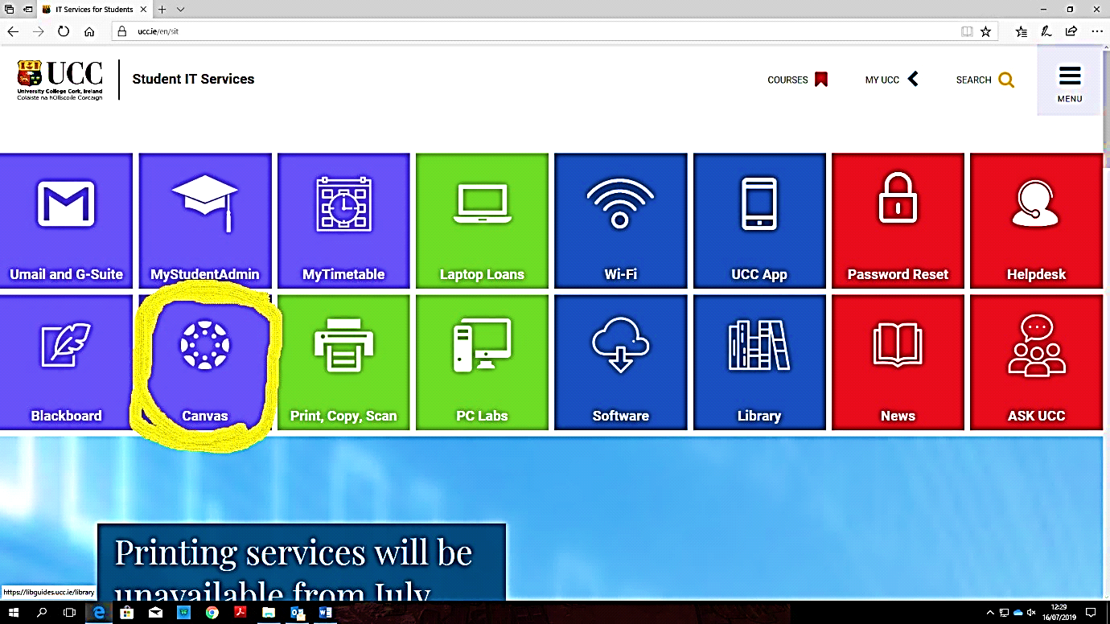

Step 2 – Click the **Canvas** icon

Step 3 – Logon using your full student umail address and Student IT password

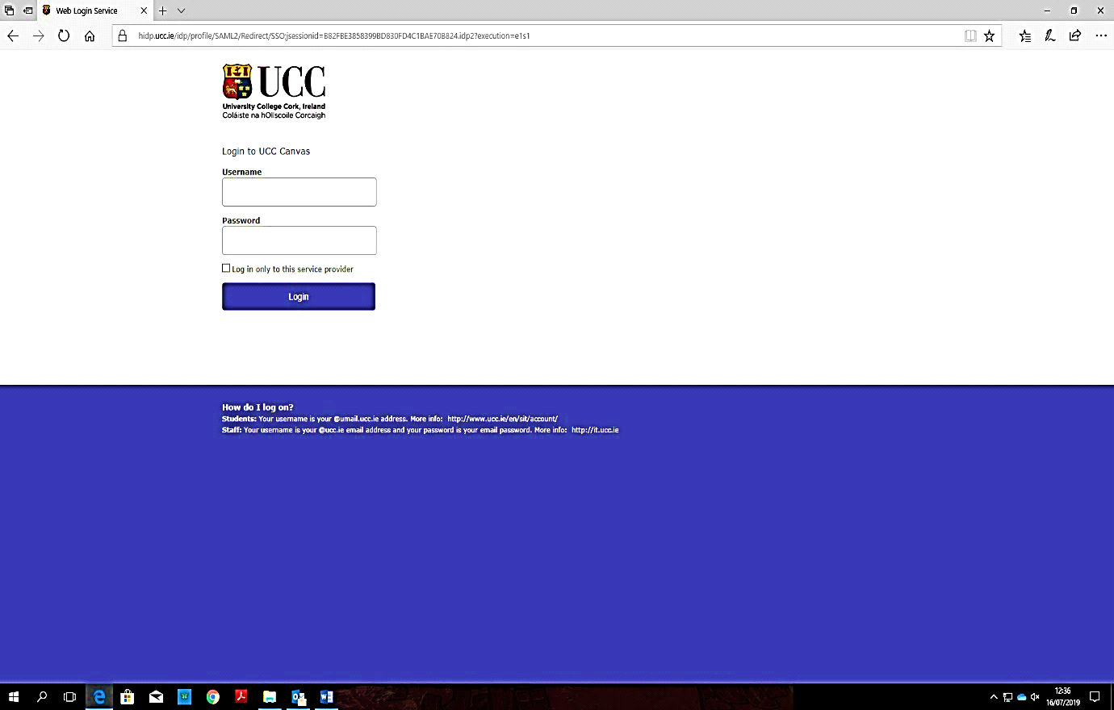

Step 4 – This will bring you to the list of the modules you are registered for.

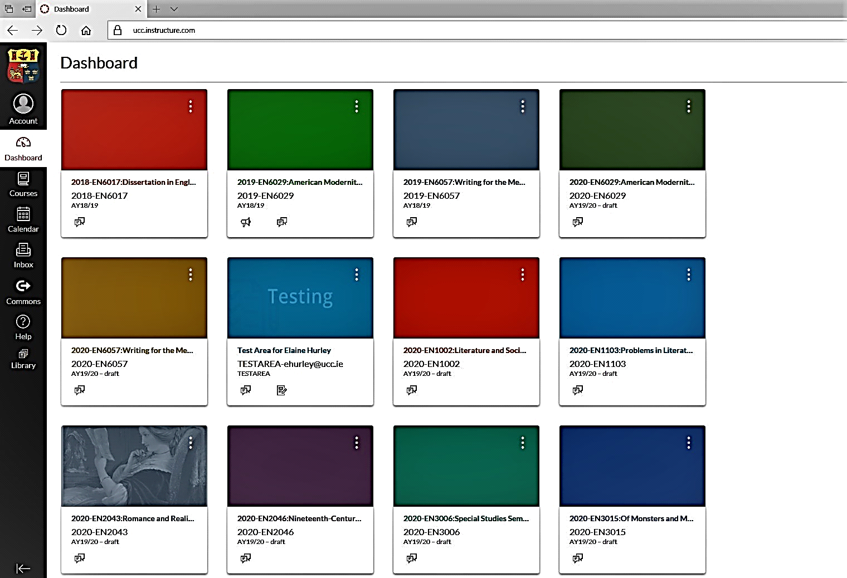

Step 5 – Select a module (EN1002)

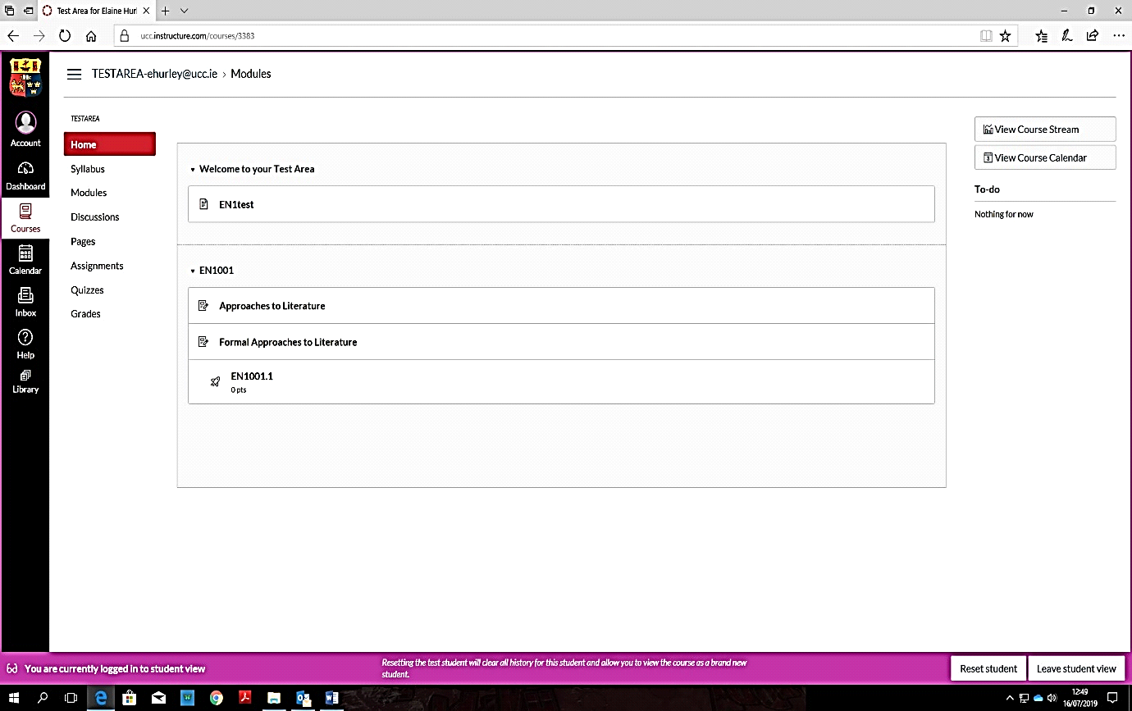

Step 6 – Select Assignment on the left hand column, then select Essay 1 Assignment

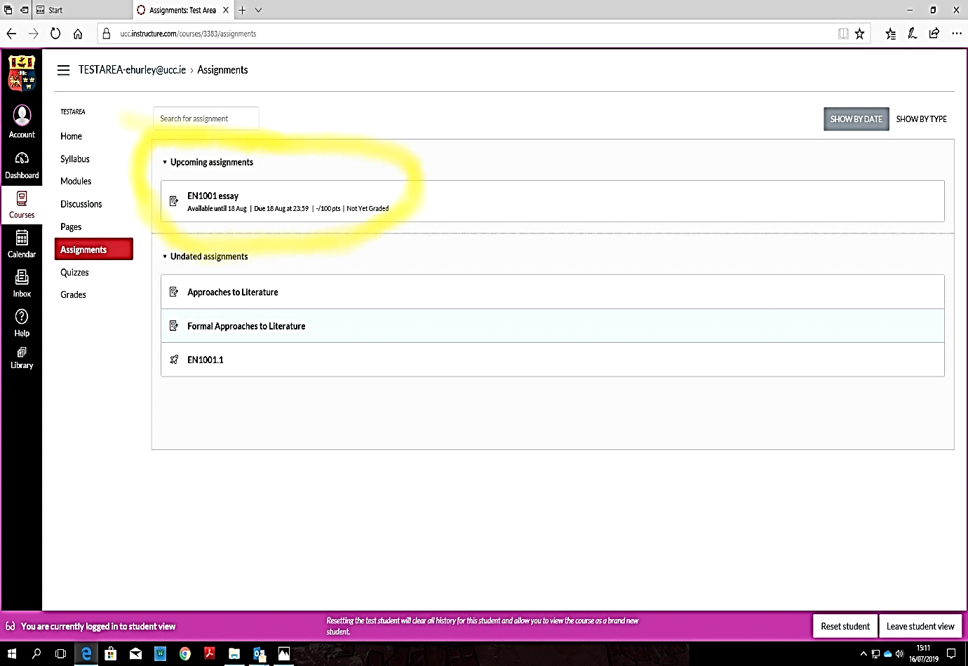

Step 7 – Select Submit Assignment

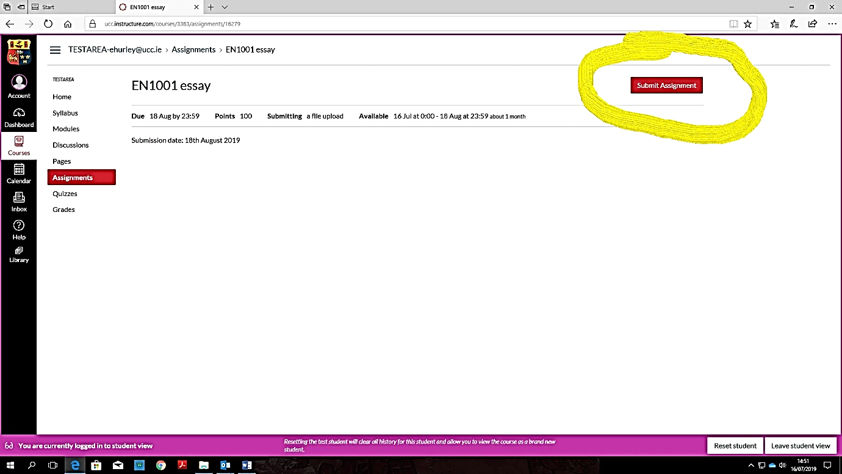

Step 8 – Upload file and submit assignment

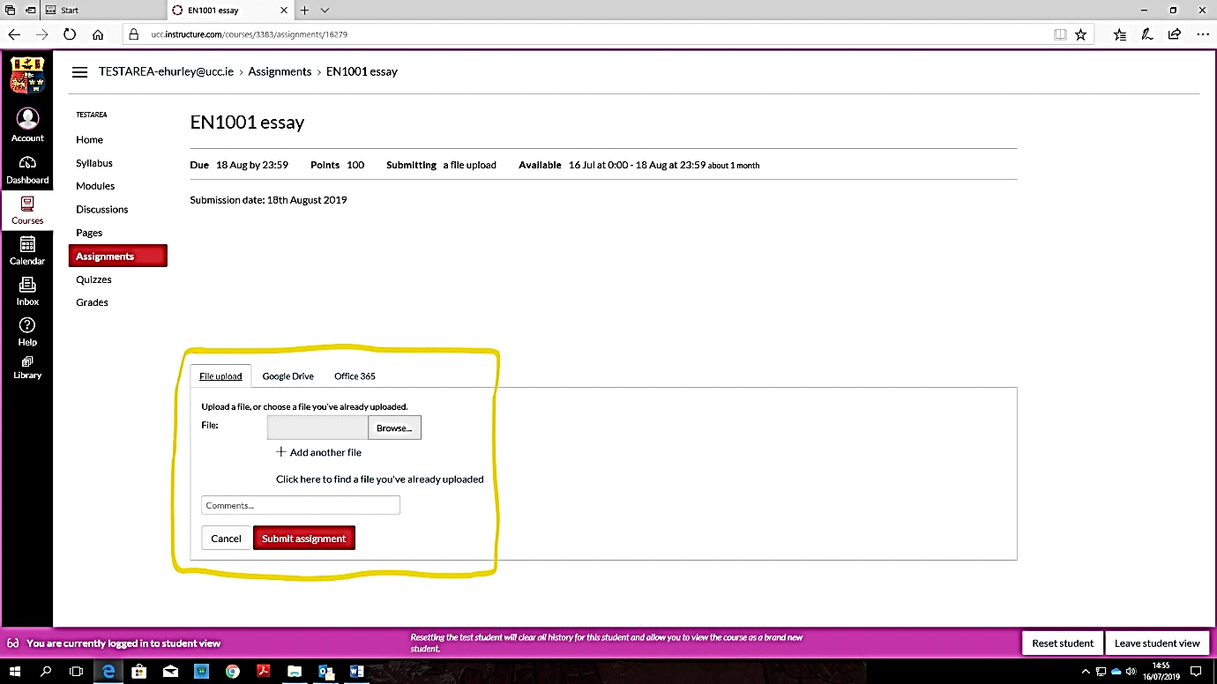

1. . ‘UCC Plagiarism Policy.’ Student Records and Examinations Office. May 2021.

   <https://www.ucc.ie/en/media/support/academicsecretariat/policies/examinations/UCCPlagiarismPolicy-V3.0-May2021(4).pdf>