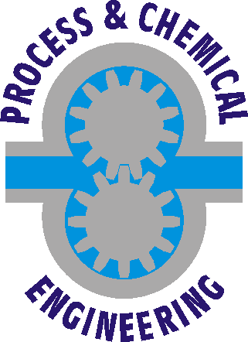
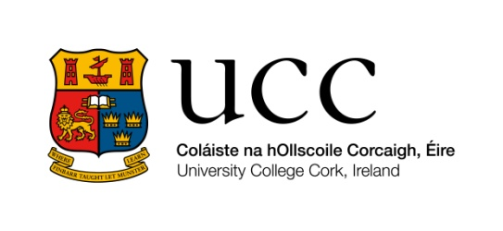

Department of Process & Chemical Engineering
University College Cork

MEngSc/ PGDip in Pharmaceutical &Biopharmaceutical Engineering

Sample Assignment Submission Cover Sheet

Code and Name of the Module

Title of the Assignment

Joe Bloggs
25th December , 2076

Lecturer: Dr. Aodh B. See

