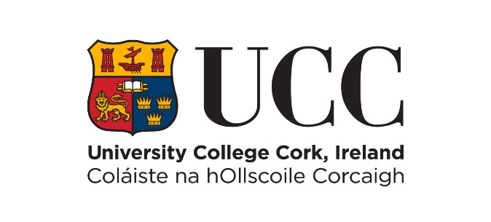

An Scoil Altrachta agus Cnáimhseachais
Catherine McAuley School of Nursing and Midwifery
Plagiarism Policy and Assignment Cover Sheet

Plagiarism Policy
What is plagiarism?
Plagiarism is the presentation of someone else’s words or ideas as your own work. Whether done deliberately or in error it is a form of cheating and a breach of academic integrity.

Plagiarism includes the following:
1. Copying sentences, paragraphs, phrases without appropriate attribution (using quotation marks and crediting the author in a citation) from published or unpublished sources;
2. Presenting sentences, paragraphs, phrases with only slight changes, from the work of others as your own work;
3. Presenting someone else’s ideas or arguments as if they were your own;
4. Submitting work for assessment which you have already submitted, partially or in full, to fulfil the requirements of another seminar/lecture course or examination (this is self-plagiarism);
5. Allowing someone else to copy your work - both parties will be penalised (this is collusion).

Plagiarism can occur in take-home assignments, in-class tests, class presentations or examinations. In every case it will be penalised according to the UCC Plagiarism Policy https://www.ucc.ie/en/exams/procedures-regulations/

Please use the link below to find the necessary information regarding the requirements of the School of Nursing & Midwifery in relation to academic writing and referencing.
http://www.ucc.ie/en/nursingmidwifery/students/academicwritingandreferencing/

Other resources for learning and writing for students at UCC can be found at:
https://www.ucc.ie/en/red/writing/

Assignment Cover Sheet
When you submit any assignment, you will be required to attach the completed Cover Sheet overleaf and sign the 2 declarations (for hard copy submissions use a handwritten signature OR for online submissions type your name on the two signature lines). No other cover sheet is required – there is no need for a second page with name, title, etc.

NB Every assignment must have this Cover Sheet attached. Any assignment that does not have this fully completed Cover Sheet attached will not be accepted.
Catherine McAuley
School of Nursing and Midwifery
Brookfield Health Sciences Complex
University College Cork

***Please ensure you sign the form TWICE below***

Module Code and Title:

Title of Course:

Title of Project/Essay:

Student name: Student Number:

Word Count: Date:

I have read the School’s Policy on Plagiarism, and I declare that the content of this assignment is all my own work. Where the work of others has been used to augment my assignment it has been referenced in accordance with academic convention.

This essay complies with School of Nursing and Midwifery requirements and guidelines on plagiarism:

YES NO

(Please tick one box.)

Signed . . . . . . . . . . . . . . . . . . . . . . . . . . . . . . .
For hard copy submissions, use a handwritten signature. Typed names ONLY accepted for online submissions.

I attest that I have not submitted this material in whole or in part for the assessment of another programme or award in this School or university or any other higher education institution.

YES NO

(Please tick one box.)

Signed . . . . . . . . . . . . . . . . . . . . . . . . . . . . . . .
For hard copy submissions, use a handwritten signature. Typed names ONLY accepted for online submissions.

