THE CHANGING NATURE OF LOCAL GOVERNMENT IN IRELAND
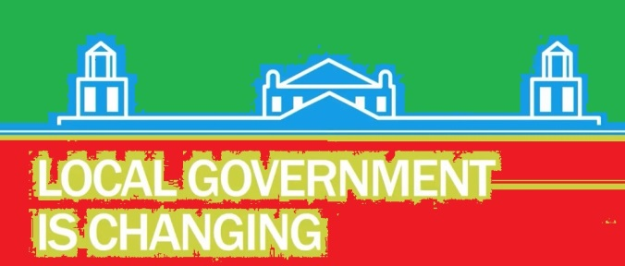
Symposium to mark the launch of a special edition of Administration
on local government in Ireland

TIMETABLE – WEDNESDAY 16 SEPTEMBER 2015

The symposium will take place in UCC’s O’Rahilly Building (Room 2:55) from 3:00-5:30pm and will be followed by the launch of the special edition.

2:30 Registration in Social Area (O’Rahilly Building, second floor, Block B)

3:00 Welcome

3:05 ‘Change and reform’ - Aodh Quinlivan, University College Cork

3:25 ‘The role of the county councillor in a changing environment’
Marcia D’Alton, Cork County Council

3:45 ‘Can local government emerge from the financial crossroads?’
John Considine and Theresa Reidy, University College Cork

4:05 ‘An evolving political landscape’- Adrian Kavanagh, Maynooth University

4:25 ‘Women in Local Government’ - Fiona Buckley and Caroline Hofman, University College Cork

4:45 ‘Local Government and the Print Media’ - Eoin English, Irish Examiner

5:05 Questions & Answers

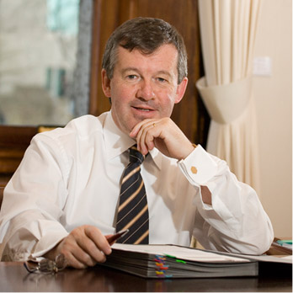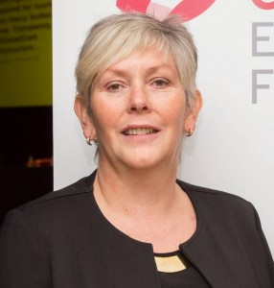
5:30 - Reception and launch of ‘The Changing Nature of Local Government in Ireland’

Social Area, Block B, O’Rahilly Building

Dr Michael Murphy,
President of UCC

Ann Doherty,
Chief Executive, Cork City Council

- This event is running with the support of the Institute of Public Administration (publisher of Administration) and the Political Studies Association of Ireland (PSAI) and is hosted by the Department of Government in UCC.
- The event is free of charge but registration is required.

For any queries and further information, contact Aodh Quinlivan at a.quinlivan@ucc.ie

