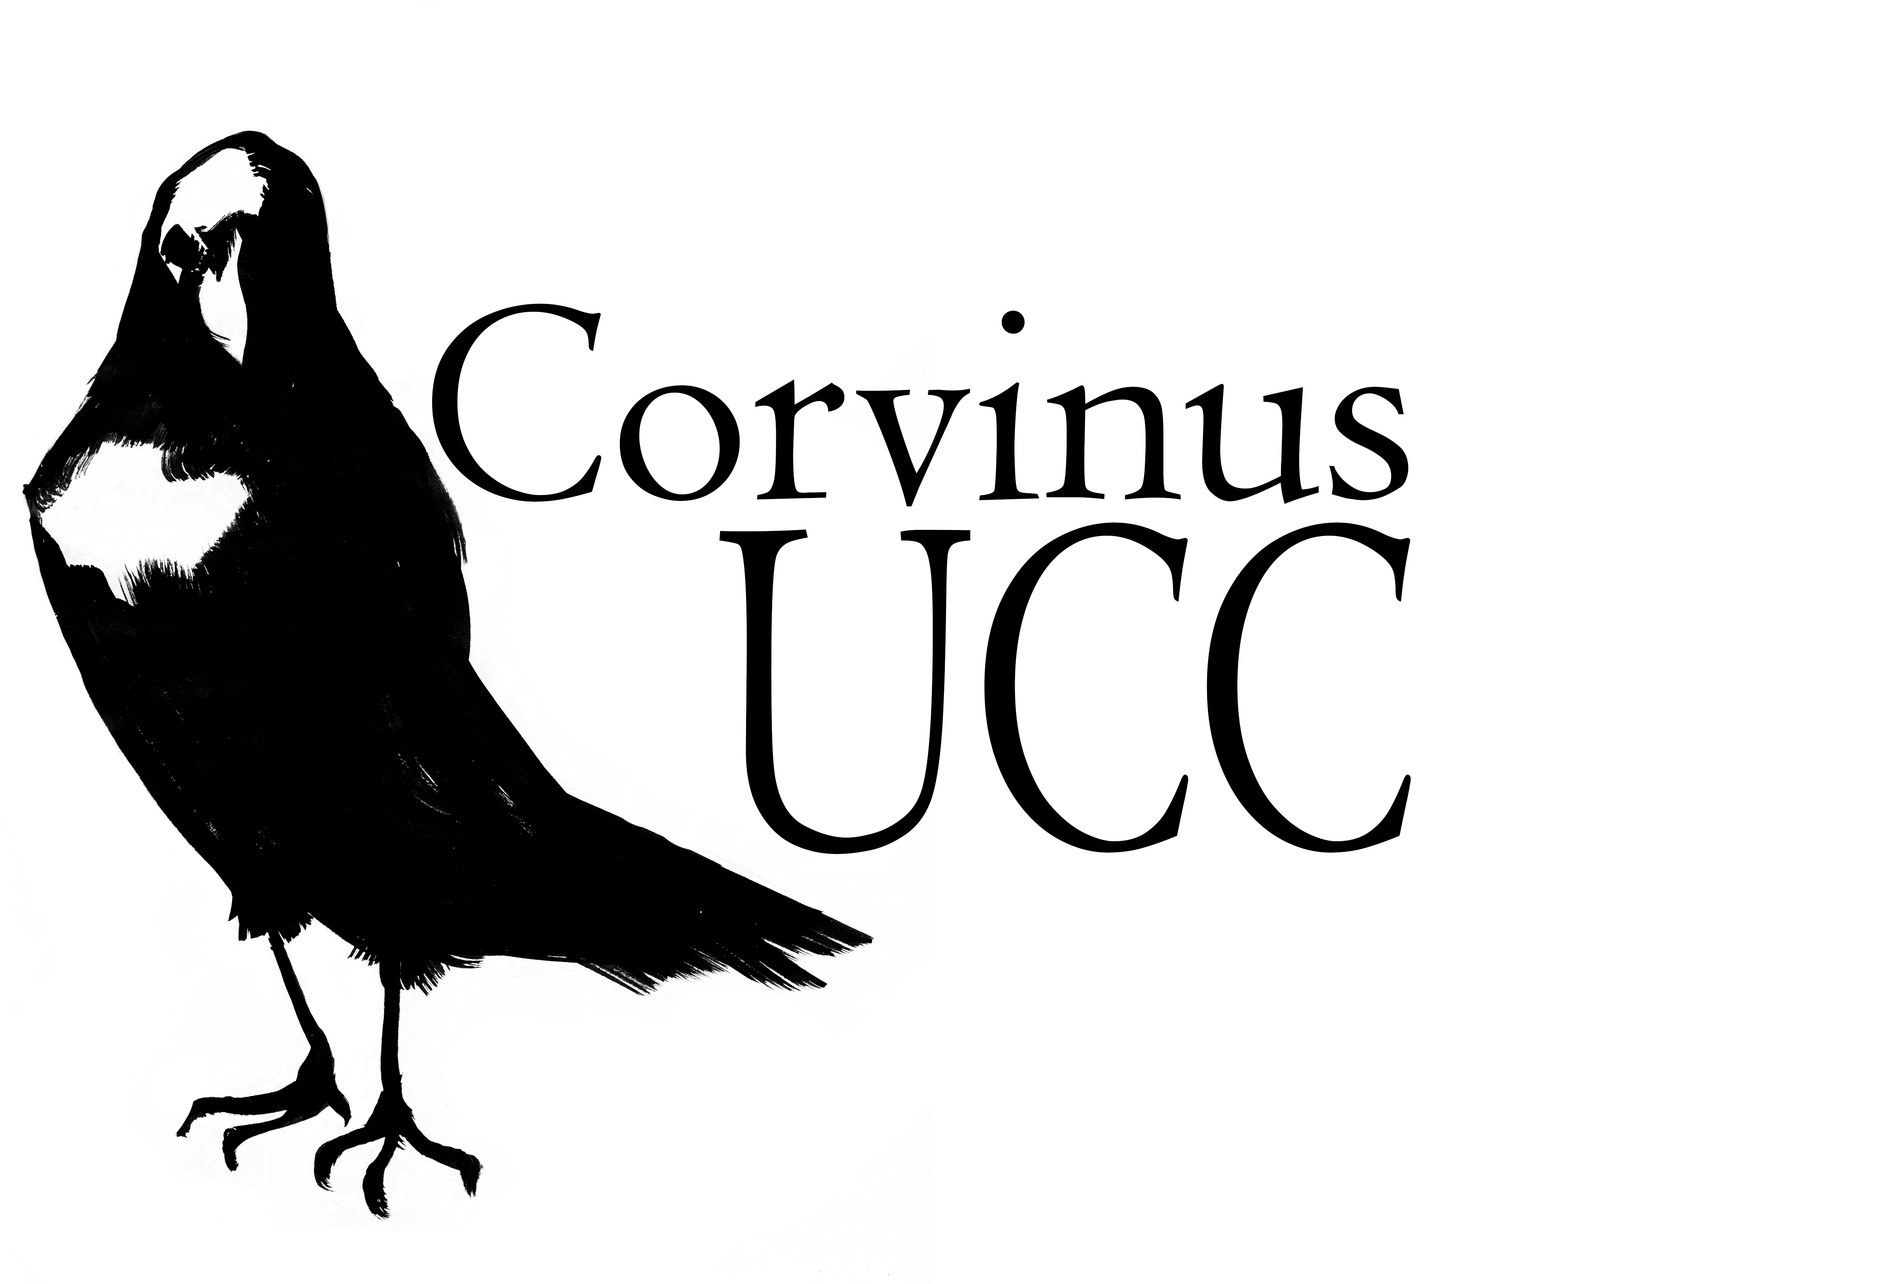
CACSSS welcomed the first Corvinus Students
Corvinus is a new Transition Year Programme for second level TY students interested in literary, creative, and historical humanities. This exciting week-long programme includes a range of workshops and taster lectures/seminars in the areas of Celtic Civilisation, English, Greek and Roman Civilisation, History, History of Art and Theatre, with seventeen students from fourteen schools across Munster and Dublin participating this year.
Throughout the week of 24 - 28 February 2020, the students attended undergraduate lectures, workshops and seminars, in Classics looking at the mosaics and frescoes of Pompeii with Mr Sean Murphy and doing a special workshop on Spectacle in Ancient Rome with Dr Catherine Ware. The course included a walking tour of the campus with Dr Diarmuid Scully (History), an introduction to the library with Mr Cathal Kerrigan and a trip to the Glucksman where they learned first hand about collage from Mr Tadhg Crowley, Senior Curator.
The Corvinus programme was founded by Dr Catherine Ware (Classics, Corvinus co-ordinator) and Dr Malgorzata Krasnodebska-D'Aughton (History). Corvinus was launched on Monday, 24 February by Prof. Chris Williams, Head of CACSSS and closed on Friday, 28 February with the presentation of parchments by Prof. Patrick O'Shea, UCC President.
It's Corvinus week and the TY students have been going to lectures on Greek and Roman Civilisation, English, History and Theatre

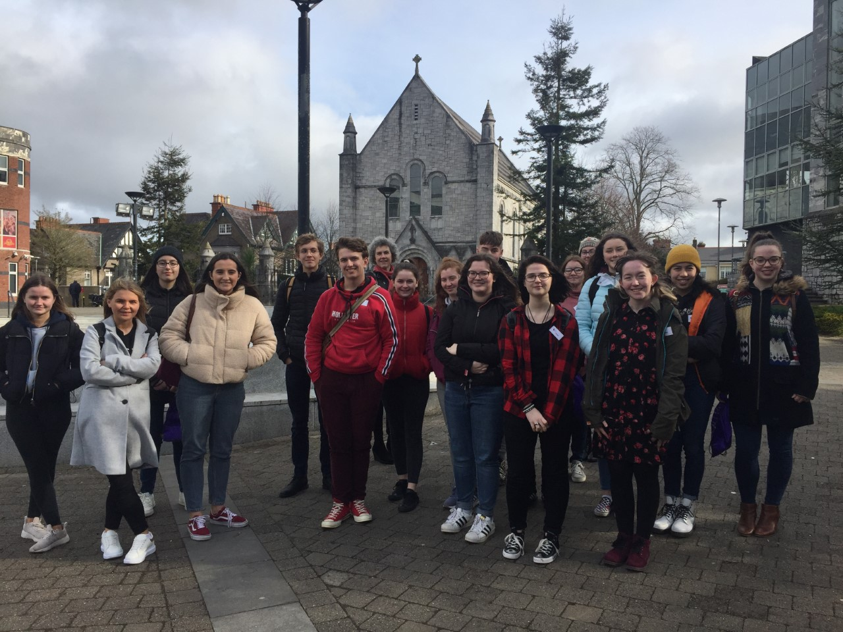
On a tour of the campus with Dr Diarmuid Scully.
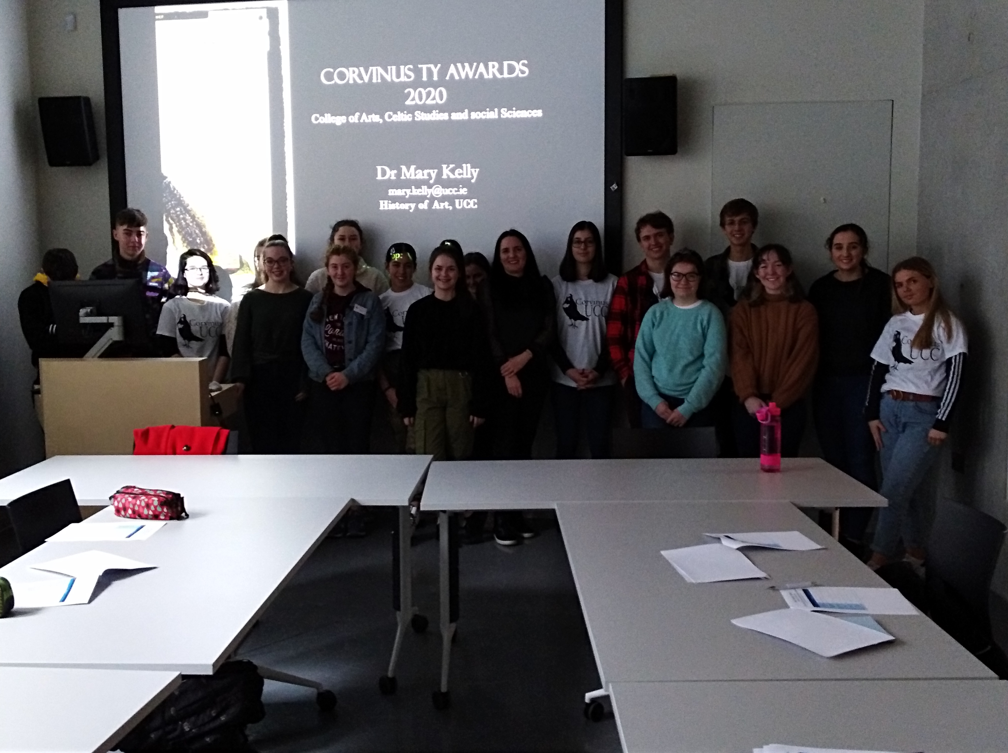
History of Art Toolkit Workshop with Dr Mary Kelly
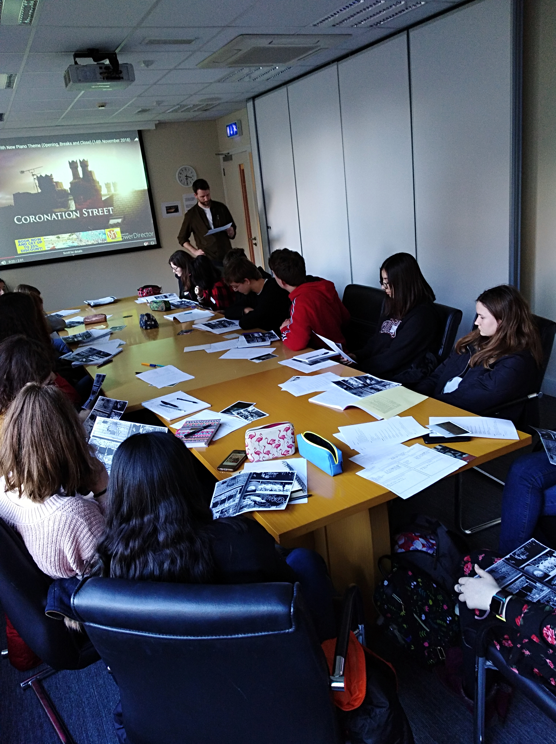
A creative writing workshop with author Danny Denton
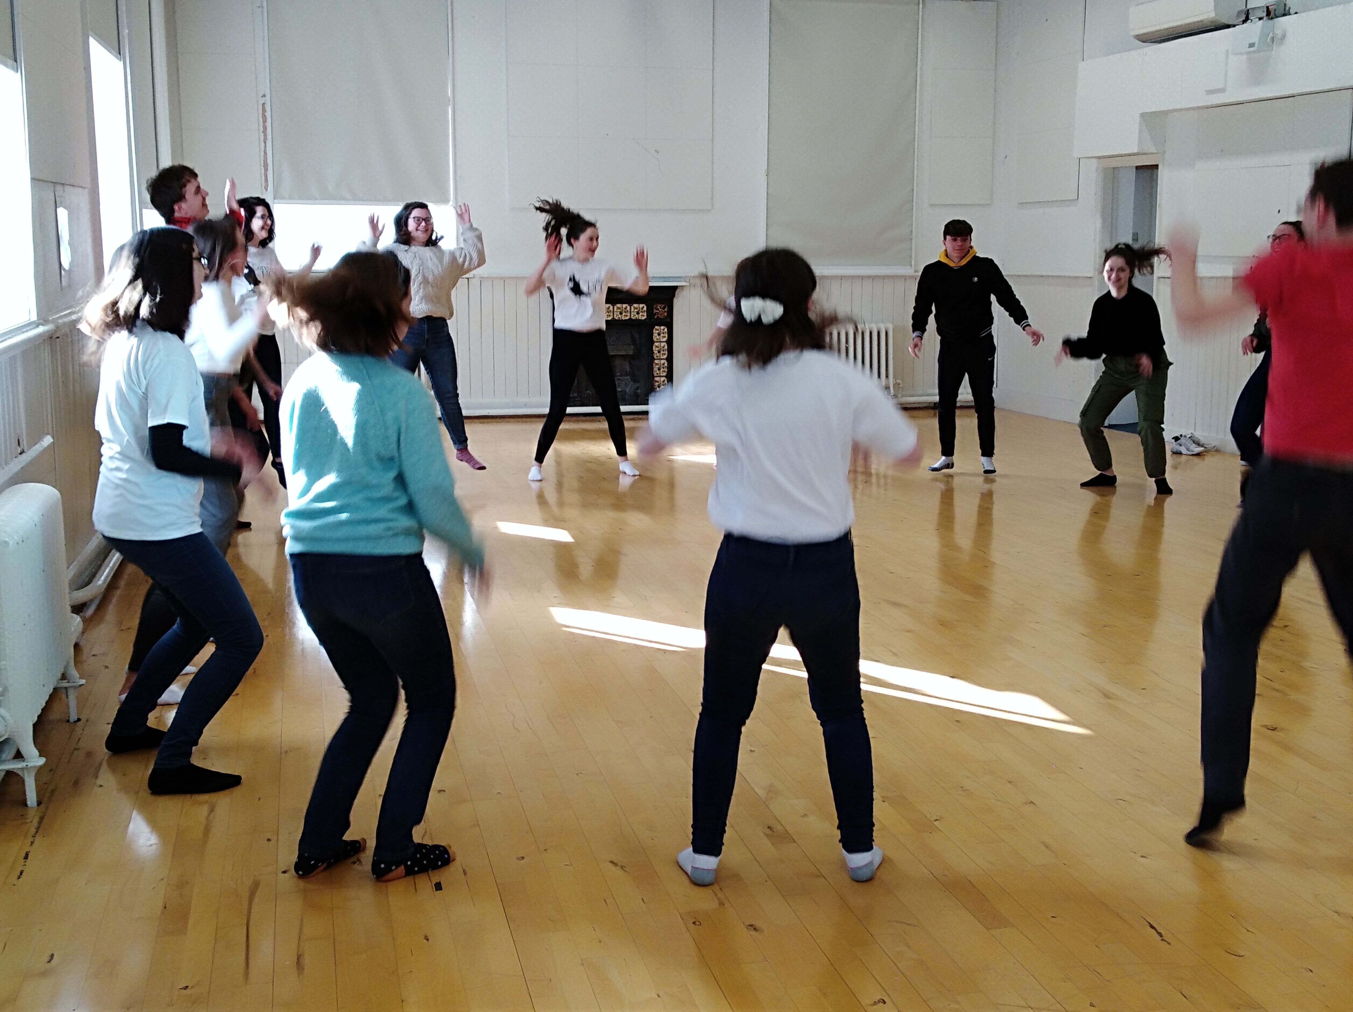
A Workshop on Theatre of the Image with Fionn Woodhouse
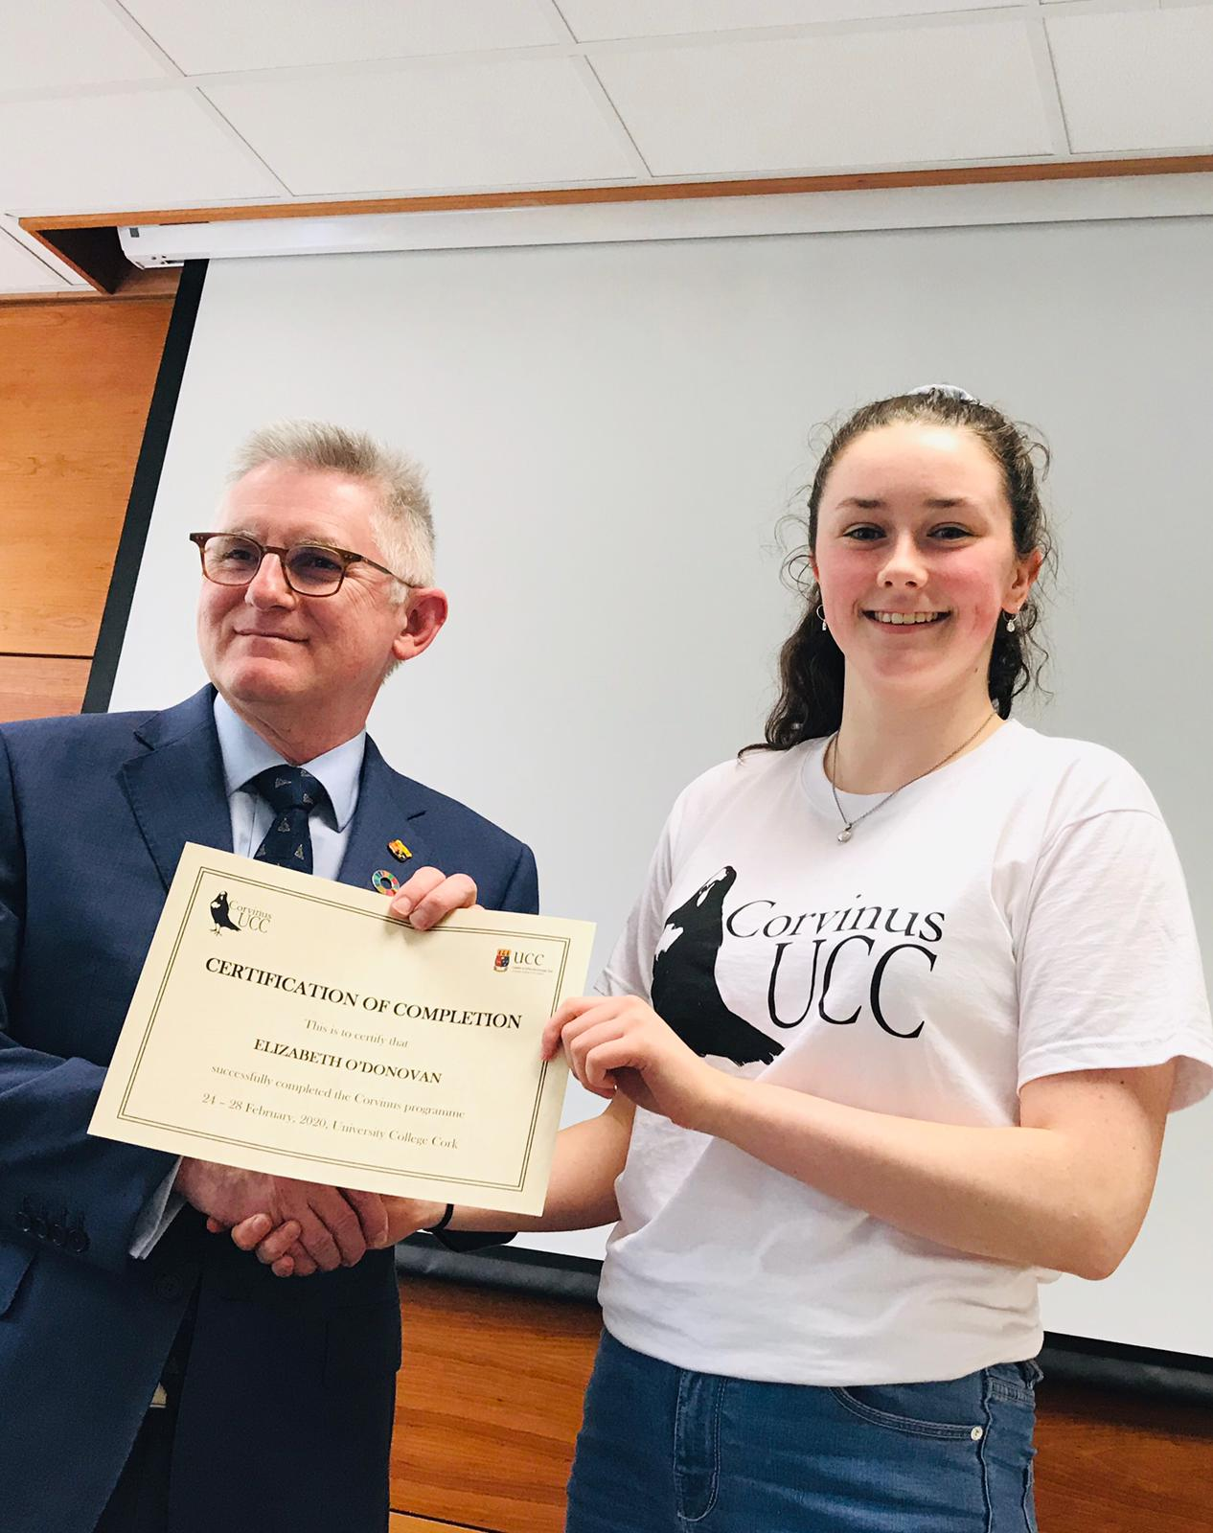
Elizabeth O'Donovan receives her Certificate of Completion from Professor O'Shea, President of UCC
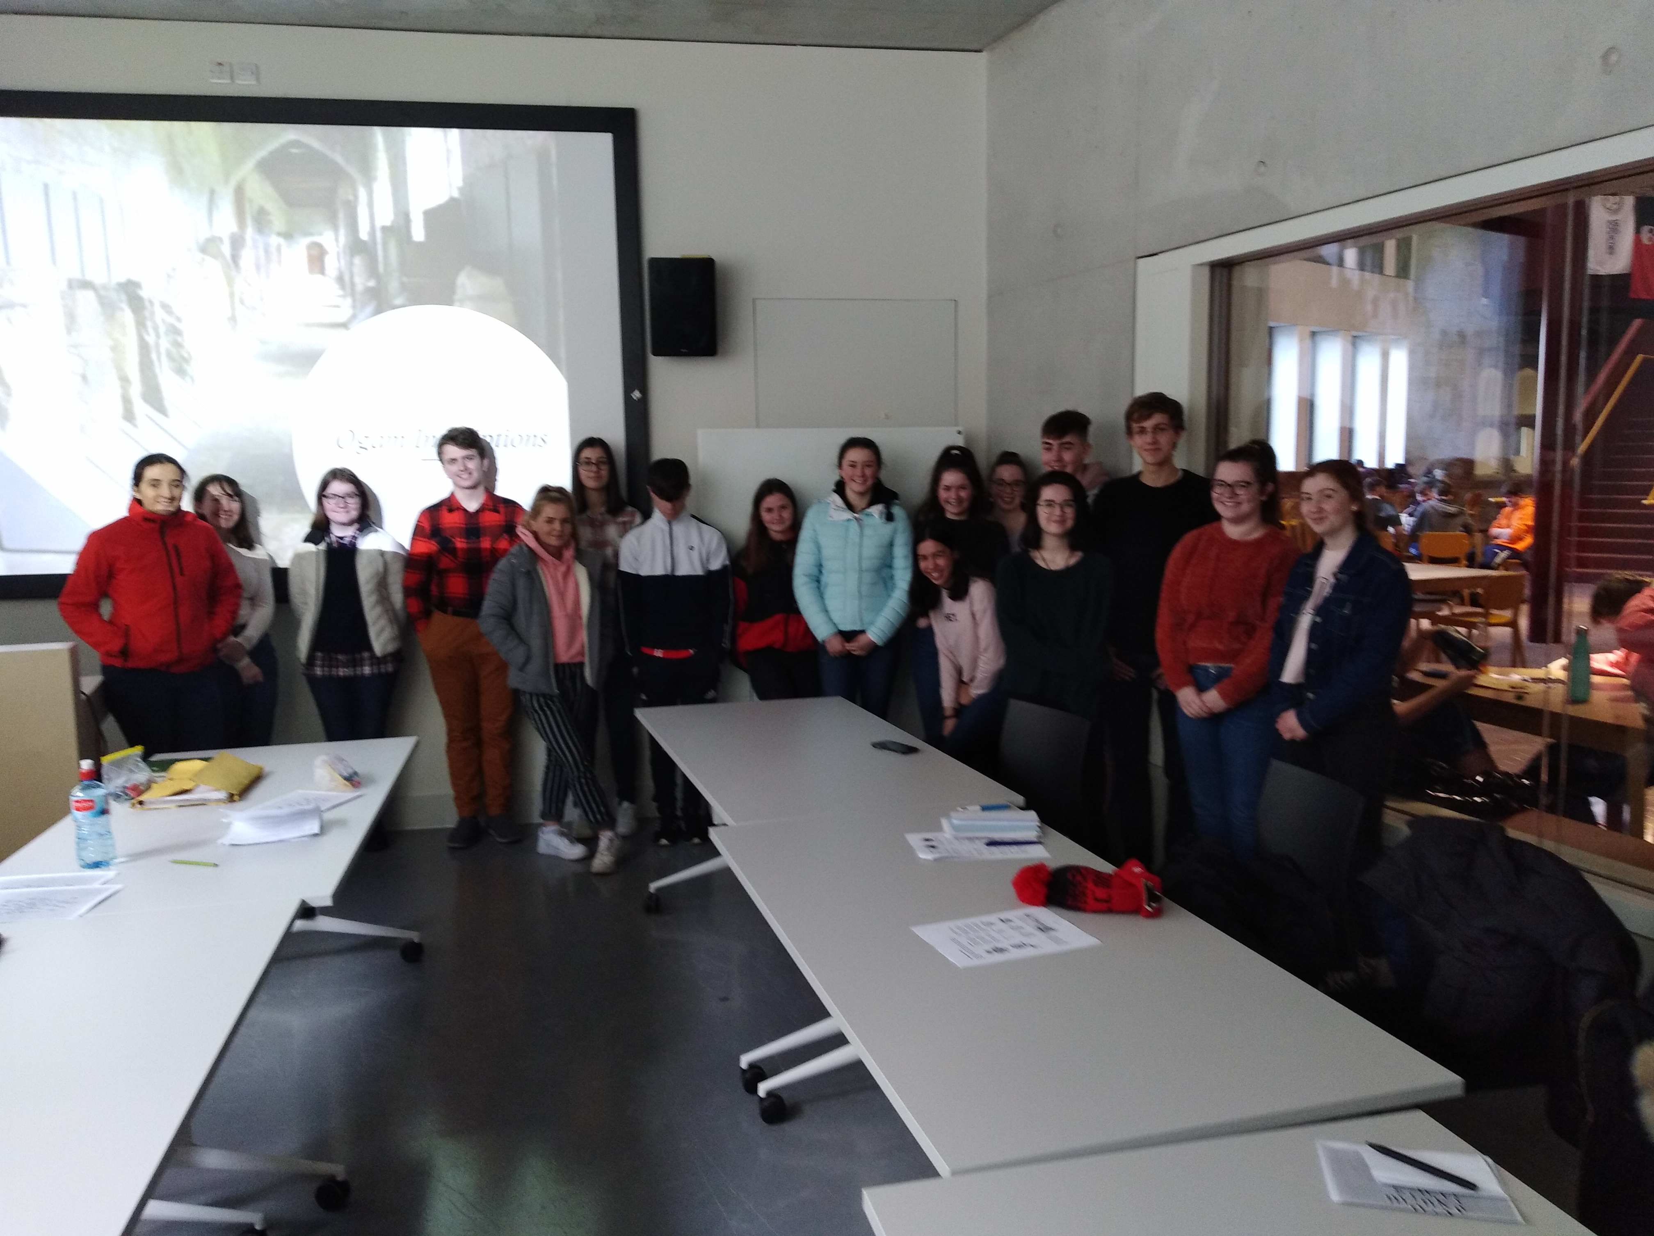
Enjoying a workshop on Palaeography and Ogham
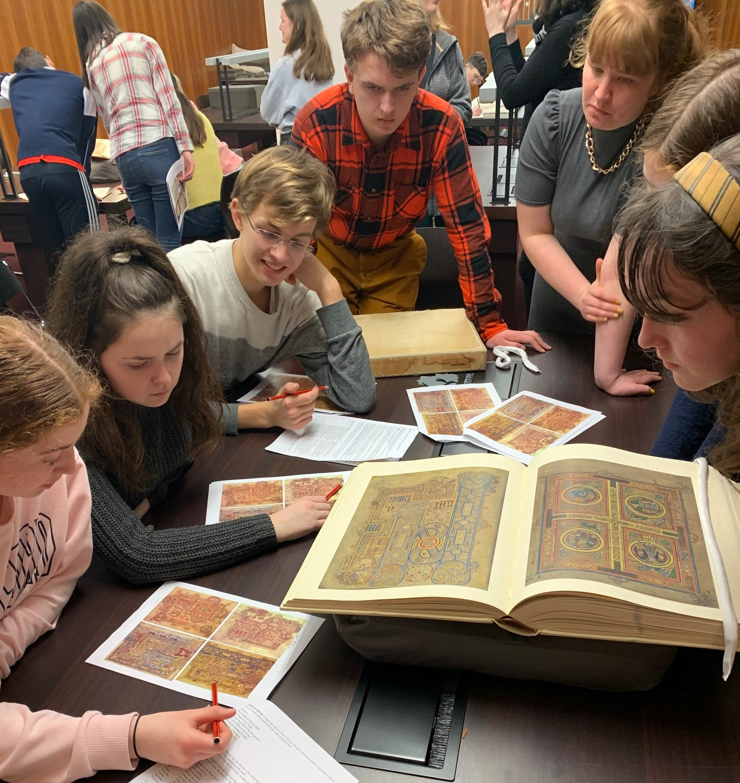
In Special Collections, Boole Library UCC
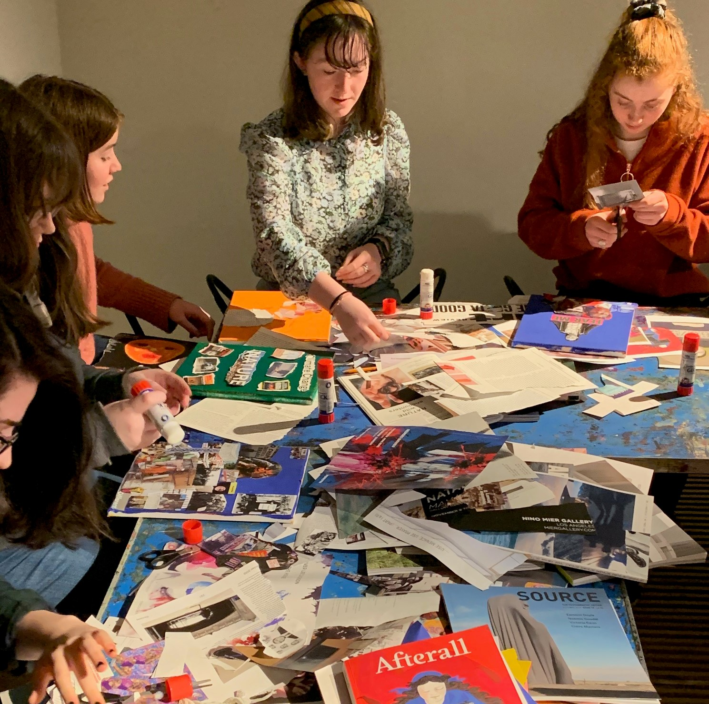
Learning about Collage in the Glucksman Gallery
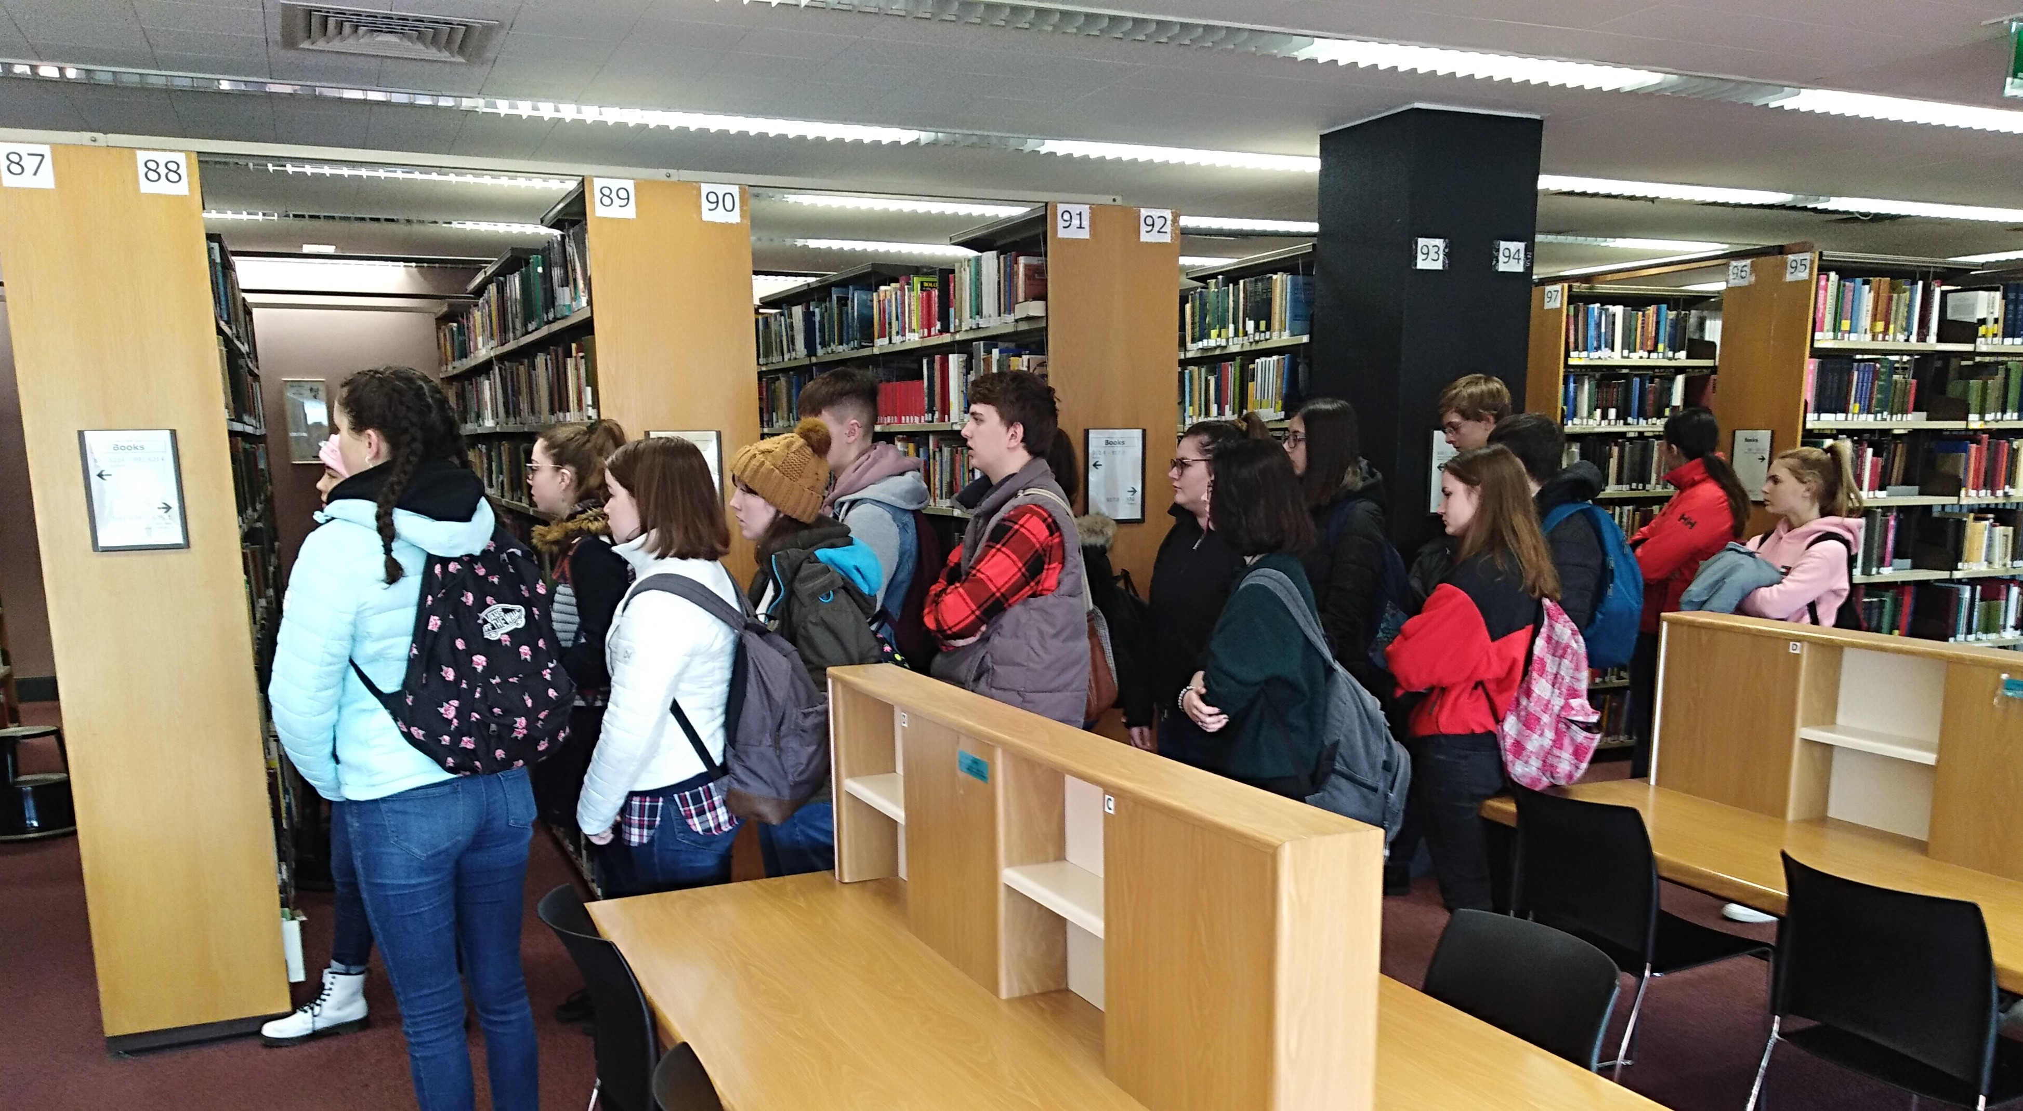
On a library tour of the Boole Library

