QUERCUS APPLICATION INSTRUCTIONS
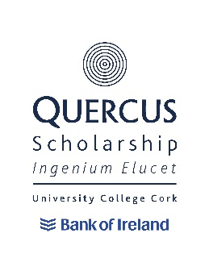
Click on the APPLY NOW button on the Quercus webpage. This can be found on the home page, or at the bottom of each of the strand pages. This will bring you to the Application Portal. 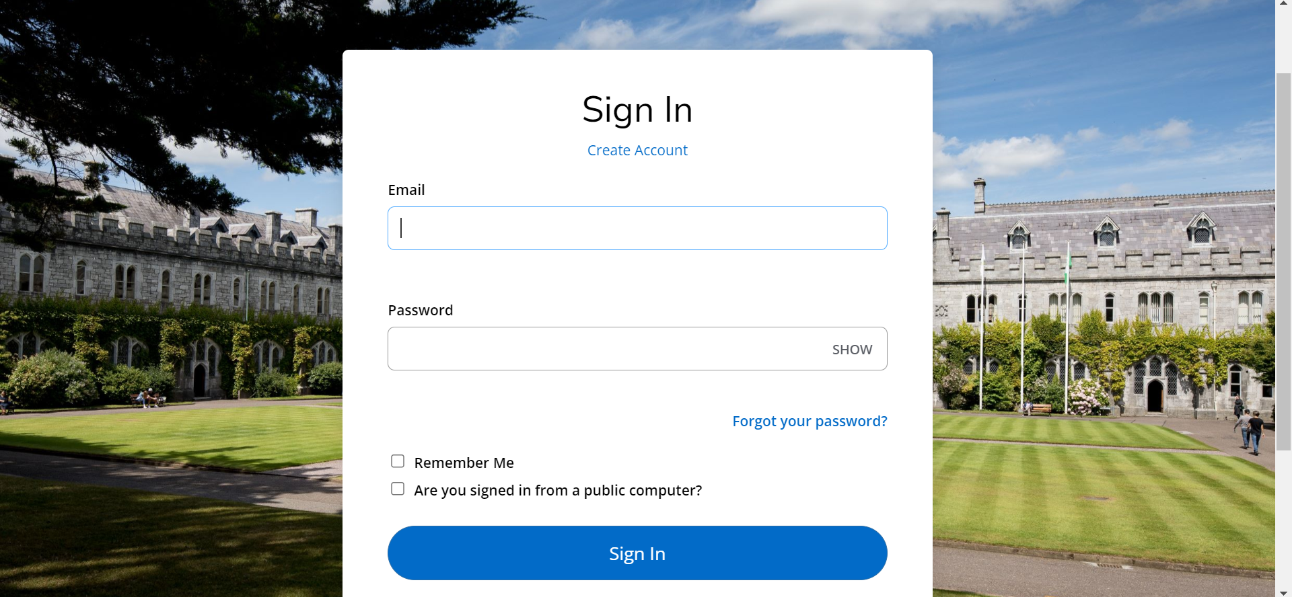
Select Create Account. Put in First Name, Last Name, Email Address, Confirm Email Address, Mobile and Country of Residence. For Academic Level select Quercus Programme from the drop-down menu. For Course Type select Quercus Programme. For Academic Programme select the Strand that you want to apply for from the drop-down menu, i.e., Active Citizenship, Creative & Performing Arts’. Innovation/Entrepreneurship, Sport. For Entry Term select Academic Year 2024-25.
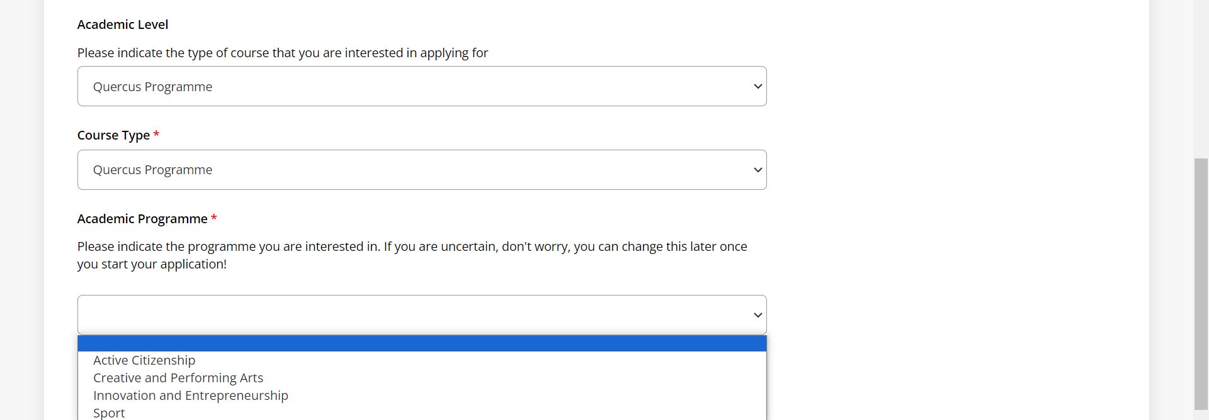

Put in a password, confirm password, and click Create Account. Use a password that you will remember!

When you click on Create Account it will automatically bring you back to your Account page. In the box that says My Applications You Do Not Currently Have Any Applications select that button that says Create a New Application.
Scroll down to the bottom of the page to Number 8: Quercus Application and select Start a New Quercus Programme Application.
You will then be brought to a Personal Details page. Fill all the information, especially those boxes marked with an asterisk *. When you get to the Additional Information section at the end of this page do the following if you are a CAO applicant: Tick no for if you are currently registered at University College Cork and enter your CAO number.
If you are a current UCC student do the following: Tick yes for are you currently registered at University College Cork and enter your UCC Student number. If you are a UCC student and intend on applying for a new course through the CAO, then tick yes for do you intend to apply through the CAO for a new UCC programme of study and then enter the new programme of study that you would like to study.
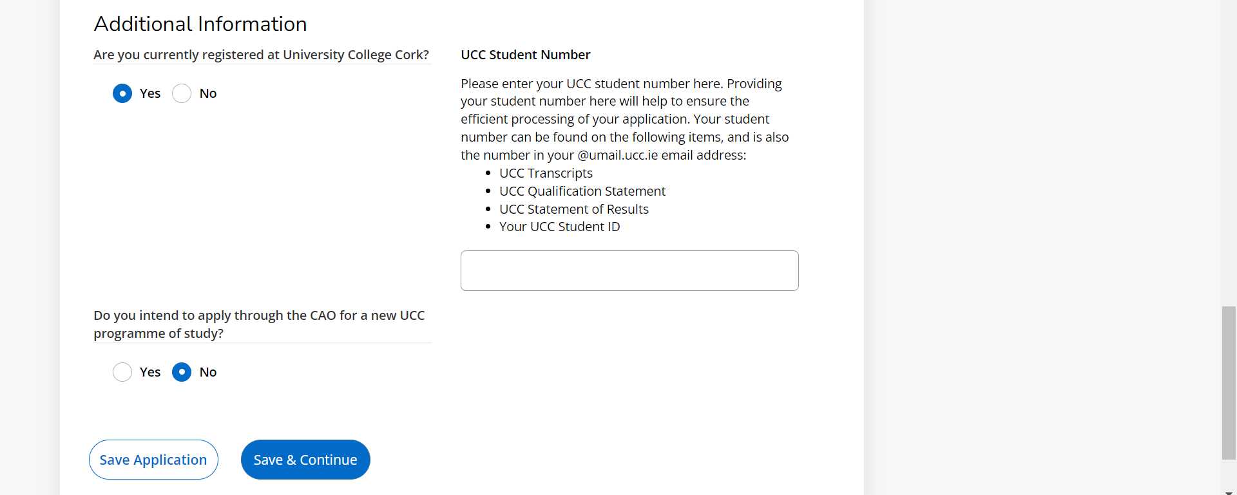
You will then be brought to the Programme page. This page will already be populated for you based on what you have entered so far. In Application Type it should say Quercus Programme, in Strand it should whatever strand you have chosen to apply for, i.e., Active Citizenship, Creative & Performing Arts, Innovation/Entrepreneurship, Sports, and in Entry Term it should say Academic Term 2024-25.
You will find dropdowns which will allow you to select your talent. Please only select talents if you have a proven track record in that talent i.e., awards, recognition etc. Click save and continue.
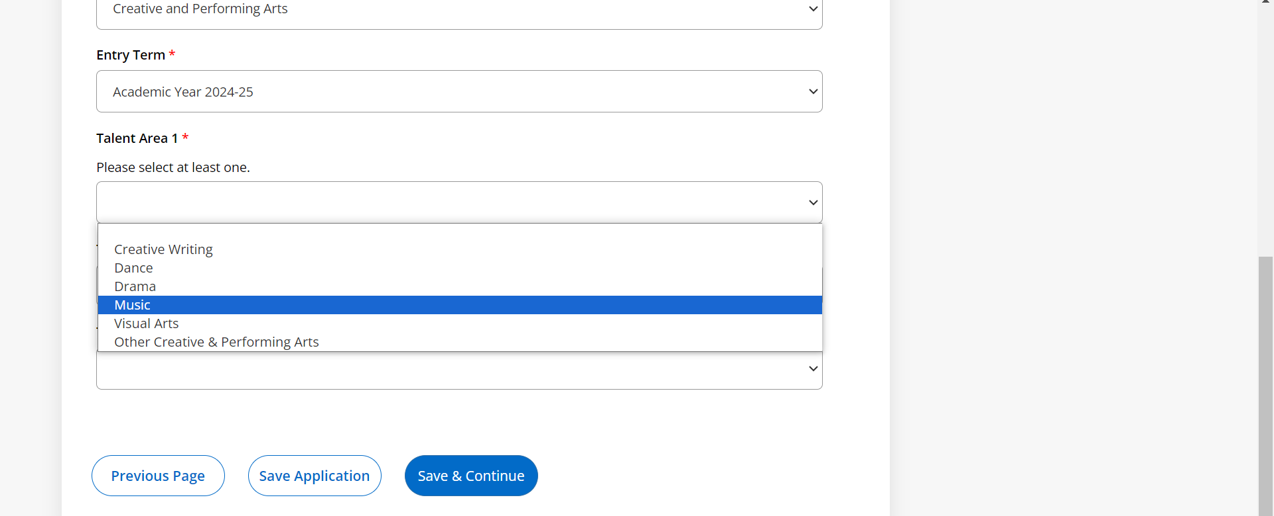
This will bring you to the Education page. Click the + next to add details of post primary/further education. Start typing the name of your secondary school and it will pop up from drop-down menu, click to select. If your school is not listed, then you can enter it manually by clicking School Not Found. Fill in the rest of the information and click Save and Continue.
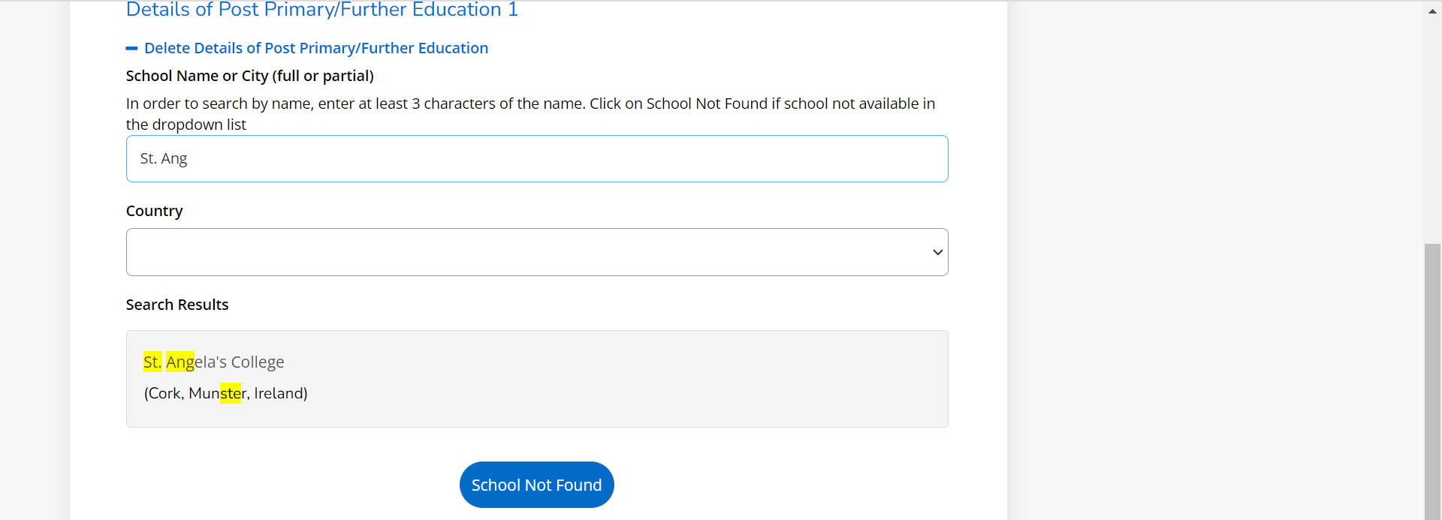

In the Confirmation page tick Yes for the 3 confirmation buttons. Enter your signature and signature date then preview before submission. Once you have previewed and checked that all your biographical details are correct then press Submit.
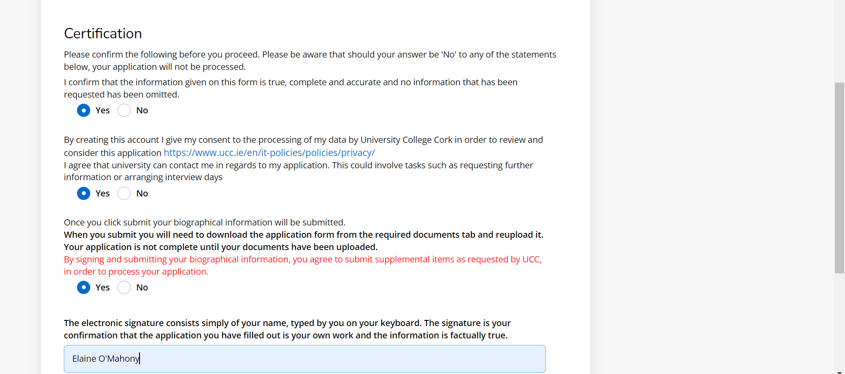
This will bring you back to your account page. Under My Applications you will see the name of whatever Application Strand you have chosen to apply for, i.e., Active Citizenship, Creative & Performing Arts, Innovation/Entrepreneurship or Sports. When something needs to be done for your application you will see the Status set to Action Required. If you click on Action Required, it will tell you what Action needs doing. Click on the Application Name, i.e., Academic Year 2024-25 – Creative and Performing Arts, to add those supplemental items.
NB: Your application is not considered complete unless you have uploaded the required supplemental items before the closing date of 4:30pm on 7th February 2024.

Once you have clicked on the Application Name, for example Academic Year 2024-25 – Creative & Performing Arts, then you will be brought to a page where you can upload your supporting documentation.
APPLICATION FORM
This part of the instructions is very important.
You will find the Quercus Creative & Performing Arts Form by clicking on the blue writing which says Quercus Creative and Performing Arts Application Form.
Download this application form unto your PC/Laptop etc. so that you can take your time filling it in. This form needs detail and attention and cannot be filled in on a phone. You should also download it well in advance of the closing date so that you can take your time and concentrate on filling it in. Once you have the form filled in, save it as a PDF and upload it into your application account in the upload space provided, see example below. Below is what the application form looks like.
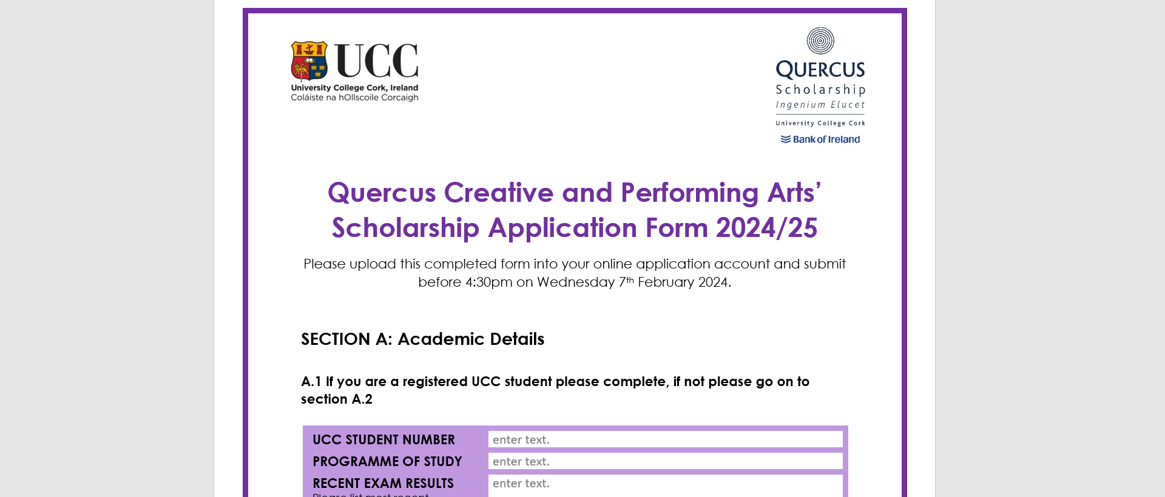
The Application Form must be uploaded into your application account before the deadline of February 7th, 2024, at 4:30pm. If it is not, then you will not go any further in the application process.
You must also upload one academic reference and one Creative and Performing Arts Reference. These references need to be the actual written/typed references from your referees. Their names and phone numbers will be no good as we will not be searching for references on your behalf, you must supply the action physical reference yourself. Though the closing date for uploading the Application Form is 4:30pm on Wednesday 7th February 2024, we will give you an extra 10 days to upload references.
To upload your application form, click on Choose File, browse to where you stored the application form and then click on it, once the fill is uploaded you then need to press upload, which will be in blue writing under choose file once you’ve uploaded the form. When you have correctly uploaded the form, it should say REMOVE. No need to do anything else with the application form any more after that. Once you see the word REMOVE do not click on it, that means that your application form has been successfully uploaded into your account. If you need to upload a new application form, you can do that right up until the closing date. After that point you will no longer be able to access the upload application space.
You must also upload two references. You will get 10 extra days to upload these after the application closing date. These ten days do not include the application form, only the references. If you do not have the application form uploaded by Feb 7th, 2024, you will not go any further in the application process. You must upload one academic reference and one Creative and Performing Arts reference. You can, however, upload up to five references. When they are uploaded correctly you will see REMOVE next to them – you will not need to do anything else after this.

PLEASE NOTE CREATIVE WRITING AND VISUAL ARTS APPLICANTS – please upload samples of your work into the same space that you upload your references.

