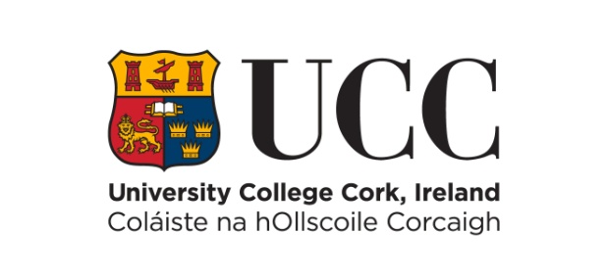

REQUEST FOR REASONS FOR ACTS OF THE UNIVERSITY

Section 10 of the Freedom of Information Act 2014

1. DETAILS OF REQUESTER (PLEASE USE BLOCK CAPITALS)

Surname: __________________________ First Name(s):_______________________

Email Address: __________________________________________________________

Address for correspondence: ____________________________________________

_________________________________________________________________________

_________________________________________________________________________

Date of Birth: ____________________________________________________________
(required for identification purposes only)

Contact Telephone Numbers:
Mobile: _________________ Home: ________________ Business: ________________

2. DETAILS OF REQUEST

In accordance with section 10 of the FOI Act 2014, I request a statement in writing relating to an act of University College Cork, which has affected me and in which I have a material interest. I request a statement of the reasons for the act and any findings on any material issues of fact made for the purposes of the act.

[Please give details of the act(s) of the University for which you require reasons to be provided. Please be as specific as possible and state as accurately as you can the date of the act and your exact name and address at the time.]
____________________________________________

2. DETAILS OF REQUEST (continued)

Please Note:
- Requests under section 10 of the FOI Act 2014, can only be accepted in relation to acts of the University occurring on or after the commencement date of FOI for the University sector – i.e. 1st October 2001.
- Before you are given access to personal information relating to yourself, you may be asked to produce proof of identification (e.g. your birth certificate, driving licence, passport, staff ID card, student ID card or other form of identity).

3. APPLICATION

Signed: ____________________________________ Date: _____________________

Please send your completed FOI request form by email to: foi@ucc.ie.

Alternatively, you may send your request by post to:

Freedom of Information Officer
Office of Corporate & Legal Affairs
University College Cork
College Road
Cork
If you require any assistance in making an FOI request, please contact the Freedom of Information Officer by email at: foi@ucc.ie or telephone: +353 (0)21 4903949.

