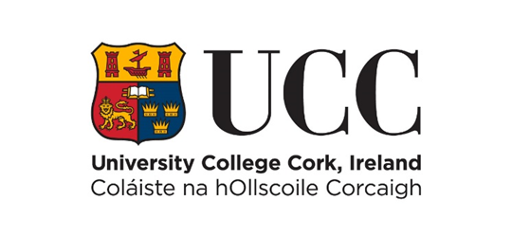

Internal Progression Process Scheme
Template for CV- Expression of Interest for Progression across the Merit Bar
COVER PAGE – PLEASE READ CAREFULLY
Name: Year of appointment to current post:
School: Discipline:
Please indicate whether part-time or full-time:
Link to IRIS profile (or equivalent):
Typed CVs must be submitted online using this template only via e-recruitment using Employee Self Service (ESS) – handwritten forms will not be considered. Please use font type Calibri, Size 11, single spaced, portrait orientation only, on this form.
The closing date for receipt of CV’s is strictly 12 noon (Irish Local Time) on 14th June 2022. No applications will be accepted for consideration after this time. Before proceeding, please ensure that you have carefully read the Policy on Progression across the Merit Bar.
Please ensure that the information and summary of achievements listed in each section of this EOI can be supported by indicative evidence if shortlisted to proceed to full application. You must indicate here how you have satisfied the relevant essential criteria requirements as found in Appendix 1 of the Policy to establish a prima facie case for Progression. Candidates who establish a prima facie case for progression will be shortlisted and invited to make a full application (Stage 2).
The Board reserves the right to verify the information supplied by applicants. Candidates should note that any inaccurate or surplus information will render the application null and void.
Details submitted as part of this Progression Process (including for example, any details submitted as part of this CV) will be shared with the College Committee Board members and the Lecturer Progression and Establishment Board members, the Human Resources Department and where applicable, members of the Appeals Board.
For further information see Appendix 3 of the Guidelines for Personal Circumstance / COVID 19 Impact Statement

NB: This template may not be altered. CVs exceeding the specified page limit will not be considered.

- Learning and Teaching (Font Calibri, size 11, single spaced only)
Note: Answers must not exceed the two page limit.

Research and Innovation (Font Calibri, size 11, single spaced only)
Note: Answers must not exceed the two page limit. Please list your top 5 publications/outputs on page 6 of this form.

Contribution to Academic Citizenship and Engagement (Font Calibri, size 11, single spaced only)
Note: Answers must not exceed the one page limit.

Top Five Research Publications /Outputs
Please provide a list of your top five research publications or outputs below. You should not provide links at this stage. Candidates should outline why they chose these publications/ outputs. Note: Answers must not exceed the one page limit.

