EUROPE DAY FESTIVAL 2023
TIMETABLE OF ACTIVITIES
The event starts at 1.00pm in the Concert Hall of Cork City Hall. It will end at 5.00pm.
Throughout the day, we will have singing and dancing performances on the main stage of Cork City Concert Hall. There will be lots of different activities to discover and have fun on the theme of the European Union and its values of solidarity, equality, democracy, freedom, and non-discrimination.
All activities are child-friendly, light-hearted and based on exchange.
One of the key activities for which you will have to register is the EU-themed Treasure Hunt. It involves solving 27 clues while observing your surroundings and walking a trail of 2km. Only teams of 4, comprising two aged 13 and over (one or both must be 18+) and two aged 12 and under, can take part. The winning prize is a two-night trip to a European city, flights sponsored by Cork airport and accommodation sponsored by Cork City Council.
Singing by primary and secondary schools. Choreography by Aideen Johnson.

Activity | Time | Location
Launch of the Treasure Hunt by Cllr Canty | 12pm | Main stage, Concert Hall
‘Pick a pic’ with Kasper and Jane | 1.15pm | Main stage, Concert Hall
Singing performance by Scoil Mhuire accompanied by dance group from Aideen Johson school of dance | 1.30pm | Main stage Concert Hall
Launch of the Europe Day festival by Lord Mayor Deirdre Forde | 1.45pm | Main stage Concert Hall
Singing performance Nagle Community College | 2.20pm | Main stage Concert Hall
‘Pick a pic’ with Kasper and Jane | 2.35pm | Main stage Concert Hall
Breton singing group | 2.40pm | Millenium Hall
Georgia’s multilingual singers | 2.55pm | Main stage Concert Hall
Singing performance by Glasheen GNS accompanied by dance group from Aideen Johnson school of dance | 3.10pm | Main stage Concert Hall
Rap song on EU values by Scoil Maria Assumpta | 3.25pm | Main stage Concert Hall
Singing performance Scoil Naomh Pádraig, Kanturk | 3.35pm | Main stage Concert Hall
‘Pick a pic’ with Kasper and Jane | 3.50pm | Main stage Concert Hall
Singing performance Scoil Naomh Eltin | 4.10pm | Main stage Concert Hall
Flute performance by a group of French children | 4.20pm | Millenium Hall
Singing performance Nagle Community College | 4.25pm | Main stage Concert Hall
Grilling of our 4 EU citizens by the children! | 4.40pm | Main stage Concert Hall
Singing performance by St Columbas GNS | 4.55pm | Main stage Concert Hall

Activities:

Activity | Description | Time | Location | Age group
Face painting | Get your face painted on a European theme – a flag, a symbol, stars… | 1-5pm | Concert Hall | From 3
Multilingual reading | Three books – Little Red Riding Hood, Cinderella, The Very Hungry Caterpillar – will be read in English, Irish, Swedish, Greek, German, and French. | 1-5pm | Concert Hall | From 3
Crêpes | French children will make and sell crêpes with salted caramel or sugar | 2-4.30pm | Foyer | From 3
Arts and craft | Come and make your best Europe Day costume, your EU badge or your favourite EU decoration | 1-5pm | Concert Hall | From 3
Viewpoints exhibition | This is a stunning exhibition exploring the realm of children’s literature as a place for young people to develop and understand their rights. So many points of connections with young children’s rights in the EU and with European values. | 1-5pm | All halls | From 3
Values through Art | Children of three schools used their imagination and the inspiration of famous European artists to compose collages representing their values. | 1-5pm | All halls | From 5 years old
EU smoothie | Come and make your EU smoothie to understand how the EU works. | At 2pm, 2.30pm, 3pm, 3.30pm, 4pm, 4.30pm | Concert Hall | From 5
Videos on the EU | Short, fun and informative videos on the EU for all ages | 1-5pm | Millenium Hall | From 5
Multilingual singing | Our Greek facilitator will teach you how to sing ‘If you’re happy, clap your hands’ in English, Greek, French and Italian. | At 2pm and 3.45pm  Performance in Concert Hall at 3pm | Millenium Hall | From 5
Collaborative art | A wall for the future using different techniques to visualise the EU | 1-5pm | Concert Hall | From 5
Puppet Making and performance | Ever fancied making your own puppet? Come and join in to design your own European dressed puppet and learn about other cultures | 1-5pm | Concert Hall | From 6
Two game sections | Lots of games on the European Union and Europe | 1-5pm | Concert Hall | From 8
Multilingual playing | Passport and map games in several languages to get a flavour of the diversity of the European Union | 1-5pm | Concert Hall | From 8
Family Quiz | Come and compete to win prizes – test your knowledge on the EU | 1-5pm | Concert Hall | From 8
GMC Beats | Rap workshop on the theme of EU values | 2-4pm | Concert Hall | From 8
Pick a pic with Kasper and Jane | Look at the wall of picture tiles Kasper and Jane have out together. Just pick one and ask what the link is with the European Union and Ireland. Kasper will also give you the Danish perspective on it! | At 1.15pm, 2.35pm, 3.50pm | Concert Hall | From 8
EU and me | Social media booth for fun | 1-5pm | Concert Hall | From 12
EU-themed treasure hunt | Treasure hunt based on observation; no prior knowledge required. European theme. 27 teams of 4 | 12-4pm | Cork City | 2 x 12 and under  2 x 13 and over
Simulations | Simulation on the EU budget led by Kasper, our Danish facilitator. How would YOU distribute European funding? | At 1.45pm, 2.30pm, 3.15pm, 4pm | Concert Hall | From 13
Debate | Come and ask any question you have to our Danish and Irish facilitators, different perspectives from two small countries in the EU | 1-5pm | Concert Hall | From 13
Let’s ask Chatbot | Ask Chatbot questions on the last 50 years of Ireland in the EU – in 10 different languages | 1-5pm | Concert Hall | From 13
Grilling of our 4 EU citizens by the children! | Are you under 18? Today, you are the only ones allowed to ask a question to our 4 EU citizens. Anything you want to know about the EU and what it’s like in France, Greece, Denmark and Sweden | 4.40 to 4.55pm | Concert Hall | From 8 years old

CORK CITY CONCERT HALL:

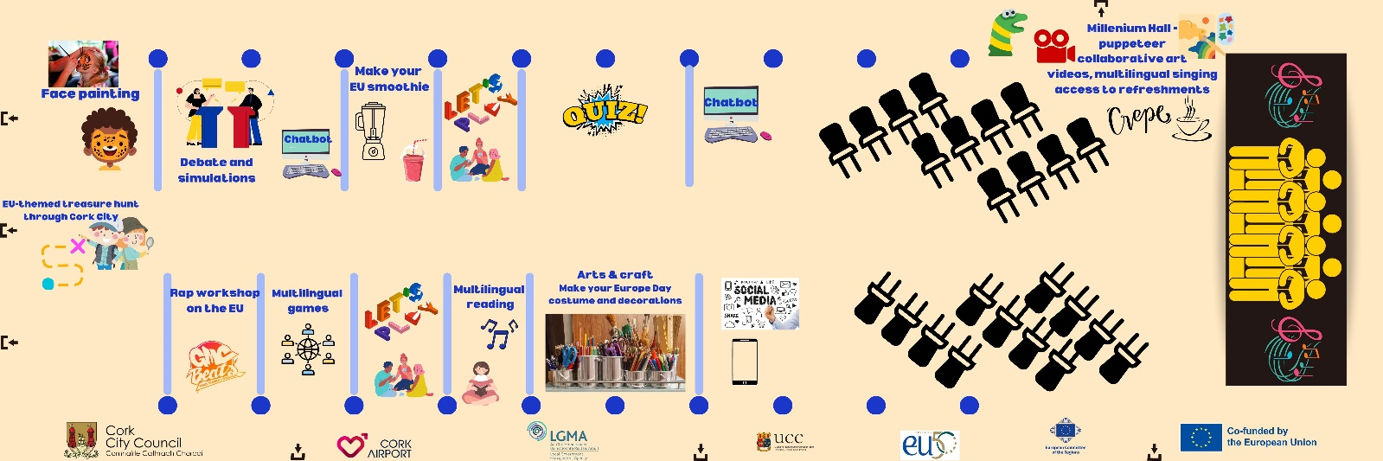

CORK CITY MILLENIUM HALL:

