Please bring this handout with you to the workshop
Designing Inquiry-Based Learning Activities
Mick Healey
HE Consultant and Researcher
Emeritus Professor University of Gloucestershire; Adjunct Professor Macquarie University mhealey@glos.ac.uk; www.mickhealey.co.uk
Workshop Presented at University College Cork
5 February 2014, 09.30-12.30

For further case studies and references see: www.mickhealey.co.uk/resources
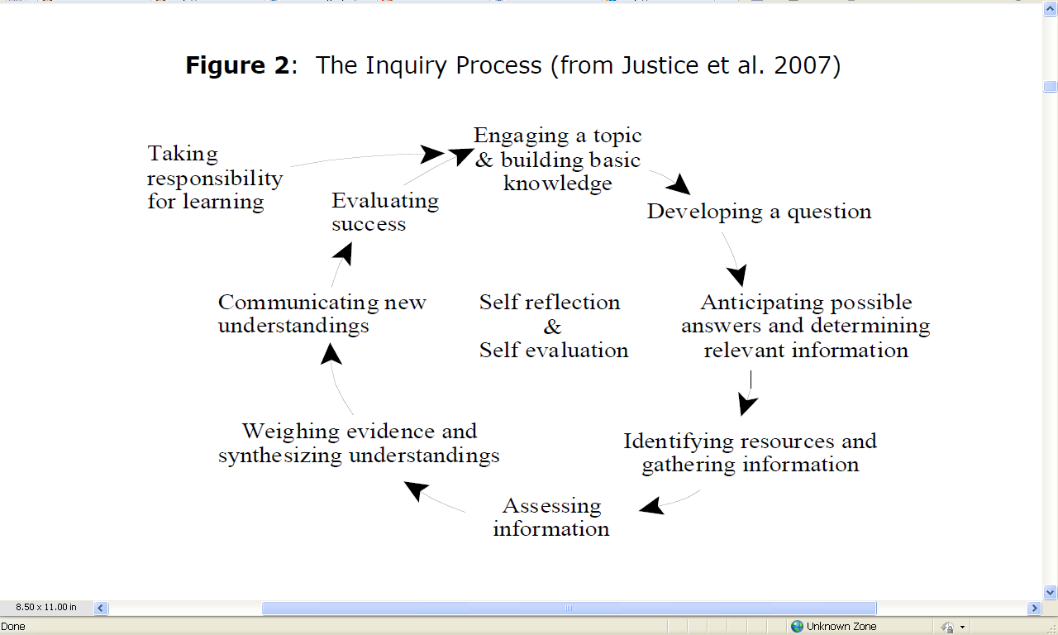
Useful Resources
Levy, P, Sabine, L, McKinney, P, Nibbs, A and Wood, J (2010) The Sheffield Companion to Inquiry-based Learning University of Sheffield http://www.shef.ac.uk/polopoly_fs/1.122757!/file/Sheffield_IBL_Companion.pdf
McMaster University Inquiry http://cll.mcmaster.ca/resources/inquiry.html
McMaster University Centre for Leadership in Learning, Inquiry-based learning resources www.mcmaster.ca/cll/inquiry/inquiry.resources.htm

University of Birmingham Enquiry Based Learning http://www.ebl.bham.ac.uk

University of Birmingham Centre for Excellence in Interdisciplinary Mental Health Designing for enquiry based blended learning (DiBL) http://www.ceimh.bham.ac.uk/newsandevents/DIBL.shtml
University of Birmingham (2010) Enquiry-Based Learning from Theory into Practice http://www.ebl.bham.ac.uk/resources/Literature_Review.pdf
University of Gloucestershire Centre for Active Learning http://insight.glos.ac.uk/tli/activities/activelearning
University of Manchester Centre for Excellence in Enquiry-Based Learning http://www.ceebl.manchester.ac.uk/ebl/
University of Sheffield IBL at Sheffield http://www.shef.ac.uk/ibl
1. Example of an inquiry based learning course 1: McMaster University

INQUIRY 1SS3
INQUIRY IN THE SOCIAL SCIENCES 2010/11
Wednesday 2:30 – 5:20 pm GSB 102

Sue Vajoczki

Course Description

Inquiry courses are designed to develop and to teach students how to learn and how to share knowledge. Thus, inquiry courses are skill-driven, rather than content-driven, focusing on the skills required to perform effectively in university. Students can take these personal transferable skills and approaches into other courses, throughout their university career, and beyond. Students will engage in a process to begin to learn how to formulate questions, gather and interpret evidence, and draw conclusions, using as content, topics central to research in the Social Sciences (e.g., social identity, globalization, health, gender).

Theme:

The theme in this section is student success: social and cultural factors. Why do some students succeed at university whereas others do not? Why do students with similar grades in high school have widely different success at university? Can a student’s likelihood for success at university be enhanced by addressing social and/or cultural influences? What is success? Do students own definition of success influence their outcome in higher education?

Course Objectives:

Upon successful completion of this course a student should be able to:

- develop a researchable question and refine it;
- demonstrate the ability to obtain information relevant to answering the question;
- critically evaluate the validity and relevance of materials’
- communicate a coherent response to the researchable questions; and,
- critically reflect on the learning process.

Objectives of the Assignments:

- to consolidate and expand on the information students acquire in the readings and classes;
- to increase student’s self-awareness and self-evaluation skills;
- to develop research skills that will assist the student in
  - critically assessing the information they are provided
  - finding additional information
  - synthesising the information into a coherent whole
  - developing their ability to communicate findings

Course Format and Evaluation:
Inquiry 1SS3 is a multiple section course with individual section size not greater than 30 students. Students will be active participants in every class. The classes meet once per week in either the day or the evening in a three-hour block of time. Each section of this class is facilitated by a different instructor, so the exact classroom experience will vary. However, we have consistent expectations. You will be a member of a group and will have many opportunities for discussions with your instructor and other students. You will also have library sessions and other presentations or group activities related to the objectives of the course. The main emphasis, however, and what you will be assessed on, will be your activities in the process of following a research question through to its fruition, using scholarly (academic) methods. Learning these methods in your first year should prove highly valuable to you in your subsequent courses towards your degree, and thereafter in the pursuit of lifelong learning.

Required Textbooks:

Northey, M., Tepperman, L., and Albanese, P. (2009). Making Sense: A Student’s Guide to Research and Writing. 4th Edition. Toronto, Canada: Oxford University Press. (available in the bookstore)

Weston, A. (2007). Creativity for Critical Thinkers. Toronto, Canada: Oxford University Press. (available in the bookstore)

Elements of Evaluation:

Assessment Activity | % Final  Grade | Date  Assigned | Date  Due
Reflection #1 on Student Success | 7.5 | Jan 5 | Jan 12
Reflection #2 on Student Success | 7.5 | Jan 5 | Mar 9
Critical Incident Reports | 20 | Jan 5 | Determined at first class
Group Work Contract | 5 | Jan 12 | Jan 19
Class Participation | 10 | Jan 5 | Mar 30
Library Assignment Summative | 15 |  | February 9
Capstone Assignment (presentation, electronic submission & abstract) | 35 | January 12 | March 23rd or 30th depending on mode of presentation

Course Schedule:
Date | Topic | Reading complete  PRIOR to class
Jan 5 | Introduction to the Course  What is Inquiry?  What is my approach to learning?
Jan 12 | How to work effectively in a group?  Asking questions?  Books & Article Searching – Wong Classroom 4:00-5:20 | Weston chapters 1, 2 & 3
Jan 19 | Cross-cultural simulation Exercise: Bafa Bafa | Weston chapters 4, 5 & 6  Northey et al. Chapter 1
Jan 26 | Web/New Media – Lyons New Media Centre 2:30-4:20  Reading critically and asking questions | Northey et al.  Chapter 2 & 3
Feb 2 | Creating a proposal | Northey et al.  Chapter 4
Feb 9 | Oral communication strategies  Library Assessment – KTH B123 4:30 pm | Northey et al.  Chapter 5
Feb 16 | Ethics and research | Northey et al.  Chapter 6
Feb 23 | READING WEEK
Mar 2 | Staying on track | Northey et al.  Chapter 7
Mar 9 | Workshop | Northey et al.  Chapter 8 & 9
Mar 16 | Peer review | Northey et al.  Chapter 10
Mar 23 | Poster Presentations | Northey et al., Chapters 11, 12 & 13
Mar 30 | Video & Graphic Novel Presentations

2. Example of an inquiry based learning course 2: University of Gloucestershire

EL325 Issues in Environmental Geography, 2007-08

Teaching Staff: Jane Roberts, Module Tutor (CL058; jroberts@glos.ac.uk)
Mick Healey (QU124; mhealey@glos.ac.uk)

Teaching Timetable: Semester 2, Monday, 14.15-17.15. ROOM: CE102
Programme: (L) = Lecture (P) = Practical (S) = Seminar/Workshop

1 | 12 Feb | JR | Course introduction  Project examples  Setting up project groups | (L&P)
2 | 19 Feb | MJH | Workshop: Teamwork issues Development of ideas for projects and their implementation | (S)
3 | 26 Feb | JR | Lecture: Should we believe Malthus or Brundtland? | (L)
4 | 5 March | JR/ MJH | Lecture: Grand narratives in post-modern times Group tutorials on outline project proposals | (L)(S)
5 | 12 March | JR | Environmental philosophies: why do they matter?  Formative presentations | (P)
6 | 19 March | JR | Group tutorials | (S)
7 | 26 March | JR | Group tutorials | (S)
 |  |  | Easter Vacation
8 | 23 April | JR | Group tutorials | (S)
9 | 30 April | JR/MJH | Workshop: Preparation for presentations and project report | (S)
10 | 7 May |  | May Day Holiday
11 | 14 May | JR/ MJH | Presentations and module evaluations  This session will run 2.15-6.15 | (P)
12 | 21 May | NO SESSION | Preparation of group report and reflective essay

Tutor | Jane Roberts
Brief Description | This module aims to enable students to apply the knowledge, skills and understanding which they have developed over their geography programme to a particular local or regional issue.
Status | Compulsory for GE Single Honours, Major and Joint  Acceptable for HG, PG
Context | This module is a capstone course for the Geography Field. The integrative nature of the module follows from the philosophy of the Geography Field.
Content Summary | This module is concerned with analysing competing environmental philosophies and applying them to understanding a particular local or regional environmental issue. The nature of different environmental philosophies will be discussed at the beginning of the module. Most of the time will, however, be spent in working on defining and analysing a particular environmental issue, applying the philosophies to understanding the issue and coming up with policy recommendations. The work will be undertaken in groups, each of which will produce a consultancy project and will make a presentation of their findings to the 'clients'. Tutorial support will be given on researching the issue, working in teams and presenting the findings.
Learning Outcomes | i. Knowledge and understanding  On completion of this module students should be able to demonstrate that they:  a) can describe the development of environmental philosophies in geography;  b) can conceptualise the principal features of a particular local or regional environmental issue;  c) can recognise and analyse the interlinkages between the social, economic, political and natural environmental factors at work in their chosen environmental issue;  d) are familiar with a range of primary and secondary data as appropriate to a particular local, regional or national environmental issue;  e) have reflected on the processes involved in working in a group.  ii. Skills  On completion of this module students should be able to demonstrate that they:  a) have further developed skills in presenting material orally and in report form;  b) can work effectively as a member of a group.

Assessment

There are three elements to the assessment:
- Group report (60%)
- Oral presentation of project (30%)
- Individual Learning Journal and Reflective Essay (together counting for 10%)

Peer and Self Assessment of Group Project Preparation

One of the advantages of working as a member of a team is that you can all benefit from each other's strengths. The purpose of this exercise is to give recognition to the varied contributions that individuals make to the working of a group.

The tutor will use the completed form as a guide to distribute marks between team members. If very large differences occur in the perception of the contribution of particular individuals the tutor may ask the group to discuss these and come to an agreement.

Below is a list of some of the processes which you will be involved in completing a group project. You may modify this list and weightings if everyone in the group is agreed. This is best done near the beginning when you have devised a work plan. You may wish to revise the scheme at the end, but this may result in conflict.

Project processes

1 Ideas and suggestions
2 Leadership, group organisation and support, minute taking
3 Data collection/collation/analysis
4 Report writing, production and editing
5 Preparing/giving verbal presentation

Using the Self and Peer Assessment Form independently assess the relative contribution of each team member, including yourself. The following grading system should be applied:

1 Minimal, or did not contribute in this way
2 Below average
3 Average
4 Above average
5 Outstanding

In assessing the relative contributions of team members account should be taken of the quality and effectiveness of the contribution as well as the amount of effort expended.
Average refers to the average contribution of your group members to that particular process.

A discussion of how this scheme operates may be found in:
Healey M and Addis M (2004) Use of peer and self-assessment to distribute group marks among individual team members: Ten years experience, in Healey M and Roberts J (Eds) Engaging students in active learning: case studies in geography, environment and related disciplines, Cheltenham: University of Gloucestershire, Geography Discipline Network and School of Environment pp116-121 http://www2.glos.ac.uk/gdn/active/student.htm
Self and Peer Assessment Form

Your name:

1 List the names of your team in the table below.

2 Allocate points to each member of your team, including yourself, for each project process using the following grading scheme, where average refers to the average contribution of members of your group to that particular process:
1 Minimal, or did not contribute in this way
2 Below average
3 Average
4 Above average
5 Outstanding

3 You are encouraged to be frank and honest in allocating scores.

4 Sum the number of points allocated to each person and calculate the overall number of points you have given to your team.

 | Project process score
Group members in alphabetical order including yourself | 1 | 2 | 3 | 4 | 5 |  | TOTAL
A.
B.
C.
D.
E.
F.
OVERALL TOTAL

Comments: Use this space if you wish to draw to the attention of the tutor any particular points about either the way your group operated or the assessment procedures.

3. Inquiry based learning planner

http://www.shef.ac.uk/polopoly_fs/1.122759!/file/IBLPlanner.pdf
This Planner offers a point of departure for designing IBL, and discussing and sharing IBL designs, in any academic discipline. Already-produced designs – for example, in the form of case studies or activity-sequences – can be used in conjunction with the planner for inspiration and adaptation.

Designing for IBL | Questions to ask
Students | ▪ What relevant subject and process knowledge and skills will students bring to the inquiry? How do they understand inquiry and research, and their own roles as student researchers?  ▪ How might IBL challenge them, e.g. in relation to their beliefs about their role in knowledge-creation, expectations about learning and teaching, self-confidence, skills?  ▪ What are their likely needs for support and guidance, in relation to the subject-matter and the inquiry process?
Intended learning outcomes | ▪ Will the main focus be on students acquiring existing knowledge (‘inquiry for learning’) or on building new knowledge (‘inquiry for knowledge-building’)?  ▪ What will the balance be between subject and process learning outcomes?  ▪ Will students play a role in determining learning outcomes?
Inquiry theme | ▪ What will students explore? How will their inquiries relate to the curriculum?  ▪ Who will establish the inquiry question – teacher, students, someone else?  ▪ Will there be a link between students’ inquiries and their academic tutors’ research interests? If so, will this be made explicit?
Inquiry process | ▪ What is the appropriate scale and timescale of the inquiry?  ▪ Will the process be tightly or loosely structured by academic tutors? A step-by-step sequence of tasks, or a more flexible, emergent process? More strongly teacher- or student-designed?  ▪ Will students have choices in deciding how to approach the inquiry  ▪ Will an established framework or protocol be used to structure the process? Will it follow the pattern of research practice in the discipline?
Tasks | ▪ What will the stimulus for the inquiry be (an open question; a scenario; a problem; an image; an artefact; a performance; a discussion; something else)?  ▪ How will the tasks be sequenced? Will a digital design tool be used (e.g. LAMS)?  ▪ What tasks will there be to help students engage with relevant theory/subject-matter (e.g. reflection; discussion; peer-to-peer information-sharing; lectures; practical workshops; laboratory sessions)?  ▪ What tasks will there be to help students develop process awareness and skills (e.g. in areas such as research methods, information literacy, group-work, reflective writing)?
Assessments | ▪ What will be assessed (research product; aspects of the process; reflection on the process)? What form will assessed outcomes take (poster; wiki; essay; design; report; film; other?) Will assessment be individual or collective?  ▪ What will the assessment criteria be? Will students play a role in establishing assessment criteria?  ▪ Who will assess (academic tutors; student peers; self-assessment; other)? How will summative feedback be given?
Information | ▪ How will students access relevant information? What will the balance be between providing information to students, and requiring students to seek and select information themselves?  ▪ Will students be directed to information on process issues as well as discipline-based subject-matter?
Spaces | ▪ Is there a need for a particular type of learning/teaching space during and outside of ‘contact’ time?
Technologies | ▪ Which technologies will be needed and appropriate? Special equipment? Platforms for collaboration and content-creation; mobile technologies; the institutions’ virtual learning environment; etc?  ▪ Will students play a role in deciding which technologies to use?
Tutoring | ▪ Who will be involved in guidance and tutoring (academic staff; learning support professionals, e.g. librarians; student mentors; external tutors; other)?  ▪ How and when will formative and summative feedback be provided?
Peer-to-peer | ▪ Will students work together? If so, in what way? Will there be an focus on ‘inquiry community’?  ▪ Will students work in partnership with academic staff or other researchers?
Dissemination | ▪ Will students share the results of their inquiries with each other? More widely at department or Faculty level, or with a practitioner/research community beyond the university?  ▪ How will results be shared (on web, at an event, via presentations, posters, suitable peer-reviewed outlets; other)?

Source: Levy, P. (2010) Inquiry-based Learning Planner. Sheffield: Centre for Inquiry-based Learning in the Arts and Social Sciences, University of Sheffield.

4. Inquiry Based Learning in a Professional Learning Context (adapted from Price, 2003).

Inquiry based learning (IBL) encourages blended professional learning grounded in practice. The aim of IBL is to promote active deep learning, independent study to develop inquisitive, transferable and co-operative skills essential to practice. There is a great deal to gain from active study that involves inductive and deductive thinking and which requires you to work closely with others, within teams, to make sense of the learning environment and the challenges that exist there.

The IBL Process
IBL develops through a process of formulation, shaping, refining and closure
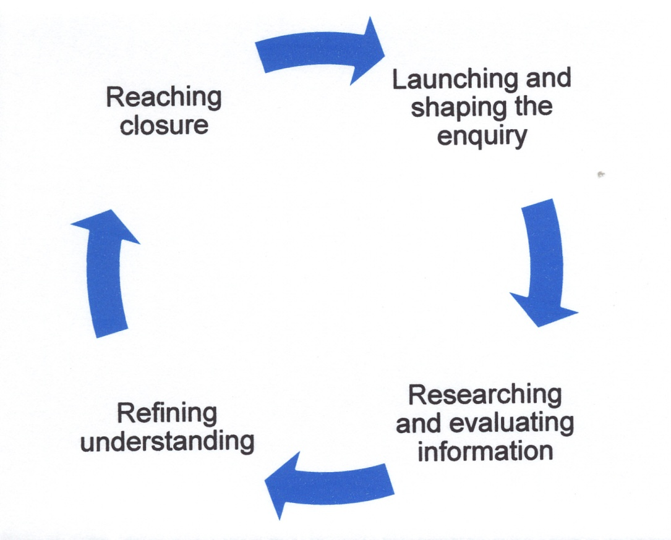

Session 1

Launching the inquiry and shaping: The inquiry launch begins with a conversation amongst the team about how to manage the team and the inquiry. If appropriate, roles are allocated to team members e.g. scribe, time keeper, leader. At the launch, the inquiry is ‘exploded’ out to generate ideas and discussion around the concepts being exploded. This stage is very much about discussion around the inquiry, focussing of ideas, allocating the team to explore certain concepts, consideration of resources and shaping of the inquiry’s future.

Interpreting-Analysis-Explanation (IAE) approach
IBL puts you at the centre of learning, it gets you to understand different pieces of information that you are surrounded by. At the heart of IBL is the philosophy that instead of telling you the information, you have to find it out for yourself. This is the important in motivating you to learn, you are encouraged to seek out information from the: library; world; web based info to find information. You then have to communicate this information with your team members.

Once you’ve found some information I then want you to do 3 things with it:
- Realise there are no prizes for finding information – you need to understand it, this is called INTERPRETING. You find 3 or 4 most important points then write these as concepts.
- Make connections, tell me why A is connected to B and tell me how. Also tell me how B is connected to A as it may be different - this is ANALYSIS
- Write these in your own words – this gives us an EXPLANATION

The Why/How tree
Once you have an explanation, you then need to ask yourself WHY this statement is important to the work in hand.

Then you ask HOW this is relevant to the work in hand?

These are now statements in their own right, now tell us why this is important and how this is relevant. You are now thinking at a deeper level as you are being forced to explore the why and how.

Masters level students should be able to go down to a 4th or 5th level, this is a very deep understanding of the subject matter. This is called ‘the why and how tree’.
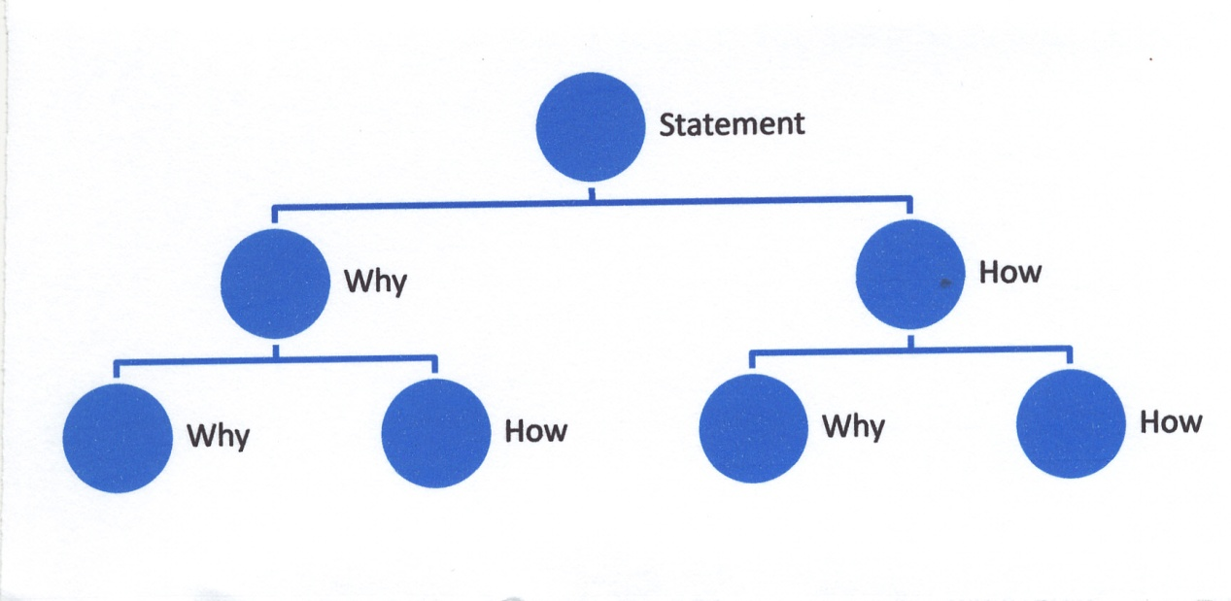
The why and how tree

Online activity: Record your initial inquiry explosion, have the team task allocation and promote ongoing discussion.

Session 2 and subsequent sessions

Gathering Information: Research/evidence and information is gathered individually and discussed and challenged by the team in light of what has been learnt. The information is then considered as to whether it is factual or possibly significant. The team then decides how the information fits together and how to continue to find out what needs to be known.

Refining Understanding: This is the point where the inquiry has to stop exploding outwards and needs to focus inwards to begin to reach closure. Each team member should begin to focus on how they will bring the inquiry to closure and what aspect they will be responsible for.

Online activity: Post information for each other but don’t be tempted to post whole articles or polices, instead post a précis which indicates your learning from the article or policy to enable your team members to understand the key learning and relevance. Continue any discussion between sessions and begin to develop a picture of how the inquiry is progressing with annotated notes from session meetings outlining key points and learning.

Session 3

Reaching Closure: It is not always possible with IBL to provide a solution but you do need to reach closure with an inquiry. The closure of the inquiry is presented individually or in small teams to the rest of the team to demonstrate understanding of the inquiry and articulate what has been learnt. The content needs to demonstrate evidence of wide reading and depth and breadth of knowledge.

Online activity: Each team member’s online page should include an annotated reference list, supporting material which documents the learning journey through the inquiry.

Price, B. (2003) Studying Nursing Using Problem-based and Enquiry based learning. Basingstoke: Palgrave MacMillan.

5. Activities to get students active in their learning

This table was compiled by Rachel Spronken-Smith (Otago) in 2011 from many sources and covers a range of possible activities to promote engagement and active learning in a variety of situations.

1-2-4- more Pyramid | Each person writes brief notes about the topic and then compares them with a partner. Each pair discusses its combined list with another couple. This provides a good basis for discussion in the wider group. It is a good idea to limit the ‘1-2-4’ stages, e.g. 2 minutes or so for each individual and for paired work, 5 minutes for the ‘4’ stage.
Brainstorming  (Morrison, 2004) | Everyone thinks of as many different ideas as possible. All ideas are accepted and recorded without comment. The ideas are evaluated after a set time period or when the inspiration ends.
Buzz Groups  (Morrison, 2004) | Working in small groups, people discuss an issue. Topics can include:  - How much they already know on a topic  - What they are not sure about  - What they want the lecturer to cover next
Case studies  (Morrison, 2004) | A story or scenario is presented to the group (often, but not always) as a handout. Groups discuss the story or work together on questions.
Clickers | These can be used to good effect for class participation through students keying in responses to questions. Also useful to allow students to give an answer first and then chat with neighbours and rekey in the answer. This can lead to conversations about why students may have picked the wrong answer – it is very useful for recognising and addressing common misconceptions.
Complete diagrams or tables together | Instead of providing the finished product, if the diagram is simple, draw it on a whiteboard or OHP, and allow time for students to complete it as well.
Critical incidents | These are brief written or spoken depictions of vividly remembered events. These can be used during class to bring out those ‘aha’ moments which had a real impact on their learning, or can be used about difficult concepts. Get the students to write a description (where and when it occurred), think about what was involved (e.g. a topic or problem...) and then unpack why it was so memorable.
Cubing  (Cassidy, 2008 and  http://www.humboldt.edu/~tdd2/Cubing.htm) | Cubing involves probing a topic from six different perspectives. First, select a topic (issue, person, idea, event, problem, person, object, scene) and then allow 3-5 minutes for students to write from different perspectives (e.g. describing, comparing, associating, analysing, applying, and arguing). Cubing is an excellent tool for rapidly exploring a topic. It reveals quickly what is known and what is not known.
Demonstrations  (Morrison, 2004) | The teacher shows students how to do something, or uses equipment to explain theory/principles. This activity can also be presented by a student or group. Seeing something real helps students to remember more clearly.
Experiments  (Morrison, 2004) | The teacher or students carry out a practical activity to verify or refute a principle.
Exit ticket | At the end of a lecture get students to write an exit ticket which responds to the question “What questions remain after today's session?” and hand in on the way out. Collect any written responses and address them in the following session.
Extremes  (Morrison, 2004) | Each person thinks of the ‘best’ and ‘worst’ or ‘positive and negative’ qualities of something. These are collected and discussed to generate a ranking of extremes.
Fishbowl  (Morrison, 2004) | One group discusses a topic. The second group observes the discussion and each person records:  - A partners contributions (and gives individual feedback afterwards)  - The important parts of the discussion (may be identification of issues, applications, generalizations, etc., depending on the task instructions.
Focus breaks | These are deliberate breaks to give students some time out. Bligh (1998) discussed the learning curve in a lecture – after about 20 minutes learning is on a downward decline. However, if focus breaks are inserted whereby students can have time out for 2-3 minutes, then there is a learning gain as students’ attentions are recaptured. Thus plan to have a couple of focus breaks during a 50 minute lecture.
Group discussion  (Morrison, 2004) | Groups (up to 6 people) talk about a topic. A set of questions from the lecturer helps to structure the discussion and focus the group. The larger the group,. The more difficult it is for everyone to participate.
Interactive handouts  (Morrison, 2004) | Instead of providing complete copies of the PowerPoint slides or OHPs, give out sheets with various parts missing. These could be mathematical, formulaic, descriptive, diagrammatical, analytical and so on. The students need to complete the materials for them to be useful.
Jenkins Line | Named after Alan Jenkins (Geographer/Higher Educationalist). When a topic has polar opposites or a spectrum of possible answers or viewpoints, get students to place themselves along a line and discuss their position with their neighbours, and possibly be called upon to discuss/justify their position with the class.
Jigsaw  (Cassidy, 2008) | Each student is the 'expert' on one part; they must work collaboratively to get the full picture; have experts in the area get together first, so they become more expert, then return to the broader group where each one is the expert. Research has shown that we learn more by teaching it. For an assessment, individuals or small groups do the work. The lecturer asks them questions and can ask any member. Higher marks often result.
Lotus Blossom | In this technique the petals around the core of the blossom are figuratively "peeled back" one at a time, revealing a key component or theme. This approach is pursued in ever-widening circles until the subject or opportunity is comprehensively explored. The cluster of themes and surrounding ideas and applications, which are developed in one way or another, provide several different alternative possibilities. The guidelines for Lotus Blossom are:  1. Write the central problem in the center of the diagram.  2. Write the significant themes, components or dimensions of your subject in the surrounding circles labelled A to H surrounding the central theme.  3. Use the ideas written in the circles as the central themes for the surrounding lotus blossom petals or boxes. Thus, the idea or application you wrote in Circle A would become the central theme for the lower middle box A. It now becomes the basis for generating eight new ideas or applications.  4. Continue the process until the lotus blossom diagram is completed.  Good for getting students to unpack factors that influence key concepts.  http://www.innovationtools.com/Articles/ArticleDetails.asp?a=160
Matching  (Morrison, 2004) | Used to divide a group into pairs. Members of the group are given cards which contain either a title or a definition. They have to find the person with the complementary card. In the process they come across a range of definitions and have to think about the topic. The pairs then work together on an exercise/problem related to their title and definition. Reporting back afterwards widens learning.
Mindmaps  (Morrison, 2004) | A topic is written on the board or on butcher’s paper. The class/group suggests and organizes ideas and information, presenting them visually, often in clusters. Can be carried out using a large group on one diagram, or in smaller groups, or individually.
Mix up media | Try to use a variety of media such as PowerPoint, OHPs, video clips, whiteboard etc. Students will appreciate the variety, particularly if they can engage with some of the material.
Organising information  (Morrison, 2004) | Information items are provided out of sequence. Students work (in pairs of small groups) to arrange them in order. The results can then be reported by each group and/or discussed by the wider group. The information can be given to students on a single worksheet or already cut out into pieces for them to arrange in order.
Panel  (Morrison, 2004) | Several ‘experts’ are invited to the session and answer questions from the class. The experts may be from interest groups, other teachers and or/students. They may each speak briefly before the question session.
Playing cards | One playing card is given to each member of the class at the start of a block of teaching. They can be used in a variety of ways. For example, suits can be used to form groups of 13, particular numbers can be used to form groups of four or red or black numbers for pairs. When asking class questions, particular cards or sets of cards may be called on to comment.
Presentations  (Morrison, 2004) | Individuals or small groups find information on a topic, then prepare and deliver a short informative session to the wider group.
Problem generation and solving (fears/problems in the box)  (Morrison, 2004) | Individuals or groups consider a topic, issue, process, case, etc and raise problems or difficulties. Each person or group writes the problem on pieces of paper which are folded and put into a box. The ‘problems’ are then redistributed and solved by others and shared.
Question and answer session  (Morrison, 2004) | This is a useful activity to check students’ understanding. A time is set aside for a discussion/answer question. Questions may be submitted in writing at the previous session or on Blackboard (good for shy students).
Quick quiz  (Morrison, 2004) | During a class have a quick quiz on the material just covered. This could also take the form of a problem-solving exercise (or practice exam questions) and groups or individuals can compete for speed and accuracy.
Review sessions | Build these into the lecture sequence so that there are dedicated slots to go over any questions and allow practice in exam type questions.
Role play  (Morrison, 2004) | Groups/pairs/individuals ‘act out’ information on a specific topic, often in front of the class or group. Set a time limit for each group and allow time for participants to debrief.
Round  (Morrison, 2004) | Every person takes a turn to make a statement. Useful topics:  - One thing I need to know about…  - Something I learned today…  - One important point (about the topic)…
Snowball  (Cassidy, 2008) | On a half-sheet of paper that you will not be keeping, write down (something that you are okay with others seeing and legibly so they can read it!) one example from the last several numbered items that you do now in your teaching, or would like to ask a question or comment about. Once done, crumple it up and toss it (gently) into the crowd. Now, everyone pick one up. If it is yours, re-toss it. Read what is on the snowball you un-crumple.
Tell your partner  (Morrison, 2004) | Pairs. Each person explains a topic/concept/answer to someone else. The partner has to listen and then ask questions.
Think-pair-share  (Morrison, 2004) | Each person considers the topic/question and writes down some ideas/answers. S/he joins with one other for discussion. This provides a good basis for wider discussion and answers tend to be much more forthcoming in a plenary.
Ticket to the class  (Cassidy, 2008) | Require a 'ticket to class' to ensure pre-reading or prep is done. The class before, assign the reading and hand out a coloured slip of paper – different colours can be used for different types of questions. Each colour is a unique question that students have to write down and bring to the next class. This encourages all students to read the material, and come prepared for the session. Tickets could be collected at the door on the way in so that if there were any common recurring problems, these could be addressed in the session.
Time on task  (Cassidy, 2008) | Create lots of time on task during class time. This relates to the Seven Principles for Good Practice in Undergraduate Education by Arthur Chickering and Zelda Gamson. See: http://honolulu.hawaii.edu/intranet/committees/FacDevCom/guidebk/teachtip/7princip.htm
Using resources in class | At the beginning of the session handout out copies of a paper or papers or other relevant materials to the topic. Different materials can be distributed to different parts of the lecture theatre. Given some focusing questions for each resource (e.g. they may have to read a particular section of the paper and then answer a question). Allow students about 15 minutes to read and then they can discuss the answers with their neighbours. Then have a plenary to collate the answers and to build knowledge across the class.
Using twitter in your lectures | Use Twitter to get instant feedback from students in your lecture: they can either use their laptop or their mobile phone. For an example see how one university teacher uses it:  http://www.readwriteweb.com/archives/how_one_teacher_uses_twitter_in_the_classroom.php or  http://tinyurl.com/ml3pcp (same link, shorter address)
Learning preferences of your students | Refer your students to the learning preferences test designed specifically for university students. This can help them to appreciate that not everything that happens in lectures may suit their learing preference:  http://www.engr.ncsu.edu/learningstyles/ilsweb.html

References

Bligh, D. (1998) What’s the Use of Lectures? Exeter: Intellect.

Cassidy, A. (2008) 50 Ways to lure your learner. Presentation at the Conference of the Society for Teaching and Learning in Higher Education, University of Windsor, June 19, 2008.
Gauci, S.A., Dantas, A.M., Williams, D.A. and Kemm, R.E. (2009) Promoting student-centred active learning in lectures with a personal response system. Advances in Physiology Education 33: 60-71.
- This article first reviews the literature on the use of clickers and then explored the use of clickers on student engagement in an undergraduate physiology course with 175 students. Students evaluated the impact of clickers on their learning through both interviews and a survey and survey responses were correlated with student performance. Students felt “more engaged” (83%), “intellectually stimulated (85%) and “motivated to think” (89%) through the use of clickers in lectures. Answering clicker questions was found to be enjoyable and to improve understanding. Students in lectures using clickers performed better on exams (compared to performance in a previous course without clickers)and those students who participated most frequently with clickers had better results.
Gier, V.S. and Kreiner, D.S. (2009) Incorporating active learning with PowerPoint-based lectures using content-based questions. Teaching of Psychology, 36(2): 134-139.
- This article involved a comparative study to determine whether the use of content-based questions and subsequent discussion could enhance learning when combined with traditional PowerPoint. Students did perform significantly better when questioning was incorporated in the lecture.
Graffam, B. (2007) Active learning in medical education: Strategies for beginning implementation. Medical Teacher, 29: 38-42.
- This article makes a plea for more active learning strategies in medical education and describes some simple strategies to transform lectures into more active learning environments. The lecture strategies described include: using breaks as action moments, questioning techniques and case scenarios.
Mann, S. and Robinson, A. (2009) Boredom in the lecture theatre: an investigation into the contributors, moderators and outcomes of boredom amongst university students. British Educational Research Journal, 35(2): 243-258.
- This article explores the contributors, moderators and consequence of student boredom. 59% of students find their lectures boring half the time and 30% found most or all of their lectures boring. However, labs and computer sessions were rated overall the most boring activities. The most important teaching factors relating to boredom in lectures were copying overheads and the use of PowerPoint slides with no accompanying handout.
Marsh, E.J. and Sink, H.E. (2010) Access to handout of presentation slides during lecture: Consequences for learning. Applied Cognitive Psychology, 24:691-706.
- This article reports on two experiments to determine the impact of having slides on learning. They found that access to handouts of slides during the lecture was associated with a number of benefits including less note-taking, less time needed to prepare for a final test, better performance on the final test.
Morrison, T. (2004) Promoting active learning in lectures. Seminar and handout given in the Higher Education Development Centre, Otago University, May, 2004.
Revell, A. and Wainwright, E. (2009) What makes lectures ‘unmissable’? Insights into teaching excellence with active learning. Journal of Geography in Higher Education, 33(2): 209-223.
- This research involved interviewing ten geography academics and five focus groups with undergraduate students to determine what makes for a good lecture and what makes it unmissable. Attendance rates were significantly enhanced by three key factors: a high degree of participation and interactivity, a clear structure facilitating integrative of material and a passionate, enthusiastic lecturer.
Wilson, K. and Korn, J.H. (2007) Attention during lectures: beyond ten minutes. Teaching of Psychology, 34(2): 85-89.
- This article challenges often-cited research on student attention during lectures, surmising that the research methodology is often flawed. They suggest that lecturers should take into account individual differences in student attention when lecturing.

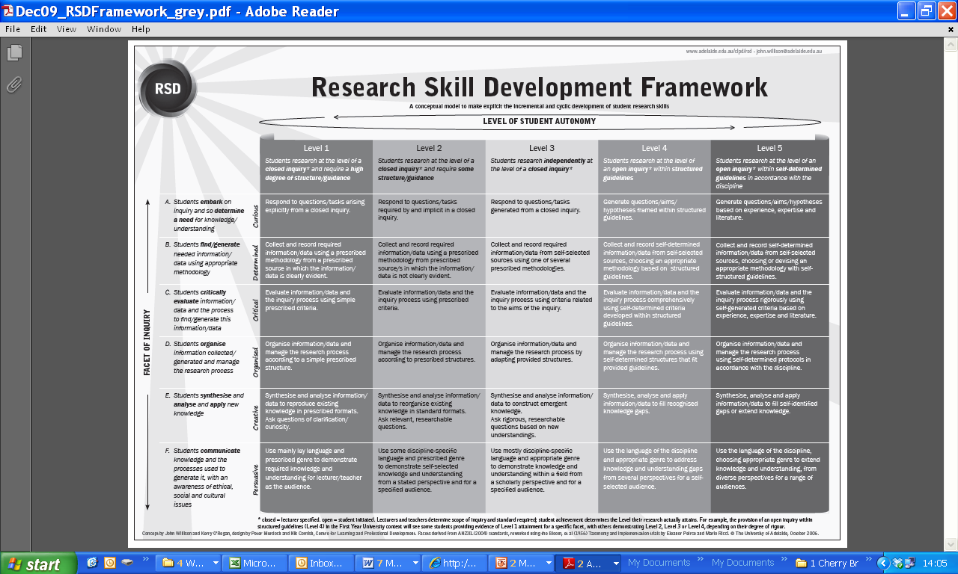

Research Skill Development Framework http://www.adelaide.edu.au/rsd/framework/

