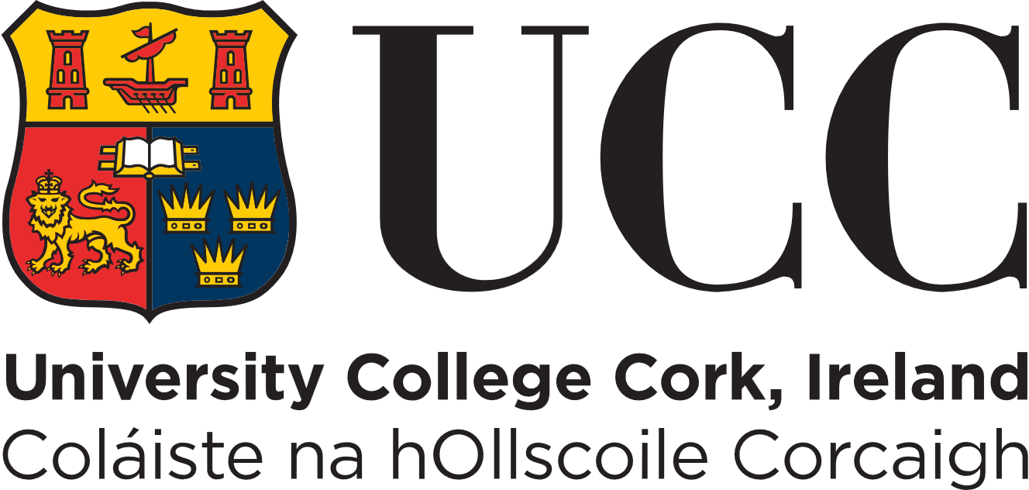
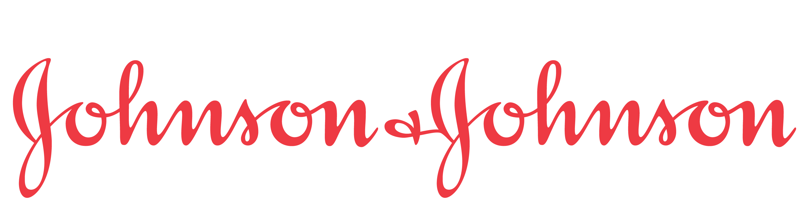

UCC-Janssen Awards Biotherapeutics, Development and Supply (BTDS) Work Placement Award and

Biotherapeutics, Development and Supply (BTDS) Education Award

Application for third year students in Biochemistry or Microbiology

Forward completed forms to stem@ucc.ie by 5pm on Friday 2nd February 2024

Please include BTDS, your name and discipline in the subject line of the email –
E.g. BTDS John X Murphy – Biochemistry

Step 1: Contact and course information

Name:

Student ID Number:

Email address & contact number:

Degree (Biochemistry or Microbiology students only):

Step 2: Application

- In your opinion what are the benefits of work placement? Consider this from both perspectives. What skills do you hope to learn and build on through a work placement at Janssen? (600 words max)
- Briefly summarise why you chose to apply for this award and how it will benefit you in the future. Please include reference to your career plans and personal ambitions. ( 300 words max)

- What you feel you can bring to our team and how your experiences and attributes will benefit the BTDS team. (200 words max)

- List any other achievements, academic and non-academic (e.g. awards, scholarships, foreign exchanges, mini business start-ups, music or sport, participation in Young Scientist or similar competitions which you feel would support this application. (200 words max)

DECLARATION BY APPLICANT

I declare that the above particulars are correct and understand that the circulated “Terms and Conditions” as laid out in the advertising of this scholarship apply. I accept that failure to abide by the “Terms and Conditions” may disqualify me from this scholarship.

Signature of Applicant: Date:

All information recorded here is strictly for use by the College of Science, Engineering & Food Science at UCC for the purpose of review in relation to the BTDS Janssen/UCC scholarship & placement programme and will not be used for any marketing purposes. All information provided in the application form will be held securely and will be destroyed after the application process has been completed. All data collected under the application form will be subject to the data protection policy of UCC. A full copy of the policy is available on our website: http://ocla.ucc.ie/dataprotection/index.asp. All queries in relation to this policy and its provision can be made to k.obrien@ucc.ie .

