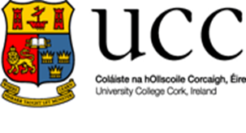
DEPARTMENT OF GOVERNMENT AND POLITICS
MEDICAL CERTIFICATE FORM

STUDENT NAME: ______________________________________________
STUDENT NO: _________________________________________________
DEGREE AND YEAR (e.g. BSCGOV 2): _______________________________
MODULE CODE IMPACTED (e.g. GV3212): ___________________________
DATE OF THE MEDICAL VISIT: ____________________________________

SIGNED (by Student): _______________________
DATE: ___________________________________

**Please attach Extension Form if needed.
This completed form needs to be attached to your medical certificate and submitted to ORB 2.50, Block B or emailed to government@ucc.ie

