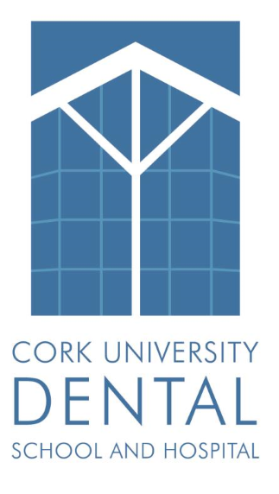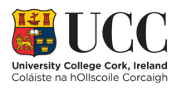
Privacy Notice for COVID -19 Research
What is COVID 19?
COVID-19 is an infectious disease caused by a newly discovered coronavirus. Currently, there are no specific vaccines or treatments for COVID-19. There is a common global effort to understand as quickly as possible, the best ways to prevent and treat COVID-19.
Why is research on COVID 19 important?
Now more than ever, we need to generate new knowledge and increase our understanding about COVID-19. This would not be possible without the participation of our patients.
“We need our collective knowledge, insight and experience to answer the questions we don’t have answers to, and to identify the questions we may not even realize we need to ask.” Dr Tedros, WHO Director General.
Research on COVID-19 at this hospital
Cork University Dental School and Hospital is a teaching hospital that participates in research with the aim of improving patient care. Research studies may be led by the Hospital staff, or the Hospital’s academic partner University, or by academic, charitable or commercial partners within and outside of Europe.
How will we use your information for research on COVID-19?
Research about COVID-19 is in the public interest. We may use your medical and dental records to carry out research. Anonymous health data may be shared for research studies, but your personal information will not be accessible to external researchers who we collaborate with.
If you are invited to partake in a research study for a new treatment, we will ask for your consent.
Is my information safe?
Cork University Dental School and Hospital and University College Cork are committed to ensuring the privacy and confidentiality of your information. All research using personal data will be compliant with the General Data Protection Regulation (GDPR) and must be approved by an independent Research Ethics Committee.
Any published results will be grouped data and you will not be identifiable.
Under GDPR, you have rights. For more information see: https://dataprotection.ie/en/individuals or contact the Data Protection Officer for Cork University Dental School and Hospital; Ms Siobhán Lynch at siobhan.lynch@ucc.ie

