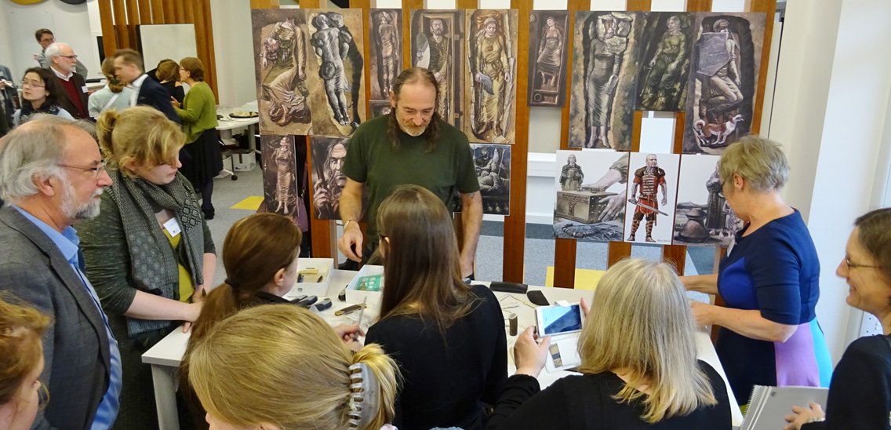
The Challenge including reference to SDGs [200 words]
Ensure your captions reinforce the key messages of the document. Go to Format – Change Picture to update image
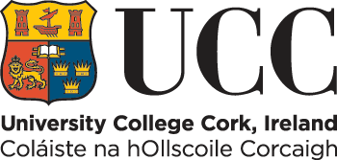

Insert Project Title here

Include an impact-focused, high-level statement: what is the research about? (10-20 words)

In this section, the researcher will explain why the research matters. The goal is to utilise a story-telling approach that includes a compelling narrative along with robust data. Why does this research matter? What’s happening in the world that makes this research needed, valuable, useful, and required? Consider local, regional, national and international issues that this research addresses. Also, consider the stakeholders that this project is relevant to.

The Research [200 words]
#UCCResearch

In this section, the researcher will explain what s/he did with a focus on what methods were used. The goal of this section is to demonstrate that the project was original, significant, rigorous and that it utilised an engaged research approach by sustaining dialogue with particular communities or partners. In this section, the inputs and activities are presented. Include testimonials or acknowledgement from external partners relevant to the research approach here

The Impact [400-600 words]

In this section, the researcher is describing how the project is relevant. See the Engaged Research Impact Categories in Part IV, with indicative actions provided. Ultimately, this section is focused on the planned outputs from the research, their outcomes and the actual or anticipated impact over time. A focus is on both the reach and significance of activities with the goal of corroborating the impact by choosing the most relevant indicative actions and customising them with the key performance indicators from this project. The researcher should explain how the research adds to the vitality and sustainability of UCC’s strategic goals in teaching and learning, research and innovation, external engagement, internationalisation, and infrastructural and financial sustainability. The researcher should broaden this reach to include how this research is changing and informing the research landscape in Ireland and beyond.

For More Information [25-50 words]

Allow the reader to find the project online and make contact with the Principal Investigator, if possible. This might include a website link, contact details, social media platforms and hashtags, or a link to the researcher’s profile.

“Add a quote by the Principal Investigator, participant or a key individual that speaks to why this project is relevant, what is achieved or how it will continue to have impact.”
- Name, Title

