**MyStudentAdmin Fees / Password Reset**

Here is the link for your MyStudentAdmin account: <https://mystudentadmin.ucc.ie/>

If you are experiencing issues with your password, click on the following link to reset it: <https://mystudentadmin.ucc.ie/pwStudentIT/> If you have forgotten your password please click on ‘Forgot your password, or generate a new one’ This shall send a link to your secondary email, allowing you to reset your password. If you open your secondary email inbox and have not received an email within 5 minutes, please contact ACE reception at (021) 4904700 or send an email to your course administrator informing them of your password reset issues.

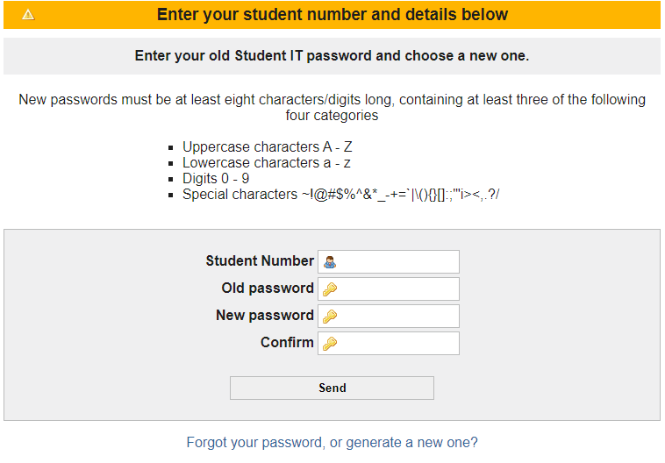

In MyStudentAdmin click on the ‘Fees’ tab (located on the left side of the screen). This shall bring up a list of subtabs. Click on the subtab ‘Pay 2nd & Subsequent Instalments’. Here you should be able to see the amount currently due by you and pay your fees. See photo below of what you shall see in your MyStudentAdmin:

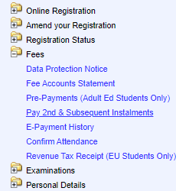

If you have any queries on your fees, please get in contact with [acefinance@ucc.ie](mailto:acefinance@ucc.ie) Always include your student number in email communications.